**# Story-categorization-using-NLP**

Self-narrated stories will be categorized into three categories using their sentiments. Three categories are: 0: Work Stress, 1: Bullying, 2: Sexual Harassment

Tactics Used:

1. Paragraph Vector using PV-DBOW and PV-DM

2. Decision Tree using Gini and Entropy

3. Logistic Regression - Epochs = 5

Validation Stat.:

1. 2-fold cross-validation

2. Train Test split 80/20

Decision Tree Results Using PV-DM, PV-DBOW, and Paired Model of PV-DM and PV-DBOW:

**Using Entropy:**

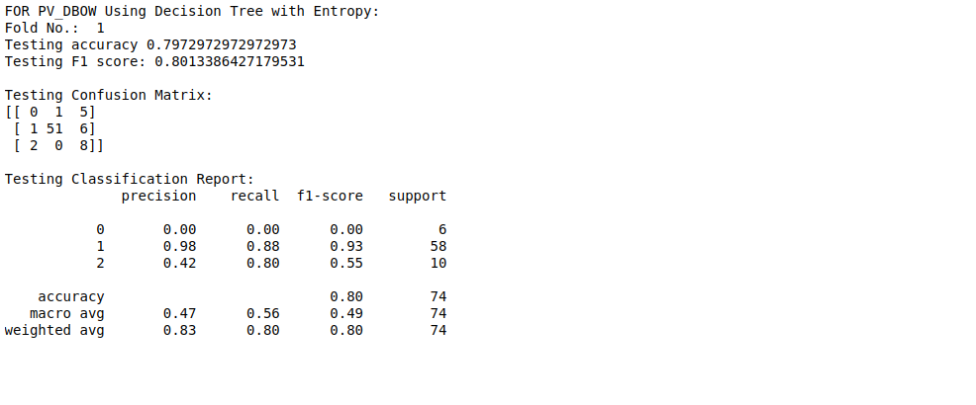

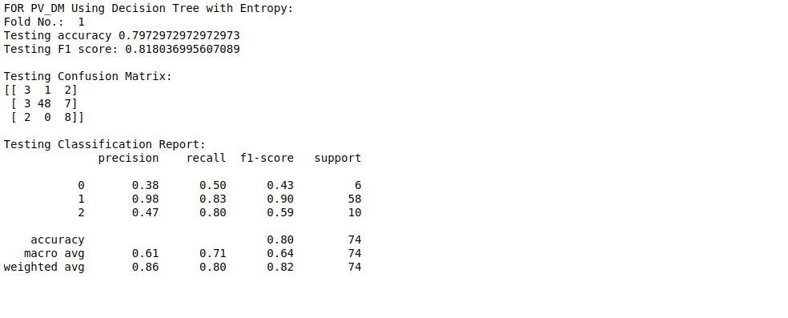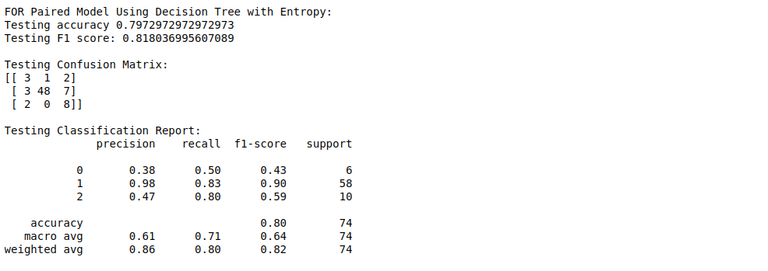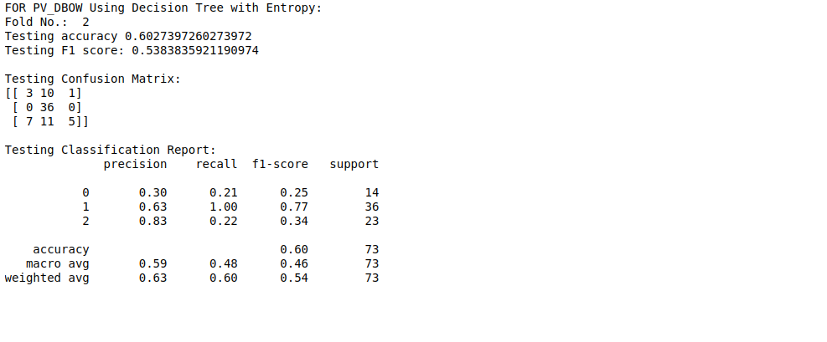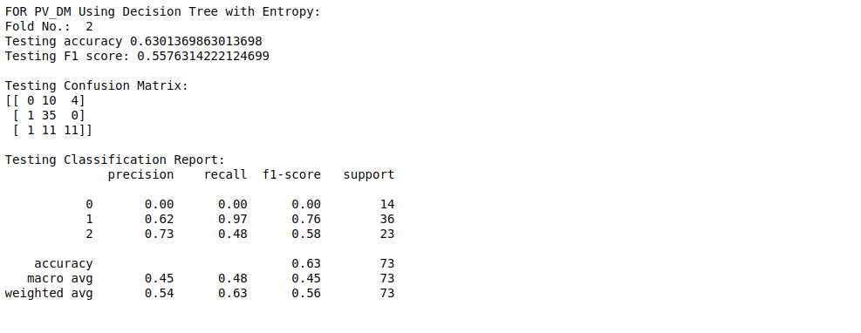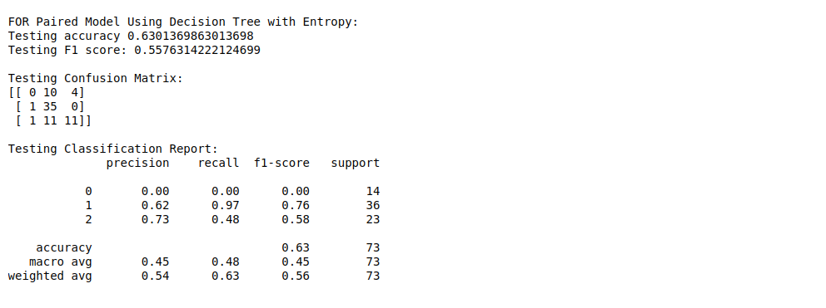

**Using Gini:**

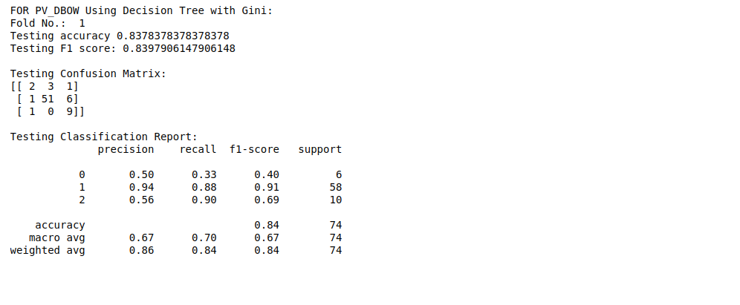

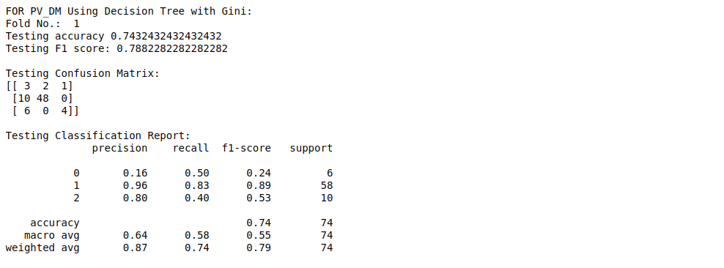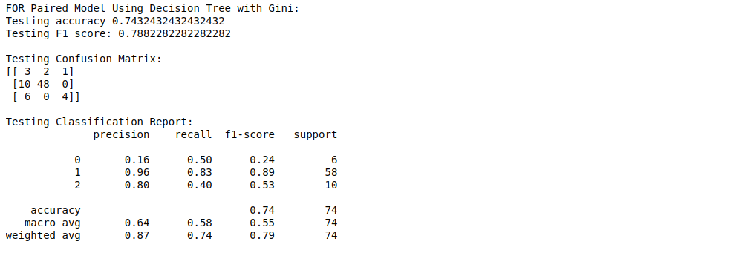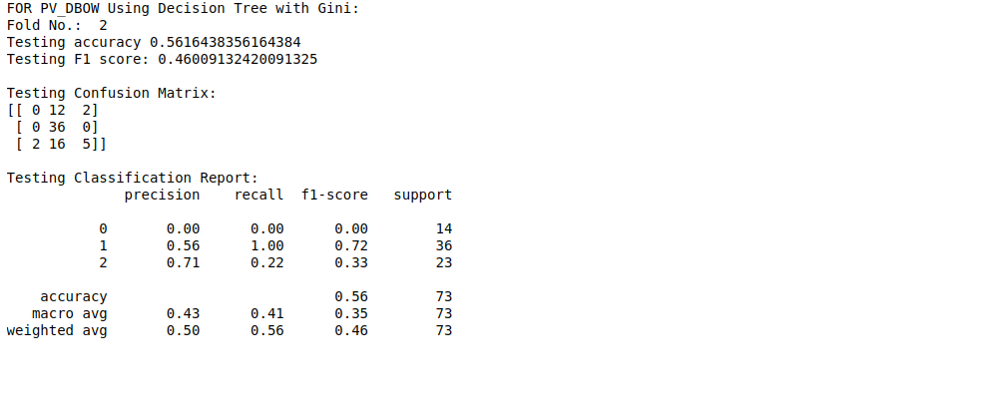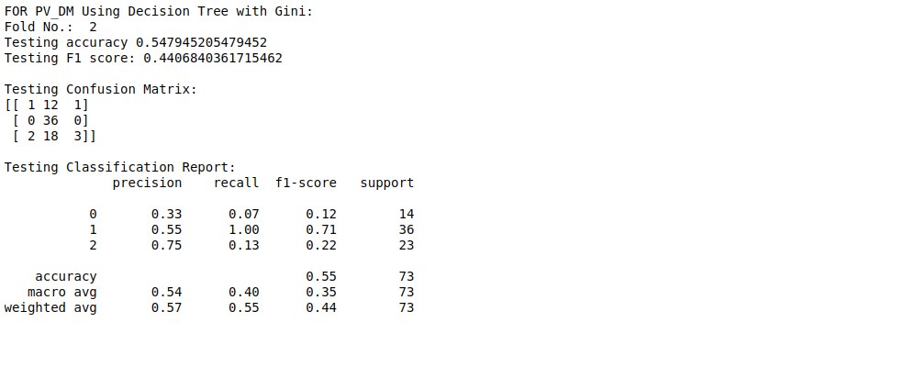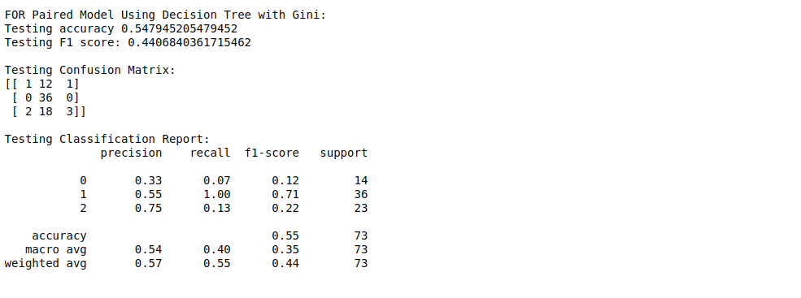

Logistic Regression Results Using PV-DM, PV-DBOW, and Paired Model of PV-DM and PV-DBOW:

**Using Logistic Regression:**