# Notes

## Simulation decomposition from M. Kozlova paper

1. Identify key variables ~V_i and possible range of values.
2. Id. Keys ~V that can be manipulated
3. Identify boundaries ~B_ij for each ~A_ij of chosen subset ~V_i variable.
   1. Maybe label them apropriately
4. Form a groups ~G_k of combinations to specify decomposition scheme

### Example categories

Rain – Min/Max from all the simulations – set boundaries to quantiles 3 thresholds ?? Dry, Moderate, Wet.

Price – Normal, optimistic, fantastic ? :D

## Seeing the model what might be done

What to monitor ?

Price ? Dam levels ?

A decision to, control flood gates

A decision to, control maintenance

## What are we to do ?

Maintenance control module

Improvement comparing to normal model

Sensitivity analysis

Multiple approaches possible

Approaches to solution

Maintenance cost estimation in next 7 days, monitor evolution of cost using, this will use last 30 samples of flow to predict future flow into dam.

* Mean of all values
* Mean of las t 30 values
* Threshold

If percentage drop of estimated maintenance cost exceeds certain threshold, there will be signal to enable maintenance. This is done for each dam separately.

There are hints, sometimes when dam is low, it happens that dam stops generating for a day. This can be addressed by extracting signal from module of generator, and used as signal to enable maintenance, one day of production thus will be spared.

So main idea of solution is, create modules that guess when it would be optimal to run maintenance, then combine the signal and in one decision module select when to run the maintenance.

Maintenance can be run when certain conditions are met:

Next day there is outage in power production, or dam is low 0-2

The estimated maintenance cost is below average, considering some threshold (parameter if simulation). 0-2

## Tests

Should be better

1)

Price increase volatility <= should benefit

Price add drift +

Price add drift and volatility

2)

Rain less often <= should benefit

## Description of DAM CONTROL module

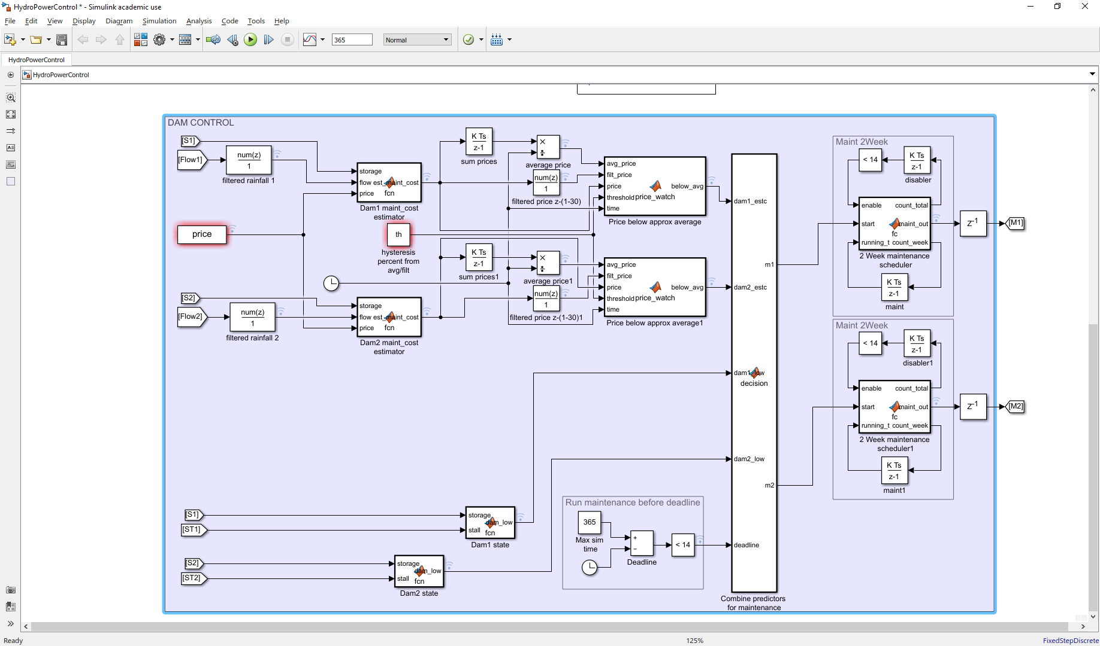

Figure 1 Dam control module

### Predictors

In simulation, one needs to decide when is the optimal time to do the maintenance. As the time goes, there is more and more information available, because of history of inputs can be accumulated. After consideration, the problem of optimization can be phrased like as follows:

When will the maintenance cost least amount of money?

This depends on price, storage level and flow, and cannot be known precisely without seeing into future. Therefore, we need to estimate. For GBM without inclination, best predictor for future is present sample, because part of GBM equation is increment with zero mean random distribution.

The magic recipe: function that computes estimate at each day, what is expected cost of maintenance if it were run that day. This way one gets time series of estimated cost for maintenance instead of price. This is good because, it can compute how much water will be available in dam and, one day outage will be visible as dip in cost. For convenience, rainfall is filtered with moving average of size 30 samples.

Problem now is how to decide when conditions are good enough to output maintenance signal, from this estimated time series. Proposed approach: accumulate mean over whole simulation, accumulate moving average values, this way, maybe regression to the mean can be utilized. As on Figure 2 one can see 3 signals. After some time mean starts to act as reliable metric, and by comparing the actual value of predictor there are two states: Actual is below Mean, Actual is Below moving Average, Actual is below Both. In this scenario, it is visible that launching the maintenance when Actual is below both is very favorable. Sensitivity can be tuned by threshold too.

There can be more sophisticated techniques but, using the score approach. 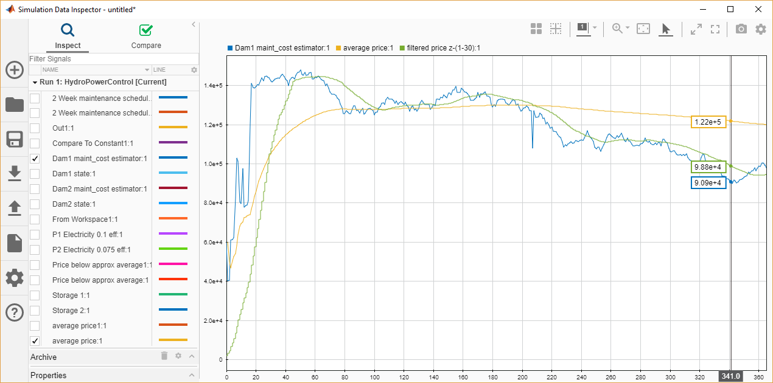

Figure 2 Maintenance cost estimator

|  |  |  |
| --- | --- | --- |
| Score Actual is smaller then col | Total mean | Moving average && Total mean |
| Actual | 1 | 2 |

Another good predictor can be dam state. If rain fall was lower, there can be days in future when dam will not be operating, this is undesirable. Enabling maintenance if dam is low can prevent one day of lost revenue, because it allows dam to replenish, also if there is outage of water supply next day one can run maintenance instead and save one day of lost revenue.

|  |  |  |
| --- | --- | --- |
| Storage is smaller than | 30% capacity | In Flow-Consumption |
| Actual | 1 | 2 |

Deadline predictor. If during whole year of operation no maintenance is run, it will be run in last two weeks

## Decision module

Logic module combines predictors into signals which tells whether to run maintenance for each dams separately. So far the operation is as follows:

If dam_low value is 2, run maintenance

If price_below average is nonzero and dam _low is 1 run maintenance.

For the time being this is resulting strategy. There are ways to make it better even with simple approaches.

### Maintenance module

In order to translate output of logic into desired form we created maintenance blocks. Those are function blocks with memory which count days of maintenance that were run already. They prevent maintenance signal from oscillating and exceeding desired count of days. Maintenance is run in 7-day blocks and those blocks can follow each other without delay.

### Evaluation of results

HydroPowerSheet – old module, statistics are as follows

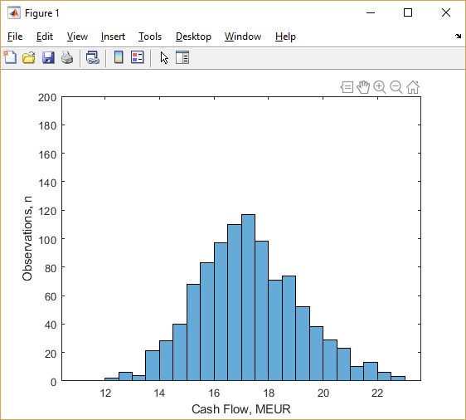 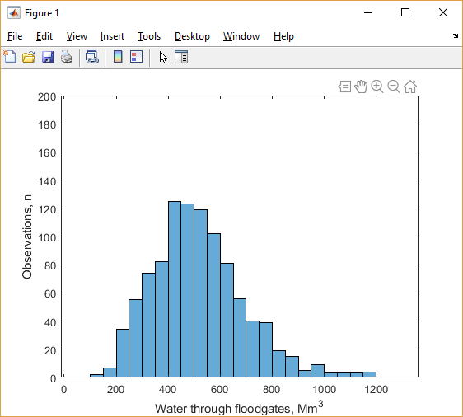

Mean total revenue 17.3250 MEur  
Water wasted mean 516.4554 Mm^3

HydroPowerControl – controlled operation are red columns.

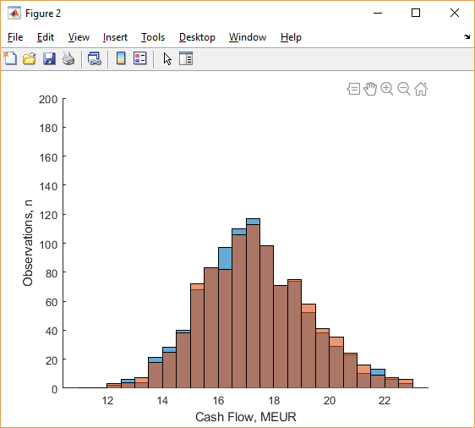 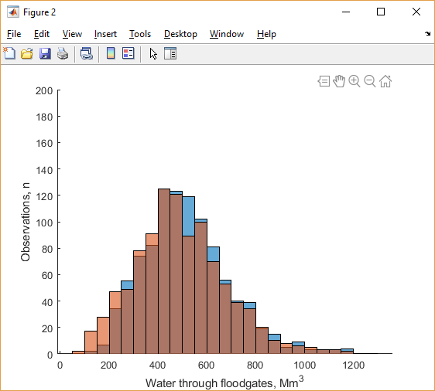

|  |  |  |
| --- | --- | --- |
|  | MEUR | Mm^3 |
| Mean Value | 17.4204 | 491.8326 |
| 10% | 15.0257 | 254.0147 |
| 90% | 20.0581 | 740.6595 |

Above results were achieved using just maintenance cost estimation and control using below_avg==2 condition.

On figure below we can see maintenance planning is far from random or static. Reason for bias in planning towards beginning might be error in actual mean estimation and effect of different kinds of scenarios (constant rising, falling or stable oscillating of cumulative mean). Columns represent amount of maintenance days out of all simulations at each time step.

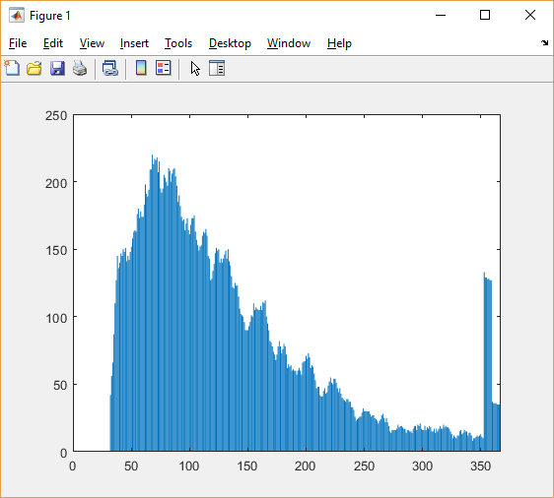

Figure 3 Vector sum of maintenance plan