**## Sensors Project – Experiment One - Brief**

# Introduction

The aim of this project is to develop an experiment to explore a range of measurements that can be undertaken on a simple circuit, including measurement of temperature in order to deduce the power transferred through different waveforms.

# Equipment

The experiment will use the following equipment:

* PicoScope 2000
* Ohmic load (Resistor)
* Non-Ohmic load (incandescent bulb?)
* PWM Controllable Fan
* Suitable analog temperatures sensors
* Suitable digital temperature sensor for calibration of analog sensors

# Experiment Concept

The concept for this experiment is to use simple circuit elements in order to take a range of different measurements using the PicoScope, and develop a range of experiments that can be undertaken using the same equipment and circuits. Some ideas are listed below.

### Power Transfer Experiment

Measure the change of temperature of different loads, when current is supplied using different waveforms, DC, Sine, Sawtooth or Square. Calculate the efficiency of the power transfer.

### Changing Resistance with Temperature

Measure voltages around the circuit to deduce the value of the loads. Repeat measurements at different temperatures. Compare Ohmic load to non Ohmic load.

### PID Temperature Controller

Use a PWM controllable fan to implement a PID temperature controller.

## Other Sensors to Consider

* Light gate to measure fan rotation speed
* Anemometer to measure fan wind speed

## Circuit Concept

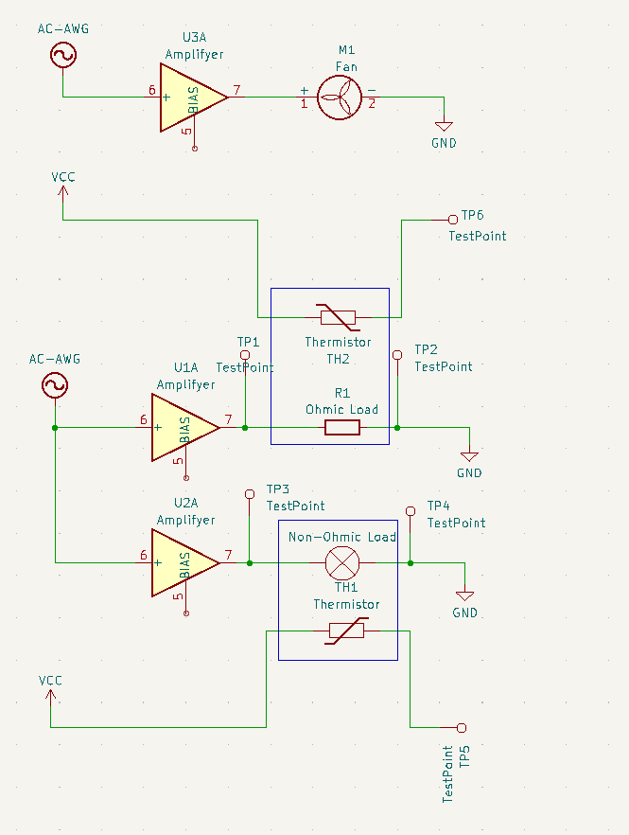

*Note circuit is high level concept only, full implementation needs to be developed.

*Test points show potential placement for PicoScope probes.

# Constraints

* All PicoScope signals must be constrained to ±5 V
* Voltage supplied to the circuit will be ±5 V
* No more than 100mA Current draw max from either +5 V or -5V bus.

# Deliverables

This project will be broken down into the following deliverables with a timeframe to be arranged between student and supervisors.

## Define Experiments to Develop

* The student should develop a list of experiments that could be undertaken with the specified hardware, and provide rational for the data that could be collected, how it could be processed and what learning outcomes can be derived from these experiments.
* Take inspiration from the suggestions above, but free to come up with alternatives or modify to suit better learning outcomes.

## Completed Schematic

* Student must take into account signal constraints, signal noise and power consumption to derive a schematic with suitable parts values to perform the experiments outlined above, while meeting the constraints given.

## Prototype Experimental Setup

* Breadboarded setup of the above schematic to show reliability of measurements, and repeatability of the experimental setup.
* Define procedure for physical assembly, mounting of sensors to test articles etc.
* Work with STO to help define PCB layout.

## Mathematical Model

* Develop a mathematical model to accompany the experimental setup.
* Show how typical results differ from idealised model and explain rational behind the differences.