The Business Case
As the preeminent online retail platform, Amazon presents a vast array of data ripe for analytical exploration. Capitalizing on this, the current study has developed a predictive model capable of estimating prospective Amazon product prices. The motivation for this innovation stems from the need to enhance sellers' decision-making processes in a highly competitive digital marketplace. Through the input of product-specific data, the model provides sellers with a prediction of prices for comparable goods on Amazon, thereby enabling more strategic pricing decisions. For example, sellers can leverage this tool to ascertain if they can underprice their competitors while maintaining profitability. Consequently, such a predictive instrument not only streamlines sellers' pricing strategies but also intensifies market competition by offering the possibility of superior deals to consumers.

The Dataset
The dataset used for this project is titled "Amazon Reviews 2023”, and is hosted on Hugging Face by the McAuley Lab. This dataset comprises a broad spectrum of product reviews aggregated from Amazon, providing invaluable insights into consumer preferences and pricing dynamics. The data encompasses a variety of attributes, including product descriptions, pricing history, user ratings, and textual reviews, which together offer a rich tapestry of information pivotal for training robust predictive algorithms. Utilizing this dataset enables us to capture and train predictive models on subtle and complex patterns hidden within Amazon reviews, which are essential for predicting product prices on the Amazon platform with high accuracy.

Exploratory Data Analysis
In our exploratory data analysis, we investigated the relationship between product ratings and prices through various visualizations, highlighting trends across different categories. In our analysis we looked into the trends in specific categories and subcategories to identify disparities in average ratings. This approach enhanced our understanding of consumer perceptions across diverse product types, as we were able to gauge the relation between the products, pricing and ratings. We also analyzed the distribution of ratings and prices to detect any outliers or unusual patterns. A check for missing data was performed to ensure the accuracy and completeness of our analysis. This exploration helped us better understand the data and give us a guide to proceed with further analysis.

Feature Engineering
The first step of the feature engineering was to reduce the number of features to work with. The initial dataset consisted of 25 features of both meta data of the product and user review data containing information on user reviews like content and date reviewed. To focus on predicting prices for products we primarily focused on using the meta data information only. The meta data contained a number of features like price, rating, category, store, description, and so on. Within these features, there were some that weren't compatible or useful for predicting the price like videos, images, and product ID. These columns were dropped as they were not needed. Finally, within the price column and throughout the dataset, there were a lot of null values. The price column was the features we were trying to predict, so it was important that there were proper values in that column, so the null rows were dropped.

Once the dataset was cleaned up, the next step was preparing the features for ML algorithms. The dataset consisted of both numerical values and string values. The categorical string features like Store and Categories were encoded with one hot encoding. Later, the Store feature was instead encoded with hashing instead of one hot encoding due to limitations with the built in Pyspark Generalized linear Regression. The descriptive features like Title and Features were first combined into a single feature called Term Frequency, then the new feature was encoded using Term-Frequency Inverse Document Frequency to determine the importance of each word.

Algorithms Used and Final Prediction Pipeline
The algorithms used were a Linear regression for a baseline and Random Forest, Gradient Boosted Tree Regression, and Generalized Linear Regression. In determining these final algorithms other algorithms like neural networks, SVM regression, and decision trees, but performance for these algorithms were sub-optimal, so they were dropped. The final algorithms chosen were also performing poorly, so to try and improve error, the data was normalized first then had the corresponding algorithm applied next. Specifically for the Generalized Linear Regression, normalization was not applied due to the hashing that was required in the earlier feature engineering.
To summarize, the final regression models used were Linear Regression, Random Forest, Gradient Boosted Tree Regression, and Generalized Linear Regression. The pipelines for each consisted of a vectorizer, normalizer, then the algorithm itself. Linear Regression performed the best, so hyperparameter optimization was applied to try and further improve that model.

Novel Approaches Taken
For the hyperparameter optimization, we initially opted for traditional methods such as GridSearch and RandomSearch. However, these were found to be too time-consuming. This was especially true for GridSearch, likely due to the combination of parameters that the technique requires, making the operation very computationally expensive. Consequently, Tree-structured Parzen Estimator (TPE) optimization, implemented using the Hyperopt Python package, was utilized as an alternative strategy. This method was chosen because it has shown potential in navigating complex hyperparameter spaces more efficiently than traditional methods.

Apart from TPE optimization for finding optimal model parameters, we also integrated feature normalization directly within the model pipelines. This strategy diverges from the conventional practice of applying normalization during the data preprocessing stage. By embedding normalization into the models themselves, we ensure that the scaling of features is tailored to each model's specific requirements and is consistently applied during both training and validation phases. This integration helps in mitigating the risk of data leakage and ensures that the models are not inadvertently trained on data scaled based on the entire dataset, thereby preserving the integrity of the validation process and potentially reducing predictive errors.

Model Evaluation Metrics
In the development of our Amazon price predictor model, the primary evaluation metric employed to assess its accuracy was the Root Mean Square Error (RMSE). RMSE is a widely used metric in regression analysis that measures the average magnitude of the errors between predicted values and actual values, thus providing a sense of how far off the predictions are from the actual outcomes on average. The formula for RMSE is as follows,
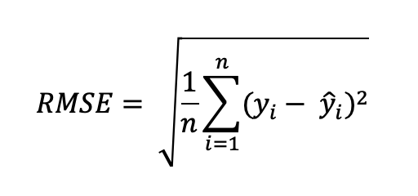
where $n$ is the number of data points, $y_{i}$ represents the actual price of the product, and $\hat{y_{i}}$denotes the predicted price from the model. By squaring the errors before averaging them, RMSE gives a higher weight to larger errors. This characteristic makes RMSE particularly useful in scenarios where large errors are particularly undesirable.

The square root in the RMSE formula then converts these squared units back into the same units as the original prices, making the interpretation of RMSE more intuitive. A lower RMSE value indicates better fit of the model to the data, as it signifies smaller average errors between the predicted and actual prices. This metric was crucial for our project as it directly reflects the effectiveness of the model in predicting product prices on Amazon, with high accuracy being paramount for both competitive pricing strategies and consumer satisfaction.

Model Performance and Scalability
The model performances are reported in the table below, where we observe that the train and test RMSE values are above 100 for all our models. Linear regression was the most performant model, achieving an RMSE of approximately 115 on the test set. Nevertheless, our model performance is quite poor. The RMSE values are too large for a viable price predictor model. It is notable that hyperparameter optimization did not yield significant improvements in the performance of our models. This is understandable for the linear models due to the highly nonlinear nature of our data. However, for the Random Forest and Gradient Boosted Tree regression models, this indicates that the poor model performance is due to low quantity and/or low quality of data.

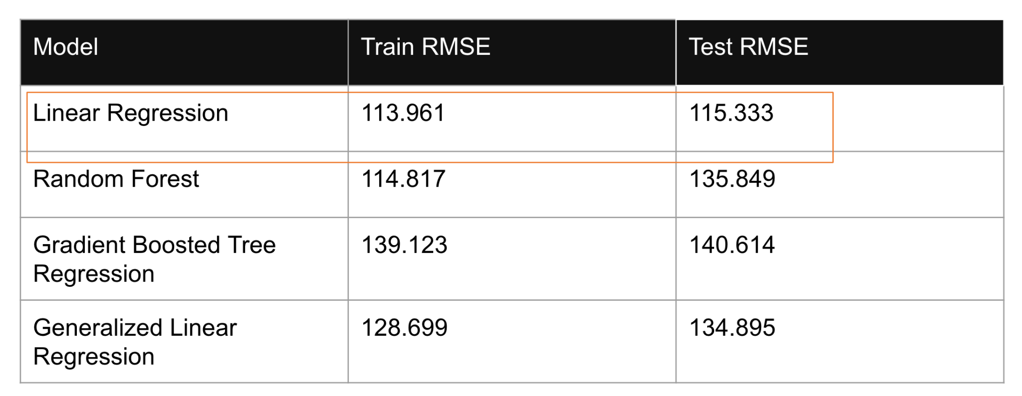

Model scalability was also an issue.. Linear regression was once again the best model in this regard, as it required less than 10 minutes to generate predictions. However, the remaining models all needed several hours to run. This is too long for a useful price predictor tool.

Overall, linear regression was the best model for predicting Amazon product prices, both in terms of model accuracy and execution time. However, our models still need significant improvement in both speed and accuracy to be deployable as an effective price prediction tool for users.

Limitations, Challenges, and Future Work
Data was a key limitation for our project. Due to limited computational resources, our project was constrained to using only a small portion of the original dataset. This limitation has been a significant bottleneck, reducing the breadth of data analysis and potentially impacting the robustness and generalizability of our findings.

Additionally, throughout the project, we encountered numerous challenges with the Google Cloud Platform. These issues primarily involved frequent disconnections during runtime and inadequate support for collaborative work. Such disruptions have hindered the efficiency and continuity of our data processing tasks.

Furthermore, the version of PySpark we utilized was directly tied to Dataproc, which restricts the ability to update the software independently. This dependency has posed challenges in leveraging new features or optimizations available in later versions of PySpark, potentially impacting the performance and scalability of our data processing workflows.

Lastly, our models exhibited high error rates, indicating that the current training dataset might be insufficient. To enhance model accuracy, future work should focus on either expanding the existing dataset to include more diverse data points or to acquire a better-quality dataset that can provide more representative features and relationships for our models to learn from.

