FHPC @ units

Imola Fodor SM3500474

Assignment 1 , Deadline 17.12.2021

Contents

Section 1. 1

Exercise 1. Bi-directional “ring” implementation 1

Exercise 2. 3D matrix addition 2

Section 2. Benchmarking PingPong 3

Reports on Infiniband 3

Thin nodes 3

GPU nodes 6

Intel library 7

Reports on Ethernet band (TCP/IP) 8

Thin nodes 9

GPU nodes 11

Summary 12

Section 3. Jacobi 13

Same thin node 14

Across thin nodes 14

GPU on all 48 threads 15

Summary 15

# Section 1.

## Exercise 1. Bi-directional “ring” implementation

Implementation of streaming messages in a bi-directional manner with OpenMPI using P processors on a ring (i.e., 1D topology). Each processor initiates a turn, with a tag proportional to its rank (P*10), and with the message to be sent equal to its rank, negative if the message is intended to be sent “forward”, and positive if it is intended to be sent “backwards”. As each message is travelling along the ring, it gets summed with the rank it’s going through. The tags instead stay the same during the process.

The implementation of the program is relying on blocking communication with commands MPI_Send and MPI_Recv. Each processor runs a loop, in order to make in total P moves making sure its initial messages get sent across the ring reaching its source. The code itself can be found under ring.c file.

The output when the program runs on 4 processors:

I am process 0 and I have received 4 messages. My final message has the tag 0 and value msg-backward 6 and msg-forward -6.

I am process 1 and I have received 4 messages. My final message has the tag 10 and value msg-backward 6 and msg-forward -6.

I am process 2 and I have received 4 messages. My final message has the tag 20 and value msg-backward 6 and msg-forward -6.

I am process 3 and I have received 4 messages. My final message has the tag 30 and value msg-backward 6 and msg-forward -6.

Reporting the time that it takes for the processors to make the two full turns, we can take the max of all the times (from each processor) and the overall time of the execution can be reported.

In the above case it is 0.00017176 s.

Running the program on more processors (every other from 4 to 24), we get the following trend: 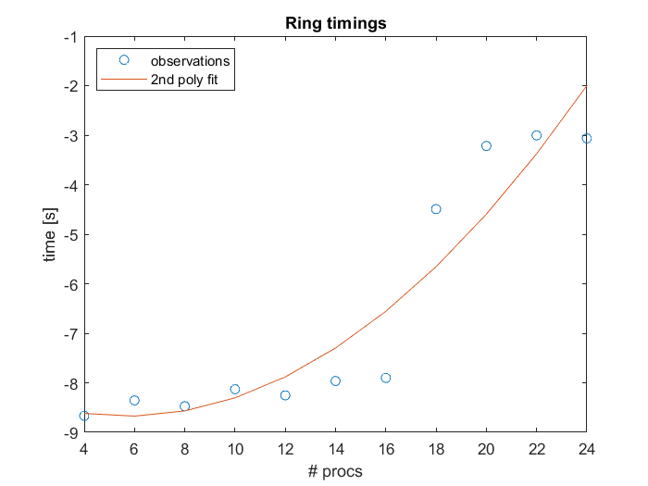

The problem in this case is not constant regardless of the number of processors, so naturally, by adding more processors we are able to solve more message passing as we increase the number of processors, hence we have the increase also in time to execution. The increase is slightly quadratic though since for small number of processors we get similar timings.

## Exercise 2. 3D matrix addition

Summing of 3D matrices, A and B, and store the result in 3D matrix C.

Combinations of 3D matrix (cubes) sizes: 2400x100x100, 1200x200x100, 800x300x100.

The scope of the exercise is to compare the summing timings of 3 combinations of cube sizes based on different distribution in the 3D topology. To the understanding of the reader (me), the task is to always use a 3D virtual topology (for contiguous memory space simulation), but to distribute (to scatter) the full cubes (A and B) as sub-arrays, sub-matrices and sub-cubes to get the 1D, 2D, 3D distribution of data and define which distribution best fits for each of the 3 cube size combination.

The implementation of the 1D distribution can be found under sum3Dmatrix.c file. The implementation of 2D and 3D distribution is lacking due to the limited skills in C programming. The general idea is to allocate 1D, 2D and 3D arrays respectively, and scatter those. Then, as done for 1D, do a local sum on sub-objects, eventually gathering all the results to the main C object on rank 0.

The implementation of the 1D code is available also without the use of the virtual topology.

Timings of the processors that took the longest time to finish:

2400x100x100 : 0.97694499 s

1200x200x100 : 0.97712265 s

800x300x100 : 0.97221219 s

# Section 2. Benchmarking PingPong

For the measurement of latency and effective bandwidth the PingPong benchmark is frequently used. The code sends a message of size N [bytes] once back and forth between two processes running. The processes can be running on two different nodes, two different sockets within one node, two different cores within one socket; furthermore, the latency and bandwidth can be checked on Infiniband 100 Gbit/s 25 Gbit/s network, on Ethernet network, etc. depending on the topology of the cluster being tested.

Herein plotted the observed (called estimated in assignment description) values for the different combinations and the predicted (called computed in the assignment description) values for each, based on least squares fit.

Both axes have been scaled logarithmically in this case because this makes it easier to judge the fit quality on all scales. Also, the sizes have been scaled logarithmically.

The fitted line is a polynomial of order 1.

$$p = a + bx$$

When reporting the predicted values, the transformation has been done to linear scale, by the formula:

$$fit = x^{a}*exp(b)$$

and the same approach for both time and bandwidth fit.

## Reports on Infiniband

Herein the reports and plots for some of the variants tried IB, namely dividing work among nodes, sockets and cores, thin and gpu nodes, openmpi and intel benchmarks.

### Thin nodes

|  |  |  |  |  |  |
| --- | --- | --- | --- | --- | --- |
| mpirun -np 2 --report-bindings --map-by node ./IMB-MPI1 PingPong | | | | | |
| Eg. thin 008 and 009 | | | | | |
| Lambda 0.36, bandwidth 0.63 | | | | | |
| size | repetitions | tusec | Mbytessec | tusec_computed | mbsec_computed |
| 0 | 1000 | 0.97 | 0 | 0.97 |  |
| 1 | 1000 | 0.98 | 1.02 | 0.303445 | 3.294 |
| 2 | 1000 | 0.98 | 2.03 | 0.392109 | 5.0985 |
| 4 | 1000 | 0.99 | 4.06 | 0.50668 | 7.8916 |
| 8 | 1000 | 0.98 | 8.16 | 0.654727 | 12.2146 |
| 16 | 1000 | 0.98 | 16.26 | 0.846031 | 18.9059 |
| 32 | 1000 | 1 | 32.04 | 1.093234 | 29.2627 |
| 64 | 1000 | 1.14 | 56.21 | 1.412666 | 45.2931 |
| 128 | 1000 | 1.18 | 108.77 | 1.825434 | 70.105 |
| 256 | 1000 | 1.4 | 182.26 | 2.358808 | 108.5092 |
| 512 | 1000 | 1.48 | 346.11 | 3.048029 | 167.9515 |
| 1024 | 1000 | 1.66 | 616.66 | 3.938634 | 259.9567 |
| 2048 | 1000 | 2.31 | 888.19 | 5.089465 | 402.3633 |
| 4096 | 1000 | 3.17 | 1290.55 | 6.576558 | 622.7814 |
| 8192 | 1000 | 4.44 | 1844.6 | 8.498165 | 963.9465 |
| 16384 | 1000 | 6.25 | 2621.81 | 10.98125 | 1492.005 |
| 32768 | 1000 | 8.43 | 3888.83 | 14.18986 | 2309.338 |
| 65536 | 640 | 12.26 | 5345.97 | 18.33601 | 3574.414 |
| 131072 | 320 | 18.39 | 7128.93 | 23.69361 | 5532.509 |
| 262144 | 160 | 32.67 | 8023.72 | 30.61666 | 8563.265 |
| 524288 | 80 | 54 | 9708.34 | 39.56255 | 13254.3 |
| 1048576 | 40 | 96.91 | 10820.5 | 51.12235 | 20515.12 |
| 2097152 | 20 | 182.24 | 11507.75 | 66.05982 | 31753.48 |
| 4194304 | 10 | 352.57 | 11896.25 | 85.36186 | 49148.31 |

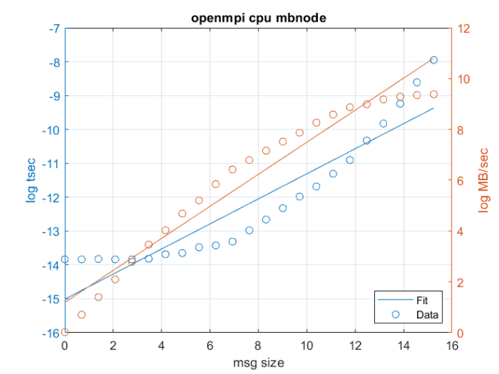

|  |  |  |  |  |  |
| --- | --- | --- | --- | --- | --- |
| mpirun -np 2 --report-bindings --map-by socket ./IMB-MPI1 PingPong | | | | | |
| Eg thin008 | | | | | |
|  | | | | | |
| size | repetitions | tusec | Mbytessec | tusec_computed | mbsec_computed |
| 0 | 1000 | 0.56 | 0 | 0.56 |  |
| 1 | 1000 | 0.63 | 1.59 | 0.199378 | 5.0142 |
| 2 | 1000 | 0.63 | 3.19 | 0.260456 | 7.677 |
| 4 | 1000 | 0.63 | 6.33 | 0.340246 | 11.7538 |
| 8 | 1000 | 0.64 | 12.51 | 0.444479 | 17.9954 |
| 16 | 1000 | 0.63 | 25.25 | 0.580642 | 27.5517 |
| 32 | 1000 | 0.7 | 45.39 | 0.758519 | 42.1827 |
| 64 | 1000 | 0.91 | 70.43 | 0.990888 | 64.5834 |
| 128 | 1000 | 1 | 128.18 | 1.294441 | 98.8797 |
| 256 | 1000 | 1.19 | 215.53 | 1.690986 | 151.3885 |
| 512 | 1000 | 1.18 | 432.2 | 2.209011 | 231.7817 |
| 1024 | 1000 | 1.37 | 750.15 | 2.88573 | 354.8667 |
| 2048 | 1000 | 1.79 | 1147.12 | 3.769759 | 543.3145 |
| 4096 | 1000 | 2.94 | 1395.24 | 4.924605 | 831.8353 |
| 8192 | 1000 | 3.29 | 2491.01 | 6.433232 | 1273.572 |
| 16384 | 1000 | 3.86 | 4245.11 | 8.40402 | 1949.887 |
| 32768 | 1000 | 4.72 | 6949.21 | 10.97855 | 2985.353 |
| 65536 | 640 | 6.8 | 9638.83 | 14.34177 | 4570.689 |
| 131072 | 320 | 10.87 | 12060.38 | 18.7353 | 6997.901 |
| 262144 | 160 | 20.11 | 13036.39 | 24.47476 | 10714.05 |
| 524288 | 80 | 39.05 | 13427.16 | 31.97248 | 16403.63 |
| 1048576 | 40 | 91.03 | 11518.82 | 41.76708 | 25114.59 |
| 2097152 | 20 | 216.62 | 9681.34 | 54.56221 | 38451.4 |
| 4194304 | 10 | 403.46 | 10395.91 | 71.27706 | 58870.56 |

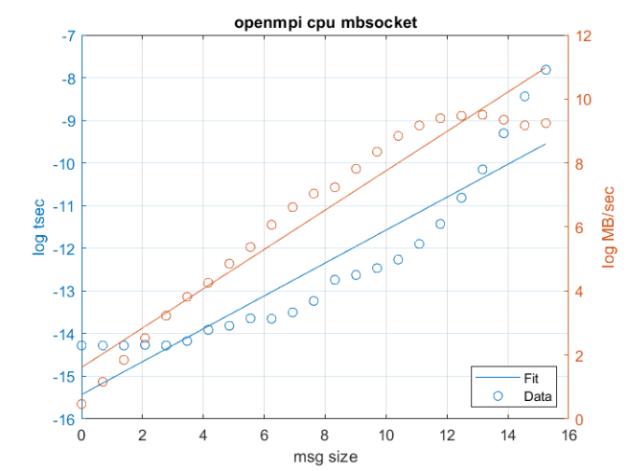

|  |  |  |  |  |  |
| --- | --- | --- | --- | --- | --- |
| mpirun -np 2 --report-bindings --map-by core ./IMB-MPI1 PingPong | | | | | |
| Eg. Thin008 | | | | | |
| Lambda 0.45, Bandwidth 0.54 | | | | | |
| size | repetitions | tusec | Mbytessec | tusec_computed | mbsec_computed |
| 0 | 1000 | 0.24 | 0 | 0.24 |  |
| 1 | 1000 | 0.27 | 3.65 | 0.070211 | 14.2305 |
| 2 | 1000 | 0.29 | 6.95 | 0.096335 | 20.744 |
| 4 | 1000 | 0.3 | 13.55 | 0.13218 | 30.239 |
| 8 | 1000 | 0.29 | 27.51 | 0.181361 | 44.08 |
| 16 | 1000 | 0.29 | 54.53 | 0.248843 | 64.2562 |
| 32 | 1000 | 0.29 | 109.19 | 0.341433 | 93.6675 |
| 64 | 1000 | 0.34 | 189.74 | 0.468475 | 136.541 |
| 128 | 1000 | 0.37 | 344.26 | 0.642787 | 199.0384 |
| 256 | 1000 | 0.46 | 561.47 | 0.881957 | 290.1422 |
| 512 | 1000 | 0.63 | 815.21 | 1.210119 | 422.9459 |
| 1024 | 1000 | 0.72 | 1420.84 | 1.660384 | 616.5364 |
| 2048 | 1000 | 0.84 | 2429.65 | 2.278185 | 898.7371 |
| 4096 | 1000 | 1.76 | 2320.73 | 3.125859 | 1310.107 |
| 8192 | 1000 | 2.17 | 3778.4 | 4.288939 | 1909.768 |
| 16384 | 1000 | 2.74 | 5982.87 | 5.884782 | 2783.906 |
| 32768 | 1000 | 3.92 | 8368.45 | 8.074411 | 4058.153 |
| 65536 | 640 | 5.05 | 12977.33 | 11.07876 | 5915.649 |
| 131072 | 320 | 10.56 | 12410.58 | 15.20099 | 8623.356 |
| 262144 | 160 | 18.7 | 14016.33 | 20.85702 | 12570.43 |
| 524288 | 80 | 38.52 | 13611.36 | 28.61757 | 18324.16 |
| 1048576 | 40 | 91.49 | 11460.85 | 39.26569 | 26711.49 |
| 2097152 | 20 | 215.46 | 9733.4 | 53.8758 | 38937.86 |
| 4194304 | 10 | 427.41 | 9813.26 | 73.92209 | 56760.47 |

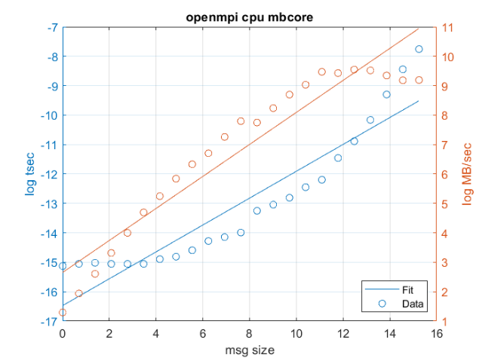

### GPU nodes

|  |  |  |  |  |  |
| --- | --- | --- | --- | --- | --- |
| mpirun -np 2 --report-bindings --map-by node ./IMB-MPI1 PingPong | | | | | |
| Eg. thin 08 and 09 | | | | | |
|  | | | | | |
| size | repetitions | tusec | Mbytessec | tusec_computed | mbsec_computed |
| 0 | 1000 | 1.36 | 0 | 0 | 0 |
| 1 | 1000 | 1.36 | 0.74 | 0.459918 | 2.1777 |
| 2 | 1000 | 1.35 | 1.48 | 0.584421 | 3.4272 |
| 4 | 1000 | 1.36 | 2.95 | 0.742628 | 5.3936 |
| 8 | 1000 | 1.36 | 5.87 | 0.943663 | 8.4883 |
| 16 | 1000 | 1.36 | 11.77 | 1.199119 | 13.3587 |
| 32 | 1000 | 1.4 | 22.89 | 1.523729 | 21.0236 |
| 64 | 1000 | 1.69 | 37.96 | 1.936214 | 33.0864 |
| 128 | 1000 | 1.73 | 74.19 | 2.460362 | 52.0707 |
| 256 | 1000 | 1.99 | 128.52 | 3.1264 | 81.9476 |
| 512 | 1000 | 2.07 | 247.03 | 3.972739 | 128.9672 |
| 1024 | 1000 | 2.3 | 445.33 | 5.048188 | 202.9656 |
| 2048 | 1000 | 2.97 | 688.85 | 6.41477 | 319.4225 |
| 4096 | 1000 | 3.98 | 1029.23 | 8.151296 | 502.6997 |
| 8192 | 1000 | 5.52 | 1485.28 | 10.35791 | 791.1371 |
| 16384 | 1000 | 7.35 | 2228.76 | 13.16187 | 1245.073 |
| 32768 | 1000 | 10.04 | 3264.3 | 16.72489 | 1959.467 |
| 65536 | 640 | 14.55 | 4505.73 | 21.25244 | 3083.764 |
| 131072 | 320 | 23.76 | 5516.79 | 27.00563 | 4853.156 |
| 262144 | 160 | 34.07 | 7693.21 | 34.31626 | 7637.783 |
| 524288 | 80 | 55.87 | 9384.84 | 43.60592 | 12020.17 |
| 1048576 | 40 | 98.81 | 10611.72 | 55.41036 | 18917.06 |
| 2097152 | 20 | 184.81 | 11347.69 | 70.41035 | 29771.22 |
| 4194304 | 10 | 354.55 | 11829.86 | 89.47095 | 46853.26 |

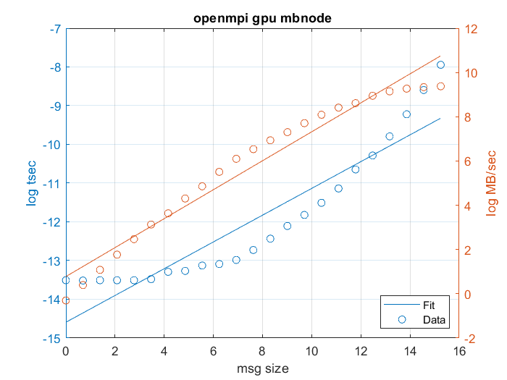

### Intel library

|  |  |  |  |  |  |
| --- | --- | --- | --- | --- | --- |
| mpirun -np 2 -env --map-by node ./IMB-MPI1 PingPong -msglog 4 | | | | | |
| Eg. thin 08 and 09 | | | | | |
|  | | | | | |
| size | repetitions | tusec | Mbytessec | tusec_computed | mbsec_computed |
| 0 | 1000 | 0.43 | 0 | 0 | 0 |
| 1 | 1000 | 0.43 | 2.32 | 0.431982 | 2.3165 |
| 2 | 1000 | 0.43 | 4.64 | 0.431982 | 4.6247 |
| 4 | 1000 | 0.44 | 9.14 | 0.431982 | 9.2328 |
| 8 | 1000 | 0.43 | 18.51 | 0.431982 | 18.4328 |
| 16 | 1000 | 0.43 | 36.84 | 0.431982 | 36.7998 |

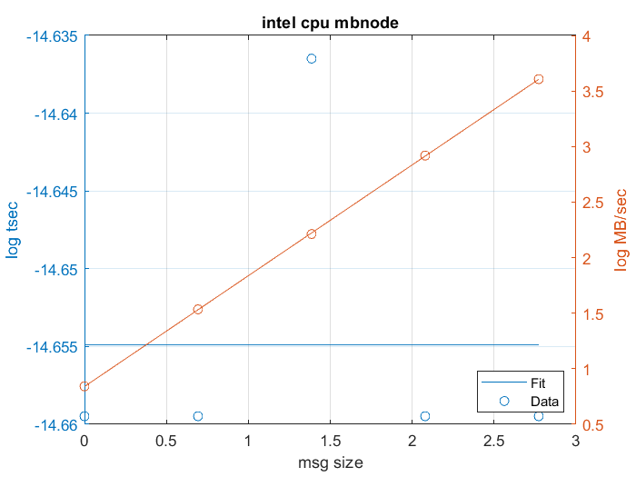

|  |  |  |  |  |  |
| --- | --- | --- | --- | --- | --- |
| mpirun -np 2 --map-by node ./IMB-MPI1 PingPong -msglog 4 NOTE: on dssc_gpu | | | | | |
| Eg. thin 08 and 09 | | | | | |
|  | | | | | |
| size | repetitions | tusec | Mbytessec | tusec_computed | mbsec_computed |
| 0 | 1000 | 0.47 | 0 | 0 | 0 |
| 1 | 1000 | 0.47 | 2.13 | 0.47 | 2.1324 |
| 2 | 1000 | 0.47 | 4.26 | 0.47 | 4.2685 |
| 4 | 1000 | 0.47 | 8.59 | 0.47 | 8.5445 |
| 8 | 1000 | 0.47 | 17.1 | 0.47 | 17.1039 |
| 16 | 1000 | 0.47 | 34.17 | 0.47 | 34.238 |

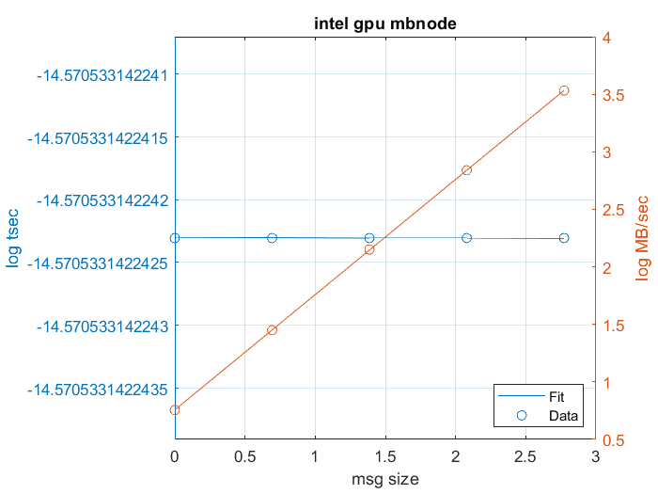

## Reports on Ethernet band (TCP/IP)

Herein the reports and plots for some of the variants tried on TCP, namely dividing work among nodes, sockets and cores, thin and gpu nodes, openmpi and intel benchmarks.

### Thin nodes

|  |  |  |  |  |  |
| --- | --- | --- | --- | --- | --- |
| mpirun -np 2 --report-bindings --mca pml ob1 --mca btl tcp,self ./IMB-MPI1 PingPong | | | | | |
| Probably has chosen one node | | | | | |
|  | | | | | |
| size | repetitions | tusec | Mbytessec | tusec_computed | mbsec_computed |
| 0 | 1000 | 7.91 | 0 | 0 | 0 |
| 1 | 1000 | 7.93 | 0.13 | 2.61436 | 0.3843 |
| 2 | 1000 | 7.97 | 0.25 | 3.211471 | 0.6256 |
| 4 | 1000 | 7.99 | 0.5 | 3.944961 | 1.0182 |
| 8 | 1000 | 7.94 | 1.01 | 4.845977 | 1.6572 |
| 16 | 1000 | 7.98 | 2.01 | 5.952782 | 2.6974 |
| 32 | 1000 | 7.98 | 4.01 | 7.312378 | 4.3903 |
| 64 | 1000 | 7.92 | 8.08 | 8.982501 | 7.1458 |
| 128 | 1000 | 8.47 | 15.12 | 11.03407 | 11.6306 |
| 256 | 1000 | 8.49 | 30.14 | 13.55422 | 18.9303 |
| 512 | 1000 | 8.55 | 59.88 | 16.64996 | 30.8114 |
| 1024 | 1000 | 9.74 | 105.11 | 20.45276 | 50.1493 |
| 2048 | 1000 | 9.04 | 226.54 | 25.1241 | 81.6242 |
| 4096 | 1000 | 11.03 | 371.33 | 30.86236 | 132.8534 |
| 8192 | 1000 | 11.59 | 707.01 | 37.91122 | 216.2353 |
| 16384 | 1000 | 15.7 | 1043.79 | 46.57002 | 351.9497 |
| 32768 | 1000 | 25.66 | 1277.18 | 57.20646 | 572.8415 |
| 65536 | 640 | 56.92 | 1151.46 | 70.27223 | 932.3701 |
| 131072 | 320 | 81.65 | 1605.34 | 86.32218 | 1517.547 |
| 262144 | 160 | 122.68 | 2136.85 | 106.0379 | 2469.996 |
| 524288 | 80 | 195.55 | 2681.1 | 130.2566 | 4020.222 |
| 1048576 | 40 | 327.86 | 3198.25 | 160.0068 | 6543.407 |
| 2097152 | 20 | 623.92 | 3361.22 | 196.5518 | 10650.2 |
| 4194304 | 10 | 1238.46 | 3386.71 | 241.4436 | 17334.52 |

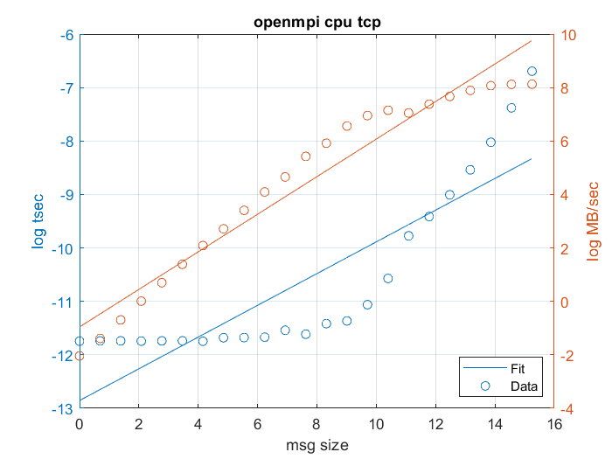

|  |  |  |  |  |  |
| --- | --- | --- | --- | --- | --- |
| mpirun -np 2 --report-bindings --mca pml ob1 --mca btl tcp,vader,self ./IMB-MPI1 PingPong | | | | | |
| On one thin node | | | | | |
|  | | | | | |
| size | repetitions | tusec | Mbytessec | tusec_computed | mbsec_computed |
| 0 | 1000 | 0.25 | 0 | 0 | 0 |
| 1 | 1000 | 0.3 | 3.34 | 0.073157 | 13.6585 |
| 2 | 1000 | 0.3 | 6.64 | 0.100083 | 19.9685 |
| 4 | 1000 | 0.3 | 13.4 | 0.136918 | 29.1934 |
| 8 | 1000 | 0.3 | 26.6 | 0.187311 | 42.68 |
| 16 | 1000 | 0.3 | 52.97 | 0.256252 | 62.3971 |
| 32 | 1000 | 0.3 | 107.05 | 0.350566 | 91.2231 |
| 64 | 1000 | 0.35 | 183.6 | 0.479592 | 133.3659 |
| 128 | 1000 | 0.39 | 326.98 | 0.656107 | 194.9777 |
| 256 | 1000 | 0.45 | 564.08 | 0.897589 | 285.0526 |
| 512 | 1000 | 0.63 | 816.44 | 1.227949 | 416.7399 |
| 1024 | 1000 | 0.71 | 1433.83 | 1.679898 | 609.2635 |
| 2048 | 1000 | 0.82 | 2509.06 | 2.298188 | 890.7283 |
| 4096 | 1000 | 1.76 | 2323.68 | 3.144042 | 1302.223 |
| 8192 | 1000 | 2.11 | 3881.27 | 4.301213 | 1903.818 |
| 16384 | 1000 | 2.65 | 6176.49 | 5.884284 | 2783.335 |
| 32768 | 1000 | 4 | 8192.8 | 8.050008 | 4069.167 |
| 65536 | 640 | 5.46 | 12007.13 | 11.01283 | 5949.023 |
| 131072 | 320 | 10.22 | 12822.73 | 15.06613 | 8697.325 |
| 262144 | 160 | 18.71 | 14007.55 | 20.61125 | 12715.28 |
| 524288 | 80 | 38.07 | 13770.49 | 28.19727 | 18589.42 |
| 1048576 | 40 | 88.32 | 11872.46 | 38.57534 | 27177.28 |
| 2097152 | 20 | 213.95 | 9801.95 | 52.77308 | 39732.51 |
| 4194304 | 10 | 422.29 | 9932.23 | 72.19633 | 58087.96 |

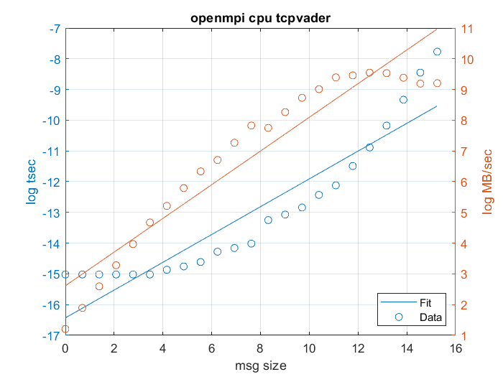

|  |  |  |  |  |  |
| --- | --- | --- | --- | --- | --- |
| mpirun -np 2 --mca pml ob1 --report-bindings --oversubscribe --map-by node --mca btl tcp,self ./IMB-MPI1 PingPong NOTE: on dssc | | | | | |
| size | repetitions | tusec | Mbytessec | tusec_computed | mbsec_computed |
| 0 | 1000 | 16.2 | 0 | 0 | 0 |
| 1 | 1000 | 16.11 | 0.06 | 6.516664 | 0.1534 |
| 2 | 1000 | 16 | 0.13 | 7.815613 | 0.2558 |
| 4 | 1000 | 16.12 | 0.25 | 9.373477 | 0.4266 |
| 8 | 1000 | 16.16 | 0.49 | 11.24187 | 0.7115 |
| 16 | 1000 | 16.11 | 0.99 | 13.48268 | 1.1865 |
| 32 | 1000 | 16.16 | 1.98 | 16.17014 | 1.9787 |
| 64 | 1000 | 16.29 | 3.93 | 19.39329 | 3.2997 |
| 128 | 1000 | 17.06 | 7.5 | 23.2589 | 5.5027 |
| 256 | 1000 | 17.08 | 14.99 | 27.89503 | 9.1764 |
| 512 | 1000 | 17.11 | 29.92 | 33.45527 | 15.3029 |
| 1024 | 1000 | 17.89 | 57.24 | 40.12382 | 25.5196 |
| 2048 | 1000 | 39.46 | 51.9 | 48.12159 | 42.5574 |
| 4096 | 1000 | 39.74 | 103.08 | 57.71354 | 70.9702 |
| 8192 | 1000 | 40.86 | 200.49 | 69.21742 | 118.3522 |
| 16384 | 1000 | 43.45 | 377.08 | 83.01433 | 197.3682 |
| 32768 | 1000 | 50.43 | 649.76 | 99.56135 | 329.1378 |
| 65536 | 640 | 63.57 | 1030.94 | 119.4066 | 548.8813 |
| 131072 | 320 | 117.05 | 1119.8 | 143.2076 | 915.333 |
| 262144 | 160 | 165.92 | 1579.98 | 171.7528 | 1526.44 |
| 524288 | 80 | 244.29 | 2146.17 | 205.9878 | 2545.543 |
| 1048576 | 40 | 394.94 | 2655.05 | 247.0468 | 4245.034 |
| 2097152 | 20 | 732.04 | 2864.79 | 296.29 | 7079.161 |
| 4194304 | 10 | 1589.12 | 2639.39 | 355.3486 | 11805.45 |

### GPU nodes

|  |  |  |  |  |  |
| --- | --- | --- | --- | --- | --- |
| mpirun -np 2 --mca pml ob1 --report-bindings --oversubscribe --map-by node --mca btl tcp,self ./IMB-MPI1 PingPong NOTE: on dssc_gpu | | | | | |
| Eg. thin 08 and 09 | | | | | |
|  | | | | | |
| size | repetitions | tusec | Mbytessec | tusec_computed | mbsec_computed |
| 0 | 1000 | 15.41 | 0 | 15.41 |  |
| 1 | 1000 | 15.57 | 0.06 | 16.7008 | 0.1701 |
| 2 | 1000 | 15.54 | 0.13 | 17.48651 | 0.2797 |
| 4 | 1000 | 15.54 | 0.26 | 18.30919 | 0.46 |
| 8 | 1000 | 16.12 | 0.5 | 19.17057 | 0.7565 |
| 16 | 1000 | 16.13 | 0.99 | 20.07248 | 1.2441 |
| 32 | 1000 | 16.19 | 1.98 | 21.01682 | 2.0461 |
| 64 | 1000 | 15.67 | 4.08 | 22.00559 | 3.365 |
| 128 | 1000 | 15.96 | 8.02 | 23.04088 | 5.5341 |
| 256 | 1000 | 16.19 | 15.81 | 24.12487 | 9.1015 |
| 512 | 1000 | 16.39 | 31.23 | 25.25987 | 14.9684 |
| 1024 | 1000 | 16.79 | 61.01 | 26.44825 | 24.6172 |
| 2048 | 1000 | 38.53 | 53.15 | 27.69255 | 40.4859 |
| 4096 | 1000 | 39.2 | 104.48 | 28.99539 | 66.5837 |
| 8192 | 1000 | 39.67 | 206.5 | 30.35953 | 109.5044 |
| 16384 | 1000 | 41.75 | 392.42 | 31.78784 | 180.0926 |
| 32768 | 1000 | 49.1 | 667.32 | 33.28334 | 296.1828 |
| 65536 | 640 | 81.05 | 808.63 | 34.84921 | 487.1066 |
| 131072 | 320 | 134.36 | 975.52 | 36.48875 | 801.1024 |
| 262144 | 160 | 202.48 | 1294.69 | 38.20541 | 1317.505 |
| 524288 | 80 | 317.84 | 1649.52 | 40.00285 | 2166.787 |
| 1048576 | 40 | 524.23 | 2000.23 | 41.88484 | 3563.529 |
| 2097152 | 20 | 957.16 | 2191.01 | 43.85538 | 5860.631 |
| 4194304 | 10 | 0.001961 | 2138.6 | 45.91862 | 9638.478 |

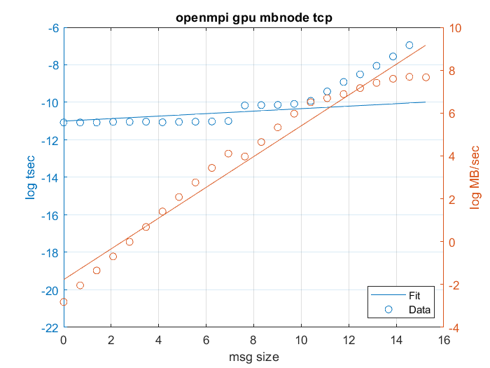

## Summary

*Infiniband vs Ethernet*

Observing the values gotten, it can be concluded that, as expected, running the communication on Infiniband is desirable. Ethernet is performing more slowly, almost for a factor of 10 in case of thin nodes without specifying the topology, and even worse than factor of 10 for both kind of nodes (thin and gpu), when mapped by node as topology.

*GPU vs Thin with OpenMPI*

Observing the worst option for topology, mapping by node, it is noted that the thin node performs better when it comes to latency, 0.97 usec against 1.36 usec of the GPU nodes.

As for mapping by socket and core (in this document not reported for gpu, see outputs_openmpi_gpu.txt), the results are utmost similar on the other hand.

*Intel bench vs OpenMPI*

The benchmark for running communication between two nodes, shows rather different results when running on intel and openMPI libraries. ~ 45 usec (mean of gpu and thin on intel) against ~ 120 usec (mean of gpu and thin on openmpi) for latency.

Annex – fits below :

Fit values of coeffs of the first degree for lambda and bandwidth respectively:

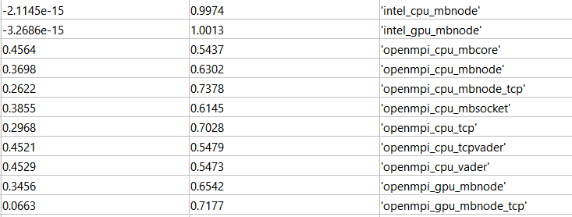

# Section 3. Jacobi

The Jacobi method is prototypical for many stencil-based iterative methods in numerical analysis and simulation. In its most straightforward form, it can be used for solving the diffusion equation for a scalar function Φ(~r,t),

$$\frac{∂Φ}{∂t}= ∆Φ$$

on a rectangular lattice subject to Dirichlet boundary conditions.

In the following benchmark we explore strong scaling, namely the performance of the model with fixed input size (work) as the resources increase to solve the same problem.

To estimate performance the formula below is used.

$$P\left(L,\sim N\right)= \frac{L^{3}*N }{Ts(L)+Tc(L,\sim N)}$$

$L^{3}$ being the problem size per process, N being the total number of processes used (NX*NY*NZ), Tc being the communication time. Tc depends on the domain cuts decided on:

$$Tc\left(L,\sim N\right)= c\left(L,\sim N\right)*B +k*Tl$$

Where B and Tl have been extrapolated from the outputs during the PingPong benchmarking, and c(L,~N) can be derived from the Cartesian decomposition:

$$c\left(L,\sim N\right)= L^{2}*k* 2* 8$$

k being the number of domain cuts larger than 1.

In contrast to weak scaling, the single-process performance on the subdomain size is hard to predict since it depends on many factors (pipelining effects, prefetching, spatial blocking strategy, copying to intermediate buffers, etc.). To address this, we run the program on single processor on both thin and GPU nodes and take as baseline the prediction for parallel performance in those conditions, namely Ts in the formula of P.

Specific computational resources were required for each of the three sections (same node, across nodes, gpu and by topology) by qsub command:

qsub -l nodes=**1/2**:ppn=24 -q **dssc_gpu/dssc** -l walltime=1:00:00 -I

The program Jacobi supplied from online resources was compiled using the command:

mpif77 -ffized-line-length-none Jacobi_MPI_vectormode.F -o jacobi3D.x

Whereas for the different combinations the following mpirun was executed:

mpirun -np **4/8/12/24/48** --map-by **node/sockets/core** jacobi3D.x 2>/dev/null.

In bold reporting the changes made to the commands according to the different requirements.

## Same thin node



## Across thin nodes



## GPU on all 48 threads



Hyperthreading for GPU nodes are enabled by default, hence taking advantage of one GPU node, with its 2 sockets, each with all 12 cores/processors leads to 48 processes running “in parallel”.

## Summary

As a summary for all three benchmarks, it can be concluded that even though a linear scalability for Tcomm (observed time) would have been expected, it was not always strictly such. On the other hand, as noted in a benchmark supplied in class lectures, Tc increases with more computational power, which is consistent also in the above reported benchmarks.