Sensor Placement with Heterogeneous Sensors
Under a Fixed Budget Constraint
An Extension of Kim et al. (2025)
Research Task Submission — May 2025

1. Problem Description

1.1 What the Original Paper Does
The paper by Kim et al. (2025) tries to solve a practical problem: where should you place sensors to detect ships passing through a region? The challenge is that you cannot know exactly which path a ship will take. Ships follow roughly straight-line paths, but there is randomness and uncertainty involved.
The key idea of the paper is a mathematical transformation. Instead of working with ship trajectories directly (which are lines in a 2D map), the authors convert each line into a single point using two numbers: the angle of the line (α) and how far the line is from the origin (p). This makes the problem much easier to handle mathematically.
Using historical ship traffic data from the AIS system near Virginia, USA, they estimate which directions and paths are most common. Then they place sensors to cover those high-traffic paths as effectively as possible. Their method uses a greedy algorithm — placing one sensor at a time, always choosing the location that improves detection the most.

1.2 The Gap I Noticed
While reading the paper, I noticed that the authors assume all sensors are identical — same detection range, same capability, same cost. In the real world, this is rarely the case. A naval barrier coverage system would likely have access to different types of sensors: some with long detection range but higher cost, and others that are cheaper but can only detect nearby targets.
This raised a natural question for me: if we have a fixed budget and two types of sensors available, how should we decide which type to buy and where to place them? This is the extension I chose to investigate.

Proposed Extension: Sensor placement under a fixed budget, using a mix of two sensor types with different detection capabilities and costs.

2. Mathematical Formulation

2.1 Two Sensor Types
I consider two types of sensors with different capabilities and costs:

Property | Type A | Type B | What it means
Detection range (σ) | 2.5 km | 1.0 km | How far it can detect
Max detection prob. (ρ) | 0.95 | 0.80 | How reliably it detects
Cost | 3 units | 1 unit | Budget used per sensor

Type A is like a long-range hydrophone — expensive but powerful. Type B is a short-range acoustic buoy — cheap but limited in coverage.

2.2 Budget Constraint
The total cost of all placed sensors cannot exceed the available budget B. For example, with B = 10:
- Placing 3 Type A sensors costs 3+3+3 = 9. One Type B can then be added (total = 10). This is valid.
- Placing 10 Type B sensors costs 10. Also valid, but each sensor has limited range.
- Placing 4 Type A sensors costs 12. This exceeds the budget and is not allowed.

2.3 How Detection Works
For each sensor, the probability of detecting a target decreases with distance. A sensor placed close to a ship's path will detect it with high probability. The same sensor placed far away will likely miss it.
When multiple sensors are deployed, the probability of a target escaping the entire network is the product of the "miss probabilities" of each individual sensor. So adding more sensors — especially near high-traffic areas — reduces the chance of any target going undetected.

2.4 Objective
The goal is to maximize the void probability — the probability that all targets passing through the area are detected (zero undetected targets). This is expressed as:
Void Probability = P(no target goes undetected)
We want this number to be as high as possible, subject to the budget constraint.

2.5 How the Algorithm Decides
I extended the greedy algorithm from the original paper to handle two sensor types. The logic is simple:
- Start with no sensors placed and the full budget available.
- At each step, try every possible location and every sensor type that fits within the remaining budget.
- Choose the combination (location + type) that increases the void probability the most.
- Place that sensor, subtract its cost from the budget, and repeat.
- Stop when the budget runs out.

This approach lets the algorithm naturally decide whether it is better to buy one expensive long-range sensor or several cheap short-range ones, depending on where the ship traffic is concentrated.

3. Simulation Setup

3.1 Area and Target Model
The simulation area is a 20 × 20 km square, representing a maritime region of interest. I simulated ship traffic as two dominant shipping lanes — one heading roughly northeast and another heading southeast — which is a simplified but realistic representation of a harbor approach channel.
The target intensity function (how many ships pass through each direction and path) was modeled using two Gaussian clusters in the representation space, producing approximately 15 ship trajectories per time period in total.

3.2 Simulation Parameters
- Area: −10 km to +10 km in both directions (400 km² total)
- Candidate sensor locations: grid with 0.5 km spacing → 1,681 possible positions
- Total budget: B = 10 units for the main comparison
- Budget sensitivity test: B = 4, 6, 8, 10, 12

3.3 Two Methods Compared
I compared two sensor placement strategies:

Method 1 — Budget-Aware Greedy (proposed): The algorithm jointly selects sensor type and location at each step, as described above. It can choose either Type A or Type B depending on what gives the best detection improvement within the remaining budget.

Method 2 — Uniform Placement (baseline): Buy as many Type B sensors as the budget allows (10 sensors for B=10) and spread them evenly across the area on a uniform grid. This is the simplest possible strategy — it does not use any information about where ships actually travel.

4. Results

4.1 Main Comparison
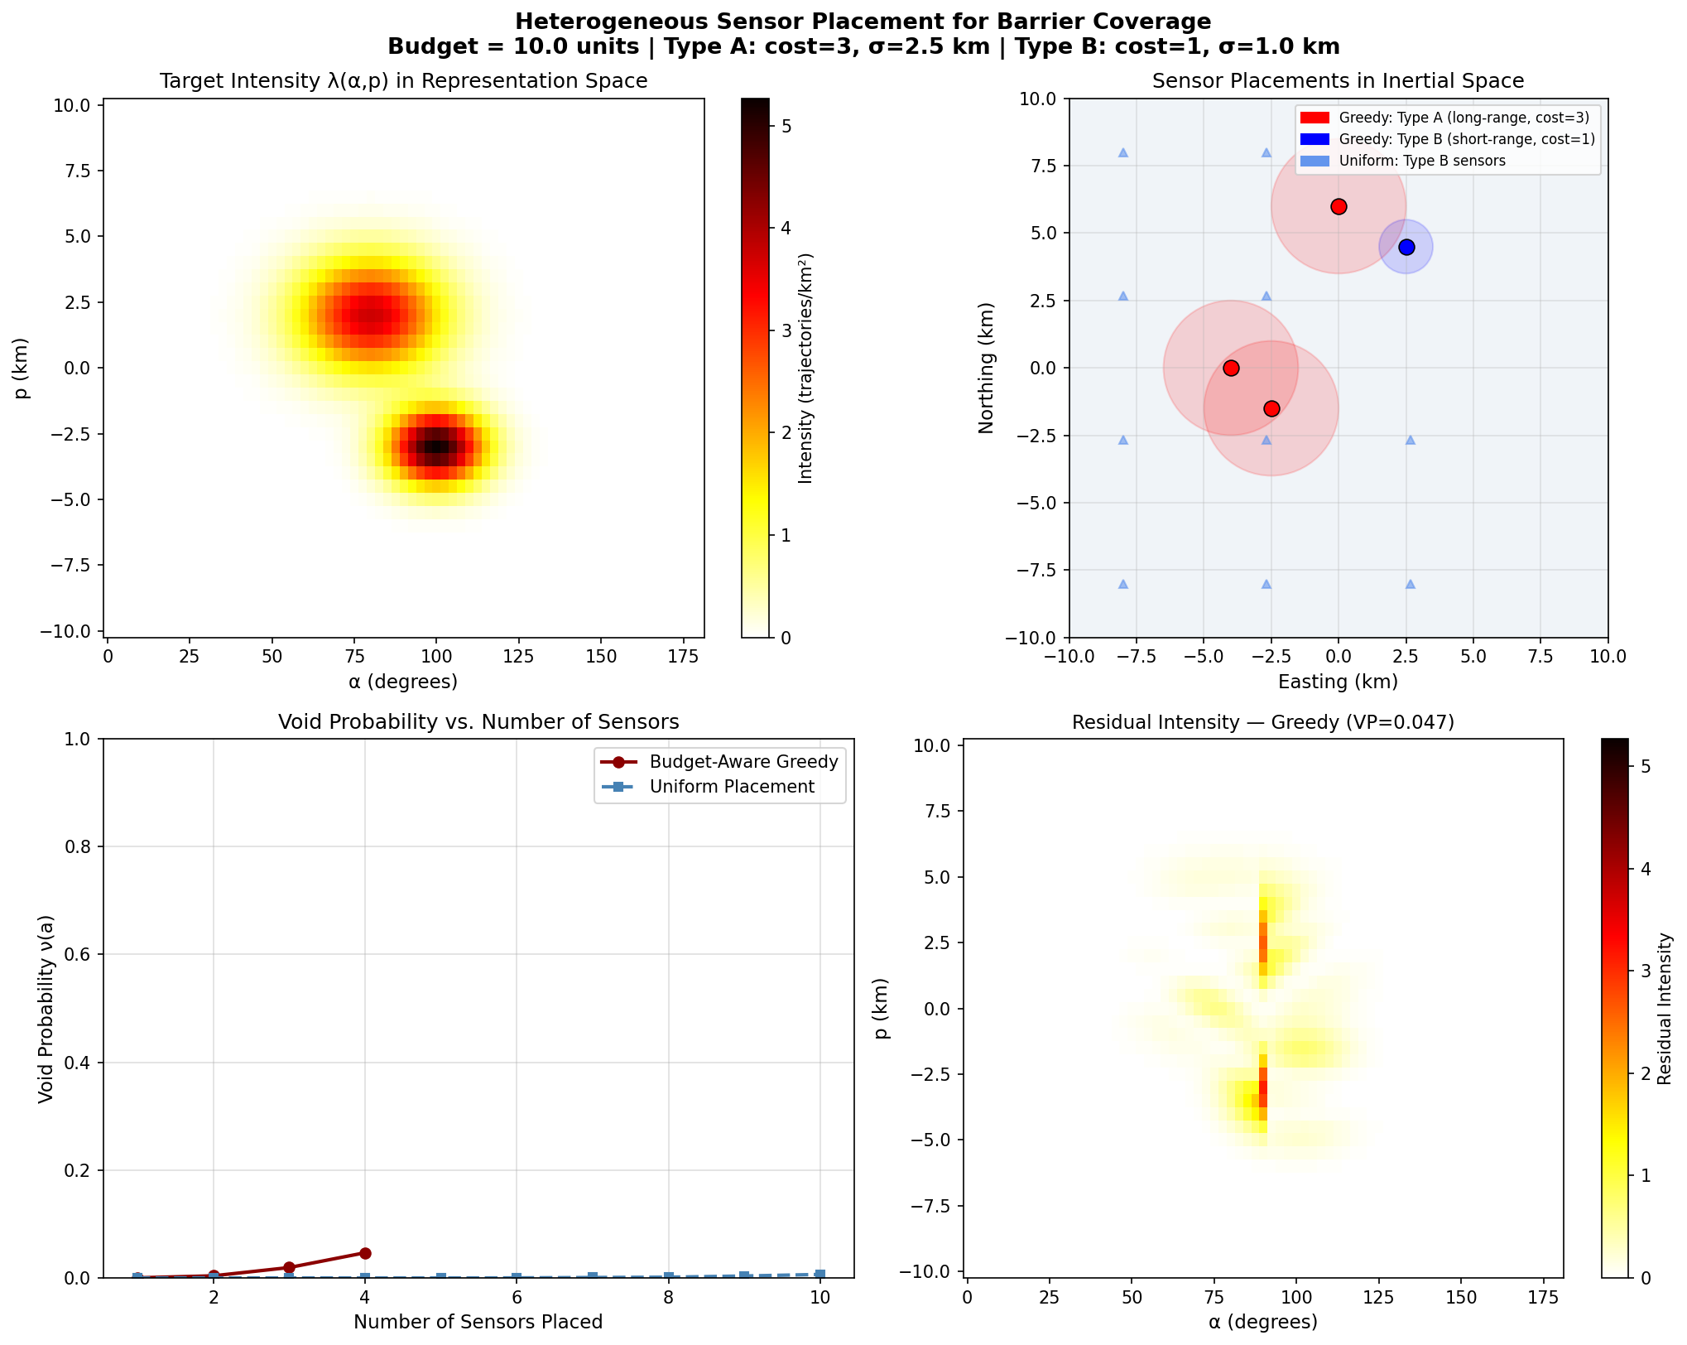
Figure 1. Top-left: ship traffic intensity in representation space (two bright clusters = two shipping lanes). Top-right: sensor locations — colored circles with rings are greedy sensors, small triangles are uniform sensors. Bottom-left: void probability as each sensor is added. Bottom-right: remaining undetected intensity after greedy placement.
The results are summarized in the table below:

Method | Sensors placed | Budget used | Void Probability
Budget-Aware Greedy | 4 (3×A + 1×B) | 10 / 10 | 0.047
Uniform Placement | 10 (all B) | 10 / 10 | 0.007

The greedy method achieves a void probability of 0.047 using only 4 sensors, compared to 0.007 for the uniform method using 10 sensors — roughly 7 times better. This is a significant result: by choosing where and what type of sensor to place, we can dramatically outperform a naive equal-spacing strategy even with the same budget.
Looking at Figure 1 (top-right), the greedy sensors are placed directly along the two main shipping corridors, while the uniform sensors are spread across the entire area including regions with no ship traffic at all.

4.2 How Much Undetected Traffic Remains
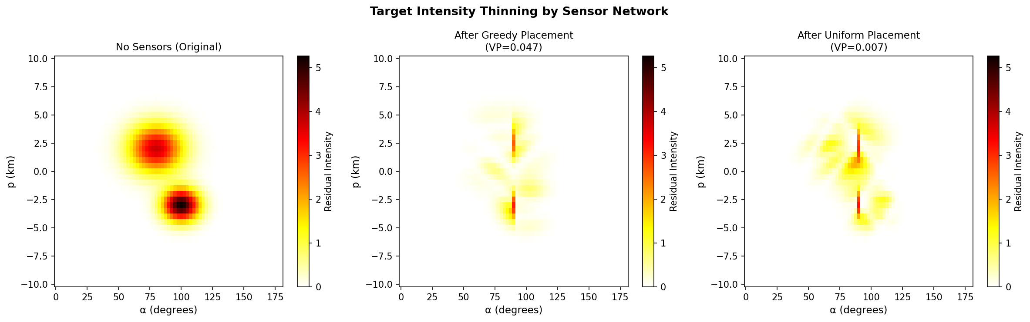
Figure 2. Residual target intensity after sensor placement. Left: no sensors — all traffic is undetected. Center: after greedy placement — both shipping corridors are significantly thinned. Right: after uniform placement — significant undetected traffic remains in both corridors.
Figure 2 makes the difference visually clear. After greedy placement (center), the two high-traffic clusters in the representation space are much dimmer, meaning most ships in those corridors would be detected. After uniform placement (right), both clusters remain bright — meaning many ships would still go undetected.

4.3 What Happens at Different Budget Levels
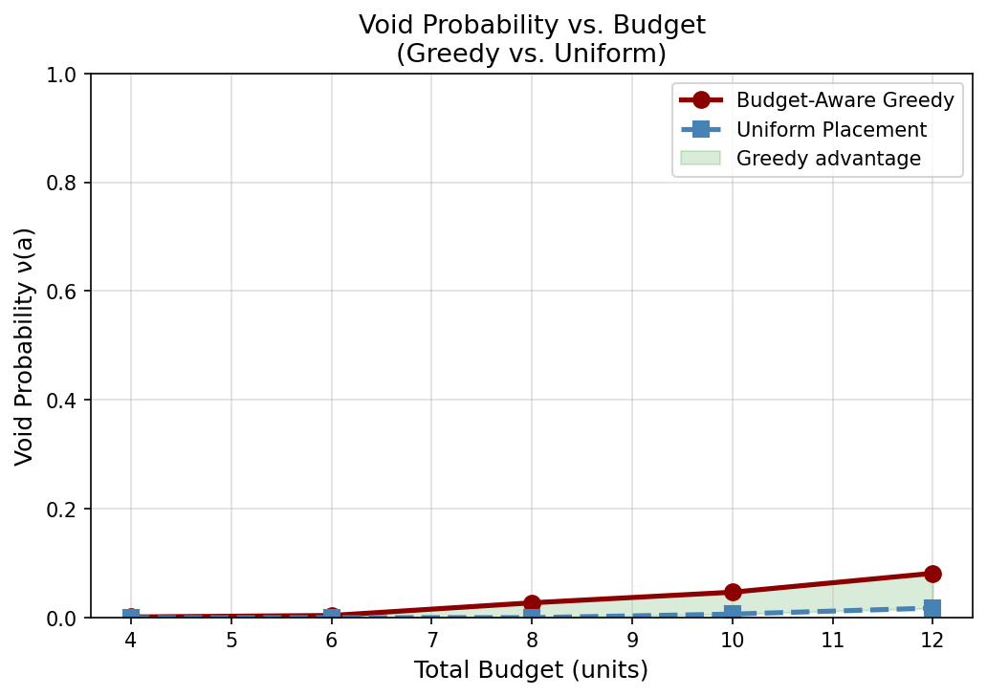
Figure 3. Void probability versus total budget. The greedy method consistently outperforms uniform placement. The green shaded area shows the advantage of the proposed method.
Figure 3 shows the results for different budget levels. The greedy method is consistently better across all budgets tested. The advantage is largest at moderate budgets (B = 6 to 10), where having the flexibility to choose sensor type matters most. At very high budgets, uniform placement eventually catches up because it can place sensors densely enough to cover the whole area.
An interesting observation: at B = 4, the greedy method still manages a void probability about 3× higher than uniform (0.0013 vs ~0.0000), even though both methods have very limited resources.

5. Discussion

5.1 What Worked Well
The main finding is clear and intuitive: it is better to place a few well-chosen, capable sensors in the right locations than to spread many weaker sensors uniformly. This confirms that sensor type selection and placement should be considered together, not separately.
The extended greedy algorithm worked well for this purpose. It naturally discovers that Type A sensors are worth their higher cost when placed along busy shipping corridors, because a single Type A sensor can cover a wide swath of trajectories. Type B sensors are then useful to fill in remaining gaps where the budget allows.
The representation space framework from the original paper turned out to be straightforward to extend. Adding sensor types only required changing the detection parameters in the existing formula — no structural changes were needed. This suggests the framework is flexible and could accommodate even more sensor types.

5.2 Limitations
The void probability values in my simulation are quite low (below 0.05). This is partly a scaling issue: I worked in physical kilometers rather than the normalized space used in the original paper, which affects how the detection functions look numerically. In a real deployment with calibrated sensor parameters, the absolute values would be more meaningful.
The intensity function was simulated using two simple Gaussian clusters rather than being estimated from real AIS data. Real ship traffic patterns are more complex and irregular, and testing on real data would be an important next step.
The greedy search is also slow for large grids. At each step it evaluates thousands of sensor-location combinations. This was manageable for this toy example but would need to be optimized for real-scale problems.

6. Possible Next Steps
Several natural directions follow from this work:
- Use real AIS ship traffic data and the INLA estimation method from the original paper to validate the approach on realistic, irregular intensity patterns.
- Test with more than two sensor types — for example, adding a medium-range sensor category — and study how the optimal mix changes with budget.
- Replace the discrete grid search with continuous gradient-based optimization (as done in the original paper), to find more precise sensor locations.
- Study the minimum viable budget: the results suggest there is a threshold below which neither method works well. Characterizing this threshold could be useful for system designers.
- Investigate anisotropic sensors (sensors that are more sensitive in certain directions), which the original paper mentions as a possible extension and could be combined with the heterogeneous budget framework here.

References
[1] M. Kim, D. J. Stilwell, H. Yetkin, and J. Jimenez, "Near-optimal Sensor Placement for Detecting Stochastic Target Trajectories in Barrier Coverage Systems," 2025 IEEE International Systems Conference (SysCon), 2025.
[2] M. Kim, H. Yetkin, D. J. Stilwell, J. Jimenez, S. Shrestha, and N. Stark, "Toward optimal placement of spatial sensors," IEEE Access, 2023.
[3] A. Krause, A. Singh, and C. Guestrin, "Near-optimal sensor placements in Gaussian processes: Theory, efficient algorithms and empirical studies," Journal of Machine Learning Research, vol. 9, no. 2, 2008.
[4] H. Rue, S. Martino, and N. Chopin, "Approximate Bayesian inference for latent Gaussian models by using integrated nested Laplace approximations," Journal of the Royal Statistical Society: Series B, vol. 71, no. 2, pp. 319–392, 2009.

