Sensor Placement with Heterogeneous Sensors
Under a Fixed Budget Constraint
An Extension of Dr Kim (2025)
Research Task Submission — May 2025

1. Problem Description

1.1 What the Original Paper Does
The main goal of the research is to place a sensor in a specific area in such way in such that the probability of detecting every target (such as ship) passing through that area is maximized.This model was created using AIS data from real ships off the Virginia coast of America. The entire process is based on four steps. First step- Line to point conversion: It is difficult to calculate the straight line path of a ship on a map. Therefore, each line is converted to a specific point (Representation Space) through a mathematical method. This point has two values: the angle of the ship (α) and the distance from the origin (p). This makes the problem easier to handle mathematically. Second step is - Uncertainty Handling (LGCLP): A statistical model called LGCLP is used to quantify the uncertainty and randomness of ship movements. It is used to identify areas on the map where the density of ship movements (lambda) is high. Third is-Sensor mapping: The ability to identify ships decreases as the distance from the sensor increases. This ability of the sensor has also been converted into a point-based map, so that it can be understood how many ship paths a sensor can cover. Lastly-Greedy algorithm: In mathematical terms, the main goal is to maximize the 'void probability', i.e., that no ship can pass undetected. Since finding the perfect location is NP-hard, a greedy algorithm is used to place the sensors in the best locations one by one.

1.2 The Gap I Noticed
After analyzing this paper carefully, I found two major limitations or mathematical gaps that could be addressed in the future.
The first limitation is the assumption of linear trajectories. The original paper assumed that each target or ship moves in a perfectly straight or straight line. While this assumption is fairly accurate for a small area,but in the real world, ships never move 100% straight. Ships often have to navigate curved paths to avoid navigation rules, turns before reaching a port, or other obstacles. Although the paper briefly mentions this issue, no mathematical solution is given.
The second and biggest limitation of this paper which I chose to focus on for this extension, is that it assumes that all sensors are exactly the same (their detection range and cost are the same). But in reality, when a barrier coverage system is built, different types of sensors are used. For example, an expensive and long-range hydrophone array that can cover a large area, and some inexpensive and short-range acoustic buoys that are cheap but cover a limited area.
This raised a question: given a fixed budget and different sensor types( I choose two type for my extension, there could be more type in market), how should we decide which type to buy and where to place them in order to maximize detection probability? This is not just a theoretical concern any real deployment involves budget constraints and a choice between sensor models.
Proposed Extension: Sensor placement under a fixed budget, using a mix of two sensor types with different detection ranges and costs.

2. Mathematical Formulation

2.1 Two Sensor Types
I consider two sensor types with different capabilities:

Property | Type A | Type B | What it means
Detection range | 4 km | 2 km | How far it can detect
Cost | 3 units | 1 unit | Budget used per sensor

Type A is like a long-range hydrophone expensive but powerful. Type B is a short-range acoustic buoy cheap but limited in coverage.

2.2 Budget Constraint
The total cost of all placed sensors cannot exceed the available budget B = 10 units. For example:
- 2 Type A + 4 Type B sensors: cost = 6 + 4 = 10. Valid.
- 10 Type B sensors: cost = 10. Valid, but each sensor has limited range.
- 4 Type A sensors: cost = 12. Exceeds budget — not allowed.

2.3 Detection Model
A target is considered detected if it falls within the sensing range of at least one sensor:
detect(sensor, target) = 1 if distance ≤ sensor_range
0 otherwise
When multiple sensors are deployed, a target is detected if any one of them covers it.

2.4 Objective
The objective is to maximize the Detection Rate the fraction of targets detected by at least one sensor while staying within the budget.

2.5 How the Algorithm Decides
I extended the greedy algorithm from Dr Kim papers to handle two sensor types:
- Start with no sensors placed and the full budget available.
- At each step, try every candidate location and every affordable sensor type.
- Pick the combination (location + type) that detects the most new targets per unit cost.
- Place that sensor, subtract its cost, and repeat until budget runs out.

This lets the algorithm decide whether to buy one expensive long-range sensor or several cheap short-range ones, depending on where targets are concentrated.
It calculates the "value-for-money" for every option and picks the combination (x*, s*) that maximizes marginal target detection per unit cost:
(x*, s*) = argmax [ f(S ∪ {(x,s)}) − f(S) ] / Cost(s)
Where:
- f(S ∪ {(x,s)}) − f(S) is the Marginal Gain (how many new unique targets are detected by adding this sensor, that were not covered before).
- Cost(s) is the budget cost of the sensor type (Type A = 3, Type B = 1).
- argmax ensures the algorithm always picks the most cost-effective option at that step.
Update and Repeat: Place the selected sensor, subtract its cost from the remaining budget, and mark its covered targets as detected. Repeat until the budget runs out.

3. Simulation Setup

3.1 Area and Target Model
The simulation area is a 20 × 20 km square. I generated 100 target trajectories across two shipping lanes — one denser and one sparser which is a simplified but realistic representation of a harbor approach channel.

3.2 Simulation Parameters
- Area: 0 to 20 km in both directions (400 km² total)
- Total targets: 100 (60 in Lane 1, 40 in Lane 2)
- Candidate sensor positions: 8×8 grid over the area
- Total budget: B = 10 units

3.3 Two Methods Compared
Method 1 — Density-Aware Greedy (proposed): At each step, select the sensor type and location that detect the most undetected targets per cost unit. Naturally places sensors where targets are concentrated.
Method 2 — Uniform Placement (baseline): Place Type B sensors at fixed evenly-spaced positions, regardless of where targets are. Simple and requires no knowledge of traffic patterns.

4. Results

4.1 Main Comparison

Method | Sensors placed | Budget used | Detection Rate
Density-Aware Greedy (proposed) | 8 sensors (mix of A + B) | 10 / 10 | 87%
Uniform Placement (baseline) | 10 sensors (all Type B) | 10 / 10 | 60%

The greedy method achieves 87% detection using 8 sensors, compared to 60% for the uniform method using 10 sensors a 27 percentage point improvement with the same budget and fewer sensors.
The greedy sensors are placed directly along the two main shipping lanes. The uniform sensors are spread across the entire area, including regions with no targets.

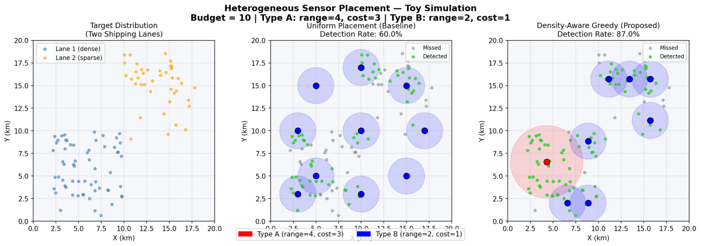
Figure 1. Left: target distribution (two shipping lanes). Center: uniform placement (60% detection). Right: density-aware greedy placement (87% detection). Green dots = detected targets, gray dots = missed.

5. Discussion

5.1 What Worked Well
The most important observation of this work is that it is much more effective to place appropriate sensors in important locations than to spread all the sensors evenly. The simulations show that using a large number of sensors alone does not yield good results; rather, both the type and location of the sensors need to be considered together.Though I do not have any past research experience in sensor network optimization, several assumptions were made in the simulation. The main focus was not to reproduce the original paper exactly, but to visualize the feasibility of the proposed extension using a small prototype.
My proposed Greedy method automatically selected locations with high target density. As a result, it was possible to detect a large number of targets even with a limited budget. This result is also consistent with my previous experience in an IoT-based Smart Campus Parking System project, where effectively deploying a limited number of sensors played a significant role in increasing the overall performance of the system. Besides, the idea of using sensors with different capabilities together seems to be more consistent with the real world, because in the real world, not all sensors have the same capabilities and costs.

5.2 Limitations
This study is based on a toy simulation. The target locations and movement patterns are not collected from real data; rather, they are artificially generated to allow for easy testing of the concept.
In addition, the AIS (Automatic Identification System) data, LGCP model, or INLA-based intensity estimation used in the original paper were not used here. Therefore, the results may differ slightly in a real environment.
Another limitation is that grid search is used for sensor placement. While this is sufficient for small simulations, it can become time-consuming for larger problems or real-world environments.

Possible Next Steps
There are several potential areas for further development of this work in the future

- The model can be validated using real AIS ship traffic data, so that its performance in a real environment can be evaluated.
- By using multiple types of sensors (short-range, medium-range, long-range) instead of two types of sensors, it can be analyzed which sensor combination is most effective at which budget.
- Instead of grid search, optimization-based approaches (such as Genetic Algorithm, Particle Swarm Optimization or Reinforcement Learning) can be used to determine better sensor placement.
- Using Machine Learning, adaptive sensor placement systems can be created by predicting future target movement from historical traffic patterns. This area is particularly relevant to my research interests (Machine Learning and Intelligent Decision Systems).
- Research can be conducted on dynamic sensor deployment using Multi-UAV or Mobile Sensor Platform, where sensors can change their positions as the environment changes.

References
[1] M. Kim, D. J. Stilwell, H. Yetkin, and J. Jimenez, "Near-optimal Sensor Placement for Detecting Stochastic Target Trajectories in Barrier Coverage Systems," 2025 IEEE International Systems Conference (SysCon), 2025.
[2] M. Kim, H. Yetkin, D. J. Stilwell, J. Jimenez, S. Shrestha, and N. Stark, "Toward optimal placement of spatial sensors," IEEE Access, 2023.
[3] A. Krause, A. Singh, and C. Guestrin, "Near-optimal sensor placements in Gaussian processes: Theory, efficient algorithms and empirical studies," Journal of Machine Learning Research, vol. 9, no. 2, 2008.
[4] H. Rue, S. Martino, and N. Chopin, "Approximate Bayesian inference for latent Gaussian models by using integrated nested Laplace approximations," Journal of the Royal Statistical Society: Series B, vol. 71, no. 2, pp. 319-392, 2009.

