王子怡 2019212212280 软工192

* 列出所有学了CS-101但没有学CS-190的学生学号

select distinct ID from takes as t1

where course_id = ‘CS-101’ and not exists

(select * from takes as t2 where t2.id = t1.id and t2.course_id =’CS-190’);

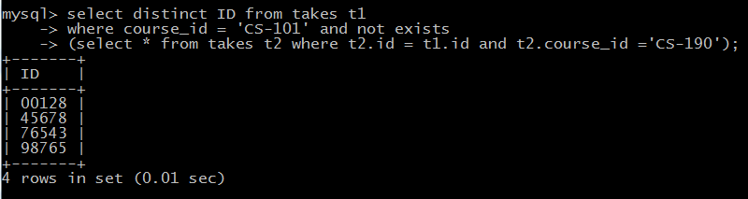

* 分别用IN和EXISTS查询上了CS-101和CS-190两门课的所有学生学号和姓名

IN:

select ID,name from student where ID in

(select distinct ID from takes where course_id =’CS-101’ or course_id =’CS-190);

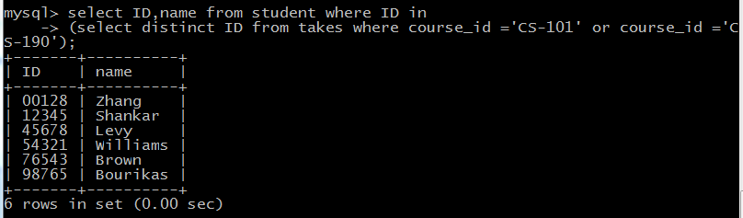

EXISTS:

select ID,name from student where exists(

select distinct ID from takes where takes.id = student.id and (takes.course_id =’CS-101’ or

takes.course_id = ’CS-190’));

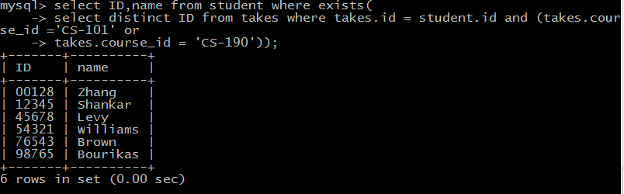

* 查询上了“计算机科学导论”（Intro. to Computer Science）但没上“图像处理”（Image Processing）的所有学生的姓名

select name from student where id in(

select distinct ID from takes t1 where course_id in(

select course_id from course where title = ‘Intro. to Computer Science’)

and not exists (select * from takes t2 where t1.id = t2.id and t2.course_id in(

select course_id from course where title = ‘Image Processing’)));

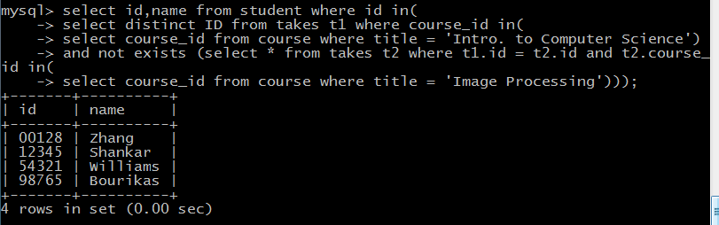

* 查询所有计算机系学生的平均绩点(tot_cred)

select tot_cred from student where dept_name =’Comp. Sci.’;

select avg(tot_cred) from student where dept_name=’Comp. Sci.’;

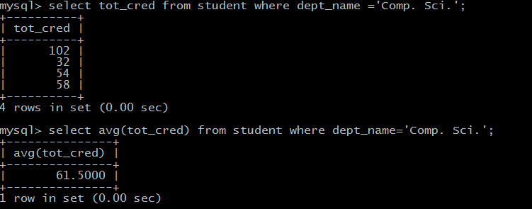

* 查询所有上了“计算机科学导论”（Intro. to Computer Science）课程的学生的平均绩点(tot_cred)

select tot_cred from student where id in(

select id from takes where course_id in(

select course_id from course where title =’Intro. to Computer Science’));

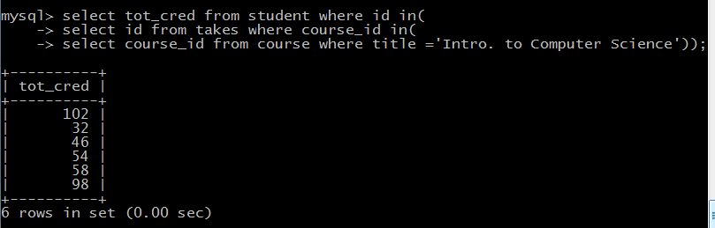

select avg(tot_cred) from student where id in(

select id from takes where course_id in(

select course_id from course where title = ‘Intro. to Computer Science’));

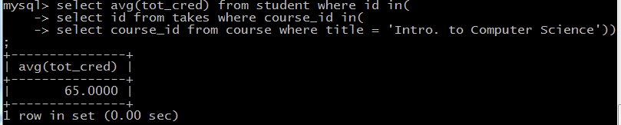

* 查询每个系的平均成绩，只打印出平均成绩大于80的系的名称和平均成绩，并按平均成绩从大到小排序

Select dept_name,avg(tot_cred) from student group by dept_name

Having avg(tot_cred)>80 order by avg(tot_cred);

