王子怡 软工192 2019212212280

* 列出所有学生(student)的学号(ID)、姓名(name)和系(dept_name)

SELECT ID,name,dept_name FROM student;

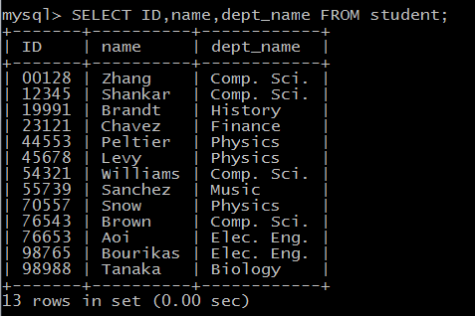

* 列出所有计算机系绩点在50以上的学生姓名和绩点

select name,tot_cred from student

Where tot_cred>50 and dept_name=’Comp. Sci’;

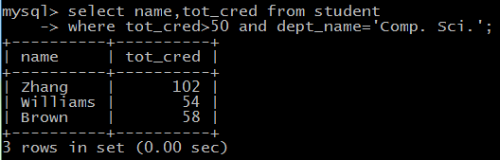

* 列出所有计算机系的课程

Select * from course where dept_name=’Comp. Sci.’;

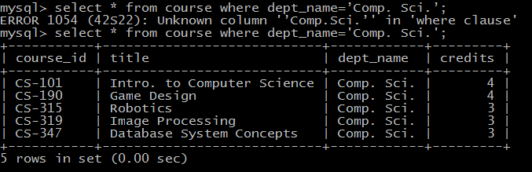

* 列出所有介绍性课程（课程名以Intro开头）

Select * from course where title like ‘Intro%’;

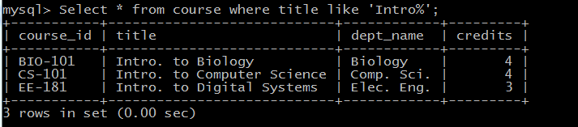

* 列出所有学了CS-101但没有学CS-190的学生学号

Select distinct ID from takes t1

Where course_id=’CS-101’ and not exists

(select * from takes t2 where t2.id=t1.id and t2.course_id = ‘CS-190’);

Select ID,name from student where ID in  
(select distinct ID from takes where course_id=’CS-101’)  
and ID in(select distinct ID from takes where course_id='CS-190');

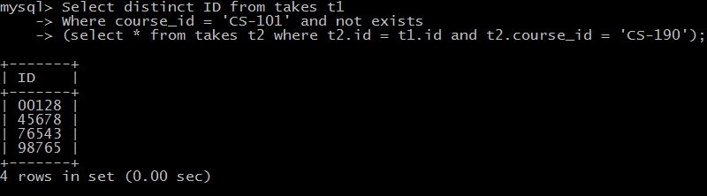

* 查询所有学生每一门课程的成绩，打印出学号、课程号和成绩，并按学号排序

Select ID,course_id,grade from takes order by ID;

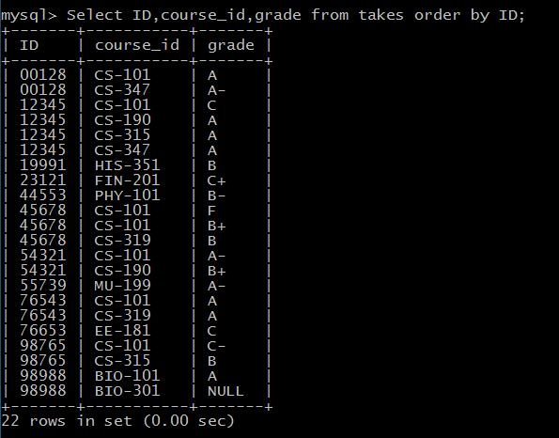

* 查询所有学生每一门课程的成绩，打印出学号、学生姓名、课程号和成绩，无需排序

Select student.ID,name,course_id,grade

From student,takes where student.ID=takes.ID;

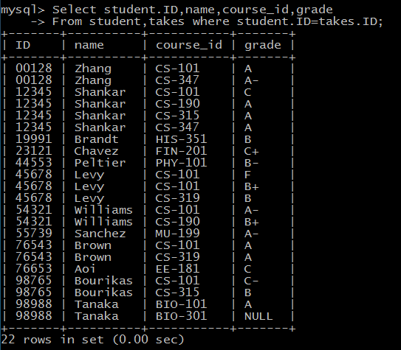

* 查询所有学生每一门课程的成绩，打印出学号、学生姓名、课程名称和成绩，并首先按课程名排序，再按学号排序

Select a.ID, a.name,c.title,b.grade

From student as a,takes as b,course as c

Where a.ID = b.ID and c.course_id = b.course_id

Order by title, a.ID;

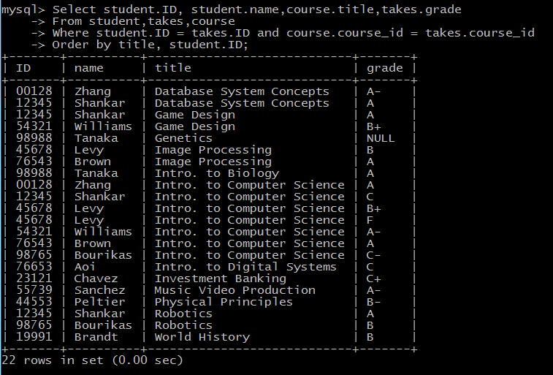

Select avg(tot_cred) from student where id in(

Select id from takes where course_id in(

Select course_id from course where title = ‘Intro. to Computer Sicence’));

AVG() 函数返回数值列的平均值

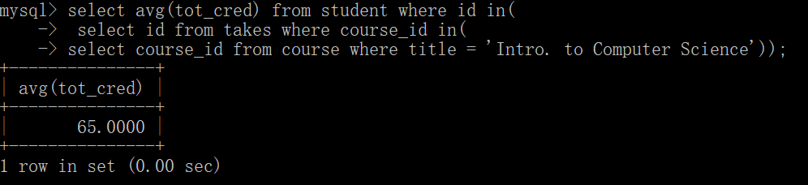

Select avg(tot_cred) from student where id in(

Select id from takes natural join course where title = ‘Intro. to Computer Sicence’);

