Final Project Report
SalesAI CRM
AI-Powered Sales & Customer Management Platform
1-Month Internship Project — Client: ABC Sales & Services Pvt. Ltd.
Submitted by: Paras Choudhary & Team

1. Project Overview
SalesAI CRM is a full-stack, AI-powered sales and customer relationship management platform, built as a 1-month internship project simulating a real client engagement for a fictional company, ABC Sales & Services Pvt. Ltd. The client's stated problem was that customer data lived in spreadsheets, leads went untracked, follow-ups were missed, and reporting was entirely manual. The project delivers an end-to-end web application that replaces that workflow with a structured, role-aware system, and adds AI-driven insights on top.

2. Objectives
- Replace manual/Excel-based tracking with a centralized, database-backed system.
- Provide a clear sales pipeline: Lead → Customer → Quotation → Sale.
- Give managers visibility through dashboards and AI-generated reports.
- Enforce role-based access so each user only sees and does what their role permits.
- Deliver production-style engineering practice: version control, testing, documentation — not just a CRUD demo.

3. Technology Stack
Layer | Technology
Backend | Python, Django 5
Database | MySQL 8 (via PyMySQL)
Frontend | HTML5, CSS3, JavaScript, Chart.js
AI | Groq API (Llama/GPT-OSS models, OpenAI-compatible)
PDF Generation | ReportLab
Version Control | Git & GitHub (two-branch workflow)

4. Team & Workflow
A 2-person team: one member owned the backend (Django models, views, business logic, AI integration, security), the other owned the frontend (templates, CSS, visual design). Work was split across two long-lived Git branches merged periodically into main, with role- and file-based ownership to minimize merge conflicts.

5. Modules Delivered
Module | Key Capabilities
Authentication | Registration, login/logout, hashed passwords, 3 roles (Admin, Manager, Sales Executive)
Customer Management | Full CRUD, search, status filter
Lead Management | Full CRUD, 7-stage pipeline, priority, one-click conversion to Customer, ownership-restricted for Sales Executives
Product Management | CRUD restricted to Admin/Manager
Follow-up Management | Linked to Customer or Lead; Today's/Overdue/Upcoming/Completed dashboard
Quotation & Sales | Multi-item quotations, automatic discount/GST calculation, PDF export, one-click conversion to a Sale with auto-generated invoice numbers
Dashboard | 6 live KPIs, 2 Chart.js visualizations
AI Module | Lead Scoring, Follow-up Message Generator, Customer Summary, AI Sales Report — all backed by a live AI API call, logged for audit
Notifications | Auto-triggered on lead assignment, follow-up scheduling, and sales, with an unread-count badge

6. Database Design
11 tables, normalized around the core sales entities (Customer, Lead, Product, Quotation, Sale) with supporting tables for follow-ups, notifications, and AI audit logs. Full schema in the separate Database Schema Document; entity relationships below.
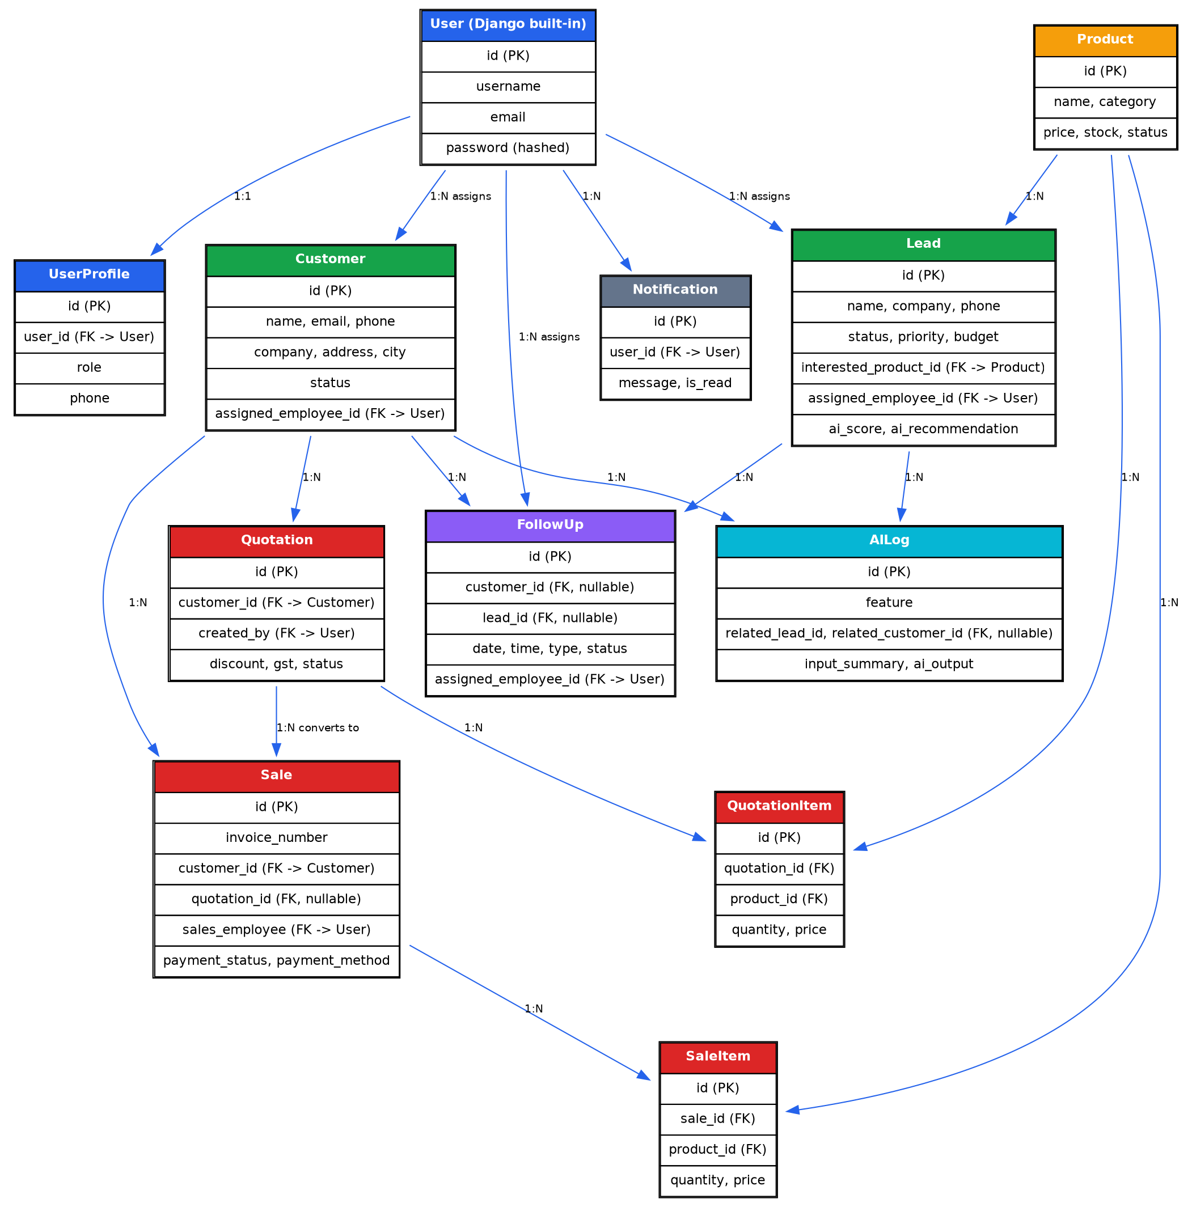

7. Security & Access Control
Role-based access control is enforced at the backend, not just hidden in the UI: unauthorized role access to a restricted view (e.g. a Sales Executive requesting the Product-add page or another user's lead) returns a real HTTP 403 Forbidden response, verified with automated tests. Passwords are hashed via Django's built-in PBKDF2 implementation; secrets (DB credentials, AI API key) are kept in a git-ignored .env file, never hardcoded or committed.

8. Testing
Automated tests were written and run throughout development covering authentication, CRUD flows, role-based access (including direct-URL bypass attempts), quotation/sale calculations, PDF generation, and AI feature integration (with the AI API call mocked for deterministic testing). See the separate Test Cases document for the full list. Real bugs found and fixed during development are logged in the separate Bug Report document.

9. Challenges Faced & Solutions
Challenge | Solution
Multiple conflicting MySQL instances on the development machine, unknown root password | Identified the correct service via Windows service inspection; reset the password using MySQL's --init-file startup method
MySQL 8's default authentication method required an undocumented extra dependency | Added the `cryptography` package to requirements.txt
Chosen AI provider's new API key format broke the REST integration mid-project | Diagnosed as a provider-side rollout issue affecting many developers; switched to a more stable provider (Groq) rather than waiting on a fix
AI provider deprecated the model in use without advance testing | Searched the provider's current model list and updated the integration
A template bug caused a page crash when an optional relation was unset | Root-caused to Django template filter argument resolution; fixed with a model-level safe accessor property
Frontend redesign accidentally dropped role-based UI logic and left one module unstyled | Caught via manual QA, cross-checked against the backend's actual enforcement (confirmed security was unaffected), and patched the specific templates

10. Outcome
A working, role-aware, AI-integrated CRM covering the full sales lifecycle from lead capture to invoiced sale, with dashboards, PDF generation, and four distinct AI features grounded in real application data (not just a chatbot bolted on). Beyond the code, the project produced a full documentation set (SRS, ER Diagram, Database Schema, UI Wireframes, API Documentation, Test Cases, Bug Report, User Manual, and this report), reflecting a real client-delivery process rather than a standalone coding exercise.

11. Possible Future Enhancements
- Deployment to a live server (currently runs locally).
- Automated email/SMS delivery for follow-up reminders and quotations.
- A richer admin panel for managing users directly within the app (currently via Django Admin).
- Export of reports (sales, leads) to Excel/PDF beyond the existing quotation PDF.

