UI Wireframes
SalesAI CRM — Low-fidelity screen layouts

1. Login Screen
Split layout: brand/pipeline visual on the left, login form on the right. Matches the actual implemented design (see auth-shell in style.css).
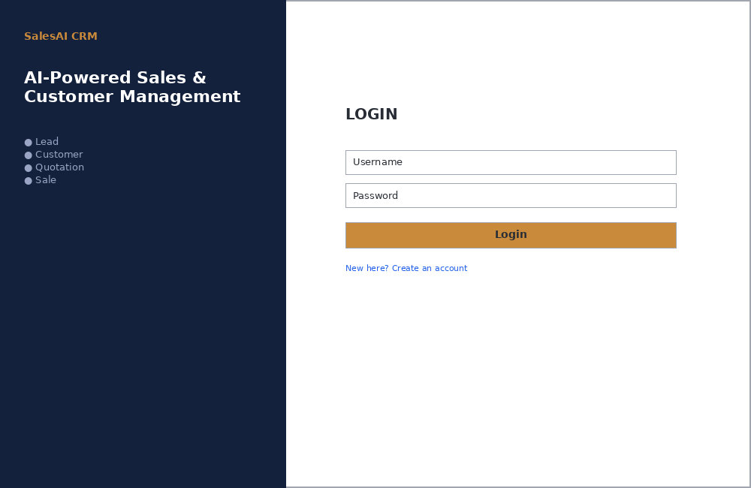

2. Dashboard
Persistent sidebar navigation (dark), main content area with 6 KPI cards, 2 charts, and quick-action shortcuts.
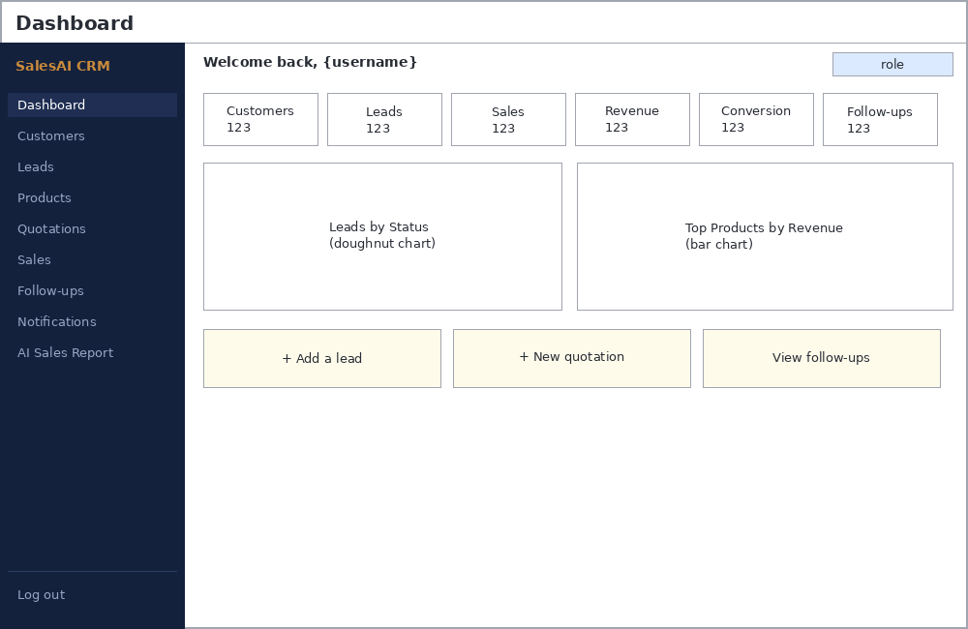

3. Leads List
Standard list-page layout used across Customers, Leads, Products, Quotations, Sales: search + filter toolbar, a data table, and an Add button. This layout is reused (not redesigned per-module) for consistency.
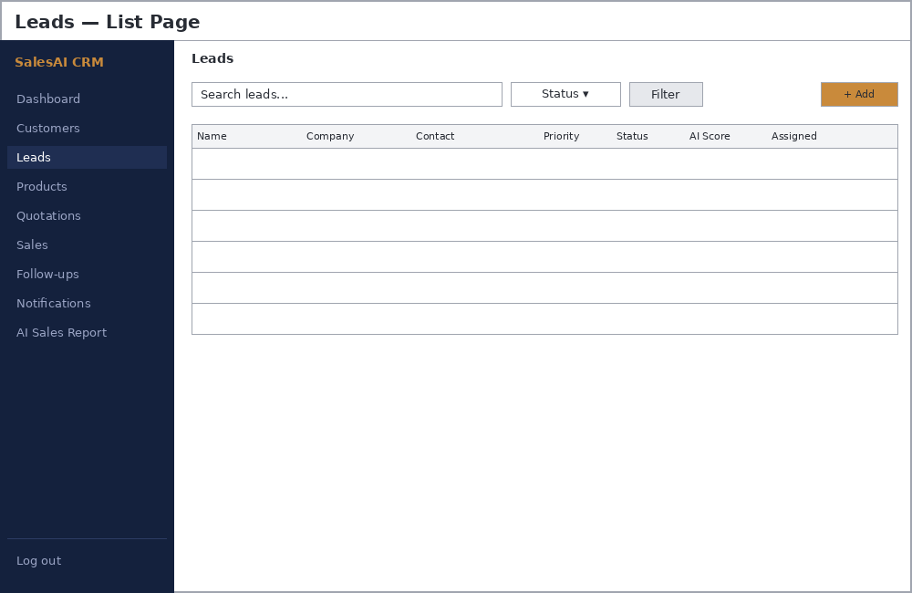

4. Quotation Form
Form layout with a repeatable item row (product, quantity, price) and a computed totals box (subtotal, discount, GST, total) — the same pattern is reused for the Sales record form.
