PROJECT REPORT
______________________________________________________________________
Simulation-Based Implementation of Lean Manufacturing Techniques
for Productivity Improvement in SMEs
A Data-Driven Case Study from a Beverage Bottling Line
Submitted by | Divash Krishnam, Ashutosh Verma, Raja
Guided by | Dr. MOHD SHUAIB
Department | Production and Industrial Engineering
Document type | Formal project report prepared from the research paper
Date | April 25, 2026

Department of Production and Industrial Engineering
Prepared from the research study and simulation analysis conducted on the beverage bottling dataset.

Certificate
This is to certify that the project report titled 'Simulation-Based Implementation of Lean Manufacturing Techniques for Productivity Improvement in SMEs: A Data-Driven Case Study from a Beverage Bottling Line' is a bonafide record of the work carried out by Divash Krishnam, Ashutosh Verma, and Raja under my guidance.
To the best of my knowledge, the work presented in this report is based on the students' analysis of the selected industrial dataset, simulation-based evaluation, and interpretation of results for academic submission in Production and Industrial Engineering.

____________________________ | ____________________________
Guide | Project Team

Declaration
We hereby declare that this project report is based on our original academic work carried out using the referenced production dataset, published literature, and the simulation analysis developed for this study.
The contents of this report have been prepared from our research paper and supporting analysis files. Wherever the ideas, methods, or datasets of other researchers have been used, proper acknowledgment has been made in the reference section.

____________________________ | ____________________________
Students | Date

Acknowledgement
We sincerely express our gratitude to Dr. MOHD SHUAIB for his guidance, support, and valuable academic direction throughout the course of this work. His feedback helped shape the structure of the study and improve the clarity of the technical analysis.
We also acknowledge the openly available bottling-line dataset and the referenced research articles that enabled a transparent and reproducible academic study. Their availability made it possible to connect lean manufacturing concepts with real operating data and simulation-based decision making.

Contents
- Abstract and project overview
- Chapter 1. Introduction and project context
- Chapter 2. Literature review and research gap
- Chapter 3. Dataset, research objective, and analytical framework
- Chapter 4. Methodology and lean scenario design
- Chapter 5. Results and analysis
- Chapter 6. Discussion and implementation recommendations
- Chapter 7. Conclusion, limitations, and future scope
- References

Abstract
Unlike studies that rely on theoretical frameworks, this report investigates how lean manufacturing priorities can be selected in an SME beverage bottling line by using real production and downtime records instead of relying purely on conceptual analysis. The dataset includes 59 production summaries, 265 hourly observations, and 1,388 downtime events recorded between July 22, 2022, and February 6, 2023. To evaluate the likely impact of lean interventions, a bootstrap simulation approach was applied using throughput, availability, pause time, and waiting-waste share, together with downtime classification into micro-, minor-, and major-stoppage groups.
The line produced 212,358 liters, but only 42.66% of monitored time was value-adding production time. The remaining 57.64% was consumed by waiting waste in the form of downtime. When the downtime events were categorized, micro-stoppages accounted for 61.31% of all events but only 13.59% of downtime minutes, whereas major stoppages represented just 6.77% of events yet consumed 66.26% of lost time. Simulation results show that 5S with visual management improves output by 2.33%, TPM improves output by 20.61%, and an integrated lean bundle improves output by 32.19% while raising simulated availability from 42.37% to 55.33%.
The report concludes that the most useful first action is not the most visible interruption but the most costly one. TPM aimed at severe stoppages offers much larger gains than 5S alone. The study therefore provides a practical, data-based project report for downtime-driven SME production systems.

Keywords
Lean manufacturing, productivity improvement, SME manufacturing, waste reduction, waiting waste, beverage bottling line, downtime analysis, total productive maintenance, 5S, bootstrap simulation.

Chapter 1. Introduction and Project Context
Not every problem on a bottling line costs the same amount of time. A line may experience many short interruptions during a shift, but only a few longer stoppages can consume most of the available production time. In lean manufacturing, that non-productive interval appears as waiting waste because monitored time passes without generating output. For SMEs, this makes prioritization difficult because maintenance capacity, technical manpower, and improvement budgets are usually limited.
In practical plant settings, the first improvement decision is often the hardest. Managers may know that downtime is hurting output, but they may still be unsure whether to focus first on workplace discipline, maintenance, line organization, or a combined improvement effort. This report addresses that decision problem through a real beverage bottling dataset collected from an IIoT-enabled production system.

Project Objectives
- To analyze the production behavior and downtime structure of a real bottling-line system.
- To identify the dominant waiting-waste pattern affecting productivity.
- To simulate the effect of selected lean interventions on throughput, availability, and waste reduction.
- To recommend an implementation priority for lean techniques based on the observed loss pattern.

Research Questions
- Which stoppage type causes the highest damage to productivity?
- How much does each lean strategy improve output, availability, and waiting-waste reduction?
- Given unequal stoppage impact, which lean action should come first?

Chapter 2. Literature Review and Research Gap
The literature relevant to this study can be grouped into four connected discussions. The first focuses on the general relationship between lean manufacturing and operational performance. Existing studies show that lean methods are often linked with performance improvement, but the strength of improvement depends heavily on context and on how limited SME resources are managed.
A second discussion concerns food and beverage production. In this setting, packaging synchronization, hygiene requirements, and high line interdependence make it difficult to transfer lean lessons directly from other industries. Prior studies confirm the value of lean in the food sector but do not clearly guide whether a bottling line should first solve micro-stoppages, major breakdowns, or both together.
A third discussion concerns simulation-based evaluation of lean alternatives. Simulation improves improvement planning because it can test counterfactual conditions before real shop-floor implementation. However, many published studies remain proprietary or are difficult for students and smaller firms to reproduce.
The key research gap is therefore clear: published work still rarely combines SME relevance, beverage-line context, open event data, uncertainty-aware simulation, and explicit downtime-driven prioritization in one reproducible workflow. This report addresses that gap by connecting event-level downtime data directly to lean-intervention selection.
Table 1. Literature Gap Summary
Theme | What the literature provides | Gap addressed in this report
Lean in SMEs | Strong conceptual support for lean adoption in small firms. | Limited plant-level ranking of lean priorities.
Food and beverage context | Good sector relevance and success-factor discussion. | Weak guidance on stoppage-specific intervention order.
Simulation studies | Useful what-if comparison before implementation. | Often proprietary and less reproducible.
Downtime analysis | Strong diagnosis of bottling-line losses. | Less explicit conversion from downtime structure to lean priority.

Chapter 3. Dataset, Research Objective, and Analytical Framework
The focus of this project is a real beverage bottling line represented through a publicly available dataset published on Zenodo in January 2026. Unlike studies based on simulated or inaccessible proprietary data, this work draws on an openly accessible industrial dataset collected from a real IIoT-monitored bottling operation.
The dataset contains four important groups of information: hourly production output records, daily production summaries, hourly operating breakdown records, and individual breakdown event records. The monitoring period spans roughly seven months and includes both 3-liter and 5-liter product sizes, which allows the study to capture real changes in line behavior over time.
Table 2. Dataset Characteristics
Attribute | Value
Monitoring period | July 22, 2022 to February 6, 2023
Production summary records | 59
Calendar production days | 56
Hourly operating observations | 265
Downtime events | 1,388
Observed product sizes | 3 L and 5 L
Total liters produced | 212,358
Total units produced | 60,888
Total monitored time | 238.65 h
Total operating time | 101.81 h

Analytical Framework
Table 3. Core Performance Relationships
Metric | Expression | Meaning
Availability | A = T_op / T_mon | Share of monitored time spent in real operation.
Downtime | T_dt = T_mon - T_op | Pause time or lost production time.
Production rate | R = Q / T_op | Liters produced per hour of operating time.
Scenario output | Q' = R x (T_mon - T'_dt) | Expected output after lean intervention.
Waste reduction | Delta W (%) = ((T_dt - T'_dt) / T_dt) x 100 | Reduction in waiting waste after improvement.

Chapter 4. Methodology and Lean Scenario Design
This project uses a data-driven simulation methodology to evaluate lean alternatives on the basis of observed production behavior. The method combines baseline performance analysis, downtime classification, waiting-waste measurement, and bootstrap simulation.

Method Steps
- Extract and clean the production, hourly operation, and downtime-event records.
- Measure baseline production, operating time, pause time, availability, and waiting-waste share.
- Classify downtime into micro-stoppages (<= 2 min), minor stoppages (2 to 10 min), and major stoppages (> 10 min).
- Estimate production rate for each observed production day.
- Run an event-level bootstrap simulation with 5,000 replications.
- Apply lean scenario rules and recalculate output, pause time, availability, and waste reduction.

Scenario Design
Table 4. Lean Scenarios Used in the Study
Scenario | Rule applied in simulation | Purpose
5S + Visual Management | 15% of micro-stoppages eliminated | Improve workplace organization and reduce short disruptions.
TPM | 25% reduction in duration of major stoppages | Improve machine reliability and reduce severe breakdown loss.
Integrated Lean Bundle | 20% micro-stop removal, 15% minor-stop reduction, 30% major-stop reduction | Model a combined improvement program.

How Lean Manufacturing Was Applied to the Data
Table 5. Mapping of Lean Tools to Loss Categories
Lean tool | Data signal used | Reason for mapping
5S + Visual Management | Micro-stoppages and short interruptions | Better workplace organization helps remove small avoidable delays.
TPM | Major stoppages and long downtime duration | Maintenance action directly targets severe breakdown loss.
Integrated Lean Bundle | Micro, minor, and major stoppages | Combined program captures both discipline and reliability effects.

The simulation logic does not impose an artificial pattern on the system. Instead, it repeatedly resamples the real behavior observed in the plant and estimates how the outcome changes when specific categories of downtime are reduced through lean interventions.

Chapter 5. Results and Analysis

Baseline Performance
The recorded production system produced 212,358 liters from 60,888 units during 238.65 monitored hours. However, operating time was only 101.81 hours, while pause time reached 137.56 hours. This means overall availability was 42.66%, and 57.64% of monitored time was consumed by waiting waste.
Table 6. Baseline Performance Indicators
Metric | Value
Total production | 212,358 L
Total units produced | 60,888
Monitored time | 238.65 h
Operating time | 101.81 h
Pause time | 137.56 h
Overall availability | 42.66%
Waiting-waste share | 57.64%
Average rate for 3 L product | 1,963.71 L/h
Average rate for 5 L product | 2,918.68 L/h

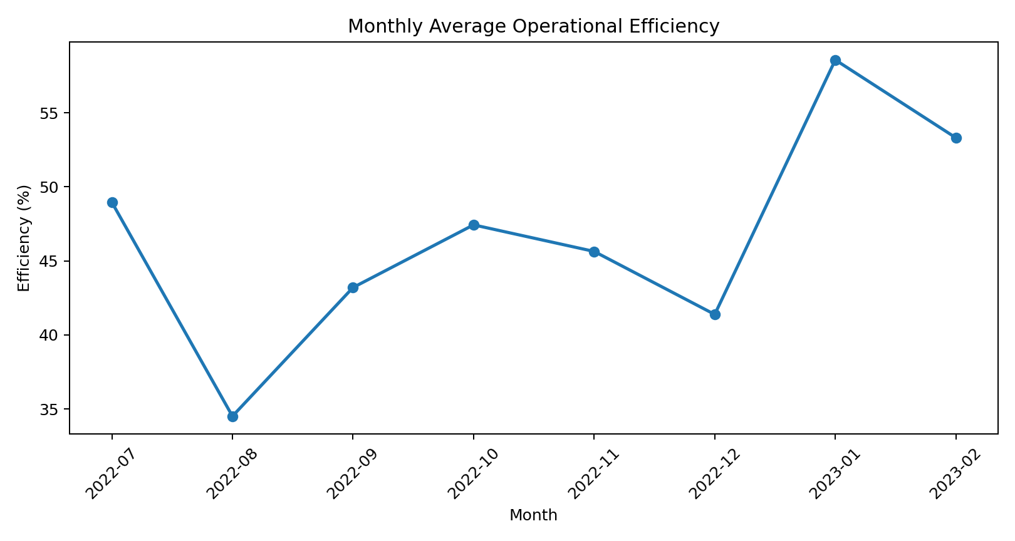
Figure 1. Monthly average operational efficiency across the monitored bottling-line period.
Monthly efficiency varies noticeably across the study period. Lower performance appears in August 2022 and December 2022, while stronger performance is visible in January 2023. This confirms that the line does not behave like a stable deterministic production system.
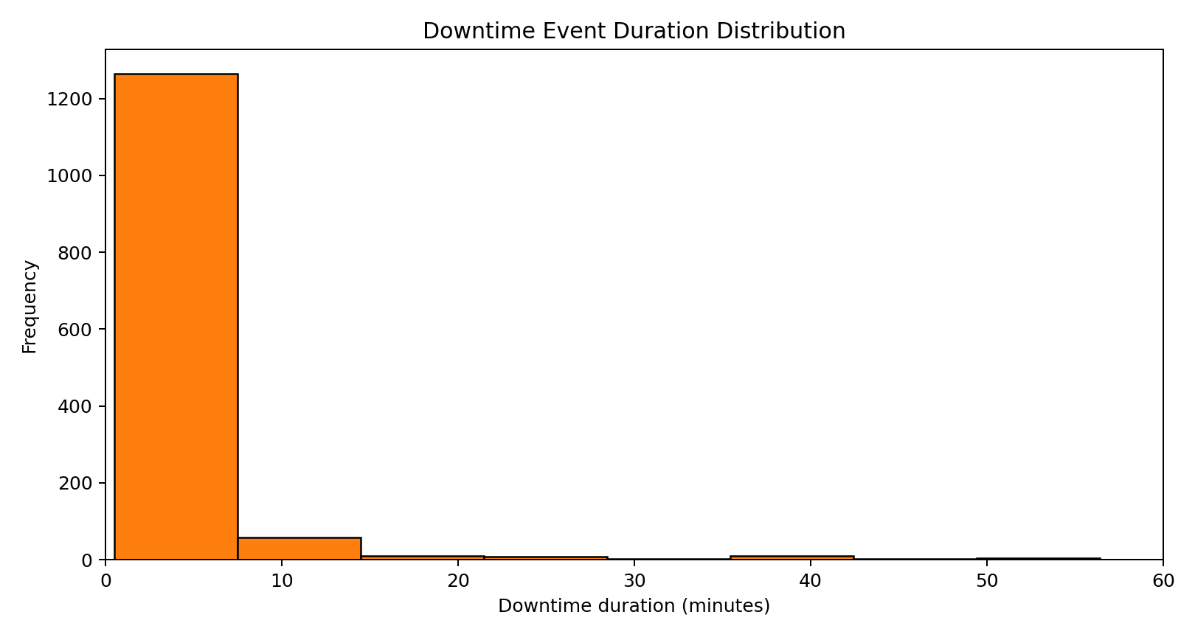
Figure 2. Downtime-event duration distribution. Most events are short, but a small number of long stoppages dominate loss.
Table 7. Downtime Category Structure
Category | Event count | Share of downtime minutes
Micro (<= 2 min) | 851 | 13.59%
Minor (2-10 min) | 443 | 20.15%
Major (> 10 min) | 94 | 66.26%

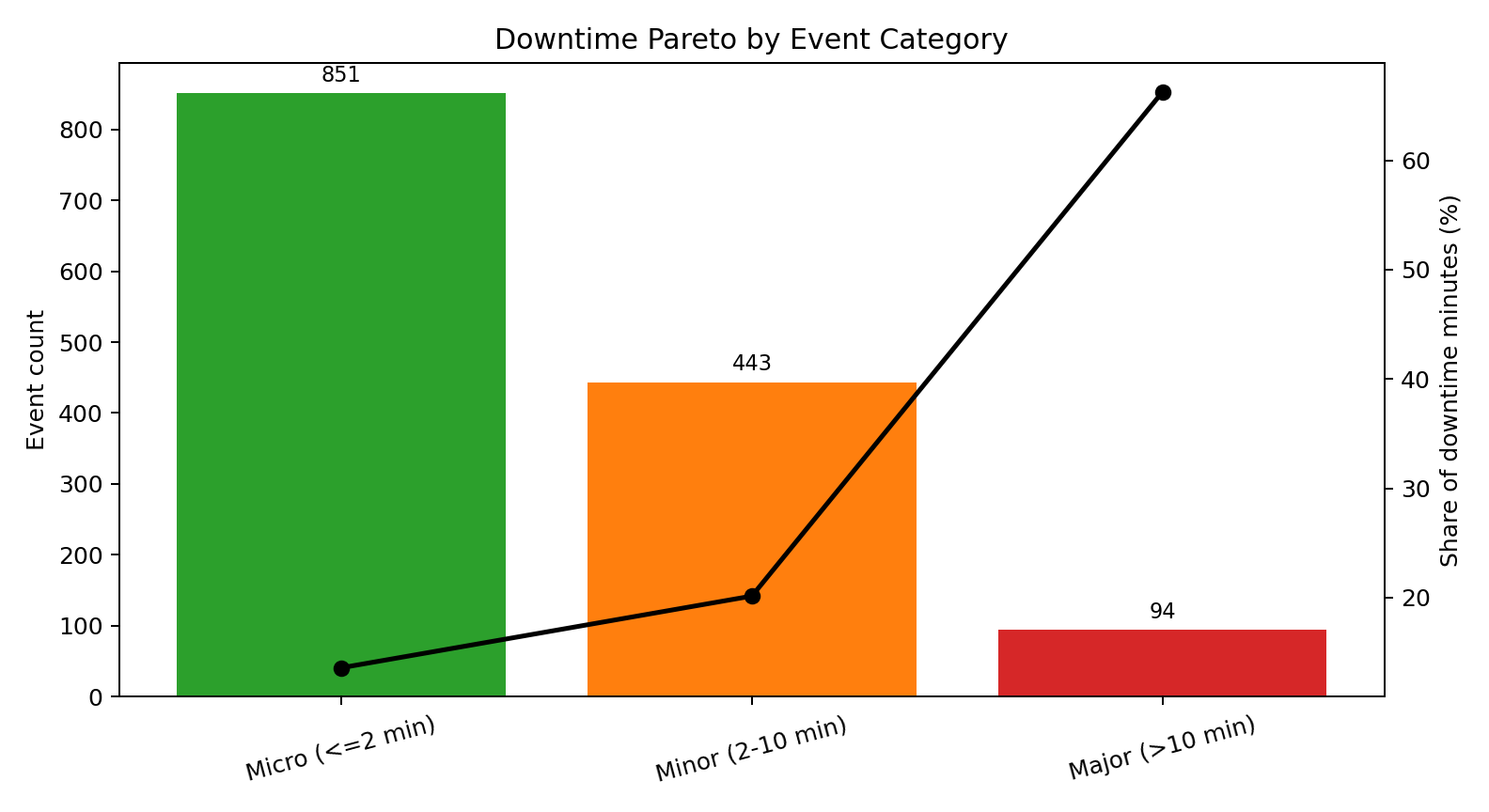
Figure 3. Downtime Pareto by event category. Major stoppages are rare but dominant in lost time.
A crucial pattern emerges once downtime is categorized. Micro-stoppages account for 61.31% of all events but only 13.59% of downtime minutes, whereas major stoppages account for just 6.77% of events yet consume 66.26% of lost time. Event frequency alone therefore cannot identify the largest productivity loss.
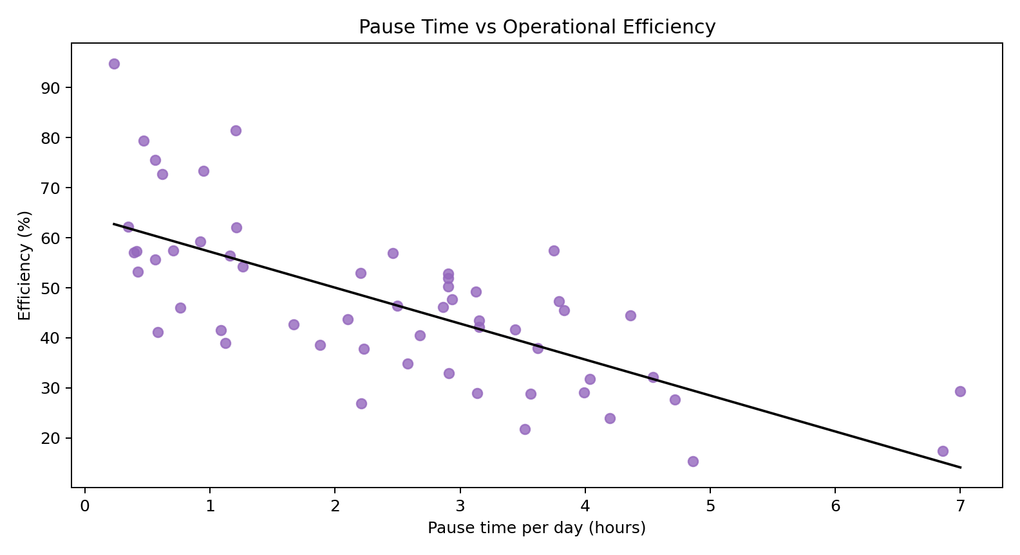
Figure 4. Daily pause time versus production efficiency. Higher pause time is associated with lower operating efficiency.
When pause time is grouped by day, it shows a strong inverse relationship with efficiency (r = -0.707). This means that as daily pause time rises, effective operating efficiency falls sharply.

Simulation Results
The simulation baseline produced 211,924.69 liters, which is very close to the real system's 212,358 liters. This indicates that the bootstrap simulation preserves actual plant behavior reasonably well and is suitable for scenario comparison.
Table 8. Simulation Results for Lean Scenarios
Scenario | Output (L) | Gain (%) | Availability (%)
Baseline | 211,924.69 | 0.00 | 42.37
5S + Visual Management | 216,866.69 | 2.33 | 43.25
TPM | 255,604.10 | 20.61 | 50.81
Integrated Lean Bundle | 280,142.22 | 32.19 | 55.33

Table 9. Waiting-Waste Reduction by Scenario
Scenario | Waiting waste (h) | Waste recovered (h) | Reduction (%)
Baseline | 137.67 | 0.00 | 0.00
5S + Visual Management | 135.57 | 2.10 | 1.52
TPM | 117.46 | 20.21 | 14.68
Integrated Lean Bundle | 106.68 | 30.99 | 22.51

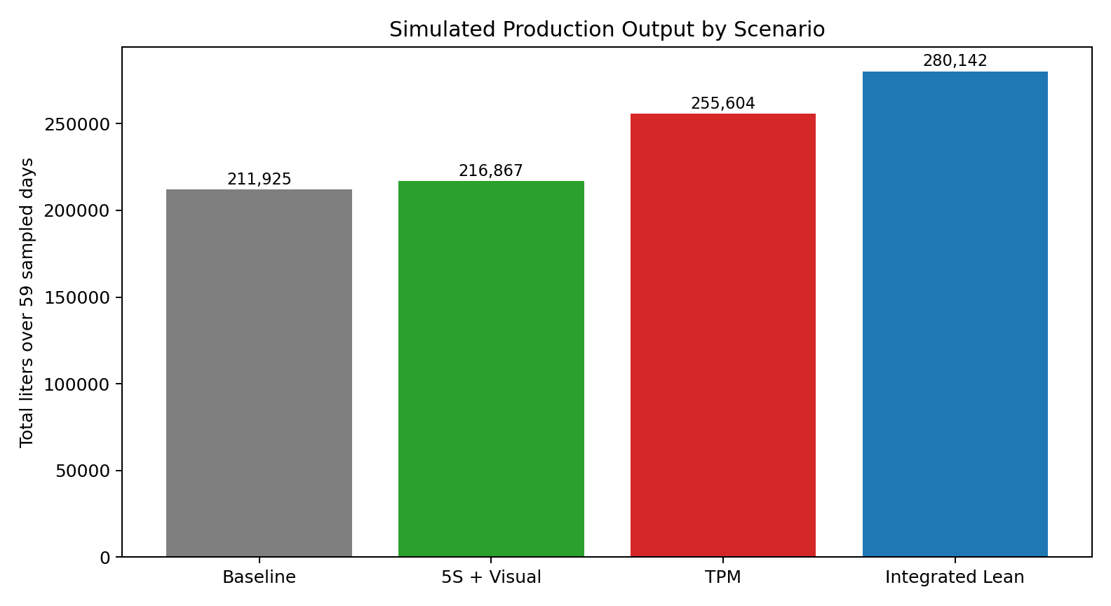
Figure 5. Simulated production output across the baseline and lean scenarios.
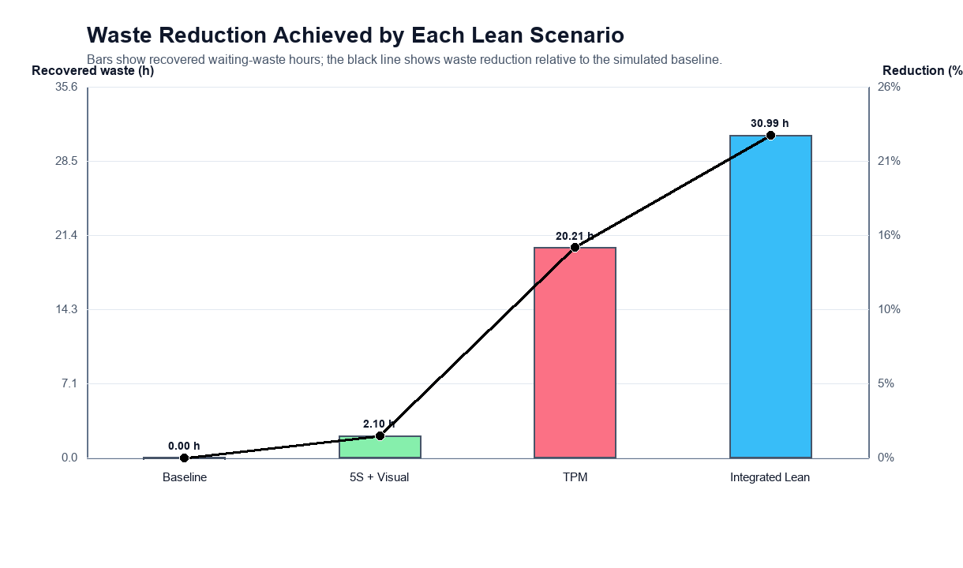
Figure 6. Waiting-waste recovery and waste-reduction percentage across lean scenarios.
The results show that 5S and visual management provide only a small gain because the scenario mainly targets micro-stoppages, which occur often but contribute relatively little to total lost time. TPM produces a much larger improvement because it directly targets major stoppages, which dominate downtime minutes. The integrated lean bundle performs best overall because it reduces waste across all three stoppage categories.

Chapter 6. Discussion and Implementation Recommendations
The findings suggest that lean implementation should be based on the structure of operational loss rather than on the visibility or frequency of events alone. In many manufacturing systems, frequent short interruptions attract attention because they are noticeable in daily work. In this bottling line, however, the largest production losses and the largest share of waiting waste are associated with major stoppages.
This is why TPM outperforms 5S in the present study. Severe stoppages are relatively rare, but they consume the majority of lost time. By focusing first on equipment reliability and breakdown recovery, the plant can recover far more productive time than by concentrating only on workplace-organization measures.

Recommended Order of Implementation
- First priority: TPM targeting long-duration stoppages through preventive maintenance planning, equipment checks, fast fault recovery, and reliability tracking.
- Second priority: 5S and visual management to reduce routine micro-disruptions, improve operator control, and standardize the workplace.
- Third priority: integrated lean bundle after maintenance discipline is established, so the plant can combine machine reliability with micro-stop reduction for higher total gains.
Table 10. Lean Implementation Roadmap
Priority | Lean focus | Expected impact
1 | TPM and maintenance discipline | Highest reduction in lost-time severity and waiting waste.
2 | 5S and visual management | Reduction in frequent micro-disruptions and better workplace control.
3 | Integrated lean bundle | Combined gains from reliability improvement and process stabilization.

Chapter 7. Conclusion, Limitations, and Future Scope
This project report shows how lean-manufacturing priorities can be selected in a beverage bottling line by using real production and downtime data. The analysis demonstrates that the line is dominated by waiting waste because more than half of monitored time is consumed without producing output. Although micro-stoppages occur most often, they are not the main source of lost production time.
The simulation confirms that the greatest improvement comes from resolving severe stoppages before focusing on the frequent but lower-impact short interruptions. For this production line, TPM is the most logical first action, while 5S and visual management become more valuable as supporting measures after major downtime is brought under better control.

Limitations
- The lean scenarios are simulated assumptions rather than observed post-implementation outcomes.
- The dataset does not include detailed cause-coded downtime labels, so the mapping from downtime category to lean tool remains implicit.
- The analysis is based on one industrial case and should not be generalized mechanically to all production systems.

Future Scope
- Collect root-cause downtime data and operator-level observations.
- Extend the study to quality loss, changeover analysis, workforce allocation, and cost-benefit evaluation.
- Validate the simulated improvement levels through real shop-floor implementation.

References
[1] I. Belekoukias, J. A. Garza-Reyes, and V. Kumar, 'The impact of lean methods and tools on the operational performance of manufacturing organisations,' International Journal of Production Research, 2014.
[2] O. Oleghe and K. Salonitis, 'Hybrid simulation modelling of the human-production process interface in lean manufacturing systems,' International Journal of Lean Six Sigma, 2019.
[3] F. Yu and Z. Chen, 'Tools, application areas and challenges of factory simulation in Small and Medium-Sized Enterprises - A Review,' Procedia CIRP, 2021.
[4] J. Possik et al., 'Lean techniques impact evaluation methodology based on a co-simulation framework for manufacturing systems,' International Journal of Computer Integrated Manufacturing, 2022.
[5] S. Frecassetti et al., 'Introducing Lean practices through simulation: A case study in an Italian SME,' Quality Management Journal, 2023.
[6] J. A. C. Bokhorst et al., 'Assessing to what extent smart manufacturing builds on lean principles,' International Journal of Production Economics, 2022.
[7] G. A. David et al., 'IoT-Driven Deep Learning for Enhanced Industrial Production Forecasting,' IEEE Internet of Things Journal, 2024.
[8] G. A. David, P. M. C. Monson, and C. Soares Junior, Industrial Production Time-Series Dataset from a Beverage Bottling Line, Zenodo, January 2026.
[9] J. M. Matindana and M. J. Shoshiwa, 'Lean manufacturing implementation in food and beverage SMEs in Tanzania,' Management System Engineering, 2025.
[10] M. Reslan et al., 'Automation of Value Stream Mapping: A Case Study on Enhancing Lean Manufacturing Tools Through Digital Twins,' Procedia CIRP, 2025.
[18] A. Belhadi et al., 'Lean production in SMEs: literature review and reflection on future challenges,' Journal of Industrial and Production Engineering, 2018.
[19] M. Dora et al., 'Operational performance and critical success factors of lean manufacturing in European food processing SMEs,' Trends in Food Science and Technology, 2013.
[20] T. Al-Hawari et al., 'Simulation-based analysis and productivity improvement of a fully automatic bottle-filling production system,' 2010 International Conference on Computer Modeling and Simulation.
[21] I. Zennaro et al., 'Micro downtime: Data collection, analysis and impact on OEE in bottling lines,' International Journal of Quality and Reliability Management, 2018.
[22] G. K. Inyiama and S. A. Oke, 'Maintenance downtime evaluation in a process bottling plant,' International Journal of Quality and Reliability Management, 2020.
[23] C. Cuggia-Jimenez et al., 'Lean manufacturing: a systematic review in the food industry,' Informacion Tecnologica, 2020.

