Simulation-Based Implementation of Lean Manufacturing Techniques
for Productivity Improvement in SMEs
A PROJECT REPORT
SUBMITTED IN PARTIAL FULFILLMENT OF THE REQUIREMENTS
FOR THE AWARD OF THE DEGREE
OF
BACHELOR OF TECHNOLOGY
IN
PRODUCTION AND INDUSTRIAL ENGINEERING
Submitted by:
Divash Krishnam
Ashutosh Verma
Raja
Under the supervision of
Dr. MOHD SHUAIB
DEPARTMENT OF PRODUCTION AND INDUSTRIAL ENGINEERING
DELHI TECHNOLOGICAL UNIVERSITY
(Formerly Delhi College of Engineering)
Bawana Road, Delhi-110042
APRIL 2026

DEPARTMENT OF PRODUCTION AND INDUSTRIAL ENGINEERING
DELHI TECHNOLOGICAL UNIVERSITY
(Formerly Delhi College of Engineering)
Bawana Road, Delhi-110042
CANDIDATE'S DECLARATION
We, Divash Krishnam, Ashutosh Verma and Raja, students of Bachelor of Technology in Production and Industrial Engineering, hereby declare that the project report titled "Simulation-Based Implementation of Lean Manufacturing Techniques for Productivity Improvement in SMEs: A Data-Driven Case Study from a Beverage Bottling Line" submitted by us to the Department of Production and Industrial Engineering, Delhi Technological University, in partial fulfillment of the requirement for the award of the Bachelor of Technology degree, is based on our own academic study of the selected industrial dataset, simulation analysis and interpretation of results. This work has not previously formed the basis for the award of any degree, diploma, fellowship or similar recognition.
Place: New Delhi
Date: 25/04/2026
Divash Krishnam
Ashutosh Verma
Raja

DEPARTMENT OF PRODUCTION AND INDUSTRIAL ENGINEERING
DELHI TECHNOLOGICAL UNIVERSITY
(Formerly Delhi College of Engineering)
Bawana Road, Delhi-110042
CERTIFICATE
I hereby certify that the project report titled "Simulation-Based Implementation of Lean Manufacturing Techniques for Productivity Improvement in SMEs: A Data-Driven Case Study from a Beverage Bottling Line" submitted by Divash Krishnam, Ashutosh Verma and Raja for fulfillment of the requirements for the award of the degree of Bachelor of Technology is a record of the project work carried out by the students under my guidance and supervision. To the best of my knowledge, this work has not been submitted in part or full for any degree or diploma to this University or elsewhere.
Place: New Delhi
Date: 25/04/2026
Dr. MOHD SHUAIB
(SUPERVISOR)
Mechanical Department
Department of Production and Industrial Engineering
Delhi Technological University

ABSTRACT
Keywords - Lean manufacturing, productivity improvement, SME manufacturing, waiting waste, downtime analysis, total productive maintenance, 5S, bootstrap simulation.
This report investigates how lean-manufacturing priorities can be selected in an SME beverage bottling line by using real production and downtime records instead of relying only on conceptual analysis. The dataset used in the study includes 59 production summaries, 265 hourly observations and 1,388 downtime events recorded between July 22, 2022 and February 6, 2023. To estimate the likely impact of lean interventions, the study applies a bootstrap-based simulation workflow and classifies downtime into micro-, minor- and major-stoppage groups.
The observed line produced 212,358 liters, but only 42.66% of monitored time was value-adding production time. The remaining 57.64% was consumed by waiting waste. Micro-stoppages accounted for 61.31% of all events but only 13.59% of downtime minutes, whereas major stoppages represented only 6.77% of events and yet consumed 66.26% of lost time. Simulation results show that 5S with visual management improves output by 2.33%, TPM improves output by 20.61%, and an integrated lean bundle improves output by 32.19% while raising simulated availability from 42.37% to 55.33%.
The main conclusion is that the most effective first action is to target the most costly stoppages rather than the most visible ones. In this case, TPM-focused intervention on major stoppages yields much greater productivity recovery than 5S alone.

ACKNOWLEDGEMENT
We express our sincere gratitude to Dr. MOHD SHUAIB, Mechanical Department, for his valuable guidance, encouragement and continuous support during the course of this work. His suggestions helped us shape the problem statement, refine the analytical approach and improve the presentation of the results.
We also acknowledge the support of the faculty members of the Department of Production and Industrial Engineering for providing an academic environment in which this project could be completed with clarity and discipline.
Finally, we thank our families and well-wishers for their motivation and encouragement throughout the preparation of this project report.
Divash Krishnam
Ashutosh Verma
Raja

Contents
Candidate's Declaration i
Certificate ii
Abstract iii
Acknowledgement iv
List of Tables vi
List of Figures vii
List of Symbols, Abbreviations and Nomenclature viii
CHAPTER 1: INTRODUCTION 1
CHAPTER 2: BACKGROUND AND LITERATURE REVIEW 2
CHAPTER 3: RESEARCH METHODOLOGY AND DATASET 3
CHAPTER 4: RESULTS AND DISCUSSION 5
CHAPTER 5: CONCLUSION 9
Appendix A 10
References 11

List of Tables
Table 3.1 : Dataset Characteristics 4
Table 4.1 : Baseline Performance Indicators 5
Table 4.2 : Downtime Category Structure 7
Table 4.3 : Simulated Scenario Outcomes 8
Table A.1 : Lean Scenario Assumptions 10

List of Figures
Figure 4.1 : Monthly Average Operational Efficiency 6
Figure 4.2 : Downtime Event Duration Distribution 6
Figure 4.3 : Downtime Pareto by Event Category 7
Figure 4.4 : Pause Time versus Operational Efficiency 7
Figure 4.5 : Simulated Production Output by Scenario 8
Figure 4.6 : Waiting-Waste Reduction by Scenario 8
Figure A.1 : Production Rate Comparison by Product Size 10

LIST OF SYMBOLS, ABBREVIATIONS AND NOMENCLATURE
A Availability of the monitored production line
T_op Operating time
T_mon Monitored time
T_dt Downtime / pause time
Q Observed output quantity
R Production rate during operating time
SME Small and Medium Enterprise
IIoT Industrial Internet of Things
TPM Total Productive Maintenance
5S Sort, Set in Order, Shine, Standardize and Sustain

Chapter 1
INTRODUCTION
1.1 Overview
Productivity loss on a bottling line is not distributed evenly across operating problems. A plant may experience many short interruptions during a shift, but a much smaller number of long stoppages can consume most of the available production time. In lean terms, that lost time appears as waiting waste because monitored time passes without generating output.
1.2 Problem Formulation
For SMEs, choosing the first improvement action is difficult because maintenance capacity, manpower and budgets are limited. If the first intervention is selected poorly, effort may be spent without recovering much productive time. The problem addressed in this report is therefore to determine which lean intervention should be given priority on the observed beverage bottling line.
1.3 Objectives
- To analyze the production behavior and downtime structure of the observed bottling-line system.
- To identify the dominant waiting-waste pattern affecting productivity.
- To simulate the effect of selected lean interventions on throughput, availability and waste reduction.
- To recommend an implementation priority for lean techniques based on the observed loss pattern.
1.4 Motivation
The study is motivated by the need to connect lean decisions to real plant data rather than to generic tool descriptions. Because the dataset contains both production output and event-level downtime records, it becomes possible to test which type of improvement recovers the most productive time in a reproducible way.

Chapter 2
BACKGROUND AND LITERATURE REVIEW
2.1 Lean Manufacturing and SME Context
Studies on lean manufacturing generally show positive links between lean practice and operational performance, but they also emphasize that SMEs face resource constraints, sequencing problems and measurement difficulties. This means lean tools should not be applied randomly; instead, they should be selected according to the most important losses in the plant.
2.2 Food and Beverage Production Context
Food and beverage lines are influenced by packaging synchronization, hygiene constraints, high line interdependence and frequent short interruptions. Research in this sector confirms the value of lean practice, but it rarely tells managers whether the first action should focus on micro-stoppages, major breakdowns or a combined improvement program.
2.3 Simulation and Downtime-Centered Studies
Simulation studies show that lean what-if analysis becomes stronger when process variability and system interaction are represented explicitly. Downtime-focused bottling studies likewise show that detailed event-level records reveal hidden inefficiencies. However, the literature still rarely combines SME relevance, beverage-line context, open event data and uncertainty-aware simulation in one workflow.
2.4 Research Gap
The key gap addressed in this report is the lack of a clear, reproducible method for converting observed stoppage patterns into a ranked lean-priority framework. This study addresses that gap by using real industrial data and bootstrap simulation to compare alternative lean actions directly.

Chapter 3
RESEARCH METHODOLOGY AND DATASET
3.1 Dataset Description
The analysis uses the Industrial Production Time-Series Dataset from a Beverage Bottling Line published on Zenodo. The dataset represents a real IIoT-monitored bottling operation and includes hourly production output records, daily production summaries, hourly operating breakdown records and individual downtime events. The monitoring period spans July 22, 2022 to February 6, 2023 and includes both 3-liter and 5-liter product sizes.
3.2 Analytical Framework
The study measures output, monitored time, operating time, pause time, availability and waiting-waste share. Downtime events are grouped into micro-stoppages (up to 2 minutes), minor stoppages (2 to 10 minutes) and major stoppages (above 10 minutes). These categories are then used to connect specific lean tools to specific loss structures.
3.3 Simulation Procedure
An event-level bootstrap simulation with 5,000 replications is used. Observed day profiles are resampled with replacement so that the variability seen in the real plant is preserved. Lean scenario rules are then applied to the sampled downtime events, and updated output, availability and waiting-waste levels are recalculated.
3.4 Scenario Design
Three scenarios are tested in the report: 5S with visual management, TPM and an integrated lean bundle. These scenario values are literature-grounded planning assumptions designed for comparison rather than guaranteed future outcomes.

Table 3.1: Dataset Characteristics
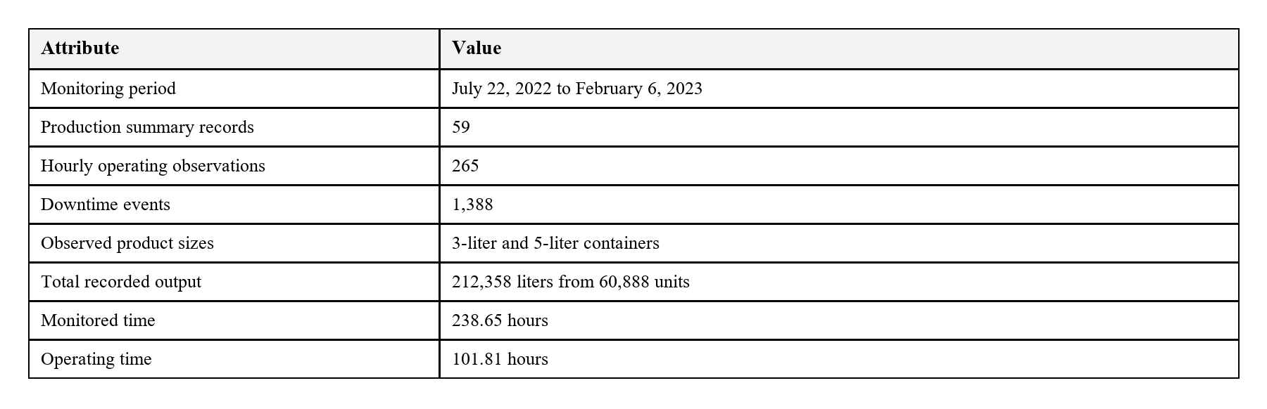
The table above shows that the dataset is rich enough for plant-level analysis because it captures both production behavior and the detailed downtime events needed for event-based simulation.
The key operational relationships used in the report are listed below:
- Availability, A = T_op / T_mon
- Downtime, T_dt = T_mon - T_op
- Production Rate, R = Q / T_op
- Scenario Output, Q' = R x (T_mon - T'_dt)
- Waiting-Waste Reduction, DeltaW(%) = ((T_dt - T'_dt) / T_dt) x 100

Chapter 4
RESULTS AND DISCUSSION
4.1 Baseline Performance
The recorded line produced 212,358 liters from 60,888 units during 238.65 monitored hours. However, effective operating time was only 101.81 hours while pause time reached 137.56 hours. This means the line operated with 42.66% availability and lost 57.64% of monitored time as waiting waste.
Table 4.1: Baseline Performance Indicators
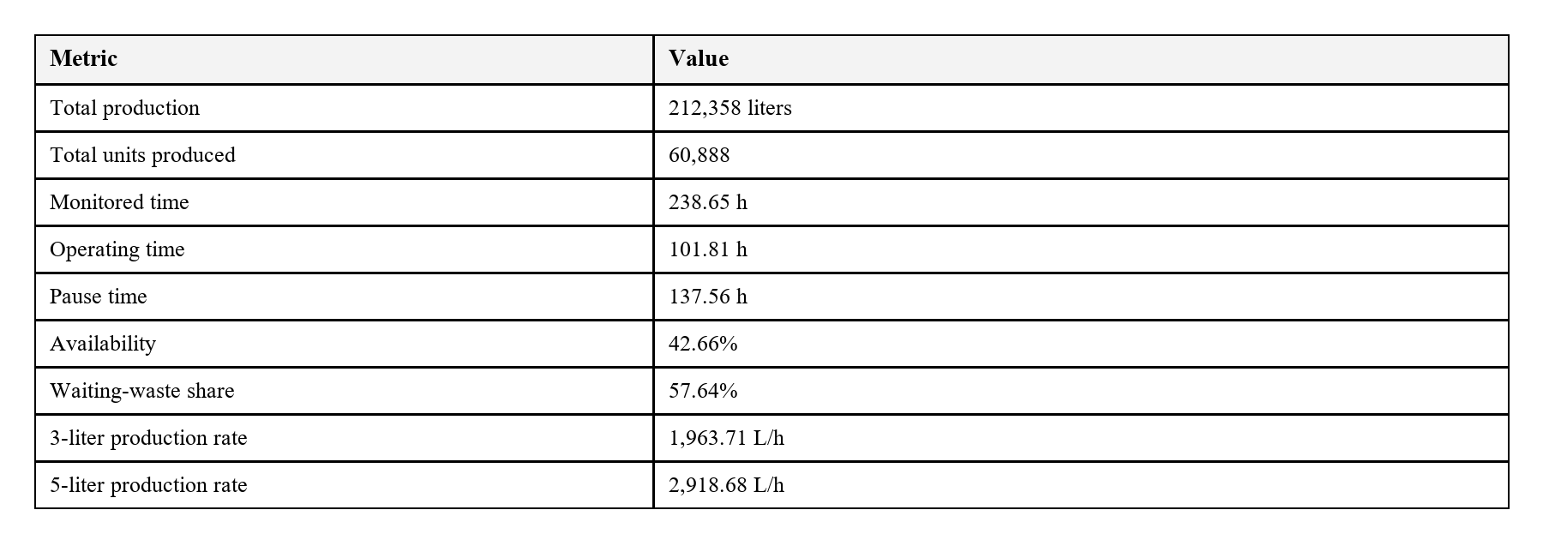

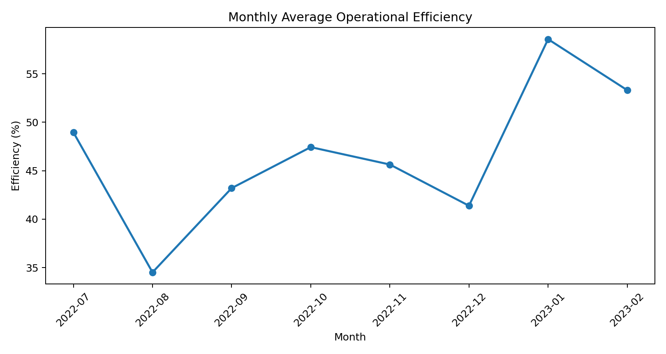
Figure 4.1: Monthly average operational efficiency across the monitored period.
Monthly efficiency varies noticeably over the monitoring window. Lower efficiency appears in August 2022 and December 2022, while January 2023 shows the strongest operational performance. This confirms that the line does not behave like a stable deterministic system.
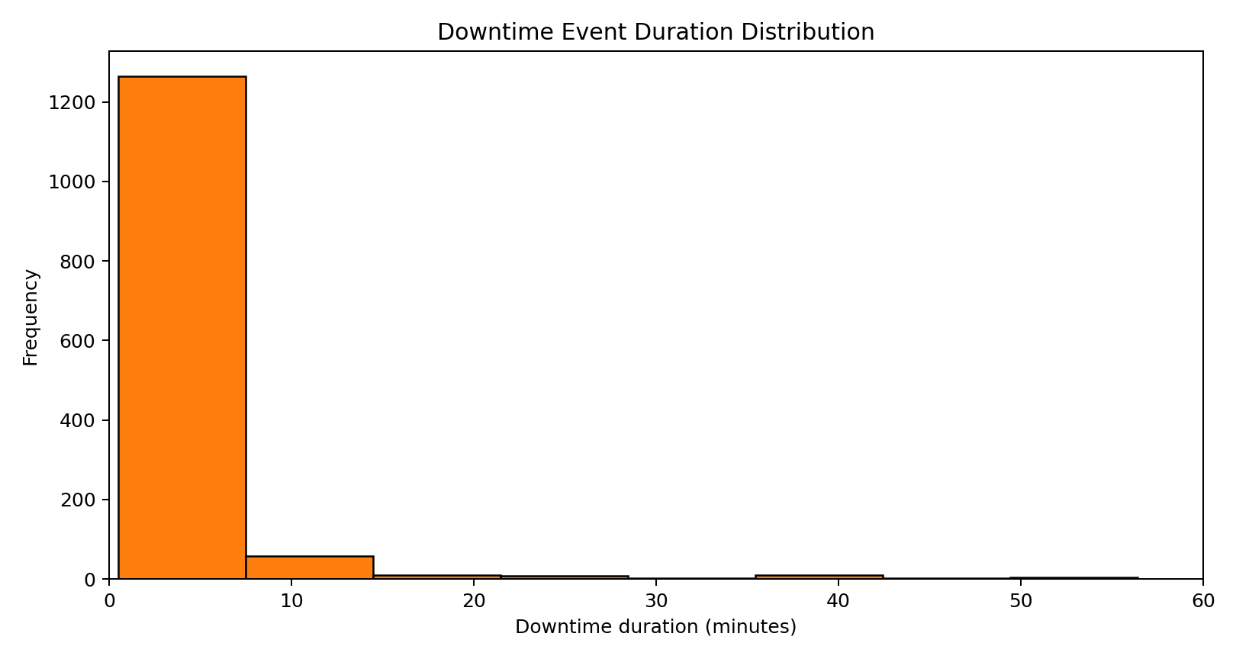
Figure 4.2: Downtime-event duration distribution.

4.2 Downtime Structure
Table 4.2: Downtime Category Structure
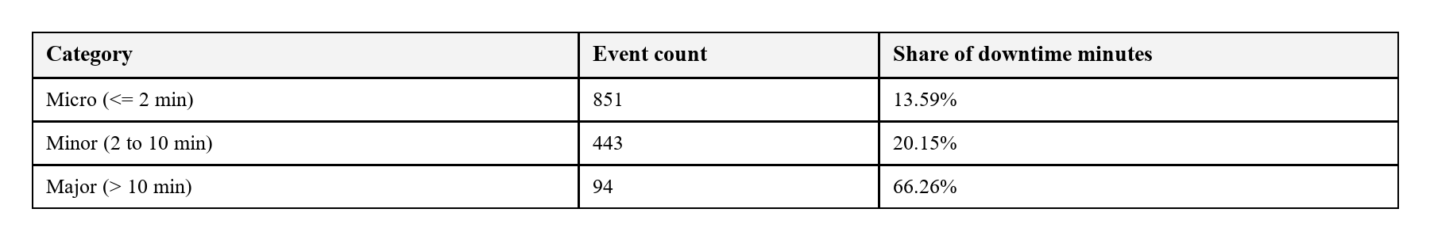
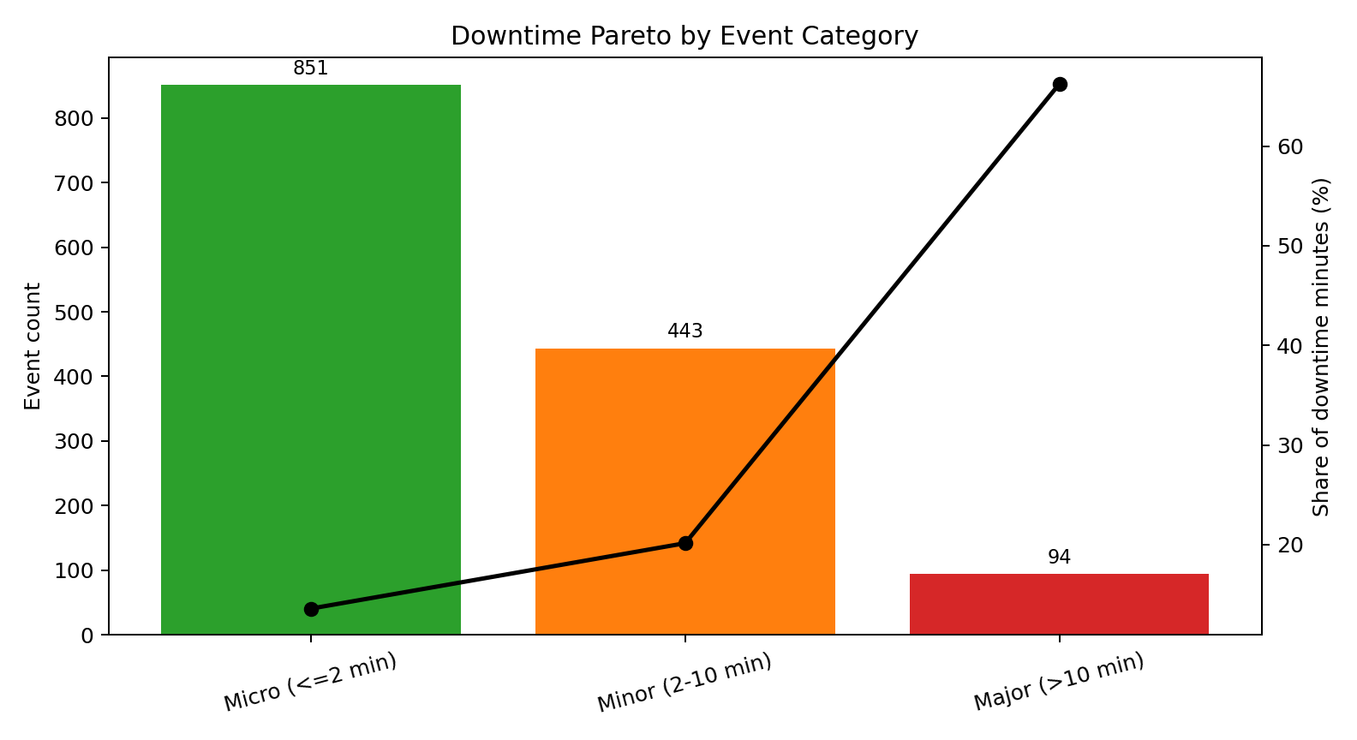
Figure 4.3: Downtime Pareto by event category.
Micro-stoppages account for 61.31% of events but only 13.59% of downtime minutes, whereas major stoppages account for just 6.77% of events and yet consume 66.26% of lost time. The key insight is that event frequency alone does not identify the most damaging loss.
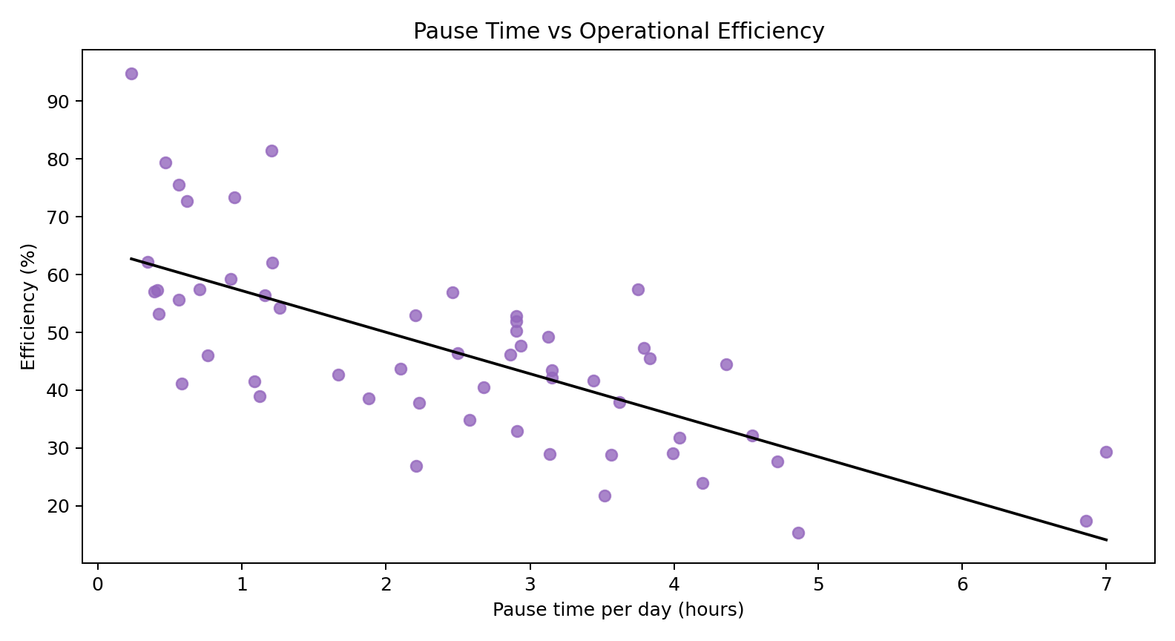
Figure 4.4: Pause time versus operational efficiency.

4.3 Simulation Results
The simulation baseline produced 211,924.69 liters, which is very close to the actual observed output. This indicates that the bootstrap model preserves real plant behavior sufficiently well for scenario comparison.
Table 4.3: Simulated Scenario Outcomes
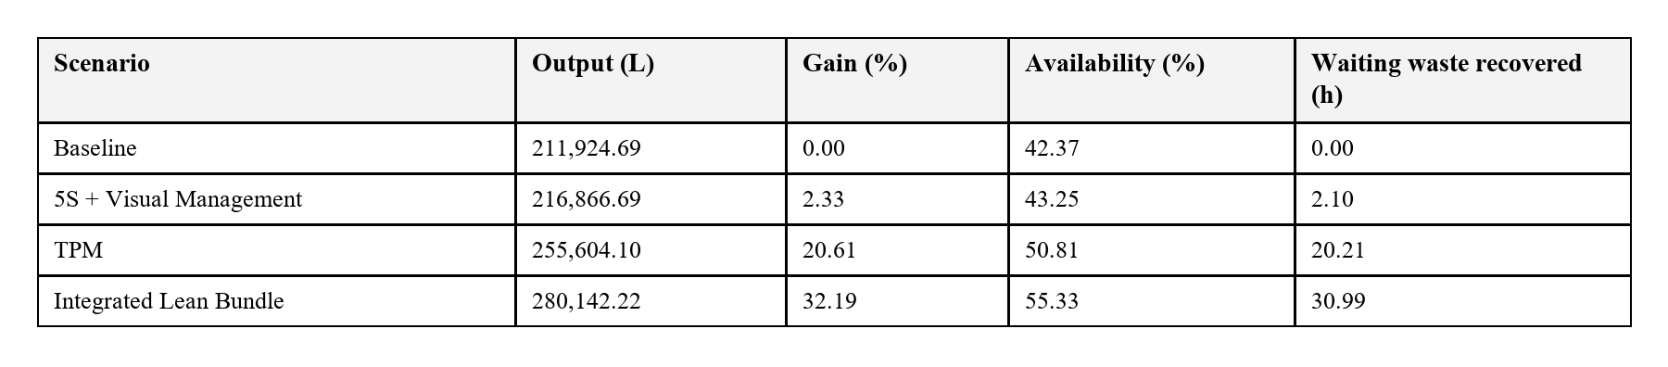
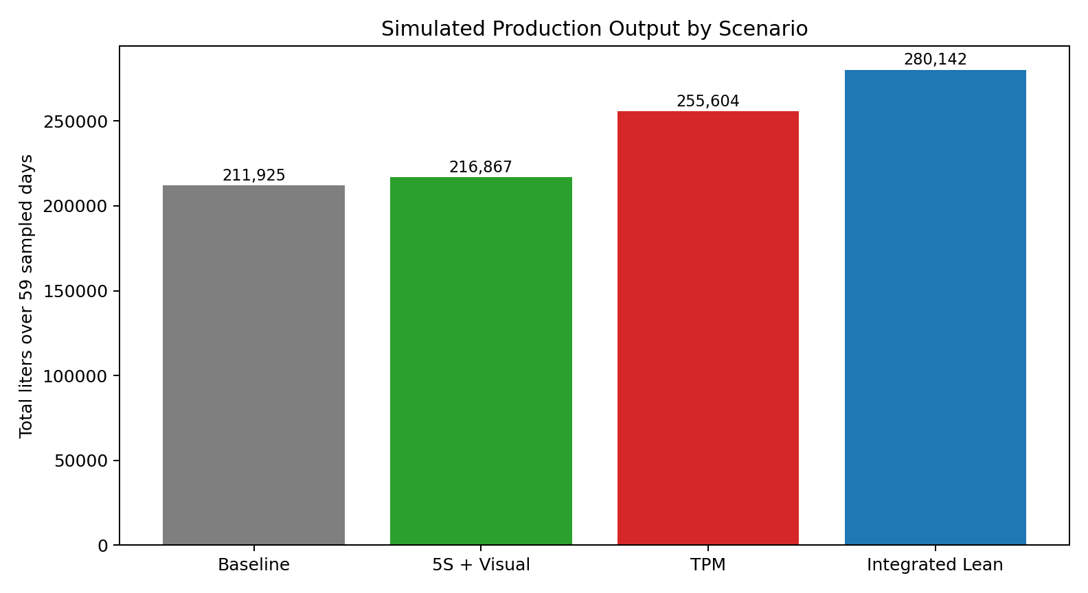
Figure 4.5: Simulated production output by scenario.
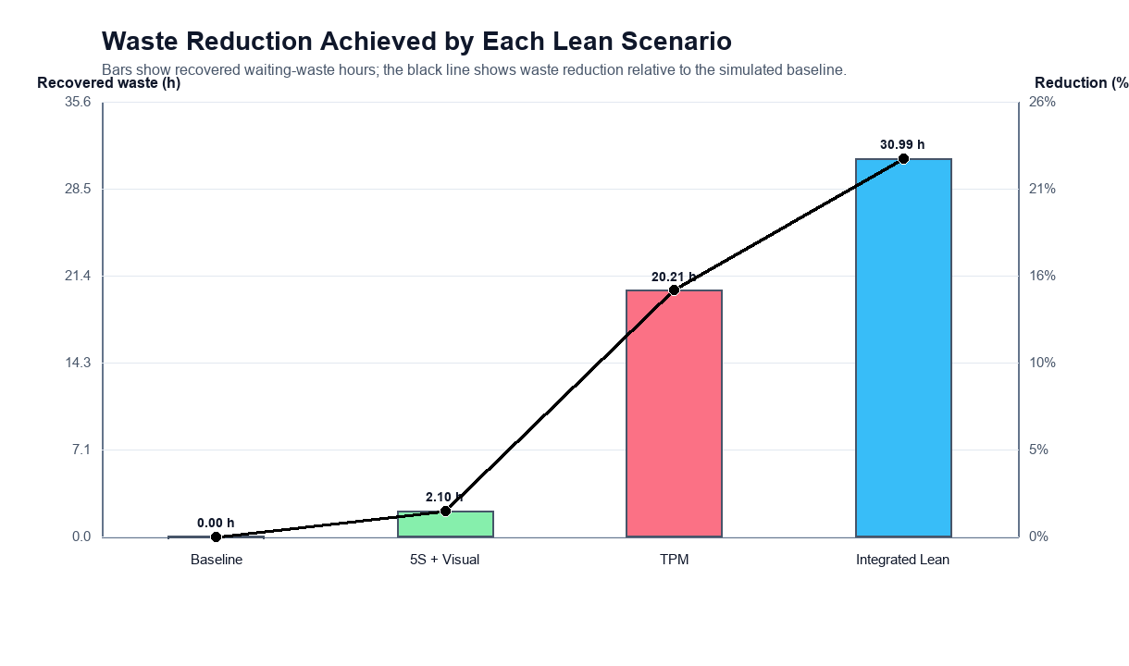
Figure 4.6: Waiting-waste reduction by scenario.
5S with visual management produces only a modest gain because it targets micro-stoppages, which are frequent but relatively low in lost-time severity. TPM yields a much larger productivity gain because it directly targets major stoppages. The integrated lean bundle performs best overall because it combines short-stop discipline with severe-stop reduction.
4.4 Implementation Recommendations
- First priority should be TPM, with emphasis on preventive maintenance, reliability tracking and rapid recovery from major stoppages.
- Second priority should be 5S and visual management to reduce routine micro-disruptions and improve workplace control.
- Third priority should be an integrated bundle after maintenance discipline is in place, so the plant can combine reliability gains with standardization benefits.

Chapter 5
CONCLUSION
5.1 Concluding Remarks
This report shows that lean priorities in a beverage bottling line can be selected more effectively when they are linked to actual production and downtime behavior. The central finding is that the greatest improvement comes from addressing the severe stoppages that consume most of the lost time rather than the highly visible micro-stoppages that occur most often.
For the observed line, TPM is the most logical first action because it directly reduces the stoppages that dominate waiting waste. 5S and visual management remain useful, but they are more effective as supporting measures after major downtime is brought under better control.
5.2 Limitations and Future Scope
- The lean scenarios are simulated planning assumptions rather than observed post-implementation outcomes.
- The dataset does not include detailed cause-coded downtime labels, so the mapping from downtime category to lean tool remains implicit.
- Future studies can extend the framework to changeover analysis, workforce allocation, quality loss and cost-benefit evaluation.

Appendix A
Table A.1: Lean Scenario Assumptions
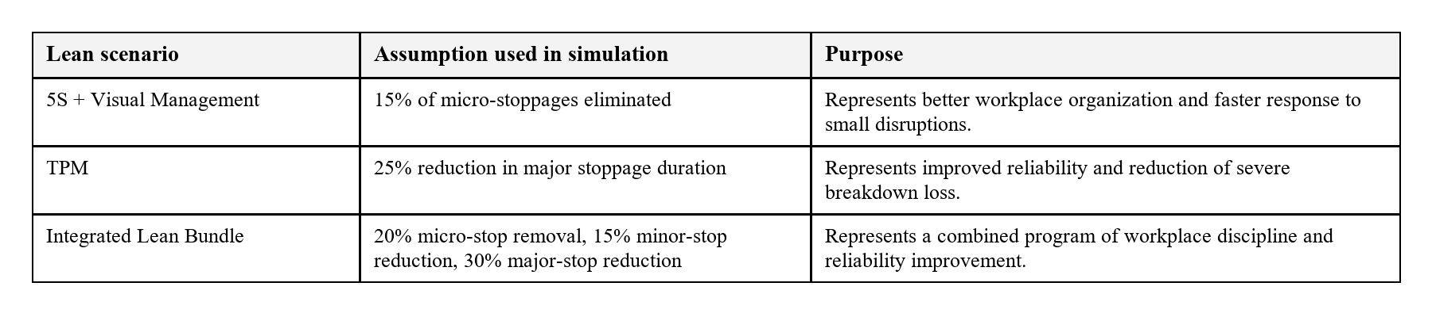
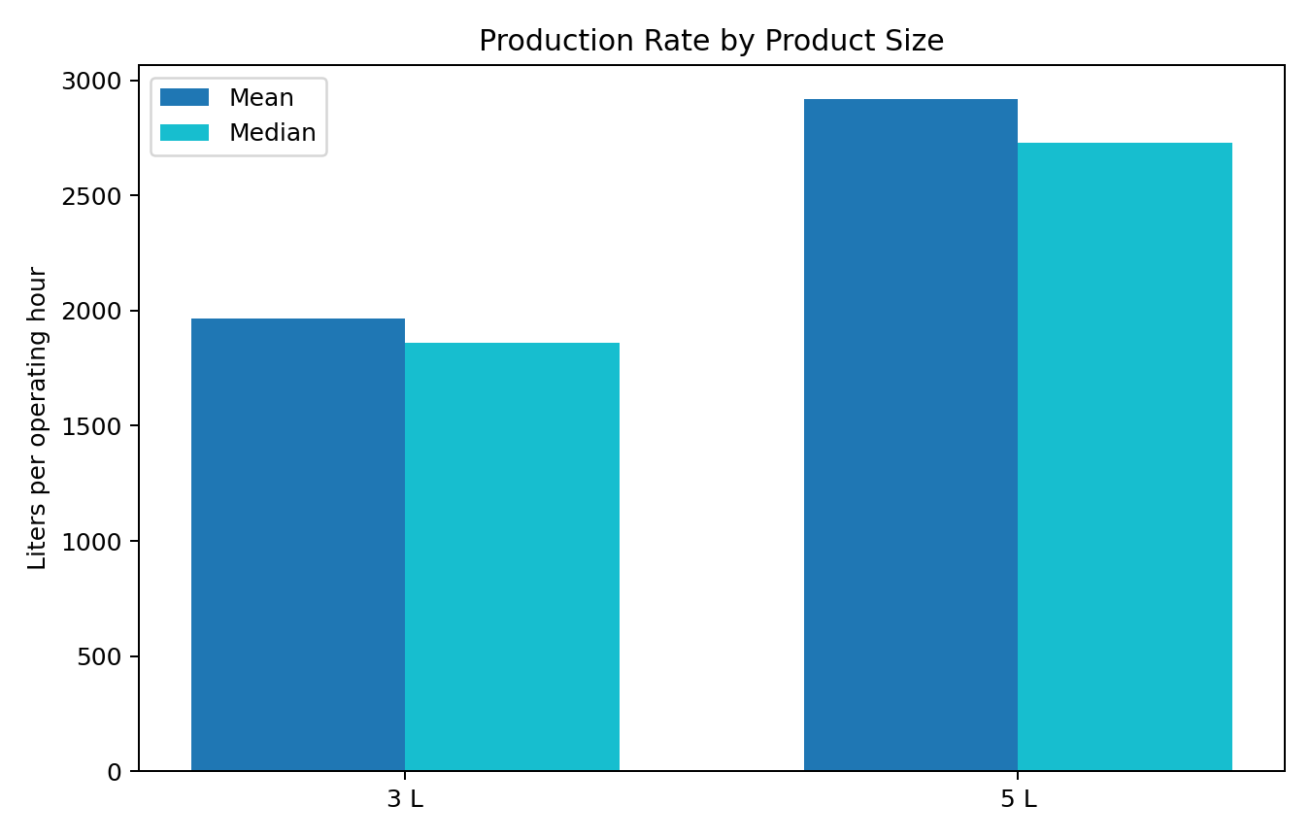
Figure A.1: Production rate comparison by product size.
The 5-liter product shows higher average and median production rates than the 3-liter product, indicating that product mix also influences line performance and may become a useful variable for future scheduling studies.

References
[1] I. Belekoukias, J. A. Garza-Reyes, and V. Kumar, International Journal of Production Research, 2014.
[2] O. Oleghe and K. Salonitis, International Journal of Lean Six Sigma, 2019.
[3] F. Yu and Z. Chen, Procedia CIRP, 2021.
[4] J. Possik et al., International Journal of Computer Integrated Manufacturing, 2022.
[5] S. Frecassetti et al., Quality Management Journal, 2023.
[6] J. A. C. Bokhorst et al., International Journal of Production Economics, 2022.
[7] G. A. David et al., IEEE Internet of Things Journal, 2024.
[8] G. A. David, P. M. C. Monson, and C. Soares Junior, Industrial Production Time-Series Dataset from a Beverage Bottling Line, Zenodo, 2026.
[9] J. M. Matindana and M. J. Shoshiwa, Management System Engineering, 2025.
[10] M. Reslan et al., Procedia CIRP, 2025.
[18] A. Belhadi et al., Journal of Industrial and Production Engineering, 2018.
[19] M. Dora et al., Trends in Food Science and Technology, 2013.
[20] T. Al-Hawari et al., 2010 International Conference on Computer Modeling and Simulation.
[21] I. Zennaro et al., International Journal of Quality and Reliability Management, 2018.
[22] G. K. Inyiama and S. A. Oke, International Journal of Quality and Reliability Management, 2020.
[23] C. Cuggia-Jimenez et al., Informacion Tecnologica, 2020.

