MIKITA BUTOUSKI

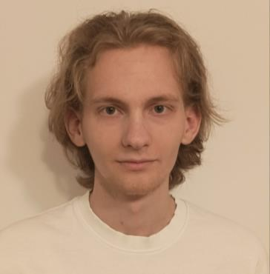

**PROFILE**

Junior Python Developer with knowledge of c# and MySQL. Student of Spolezna Akademia Nauk of Information Technologies at the Faculty “Software engeriing of Information Systems ” on the third semester of 2 year.

**CONTACT**

Telefon:

+48-572-545-817

**Junior Python Developer**

**PROGRAMMING SKILLS**

· Python syntax, c# syntax, MySQL syntax · Python OOP

· Site konstruktors , HTML , CSS · Django

· JetBrains products , VS code

**WORK EXPERIENCE**

LINKEDIN: [https://www.linkedin.com/in/mikitabut](https://www.linkedin.com/in/mikitabutouski/) [ouski/](https://www.linkedin.com/in/mikitabutouski/)

GitHub: <https://github.com/Imper4ik>

Email: [nindse@gmai.com](mailto:nindse@gmai.com)

o Optimization of work and code processes

o Creating and editing apps with HTML CSS

o Creating and editing a database

o Participated in work with Django

o Writing code for different tasks

**LANGUAGES**

**Polish B1 English B2**

**Russian and Belarusian are Native**

**ACTIVITIES AND INTERESTS**

**Сhess Traveling**

**Meeting with friends Being out in nature Football**

**Additional Skills**

**•** Medical Education

**•** Knowledge of MS Office

**EDUCATION**

**Społeczna Akademia Nauk in Warsaw**

**01.10.2021 – present**