Ministry of Education and Science of Ukraine
NTUU "Igor Sikorsky Kyiv Polytechnic Institute"
Educational and Scientific Institute of Nuclear and Thermal Energy
Department of Digital Technologies in Energy

Visualization of graphical and geometric information

Calculation and graphics work
Topic: «Operations on texture coordinates»

Variant 9

Performed:
5th year student,
the TR-01mp group
Kliuchuk V.P.
Inspected:
Docent Demchyshyn A. A.

Kyiv-2024
TASKS

The purpose of this work is to implement operations with texture coordinates, namely scaling around a point specified by the user, as indicated in the embodiment.
The first step is to extend the previous work by adding texture scaling functionality. This implies the correct integration of new functions with the already implemented texture mapping performed in the control work.
The second stage includes the implementation of the main functionality. Need to add the ability to move a point using the A and D keys to move a point along the u and W and S axes to move along the v.
At the third stage, it is necessary to prepare a report that documents all aspects of the completed task. The report should include a description of the task, theoretical foundations, implementation details, user instructions with screenshots of the program and code examples.

THEORETICAL INFORMATION

Texturing is the process of applying images (textures) to the surface of 3D objects. In WebGL, textures are used to add detail and realism to models, such as imitating wood, metal, or leather. In WebGL, textures are represented as 2D-zobrazhennya that are projected onto the surface of an object using texture coordinates.
UV coordinates are a coordinate system that determines how texture is applied to the surface of an object. They are similar to 2D-koordinati (x, y), but are called u and v to avoid confusion with the spatial coordinates x, y, z:
- U corresponds to the horizontal axis of the texture;
- V corresponds to the vertical axis of the texture.
UV coordinates are normalized, that is, u and v are usually in the range [0, 1]. For example: The point (0, 0) corresponds to the upper left corner of the texture. The point (1, 1) corresponds to the lower right corner of the texture. UV coordinates are defined for each vertex of the object, and WebGL interpolates them for all surface pixels.
There are also textures that add detail, change the perception of surfaces and allow to simulate complex materials without significantly increasing the number of polygons. Consider the main types of textures and their effects.
Diffuse Map is the base texture that defines the base color of an object's surface. It is responsible for how an object looks under standard lighting, giving it color and details such as cracks, scratches or spots. This is the basis on which the general appearance of the material is built.
Normal Map allows to create the illusion of volume and irregularities without adding new polygons. It changes the direction of surface normals, which affects lighting, and thus adds detail, for example, for fabric seams or stone textures. This greatly improves the appearance of objects with low polygonality.
Specular Map determines which parts of the surface reflect light, creating a shine effect. Thanks to this texture, metal surfaces look bright, and matte ones remain dull. This makes materials such as glass, metal or water more realistic.
Ambient Occlusion Map adds soft shadows in places where light is limited, such as in corners or between joints of surfaces. This creates depth and increases the realism of objects, making the scene more natural.
Displacement Map physically changes the geometry of the object, adding real irregularities. Unlike normal maps, the map display affects the model itself, allowing to create complex details such as the texture of mountains or brick walls that look realistic even up close.
Alpha Map is used to create transparency or cut out parts of an object. This is an ideal way to create leaves of a tree, lattice or thin details that are difficult or inefficient to model geometrically.
Metalness and Roughness Maps are an integral part of the PBR (Physically-Based Rendering) approach, which simulates realistic lighting. Metallicity determines how much the material is metallic, and coarseness determines how smooth the surface is. This allows to accurately convey the properties of materials, such as polished metal, matte plastic or rough stone.

IMPLEMENTATION DETAILS

The added changes to the implementation of textures in the project expand the functionality of the existing 3rd laboratory work. The main innovations include the ability to scale the texture, its offset in u and v coordinates, as well as interactive control of these parameters through the sliders and keyboard.
HTML has new elements for texture control. Added uOffsetSlider and vOffsetSlider sliders that allow to change texture offsets along the u and v axes. Their values are displayed in special elements <span> : uOffsetValue and vOffsetValue. A scaleSlider has also been added, which allows to scale the texture, and its value is displayed in the corresponding <span> scaleValue element.
Next, the updateSliders function was modified to support the new parameters. It reads the values of the scale, uOffset, vOffset sliders, as well as u and v. These values update global variables such as texScale, uOffset, and vOffset. The surface data is then recalculated by calling surface. BufferData (CreateSurfaceData (uData, vData, 0.06)), and the render update is performed through the draw () function. This allows to see texture changes in real time.
For more interactive texture control, the handleKeyPress function has been added. It responds to keystrokes w, s, a, and d by changing the offset values uOffset and vOffset. For example, the w and s keys increase or decrease the uOffset value, and the a and d keys change the vOffset value. Offset values are immediately displayed in the corresponding uOffsetValue and vOffsetValue elements, and the scene is updated.
getVertex has been updated to take into account new texture settings. It calculates the geometric coordinates of the vertex (x, y, z) based on the parameters u, v and scale. Texture coordinates (tU, tV) are normalized to the range [0, 1], and then modified by the offset uOffset, vOffset and scaled using texScale. Figure 1 shows the code of this function:

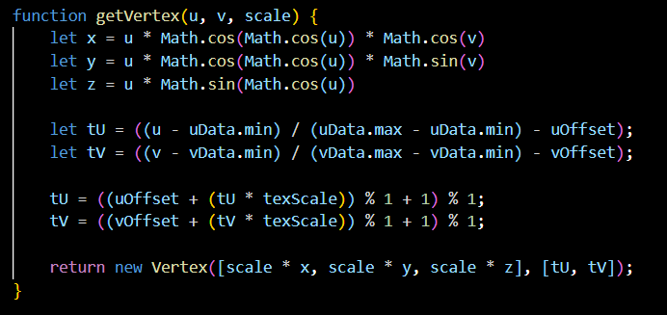
Figure 1. Point formation code

As a result of these changes, the texture has become much more interactive. We can change its scale and position in real time both through the graphical interface and using the keyboard.
USER`S INSTRUCTION

The Scale slider allows to scale the texture on an object. The scale value is displayed next to the slider bar. To change the scale, move the slider to the left to zoom out or to the right to zoom out. Texture scale changes are immediately reflected on the object.
The "U" slider allows to change the texture offset along the u axis, and the "V" slider along the v axis. Use these sliders to move the texture horizontally (u axis) or vertically (v axis). To offset the texture along the u axis, move the "U" and "V" slider to the left or the exercises. The texture offset is displayed on the object in real time. Figure 2 shows the sliders and the overall object:

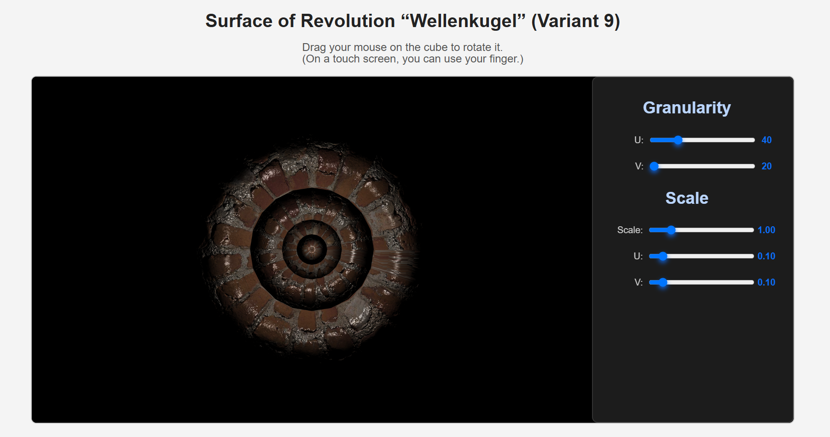
Figure 2. Object sliders

In addition to using sliders, we can also change the texture offset using the keyboard. To do this, press the corresponding keys: W to increase the texture offset along the u axis, S to reduce the texture offset along the u axis, A to reduce the texture offset along the v axis and D to increase the texture offset along the v axis. Each key press changes the texture offset to 0.01 and the new values are displayed on the screen. Figures 3 and 4 show the modified U, V and scale in Scale using keys and sliders:

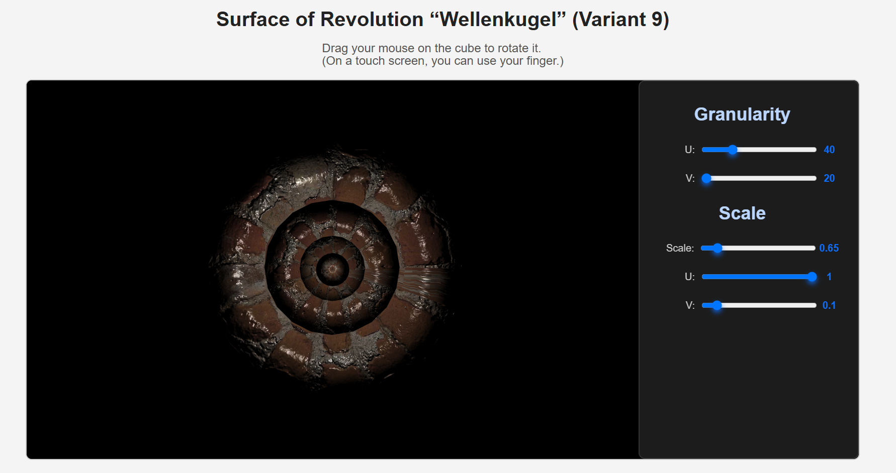
Figure 3. Changed parameter values for smaller scale

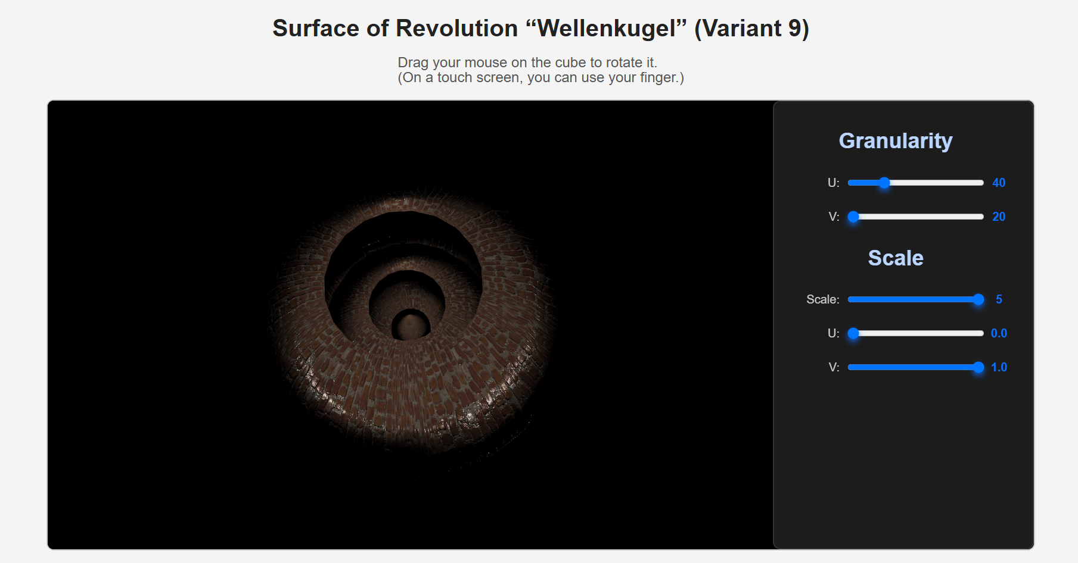
Figure 4. Changed parameter values for smaller scale

As we can see from the figures above, when change the parameters, the texture changes relative to a certain point, which is also set.
SOURCE CODE

function getVertex(u, v, scale) {
let x = u * Math.cos(Math.cos(u)) * Math.cos(v)
let y = u * Math.cos(Math.cos(u)) * Math.sin(v)
let z = u * Math.sin(Math.cos(u))

let tU = ((u - uData.min) / (uData.max - uData.min) - uOffset);
let tV = ((v - vData.min) / (vData.max - vData.min) - vOffset);

tU = ((uOffset + (tU * texScale)) % 1 + 1) % 1;
tV = ((vOffset + (tV * texScale)) % 1 + 1) % 1;

return new Vertex([scale * x, scale * y, scale * z], [tU, tV]);
}

function updateSliders() {
const uSlider = document.getElementById("uSlider");
const vSlider = document.getElementById("vSlider");
const scaleSlider = document.getElementById("scaleSlider");
const uOffsetSlider = document.getElementById("uOffsetSlider");
const vOffsetSlider = document.getElementById("vOffsetSlider");

const uValue = document.getElementById("uValue");
const vValue = document.getElementById("vValue");
const scaleValue = document.getElementById("scaleValue");
const uOffsetValue = document.getElementById("uOffsetValue");
const vOffsetValue = document.getElementById("vOffsetValue");

uValue.textContent = uSlider.value;
vValue.textContent = vSlider.value;

scaleValue.textContent = scaleSlider.value;
uOffsetValue.textContent = uOffsetSlider.value;
vOffsetValue.textContent = vOffsetSlider.value;

uData.n = parseInt(uSlider.value, 10);
vData.n = parseInt(vSlider.value, 10);

texScale = parseFloat(scaleSlider.value);
uOffset = parseFloat(uOffsetSlider.value);
vOffset = parseFloat(vOffsetSlider.value);

surface.BufferData(CreateSurfaceData(uData, vData, 0.06));
draw();
}

function handleKeyPress(event) {
console.log("Key pressed:", event.key);
const uOffsetValue = document.getElementById("uOffsetValue");
const vOffsetValue = document.getElementById("vOffsetValue");

if (event.key === 'w') {
uOffset += 0.01
} else if (event.key === 's') {
uOffset -= 0.01
} else if (event.key === 'a') {
vOffset -= 0.01
} else if (event.key === 'd') {
vOffset += 0.01;
}

uOffsetValue.textContent = uOffset.toPrecision(2);
vOffsetValue.textContent = vOffset.toPrecision(2);

surface.BufferData(CreateSurfaceData(uData, vData, 0.06));
draw();
}

<div class="option">Scale</div>
<div>
<label for="scaleSlider">Scale:</label>
<input type="range" id="scaleSlider" min="0.1" max="5.0" value="1.00" step="0.05" />
<span id="scaleValue">1.00</span>
</div>
<div>
<label for="uOffsetSlider">U:</label>
<input type="range" id="uOffsetSlider" min="0" max="1" value="0.10" step="0.01" />
<span id="uOffsetValue">0.10</span>
</div>
<div>
<label for="vOffsetSlider">V:</label>
<input type="range" id="vOffsetSlider" min="0" max="1" value="0.10" step="0.01" />
<span id="vOffsetValue">0.10</span>
</div>

