**README for Golden Gate Assembly of gRNA Expression Cassettes for CRISPR Multiplexing Protocol**

**Overview**

This Opentrons protocol automates the Golden Gate assembly of gRNA expression cassettes for CRISPR multiplexing. The protocol is designed to facilitate the generation of gRNA fragments using PCR and subsequent assembly processes as described in this [publication](https://www.ncbi.nlm.nih.gov/pmc/articles/PMC9411621/). It accommodates multiple subarrays and manages precise temperature control for enzymatic reactions.

**Author**

Hafsa Kaja Moinudeen

Xinyu Zhuang

Florence Heng

Chenhao Yang

Daimeng Yu

Zhining Zhang

**Source**

Automated protocol adapted from PMC9411621.

**Category**

Synthetic Biology

**Created and Last Modified**

* **Created At**: 2023-12-08
* **Last Modified**: 2023-12-10

**Protocol Steps**

1. **gRNA Fragment Generation:** This stage employs PCR to generate up to 24 gRNA fragments, encompassing both activation and repression types. Key steps include:
   * Addition of master mixes tailored for activation and repression gRNAs, with separate cycling for each.
   * A pause point post-PCR allows the user to purify the generated gRNA fragments through gel electrophoresis.
2. **Golden Gate Assembly:** After PCR and the generation of double-stranded gRNA fragments, the protocol facilitates the Golden Gate assembly. This process is crucial for incorporating these fragments into a subarray vector, applicable when working with more than six gRNAs.
   * This is followed by a pause in the protocol for transforming the assembled vectors into E. coli, followed by amplification and harvesting.
3. **Final Assembly:** All subarrays are combined for insertion into the CRISPRai vector. This is achieved through another round of Golden Gate assembly.
4. **Pause Points:** Throughout the protocol, there are designated pauses for essential manual interventions. These include PCR purification, transformation of vectors into E. coli, and colony picking.

**Equipment and Labware**

**Pipettes**: Single-channel P20 pipette

**Labware**: 96-well plates, tip racks, thermal cycler module, temperature module, aluminium block

**Modules**: Opentrons Thermocycler Module V2, Temperature Module Gen2

**Instructions for Use**

1. **Preparation**: Ensure all master mixes are prepared and placed in the specified wells of the aluminium block. They can be loaded on in sequence as needed.
   * Activation (dCas12a-VP) gRNA fragment PCRmaster mix– A6
   * Repression (dCas9-Mxi1) gRNA fragment PCR master mix – B6
   * Subarray plasmids 1 to 4 master mixes – C1 – C4
   * CRISPRai vector master mix – D6

Below is an image showing the organisation of the source plate that is expected by opentron at the beginning of the protocol and after every pause step.

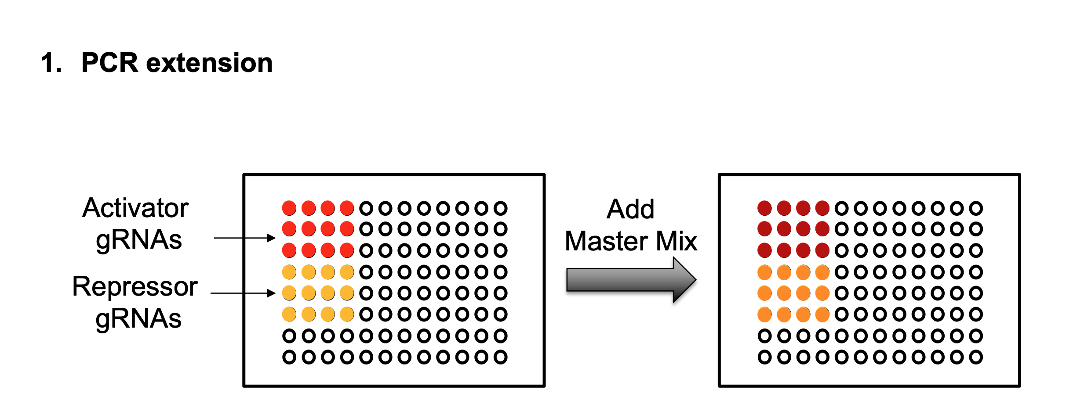

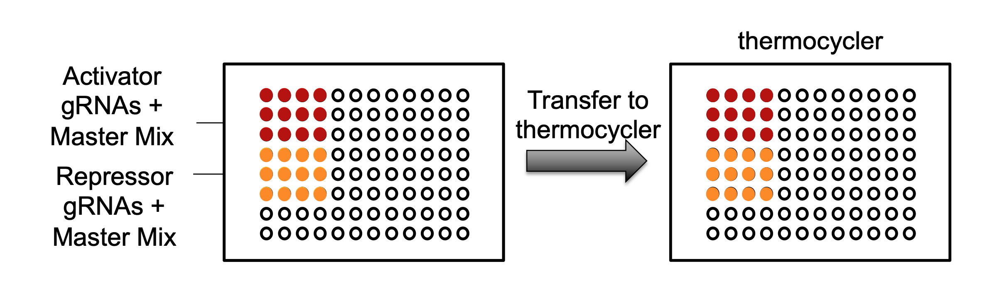

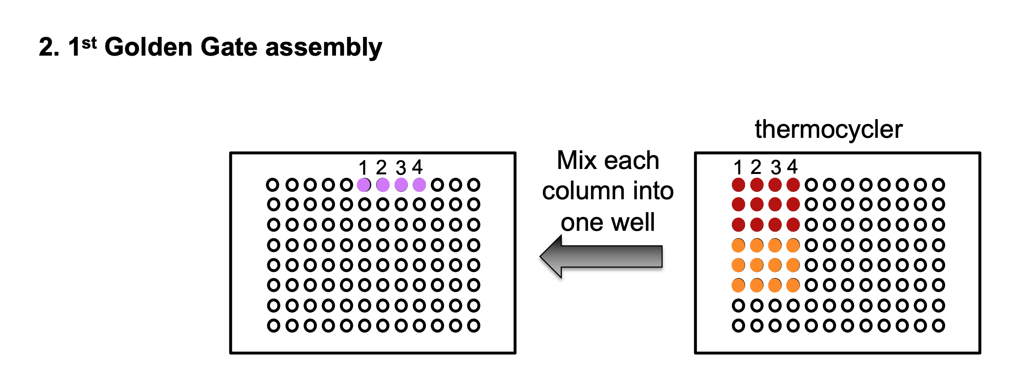

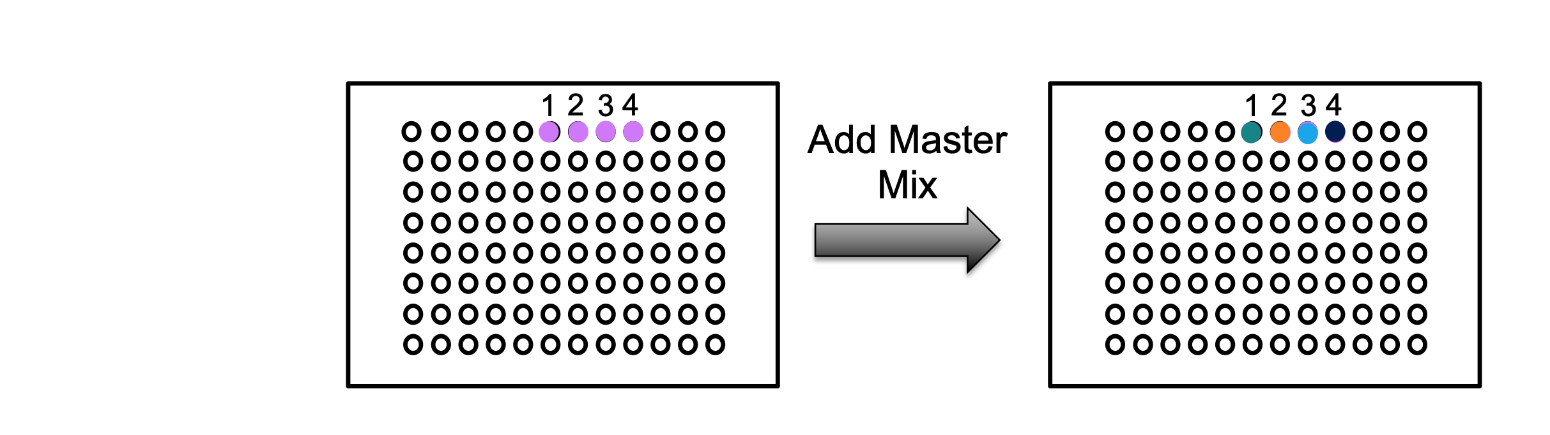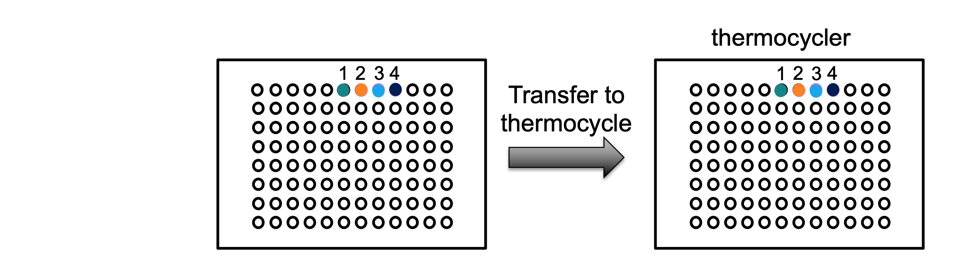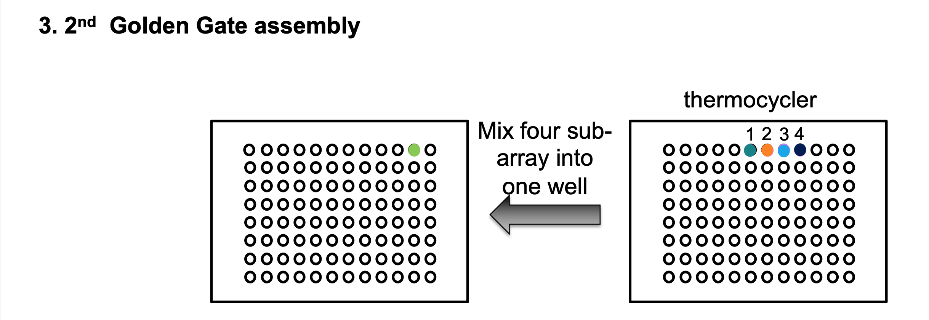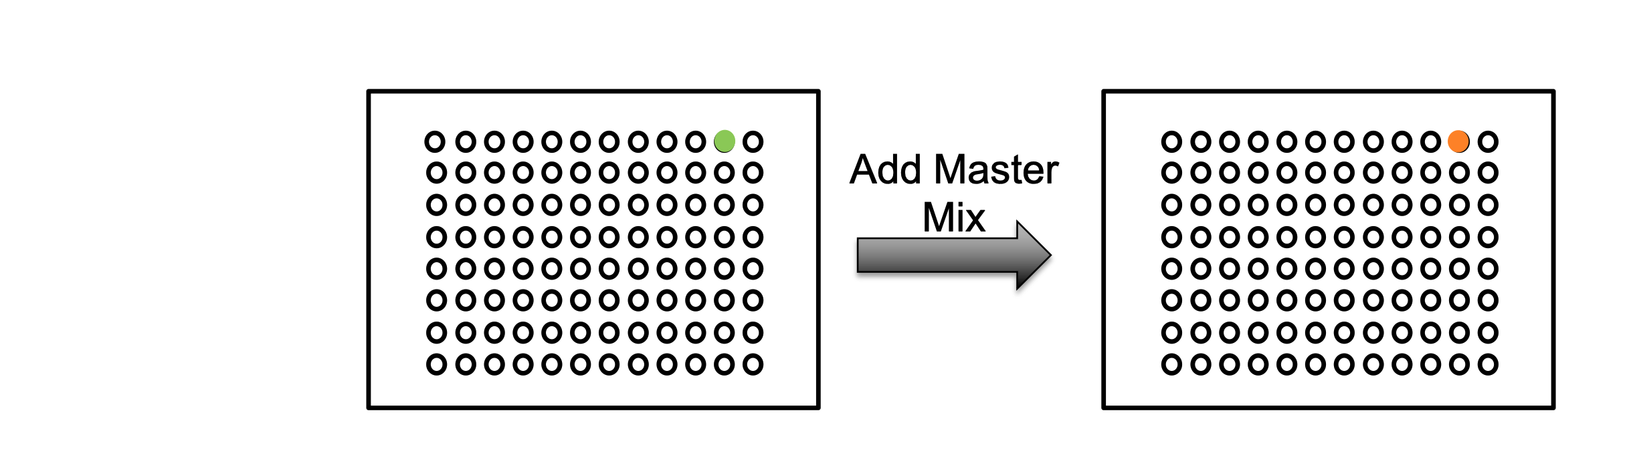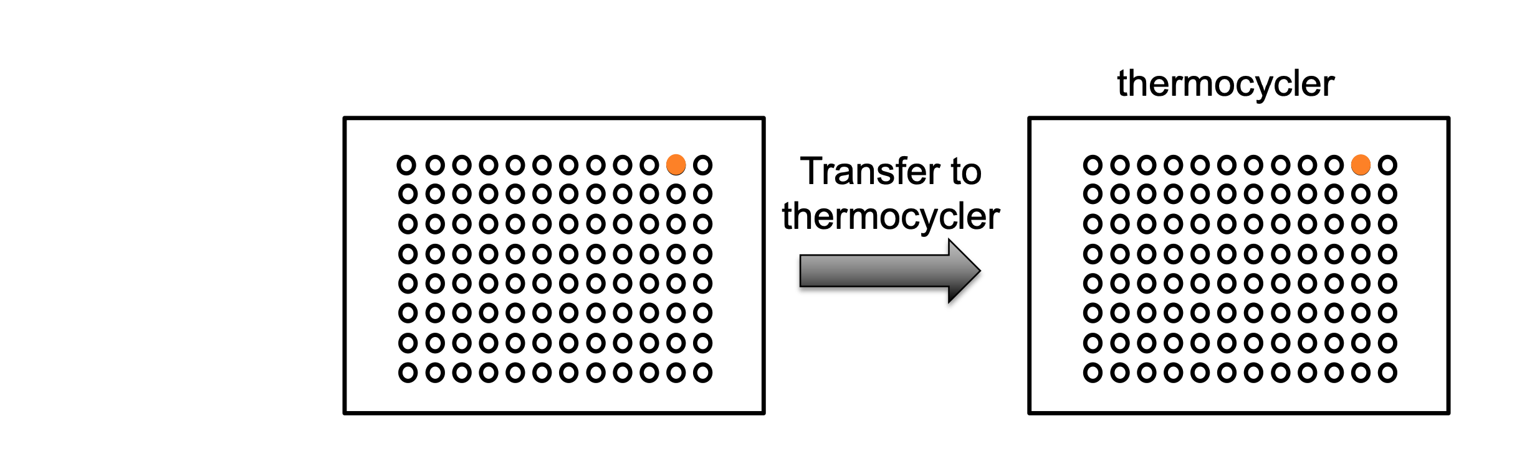

1. **Initialization**: Modify the following variables as required in the script and load the protocol onto your Opentrons OT-2 robot.

**Customization**

* + 1. Modify the num_of_arrays variable to reflect the number of subarrays being processed.
    2. **Configuring gRNA Wells**: Modify the **activation_gRNA_wells** and **repression_gRNA_wells** variables according to your experiment's layout. These variables should be strings consisting of well identifiers (A-H) where the respective gRNAs are located. You can include any number of well identifiers in these strings, in any sequence. Ensure that the order of these identifiers is consistent across all four columns for accurate pipetting.

1. **Execution**: Start the protocol. Manually intervene at pause points as required.