**MA 374 Lab 03**

Deepak Kumar Gouda | 160123054

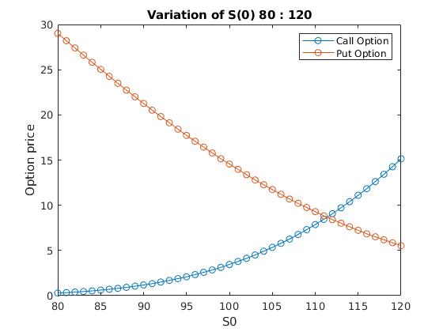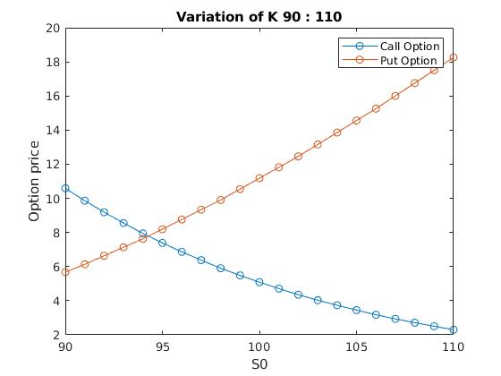1) American Option Pricing

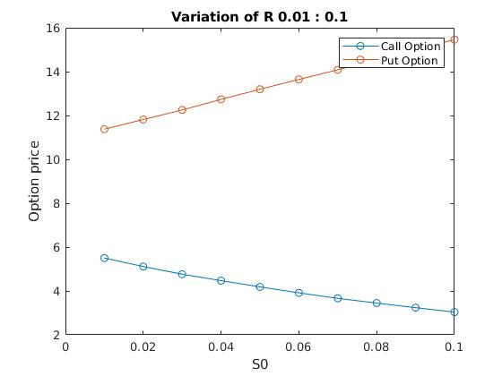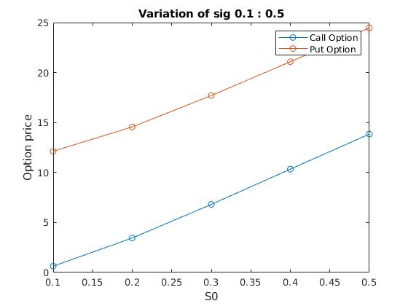

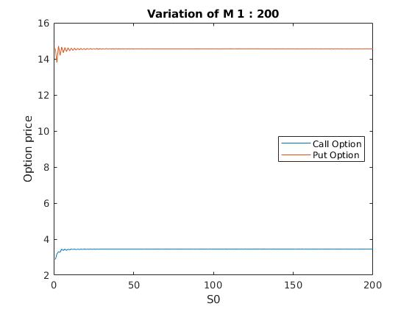

The call option converges to 14.56 and Put converges to 3.45.

2. Binomial Option Pricing method

Option prices tabulation for M = 5

1: 9.12

2: 9.50 9.02

3: 12.17 7.14 9.80 8.54

4: 17.58 7.14 8.32 6.20 13.71 6.20 9.95 7.41

5: 25.05 10.68 10.68 3.84 13.07 3.84 8.00 4.60 21.18 6.68 8.00 4.60 15.63 4.60 9.57 5.50

6: 32.10 18.80 18.80 2.90 18.80 2.90 7.81 0 21.23 5.33 7.81 0 16.26 0 9.34 0 29.48 13.57 13.57 0 16.26 0 9.34 0 25.39 6.37 9.34 0 19.45 0 11.18 0

3. Efficient Lookback Option Pricing method

|  |  |  |
| --- | --- | --- |
| Method | Computation time (in sec) | Max M |
| Binomial | 0.95 – 1.51 | 27 |
| Markov | 0.03 – 0.05 | > 50 |

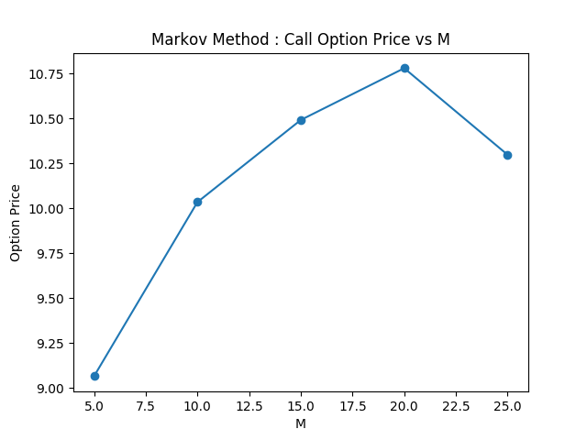.F Fig. 3 : Markov Method

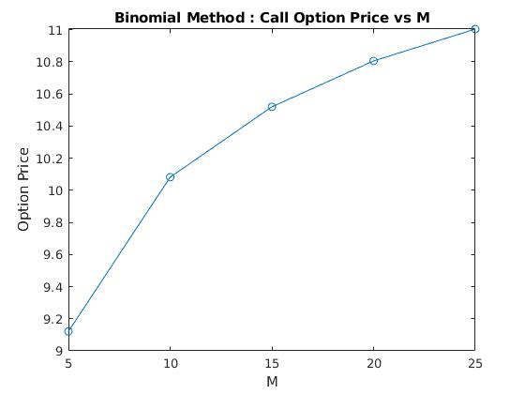  
Fig 2 : Binomial method