CO2BLOCK 储层容量与资源分配代码解析文档
Bilingual Technical Notes on the Uploaded MATLAB Packages
Reviewed files / 审阅文件 | `code7 - regional-opt 1.zip` and `Algorithm2_with modified last allocation step.zip`
Purpose / 目的 | Provide a bilingual function map, data-flow map, and a practical technical guide to inputs, outputs, logic, constraints, and implementation risks.
Prepared for / 面向对象 | Xiaowei Gao
Prepared from / 依据 | Direct inspection of the uploaded MATLAB code, Excel inputs, and MAT workspaces.

1. 执行摘要 / Executive Summary
这两套代码共享同一套盆地级物理求解核心：`read_data.m → eos.m (conditional) → calculate.m → Nordbotten_solution.m → FD_Nor.m`。
Both packages share the same basin-level physical solver core: `read_data.m → eos.m (conditional) → calculate.m → Nordbotten_solution.m → FD_Nor.m`.
第一套代码面向单次注入期下的盆地级容量评估：它对每个盆地扫描“井数 × 井距”情景，选出最大容量方案，并附带理论容量与 closed tank 容量。
Package 1 is built for basin-level capacity assessment at one chosen injection duration: it scans “number of wells × inter-well spacing” scenarios for each basin, selects the maximum-capacity scenario, and also reports theoretical and closed-tank capacities.
第二套代码先构建一个 basin × storage period 的资源矩阵，再把这个矩阵分配到一个外部增长需求曲线上。
Package 2 first builds a basin × storage-period resource matrix and then allocates that matrix to an external growth-demand trajectory.
第二套代码不是严格的全局优化器，而是顺序敏感的启发式/贪心分配器；因此 ascend、descend、random 三种排序都会影响结果。
Package 2 is not a strict global optimizer; it is an order-sensitive heuristic/greedy allocator, so the ascend, descend, and random orderings all affect the result.
“modified last allocation step” 的作用是：当最后一个 basin 会把累计速率推过峰值时，重新运行该 basin 的情景扫描，并选取满足剩余速率与体积需求的最少井数方案。
The “modified last allocation step” works as follows: when the last basin would push the cumulative rate beyond the peak demand, the code re-runs the scenario sweep for that basin and selects the minimum-number-of-sites solution that still satisfies the remaining rate and volume.

2. 函数关系图 / Function Relationship Map
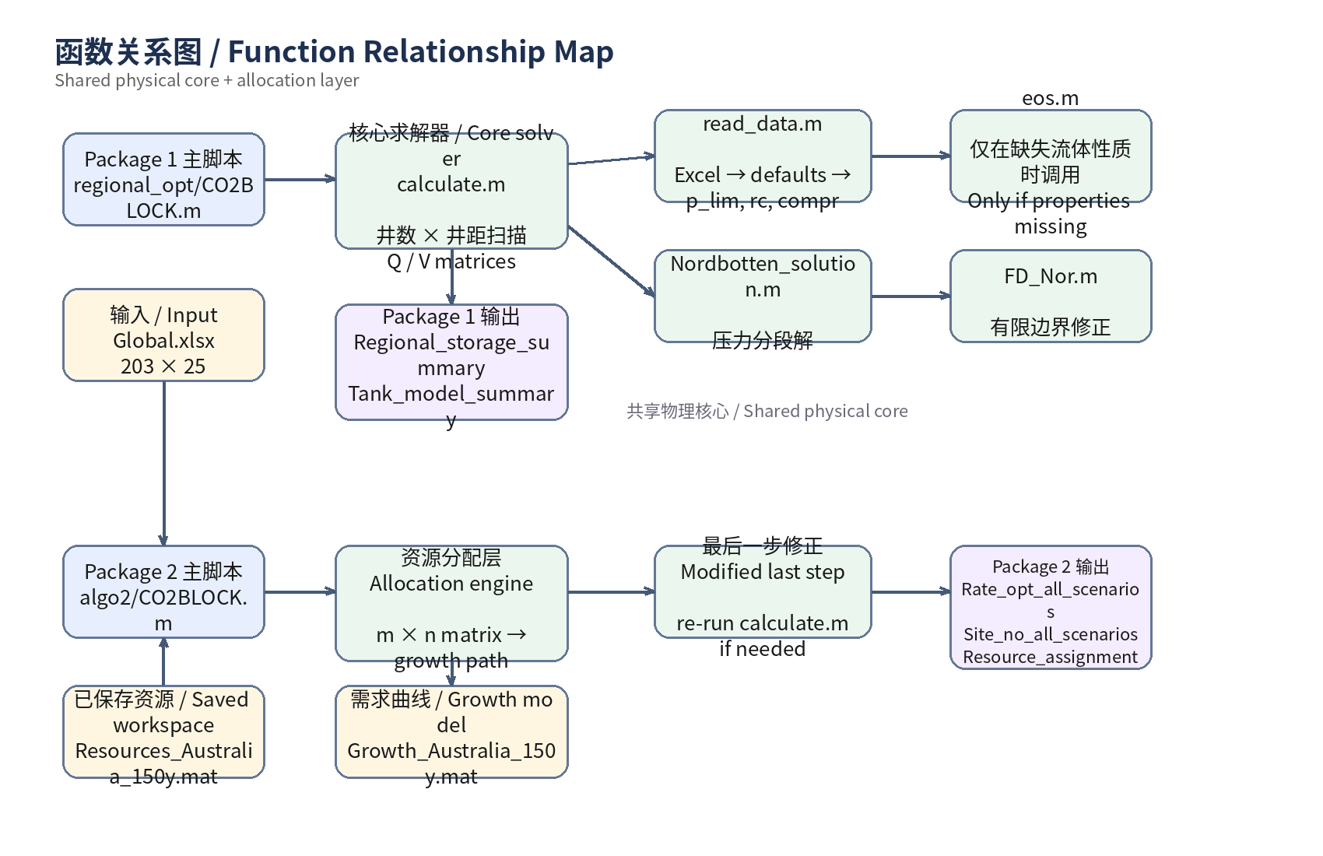
图 1. 两套代码的函数依赖结构。第二套代码在共享物理核心之上增加 allocation 层。 / Figure 1. Functional dependencies of the two packages. Package 2 adds an allocation layer on top of the shared physical core.

3. 数据流图 / Data Flow Map
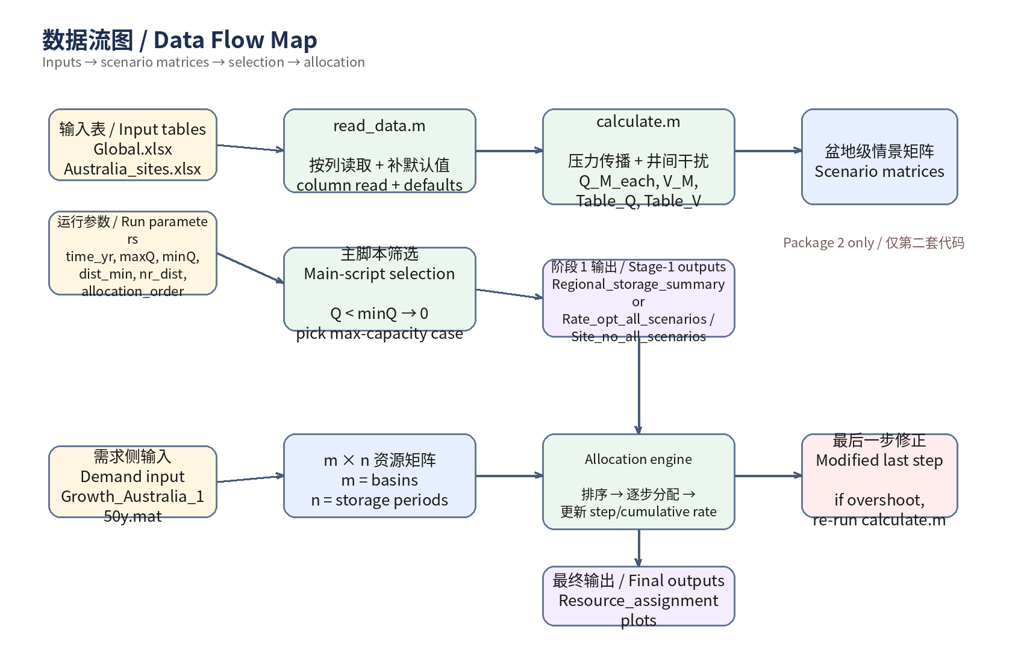
图 2. 从输入表格与参数，到情景矩阵、摘要表和资源分配结果的数据流。 / Figure 2. Data flow from input tables and run parameters to scenario matrices, summary tables, and allocation outputs.

4. 两套代码的功能分工 / Division of Labor Between the Two Packages
项目  Item | Package 1  regional-opt | Package 2  Algorithm2 | 解释 / Explanation
Primary goal / 主要目标 | Evaluate basin capacity at a single chosen injection duration | Build a basin × duration resource matrix and allocate it to a growth path | 第一套偏盆地级容量评估；第二套偏系统级路径匹配。 / Package 1 is basin-centric; Package 2 is system-path-centric.
Main input / 主要输入 | Global.xlsx (203×25) | Australia_sites.xlsx (11×27), Growth_Australia_150y.mat, optional Resources_Australia_150y.mat | 第二套可以跳过重算并直接读保存好的 workspace。 / Package 2 can skip recomputation by loading a saved workspace.
Main outputs / 主要输出 | Tank_model_summary, Regional_storage_summary, plots | Rate_opt_all_scenarios, Site_no_all_scenarios, Resource_assignment, plots | 第二套把第一阶段的盆地资源结果继续用于分配。 / Package 2 uses basin-resource results as inputs to allocation.

5. 核心模块逐文件说明 / File-by-File Core Module Notes
File | Role / 角色 | What it does / 做什么 | Notes / 备注
CO2BLOCK.m | 主脚本 / Main script | 控制运行参数、逐盆地调用 calculate、筛选最优情景，并写出摘要表与图件。第二套脚本还负责 allocation。  Controls run parameters, calls calculate basin by basin, selects the optimum scenario, and writes summary tables and figures. In Package 2 it also performs allocation. | 高度脚本化，含较多 hard-coded 文件名、年份和绘图细节。  Highly script-like, with many hard-coded filenames, years, and plotting details.
calculate.m | 核心求解器 / Core solver | 输入单个 basin 与一组运行参数，枚举井数 × 井距情景，基于压力约束计算每井注入率与总容量矩阵。  Takes one basin and a set of run parameters, enumerates well-count × spacing scenarios, and computes the per-well rate and total-capacity matrices under pressure constraints. | 整个代码的物理与几何计算中心。  The physical and geometric heart of the codebase.
read_data.m | 输入解析器 / Input parser | 从 Excel 按列位置读取 basin 参数；填补默认值；求解 p_lim、rc、compr、gamma、delta、omega。  Reads basin parameters from Excel by fixed column position; fills defaults; computes p_lim, rc, compr, gamma, delta, and omega. | 最重要的工程风险之一：依赖列位置而非列名。  One of the main engineering risks: column-position dependence.
eos.m | 流体性质补算 / Fluid-property helper | 当 CO₂ 密度、CO₂ 黏度或盐水黏度缺失时，按经验/状态方程补算。  Back-fills CO₂ density, CO₂ viscosity, and brine viscosity when missing. | 依赖 Symbolic Math Toolbox 求 CO₂ 密度。  Depends on Symbolic Math Toolbox for CO₂ density.
Nordbotten_solution.m | 压力分段解 / Piecewise pressure solution | 根据井距、羽状体尺度、影响半径和边界半径返回无量纲超压解。  Returns the dimensionless overpressure solution using distance, plume scale, radius of influence, and boundary radius. | 被 calculate.m 在每口井上重复调用。  Called repeatedly inside calculate.m for each well.
FD_Nor.m | 有限边界修正 / Finite-domain correction | 处理开放/有限边界下的外部积分项。  Handles the outer-domain term for open/finite boundaries. | 是 Nordbotten_solution.m 的下层依赖。  A lower-level dependency of Nordbotten_solution.m.

6. 输入、输出与数据结构 / Inputs, Outputs, and Data Structures
已直接核对的文件结构如下。
The inspected file structures are as follows.
File / 文件 | Observed shape / 尺寸 | Used by / 使用位置 | Meaning / 含义
Global.xlsx | 203 × 25 | Package 1 | 全球盆地输入表；read_data.m 按固定列位置读取。 / Global basin input table read by fixed column position.
Australia_sites.xlsx | 11 × 27 | Package 2 | 澳洲盆地输入表；前 25 列与 read_data.m 兼容，额外列未被核心读取。 / Australian basin input table; the first 25 columns align with read_data.m, extra columns are not consumed by the core reader.
Growth_Australia_150y.mat | 150 × 2 | Package 2 | 增长模型：第 1 列年份，第 2 列目标注入率。 / Growth model: column 1 year, column 2 target injection rate.
Resources_Australia_150y.mat | workspace MAT | Package 2 | 保存好的资源工作区，包含 Rate_opt_all_scenarios, Site_no_all_scenarios, Q_M_each, V_M 等变量。 / Saved workspace with Rate_opt_all_scenarios, Site_no_all_scenarios, Q_M_each, V_M, and related variables.
• `Rate_opt_all_scenarios`: 11 × 17 object array，其中前两列是 basin 编号与名称，后 15 列对应 10, 20, …, 150 年下注入率。 / first two columns are basin ID and name; the remaining 15 columns are rates for 10, 20, …, 150 years.
• `Site_no_all_scenarios`: 11 × 17 object array，结构与上面相同，但后 15 列记录达到该速率所需井数。 / same layout, but the last 15 columns store the number of injection sites required.
• `Q_M_each` and `V_M`: 221 × 100 numerical arrays，表示某一次 basin/scenario sweep 下“井数 × 井距”空间中的每井注入率与容量矩阵。 / 221 × 100 numerical arrays representing the per-well rate and capacity surfaces over well-count × spacing scenarios.

7. 计算逻辑细解 / Detailed Computational Logic

7.1 read_data.m：输入解析与默认值 / Input parsing and default filling
该函数读取 basin 名称、边界类型、深度、厚度、面积、渗透率、孔隙度、压缩性、流体性质、应力参数等。若输入表中缺失这些值，则使用默认地应力梯度、静水压力梯度、温度梯度、摩擦角、岩石/水压缩性、盐度等进行补值。随后计算：`rc`（边界半径，Open 为 ∞，Closed 为等面积圆半径）、`p_lim`（剪切/张裂中更严格的允许超压）、`compr = cr + por*cw` 等。
The function reads basin name, boundary type, depth, thickness, area, permeability, porosity, compressibility, fluid properties, and stress-related parameters. Missing values are back-filled using default lithostatic and hydrostatic gradients, temperature gradient, friction angle, rock/water compressibility, and salinity. It then computes `rc` (boundary radius: infinity for Open, equivalent-area circular radius for Closed), `p_lim` (the stricter of shear and tensile pressure limits), and `compr = cr + por*cw`.

7.2 eos.m：流体性质补算 / Fluid-property backfill
如果输入 Excel 没有提供 CO₂ 密度、CO₂ 黏度或盐水黏度，`eos.m` 会补算这些量。代码中盐水黏度按 Batzle & Wang 经验式，CO₂ 密度通过 Redlich–Kwong 方程求解，CO₂ 黏度按 Altunin–Sakhabetdinov 相关式。因为密度部分使用 `syms/solve/vpa`，所以运行环境通常需要 Symbolic Math Toolbox。
When the Excel inputs do not supply CO₂ density, CO₂ viscosity, or brine viscosity, `eos.m` computes them. In the code, brine viscosity follows a Batzle–Wang-type expression, CO₂ density is solved via a Redlich–Kwong equation, and CO₂ viscosity uses an Altunin–Sakhabetdinov correlation. Because the density part uses `syms/solve/vpa`, the runtime environment normally needs the Symbolic Math Toolbox.

7.3 calculate.m：盆地级情景扫描 / Basin-level scenario sweep
输入单个 basin 参数后，先计算注入总时长对应的压力影响半径 `R_influence`。然后针对一系列井网形状（近似方形/矩形阵列）和井距 `d_list`，构造井坐标，计算中心井与其他井的距离，并把每口井对中心井的超压贡献通过 `Nordbotten_solution` 累加。之后利用 `lambertw` 反推满足 `p_lim` 的极限每井注入率，再施加技术上限 `maxQ` 以及 plume/面积约束，最终得到 `Q_M_each`、`V_M`、`Table_Q` 与 `Table_V`。
After reading a single basin, `calculate.m` first computes the radius of pressure influence `R_influence` for the chosen injection duration. It then constructs near-square/rectangular well-grid scenarios and inter-well spacings `d_list`, computes the distances from the central well to every well in the grid, and superposes the overpressure contributions using `Nordbotten_solution`. It then uses `lambertw` to back out the maximum per-well injection rate consistent with `p_lim`, and finally applies the technological ceiling `maxQ` and plume/area constraints to produce `Q_M_each`, `V_M`, `Table_Q`, and `Table_V`.

7.4 Package 1 主流程 / Package 1 main flow
第一套脚本先对每个盆地直接计算两个静态上限：理论容量与 closed tank 容量；随后再调用 `calculate.m` 获得动态容量矩阵，对 `Q < minQ` 的情景置零，并从剩余情景中选出容量最大的方案。输出中会记录最优井数、井距、每井最优注入率与区域总注入率。
Package 1 first computes two static upper bounds for each basin: theoretical capacity and closed-tank capacity. It then calls `calculate.m` to obtain the dynamic-capacity matrices, sets scenarios with `Q < minQ` to zero, and selects the maximum-capacity scenario from the remaining candidates. The outputs record the optimum number of wells, spacing, per-well optimum rate, and regional total injection rate.

7.5 Package 2 主流程 / Package 2 main flow
第二套脚本可以有两种入口：`savedfile`（直接读保存好的资源工作区）或 `calculate`（重新对所有盆地和多个年限计算资源矩阵）。在重算模式下，它对 10, 20, …, 150 年每个年限分别跑所有 basin，提取每个 basin 在该年限下的最优区域注入率，从而形成 `Rate_opt_all_scenarios` 与 `Site_no_all_scenarios`。
Package 2 can start in two modes: `savedfile` (load an already prepared workspace) or `calculate` (recompute the resource matrix over all basins and durations). In recomputation mode it runs all basins for 10, 20, …, 150 years and extracts the optimum regional injection rate for each basin at each duration, thereby building `Rate_opt_all_scenarios` and `Site_no_all_scenarios`.

7.6 Allocation engine：资源分配 / Resource allocation
资源分配阶段把增长曲线 `Growth_Australia_150y` 当作 demand trajectory，把 `Rate_opt_all_scenarios` 当作 supply-side candidate matrix。代码先根据 `allocation_order` 对 basin 排序（从大到小、从小到大或随机），然后逐步从剩余需求曲线中减去当前 basin 在某一注入期下可提供的固定 plateau rate。对于每个候选 plateau，脚本通过插值寻找它与增长曲线的开始/结束交点，再用曲线下面积判断该 basin 的可供体积是否足以支撑这一分配。如果可行，则更新 step rate、累计 rate、持续期和井数，进入下一 basin。
During allocation, the code treats `Growth_Australia_150y` as the demand trajectory and `Rate_opt_all_scenarios` as the supply-side candidate matrix. It first sorts the basins according to `allocation_order` (descending, ascending, or random), then progressively subtracts a candidate fixed plateau rate from the remaining demand curve. For each candidate plateau, the script interpolates the start and end intersections with the growth curve and uses the area under the curve to determine whether the basin’s available volume can support that assignment. If feasible, it updates the step rate, cumulative rate, duration, and site count, then proceeds to the next basin.

8. 澳洲示例中可见的资源矩阵特征 / Resource-Matrix Features Seen in the Australian Example
对已保存的 `Resources_Australia_150y.mat` 进行核对后，可以直接看到资源矩阵体现出明显的“短期高年注入率、长期低年注入率”特征。下面给出两个年限下的前六大 basin，便于快速理解矩阵的物理含义。
Inspection of `Resources_Australia_150y.mat` confirms the expected pattern: short storage periods allow much higher annual rates, while long storage periods reduce annual rates. The table below shows the top six basins under two durations to illustrate the physical meaning of the matrix.
Rank / 排名 | Top rate at 10 years / 10 年下最高年注入率 | Top rate at 150 years / 150 年下最高年注入率
1 | Browse — 24,578.89 Mt/y | Browse — 1,282.08 Mt/y
2 | North Carnarvon — 7,656.68 Mt/y | North Carnarvon — 529.29 Mt/y
3 | Taranaki-Northland — 4,729.81 Mt/y | Taranaki-Northland — 318.26 Mt/y
4 | Bonaparte — 4,365.02 Mt/y | Bonaparte — 293.71 Mt/y
5 | Perth — 1,767.78 Mt/y | Perth — 124.91 Mt/y
6 | Bass — 1,694.86 Mt/y | Bass — 118.12 Mt/y

9. 主要输出文件与含义 / Main Output Files and Their Meaning
Output filename pattern / 输出文件模式 | Generated by / 由谁生成 | Meaning / 含义
Tank_model_summary_Anadarko.xls | Package 1 | 理论容量与 closed tank 容量摘要。 / Summary of theoretical and closed-tank capacities.
Regional_storage_summary_minQ=..._100y_Anadarko.xls | Package 1 | 每个 basin 的最佳动态容量方案摘要。 / Summary of the best dynamic-capacity scenario per basin.
Injectivity_<region>.pdf/.png | Package 1 | 单 basin 的注入能力等值线图。 / Basin-specific injectivity contour plot.
storage capacity_minQ=....pdf/.png | Package 1 | 总体容量相关图。 / Overall capacity plot.
Rate_opt_summary_minQ=..._maxQ=..._sites=..._150y.xlsx | Package 2 | m×n 资源矩阵（区域总注入率）。 / m×n resource matrix of regional injection rates.
Site_no_summary_minQ=..._maxQ=..._sites=..._150y.xlsx | Package 2 | m×n 井数矩阵。 / m×n matrix of site counts.
Resource_assignment_minQ=..._maxQ=..._sites=..._150y.xlsx | Package 2 | 分配结果表：step、起止时间、速率增量、累计速率、井数等。 / Allocation result table with step, dates, rate increment, cumulative rate, site count, etc.

10. 限制、风险与注意事项 / Limitations, Risks, and Practical Warnings
列顺序依赖 / Column-order dependence — Excel 输入是按列号读取，不是按列名读取。因此加列、删列或重排列顺序都可能让代码“悄悄读错”。 / The Excel inputs are read by column number, not by column name. Adding, deleting, or reordering columns can silently corrupt the mapping.
不是全局最优 / Not globally optimal — 资源分配是贪心式启发方法，不保证最优解；排序策略会影响输出。 / The allocation stage is heuristic/greedy and does not guarantee a global optimum; ordering matters.
字符串比较写法不稳 / Fragile string comparisons — 第二套脚本混用了字符数组与 string，例如 `if storage_resource_calculation == 'savedfile'` 一类写法在 MATLAB 中不够稳健，最好替换成 `strcmp` 或统一 string 类型。 / Package 2 mixes char arrays and strings, for example `if storage_resource_calculation == 'savedfile'`; this is brittle in MATLAB and should be replaced with `strcmp` or a fully consistent string style.
依赖 Symbolic Math Toolbox / Symbolic dependency — `eos.m` 中 CO₂ 密度求解用到 `syms/solve/vpa`。 / CO₂ density in `eos.m` relies on `syms/solve/vpa`.
workspace 保存不够干净 / Untidy workspace saves — `Resources_Australia_150y.mat` 保存的是整个 workspace，而不是一个清晰定义的结果 struct，因此变量污染风险较高。 / `Resources_Australia_150y.mat` stores a broad workspace rather than a clean result struct, which increases the risk of stale or irrelevant variables.
脚本化 hard-coded 细节 / Hard-coded script details — 文件名、绘图范围、年份起点、部分注释与图件风格都存在硬编码；复用时需要特别留意。 / Filenames, plot ranges, start years, annotations, and figure styles contain hard-coded details that must be checked when repurposing the scripts.

11. 建议的重构方向 / Suggested Refactoring Directions
1) 把 `read_data.m` 改成按列名读取，并在开头做 schema validation。 / Read by column names and validate the schema at the start.
2) 把 basin 属性、物理参数、求解结果、allocation 结果分别封装成 struct/class。 / Encapsulate basin properties, physical parameters, solver results, and allocation results into distinct structs/classes.
3) 把 Package 2 的 allocation 逻辑从主脚本中拆成独立函数，例如 `build_resource_matrix`, `allocate_resources`, `adjust_last_step`。 / Split Package 2’s allocation logic into dedicated functions such as `build_resource_matrix`, `allocate_resources`, and `adjust_last_step`.
4) 用干净的 MAT/JSON/HDF5 结果对象替代“保存整个 workspace”。 / Replace broad workspace saves with a clean MAT/JSON/HDF5 result object.
5) 若后续迁移到 Python，可优先保留三层设计：输入解析层、盆地级求解层、系统级 allocation 层。 / If porting to Python, keep the three-layer design: input parser, basin-level solver, and system-level allocator.

