appendices

The measured echo signals through different scan numbers are shown in Figure A-1. The network parameters were adjusted to be appropriate for the well-logging data available (Table B-1). In addition, we evaluated the effectiveness of the LMsNN method in inverting relaxation across different relaxation time ranges and *T*2 sampling points. (Figure C).

Figure A-1: The measured echo signals with high SNRs through 512 or 256 (red line) scan numbers for four cores. The echo signals with low SNRs measured by the low-scan numbers are also shown (black line).

Table B-1: LMsNN network parameters for the validation of NMR logging data.

|  |  |  |  |  |
| --- | --- | --- | --- | --- |
| **Layer No.** | **Type** | **Size** | **Strides** | **Filters** |
| 1 | Dense | 500 | - | - |
| 2 | Convolution | 51 | 1 | 32 |
| 3 | Convolution | 101 | 10 | 32 |
| 4 | Dense | 256 | - | - |
| 5 | Dense | 128 | - | - |
| 6 | Dense | 30 | - | - |

It is essential to investigate the impact of the number of *T*2 sampling points and the distribution range of the relaxation spectrum on the LMsNN method under different SNR conditions. This is particularly important for NMR logging data processing, where a limited number of *T*2 sampling points (e.g., 30 points) is commonly used to reduce artifacts in the inverted relaxation spectrum.

The kernel matrix is primarily influenced by the number of *T*2 sampling points and the relaxation spectrum range. Therefore, we conducted two comparative experiments to analyze the effect of 64 versus 30 *T*2 sampling points on LMsNN output, with a *T*2 distribution range of 0.3 to 3000 ms, and compared the results with those obtained using the BRD and SVD methods (Figure C, 1-4). The results demonstrate that the LMsNN method consistently maintains high spectral resolution, with the positions and amplitudes of the two spectral peaks remaining closest to the true *T*2 model, highlighting its robustness and accuracy in low-sampling conditions.

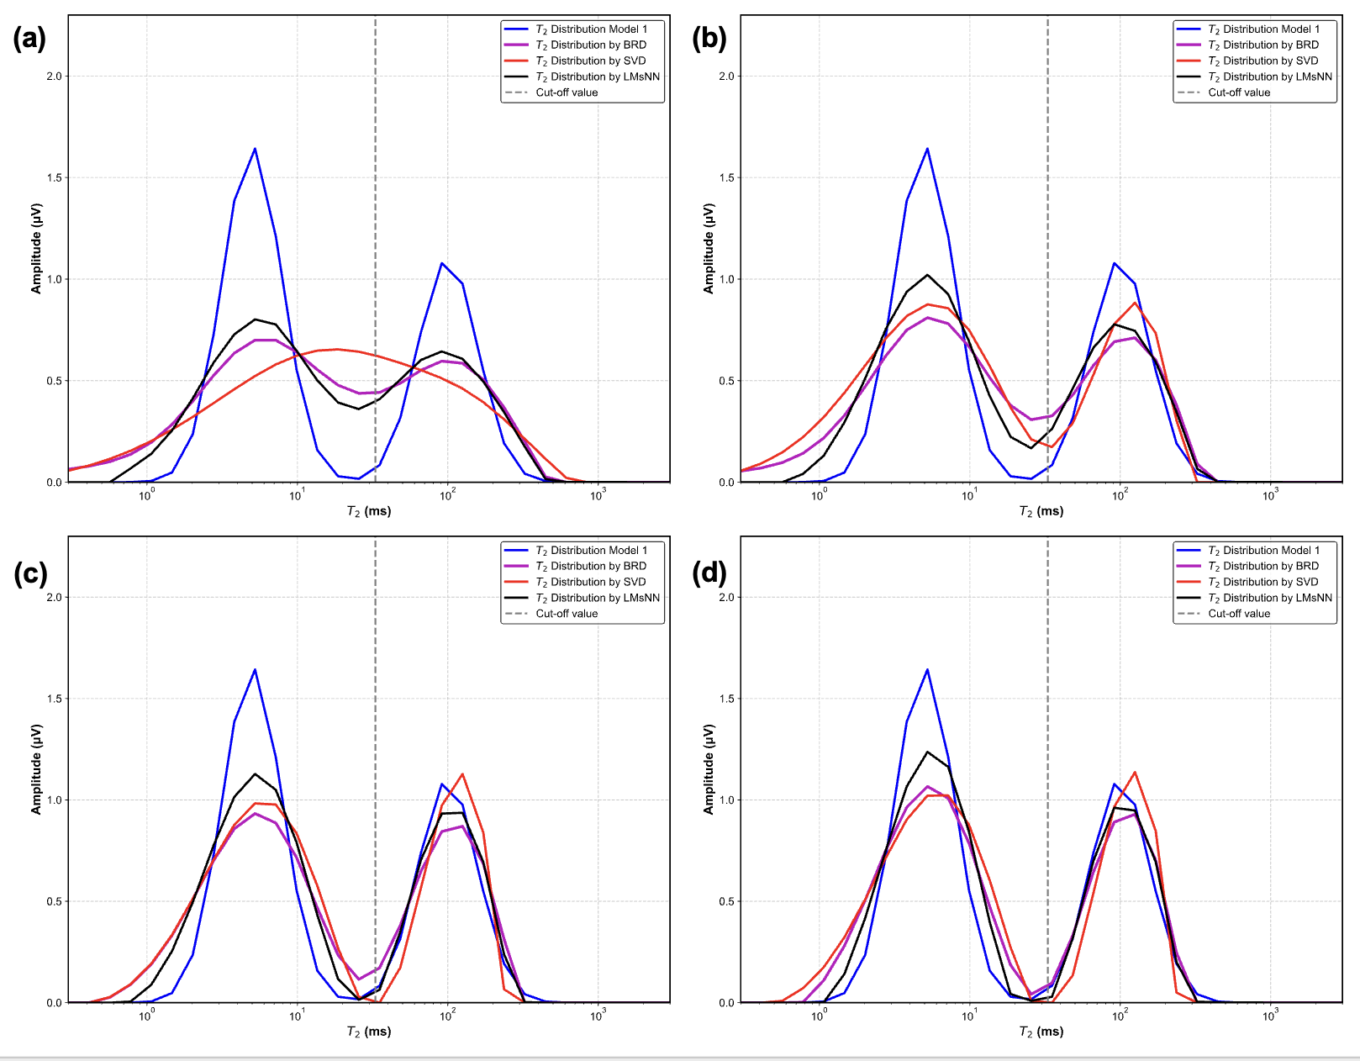

Figure C-1: Inversion results of BRD, SVD and LMsNN based on model 1. The number of *T*2 distribution points is set to 30, and the relaxation spectrum is distributed between 0.3 and 3000 ms.

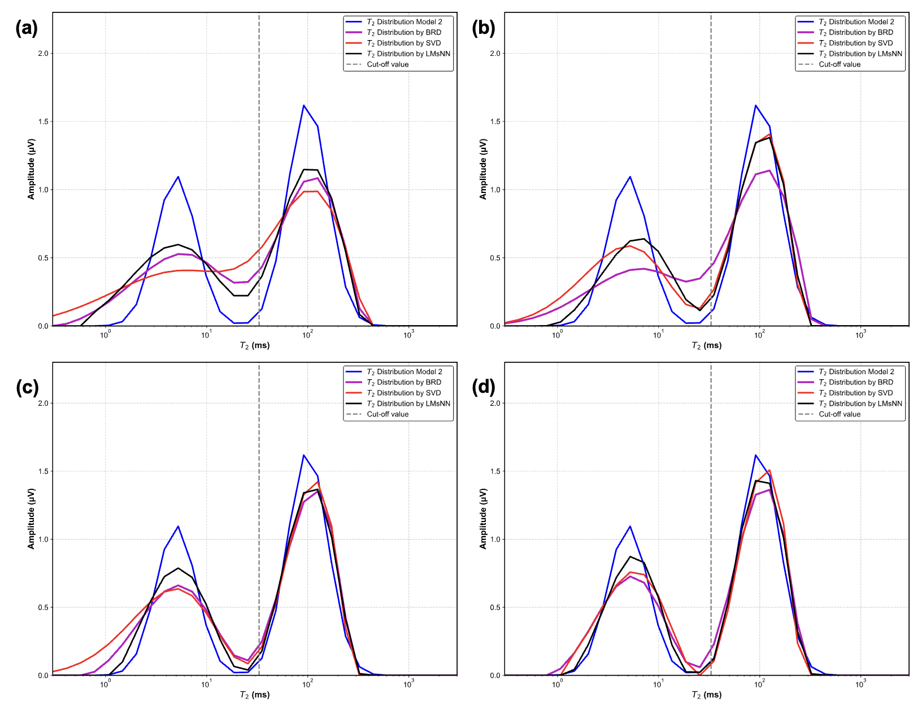

Figure C-2: Inversion results of BRD, SVD and LMsNN based on model 2. The number of *T*2 distribution points is set to 30, and the relaxation spectrum is distributed between 0.3 and 3000 ms.

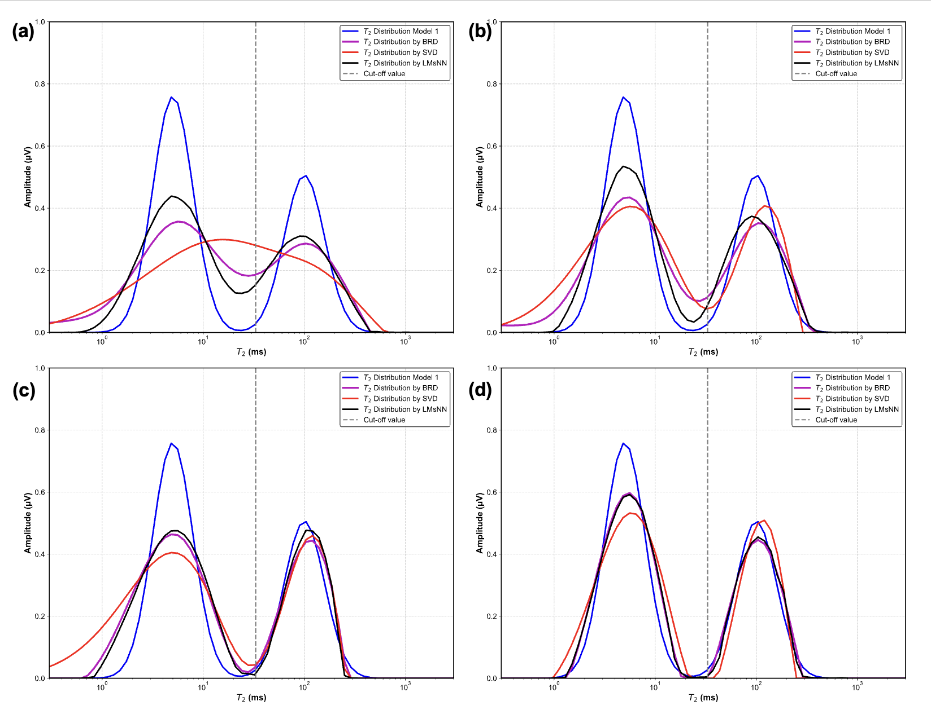

Figure C-3: Inversion results of BRD, SVD and LMsNN based on model 1. The number of *T*2 distribution points is set to 64 and the relaxation spectrum is distributed between 0.3 and 3000 ms.

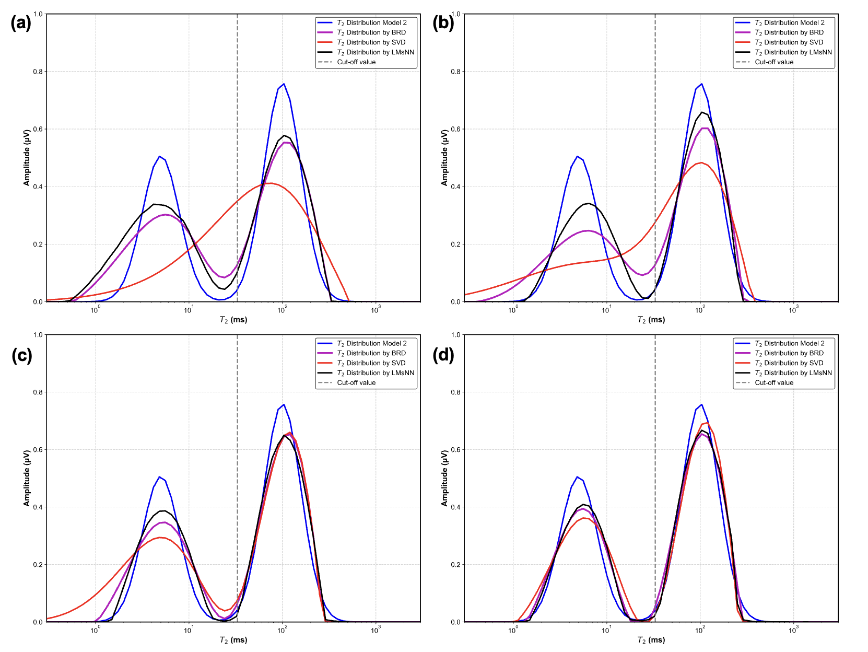

Figure C-4: Inversion results of BRD, SVD and LMsNN based on model 2. The number of *T*2 distribution points is set to 64 and the relaxation spectrum is distributed between 0.3 and 3000 ms.