exit_time_cohort_characteristics.R

ngreen1

Fri May 18 15:00:36 2018

library(ggplot2)  
library(reshape2)  
library(dplyr)

##   
## Attaching package: 'dplyr'

## The following objects are masked from 'package:stats':  
##   
## filter, lag

## The following objects are masked from 'package:base':  
##   
## intersect, setdiff, setequal, union

library(LTBIscreeningproject)

## Warning: replacing previous import 'crayon::reset' by 'git2r::reset' when  
## loading 'LTBIscreeningproject'

data("model_input_cohort")  
  
dat <- unclass(table(IMPUTED_sample$country,  
 IMPUTED_sample$visatype2)) %>% data.frame()  
  
dat$row <- seq_len(nrow(dat))  
dat2 <- melt(dat, id.vars = "row")  
  
ggplot(dat2, aes(x = variable, y = value, fill = row)) +  
 geom_bar(stat = "identity") +  
 xlab("\nType") +  
 ylab("Time\n") +  
 # guides(fill = FALSE) +  
 theme_bw()

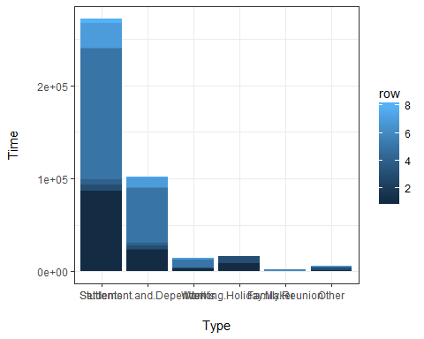

dat <- data.frame(exit_issdt = IMPUTED_sample$date_exit_uk1_issdt.years,  
 WHO = IMPUTED_sample$who_inc_Pareek2011,  
 country = IMPUTED_sample$country,  
 visa = IMPUTED_sample$visatype2,  
 agegp2 = IMPUTED_sample$agegp2)  
  
ggplot(dat, aes(x = WHO, y = exit_issdt)) +  
 # geom_boxplot()  
 geom_violin(draw_quantiles = c(0.25, 0.5, 0.75))

## Warning: Removed 103983 rows containing non-finite values (stat_ydensity).

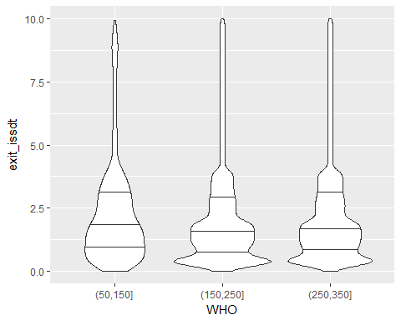

ggplot(dat, aes(x = agegp2, y = exit_issdt)) +  
 # geom_boxplot()  
 geom_violin(draw_quantiles = c(0.25, 0.5, 0.75))

## Warning: Removed 103983 rows containing non-finite values (stat_ydensity).

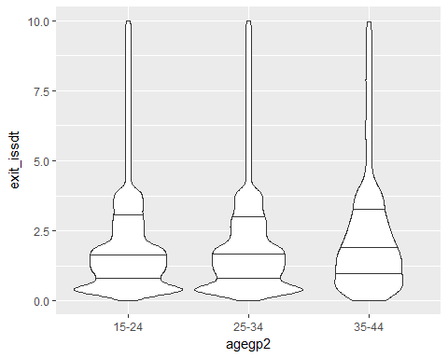

ggplot(dat, aes(x = country, y = exit_issdt)) +  
 # geom_boxplot()  
 geom_violin(draw_quantiles = c(0.25, 0.5, 0.75))

## Warning: Removed 103983 rows containing non-finite values (stat_ydensity).

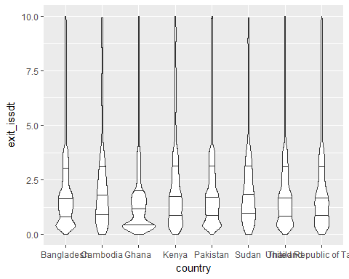

ggplot(dat, aes(x = visa, y = exit_issdt)) +  
 # geom_boxplot()  
 # geom_violin()  
 geom_violin(draw_quantiles = c(0.25, 0.5, 0.75))

## Warning: Removed 103983 rows containing non-finite values (stat_ydensity).

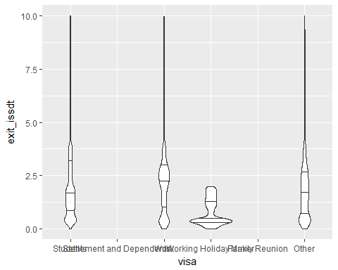

# geom_violin(scale = "count")  
  
rbind(table(ceiling(IMPUTED_sample$date_exit_uk1_issdt.years)),  
 prop.table(table(ceiling(IMPUTED_sample$date_exit_uk1_issdt.years))) %>% round(2)) %>% t()

## [,1] [,2]  
## 1 92613 0.22  
## 2 94266 0.23  
## 3 42318 0.10  
## 4 36053 0.09  
## 5 7108 0.02  
## 6 7247 0.02  
## 7 7201 0.02  
## 8 7241 0.02  
## 9 7065 0.02  
## 10 7176 0.02  
## Inf 103983 0.25

rbind(  
 table(IMPUTED_sample$visatype2,  
 ceiling(IMPUTED_sample$date_exit_uk1_issdt.years)),  
 prop.table(table(IMPUTED_sample$visatype2,  
 ceiling(IMPUTED_sample$date_exit_uk1_issdt.years)), margin = 1) %>% round(2),  
 table(IMPUTED_sample$agegp2,  
 ceiling(IMPUTED_sample$date_exit_uk1_issdt.years)),  
 prop.table(table(IMPUTED_sample$agegp2,  
 ceiling(IMPUTED_sample$date_exit_uk1_issdt.years)), margin = 1) %>% round(2),  
 table(IMPUTED_sample$who_inc_Pareek2011,  
 ceiling(IMPUTED_sample$date_exit_uk1_issdt.years)),  
 prop.table(table(IMPUTED_sample$who_inc_Pareek2011,  
 ceiling(IMPUTED_sample$date_exit_uk1_issdt.years)), margin = 1) %>% round(2))

## 1 2 3 4 5  
## Students 76726.00 84385.00 35854.00 33701.00 6795.00  
## Settlement and Dependents 0.00 0.00 0.00 0.00 0.00  
## Work 3706.00 2389.00 5075.00 1790.00 238.00  
## Working Holiday Maker 10302.00 5971.00 0.00 0.00 0.00  
## Family Reunion 0.00 0.00 0.00 0.00 0.00  
## Other 1879.00 1521.00 1389.00 562.00 75.00  
## Students 0.28 0.31 0.13 0.12 0.03  
## Settlement and Dependents 0.00 0.00 0.00 0.00 0.00  
## Work 0.25 0.16 0.35 0.12 0.02  
## Working Holiday Maker 0.63 0.37 0.00 0.00 0.00  
## Family Reunion 0.00 0.00 0.00 0.00 0.00  
## Other 0.32 0.26 0.24 0.10 0.01  
## 0-14 0.00 0.00 0.00 0.00 0.00  
## 15-24 55456.00 58001.00 24241.00 21824.00 4401.00  
## 25-34 36698.00 35790.00 17766.00 14010.00 2659.00  
## 35-44 459.00 475.00 311.00 219.00 48.00  
## 45-54 0.00 0.00 0.00 0.00 0.00  
## >=55 0.00 0.00 0.00 0.00 0.00  
## 0-14 NaN NaN NaN NaN NaN  
## 15-24 0.24 0.25 0.10 0.09 0.02  
## 25-34 0.21 0.21 0.10 0.08 0.02  
## 35-44 0.15 0.16 0.10 0.07 0.02  
## 45-54 NaN NaN NaN NaN NaN  
## >=55 NaN NaN NaN NaN NaN  
## (0,50] 0.00 0.00 0.00 0.00 0.00  
## (50,150] 336.00 372.00 210.00 171.00 25.00  
## (150,250] 45428.00 45042.00 18959.00 15832.00 3267.00  
## (250,350] 46849.00 48852.00 23149.00 20050.00 3816.00  
## (350,1e+05] 0.00 0.00 0.00 0.00 0.00  
## (0,50] NaN NaN NaN NaN NaN  
## (50,150] 0.08 0.09 0.05 0.04 0.01  
## (150,250] 0.25 0.25 0.10 0.09 0.02  
## (250,350] 0.21 0.22 0.10 0.09 0.02  
## (350,1e+05] NaN NaN NaN NaN NaN  
## 6 7 8 9 10  
## Students 6885.00 6851.00 6948.00 6709.00 6823.00  
## Settlement and Dependents 0.00 0.00 0.00 0.00 0.00  
## Work 279.00 281.00 216.00 290.00 280.00  
## Working Holiday Maker 0.00 0.00 0.00 0.00 0.00  
## Family Reunion 0.00 0.00 0.00 0.00 0.00  
## Other 83.00 69.00 77.00 66.00 73.00  
## Students 0.03 0.03 0.03 0.02 0.03  
## Settlement and Dependents 0.00 0.00 0.00 0.00 0.00  
## Work 0.02 0.02 0.01 0.02 0.02  
## Working Holiday Maker 0.00 0.00 0.00 0.00 0.00  
## Family Reunion 0.00 0.00 0.00 0.00 0.00  
## Other 0.01 0.01 0.01 0.01 0.01  
## 0-14 0.00 0.00 0.00 0.00 0.00  
## 15-24 4446.00 4400.00 4524.00 4269.00 4418.00  
## 25-34 2763.00 2758.00 2672.00 2759.00 2718.00  
## 35-44 38.00 43.00 45.00 37.00 40.00  
## 45-54 0.00 0.00 0.00 0.00 0.00  
## >=55 0.00 0.00 0.00 0.00 0.00  
## 0-14 NaN NaN NaN NaN NaN  
## 15-24 0.02 0.02 0.02 0.02 0.02  
## 25-34 0.02 0.02 0.02 0.02 0.02  
## 35-44 0.01 0.01 0.01 0.01 0.01  
## 45-54 NaN NaN NaN NaN NaN  
## >=55 NaN NaN NaN NaN NaN  
## (0,50] 0.00 0.00 0.00 0.00 0.00  
## (50,150] 27.00 24.00 22.00 35.00 23.00  
## (150,250] 3245.00 3210.00 3260.00 3089.00 3248.00  
## (250,350] 3975.00 3967.00 3959.00 3941.00 3905.00  
## (350,1e+05] 0.00 0.00 0.00 0.00 0.00  
## (0,50] NaN NaN NaN NaN NaN  
## (50,150] 0.01 0.01 0.01 0.01 0.01  
## (150,250] 0.02 0.02 0.02 0.02 0.02  
## (250,350] 0.02 0.02 0.02 0.02 0.02  
## (350,1e+05] NaN NaN NaN NaN NaN  
## Inf  
## Students 0.00  
## Settlement and Dependents 101796.00  
## Work 0.00  
## Working Holiday Maker 0.00  
## Family Reunion 2187.00  
## Other 0.00  
## Students 0.00  
## Settlement and Dependents 1.00  
## Work 0.00  
## Working Holiday Maker 0.00  
## Family Reunion 1.00  
## Other 0.00  
## 0-14 0.00  
## 15-24 49640.00  
## 25-34 53049.00  
## 35-44 1294.00  
## 45-54 0.00  
## >=55 0.00  
## 0-14 NaN  
## 15-24 0.21  
## 25-34 0.31  
## 35-44 0.43  
## 45-54 NaN  
## >=55 NaN  
## (0,50] 0.00  
## (50,150] 2916.00  
## (150,250] 37644.00  
## (250,350] 63423.00  
## (350,1e+05] 0.00  
## (0,50] NaN  
## (50,150] 0.70  
## (150,250] 0.21  
## (250,350] 0.28  
## (350,1e+05] NaN