User guide – Procssing dOPM data using the ImageJ Multi-View Reconstruction (MVR) plugin

Hugh Sparks and Chris Dunsby

v1.00

09/06/2023

Contents

Introduction 2

Step 1 – Download demo data 3

Step 2 – make MVR dataset for beads and co-register dOPM views1&2 3

Step 3 –transformation and coregistration of dOPM view 1&2 bead data 4

Step 4 - Visually inspect coregistration quality bead data 5

Step 5 - Setup MVR dataset for sample data 7

Step 6 – copy transformations in MVR bead dataset to sample dataset 8

Step 7 – resave the MVR sample dataset as ‘.hdf5’ format for viewing with ‘Bigdataviewer’ to check quality of coregistration between dOPM view 1&2 9

Step 8 - Visually inspect coregistration quality of sample data 11

Step 9 - Define a bounding box to crop out a sub-volume, optional step 12

Step 10 - Extract processed single view or fused datasets for generic downstream processing of 3D datasets 14

# Introduction

The ImageJ scripts described in this document are designed to process data generated by dual-view oblique plane microscopes (dOPM) as of 2023. The paper describing the dOPM setup can be found here: <https://doi.org/10.1364/BOE.409781>.

The dOPM data processing scripts run within ImageJ and rely mainly on the Multi-View Reconstruction (MVR) plugin <https://imagej.net/plugins/multiview-reconstruction>.

The following steps in this guide outline the procedures for deskewing and fusion of raw dOPM data.

dOPM acquires two overlapping volumes in the sample from two views we call ‘view 1’ and ‘view 2’ – see the dOPM paper for details. The raw data is skewed, i.e. the image data is not in the normal microscope coordinate frame. To process the data, we assume the user has acquired both views and they want to fuse the two views or extract one or both single views into the microscope coordinate frame.

To deskew the data, the MVR plugin is used to apply affine transformations to rotate and deskew the raw data into the microscope coordinate frame. The MVR plugin is then used to perform a bead-based image registration using a dataset of sub-resolution fluorescent beads imaged in 3D and acquired with the same scan settings as for the biological sample(s). This registration information is then assumed to be constant and is applied to all other fields of view imaged with the same microscope configuration during an experiment. The MVR paper[1] and the dOPM paper[2] for more information on multi-view reconstruction based on bead datasets.

Note there are other ways to register multi-view data, e.g. using features in the biological samples such as nuclei or membrane labels that are common to both dOPM views. This has the advantage that it does not require a bead volume to be imaged, and it does not require the assumption that the imaging conditions – and therefore registration – is the same for the sample data as the bead data. However, sample-based registration requires that there are sufficient features within the field of view and that the sample data has sufficient signal to noise ratio, so we recommend the use of bead-based registration.

# Overview

We provide some demonstration data, see ‘Step 1’ below, that can be used to work through the steps in this guide. The demo data includes:

* Sample data – some cells in 3D, which is located in the folder named ‘data’.
* Bead data – volume of fluorescent beads imaged with identical scan settings as the sample data, which is located in the folder named ‘beads’.

The key processing workflow steps, which are described in more detail in the sections below, are:

1. Download demo bead and sample data volumes.
2. Set up an MVR dataset for the bead data only.
3. Use theoretical estimates of rotation and skew of raw data from the known microscope configuration to perform an initial transform of the raw bead data into microscope space coordinates.
4. Use the ImageJ MVR plugin to obtain better estimates of the co-registration information starting from the initial transform of the bead data obtained from the previous step.
5. Visually inspect the co-registration quality of the bead data dOPM view 1&2 to check OK.
6. Set up an MVR dataset for the sample data.
7. Copy the transformations obtained for the MVR bead dataset to the sample dataset. Visually inspect the co-registration quality of the sample data dOPM view 1&2 to check OK.
8. Resave the MVR sample dataset into the ‘.hdf5’ format for fast viewing with the ‘Bigdataviewer’ and to check the quality of the co-registration between dOPM views 1&2.
9. Visually inspect coregistration quality of sample data using the Bigdataviewer.
10. If required, define a bounding box to crop out a sub-volume containing a region of interest.
11. Extract processed single view or fused datasets – resliced, de-skewed and dOPM view1&2 co-registered data.
12. At this point the user has 3D datasets transformed into the microscope Cartesian coordinates, and these images can be used for data visualisation or fed into a 3D image analysis software package or script.

# Prerequisites

For more information on the MVR plugin, see the following links and references within:

<https://imagej.net/plugins/multiview-reconstruction>

<https://imagej.net/plugins/bigstitcher/>

<https://forum.image.sc/> - community support, can make an account to post questions.

# Summary of code

The code provided is written using ImageJ Python scripts within ImageJ’s scripting functionality. GUI dialog boxes are used to prompt the user to make decisions related to dOPM data processing. Other dialog boxes also appear from the MVR plugin.

The aim of the code is to convert raw data into resliced data, either from a single view or by fusing data from two views.

We are currently developing scripts that can run all steps via the MVF batch processing commands. This will allow automation of all steps and run similar processing steps on batches of data.

# Step 0 – FIJI installation

It is necessary to follow this exact recipe to ensure the script works.

Put these scripts in fiji subfolder -> path-to-fiji\Fiji.app\plugins\Scripts\dOPM

Use this version of Fiji (all others not compatible) -> <https://imperialcollegelondon.box.com/s/555qs9ufjrrh8b43ocry4gp4x0yhh36a>

# Step 1 – Download demo data

Demo data:

<https://imperialcollegelondon.app.box.com/s/kweg5c8w3r8hhkhuxy80du6binwhlhkv>

# Step 2 – Make MVR dataset for beads and co-register dOPM views1&2

* Click on the dOPM link and select ‘make mvr dataset’.

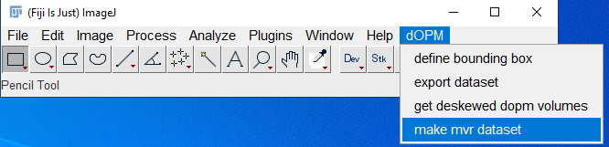

* In next dialog box choose ‘transform and register beads’.

# 

# Step 3 – Transformation and co-registration of dOPM view 1&2 bead data

* Next dialog box, choose folder where bead data folder located, see screenshot below.
* The raw data is stored using ‘.nd2’ files so leave ‘image file extension unchanged as ‘.nd2’.
* Leave the ‘file pattern’ as shown in screenshot below.
* Leave the ‘pixel size’ and ‘prism angle’ values as shown below, the user needs to keep track of pixel size and prism angle in the specific dOPM system being used – currently this is not stored in the image metadata.

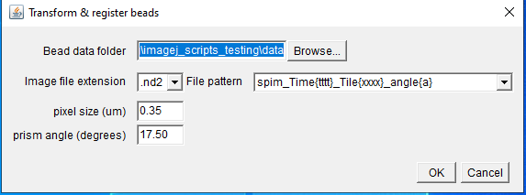

* When ‘OK’ pressed, the log window will print text indicating progress and will complete with ‘Finished’ – wait for this. Now the bead dataset is setup.

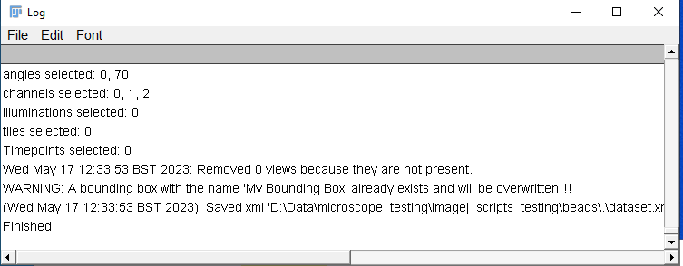

# Step 4 - Visually inspect coregistration quality bead data

* The bead dataset consists of a dataset based on the raw ‘.nd2’ data and within that there is a version where the raw data has been resaved has ‘.hdf5’ – take a look and read the wiki pages for info on MVF plugin for more information about the MVR dataset definition.
* In the next step we will visualise the bead dataset with MVF’s use of the ‘Bigdataviewer’ and check by eye if the beads from views 1&2 are visibly overlapping to be judged as coregistered.
* Go to the plugins menu and click on the ‘Multiview Reconstruction’ option and then the ‘multiview reconstruction application’ option as shown in the screenshot below.

* **Browse to your bead data folder and within that should be a folder named ‘hdf5’ that contains an .xml file, i.e. your-path\beads\hdf5\dataset.xml.**
* Click on this ‘xml’ file – this file defines the MVR dataset used for previewing with the ‘Bigdataviewer’.
* Press OK to explore this dataset within the MVR GUI; the ‘Bigdataviewer’ tool window of the data should automatically appear **– this automatic opening is because you opened the hdf5 converted dataset.**

* To get to grips with using MVR application go to the plugin’s documentation and help file.
* The screenshot below shows you an example of using the ‘Bigdataviewer’ tool within the plugin to visualise the dataset, and the two dOPM views for one spectral channel are visualised in green and magenta. Read the plugin help documentation for more detail on its use.
* In the screenshot, the two views have clearly been successfully rotated, deskewed and co-registered, since the bead’s volumes from the two views overlap. The registration process relied on calling some MVR plugin functions in the background of the dOPM script. If the bead data has not been successfully coregistered you need to get help from an expert user or be prepared to start to understand more deeply how to use the MVR plugin.
* It is possible that bead registration fails or there is an error in the way the data is generated. In this case expert help or a deeper understanding of the MVR plugin is needed.

# Step 5 - Setup MVR dataset for sample data

* Assuming that the bead data is successfully transformed, then setup the sample data dataset. This can be achieved using a similar and simpler process to that used above for the beads. In this case the transformation obtained from the bead data can be copied over.
* In the FIJI dOPM menu, select ‘make mvr dataset’.

* The next step is different to the bead dataset (steps 1-4 above). This time, select ‘transform and register data’. **This step requires that you have completed the setting up of the bead dataset (steps 1-4 above).**

# 

# Step 6 – Copy transformations in MVR bead dataset to sample dataset

* The next dialog box asks you to enter the bead data folder and the sample data folder paths.
* Keep the pixel size, file pattern prism angle settings the same as used for the bead data setup process (steps 1-4) and click OK.

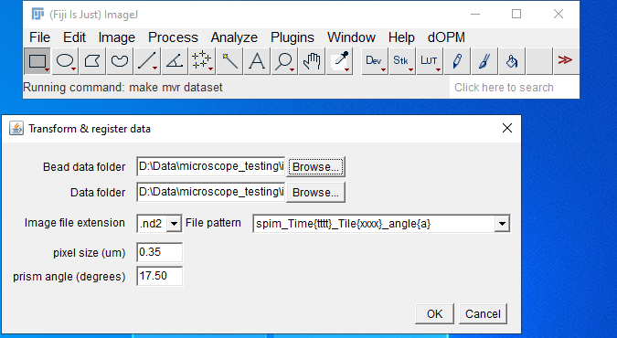

* Wait till the dialog box prints ‘Finished’.

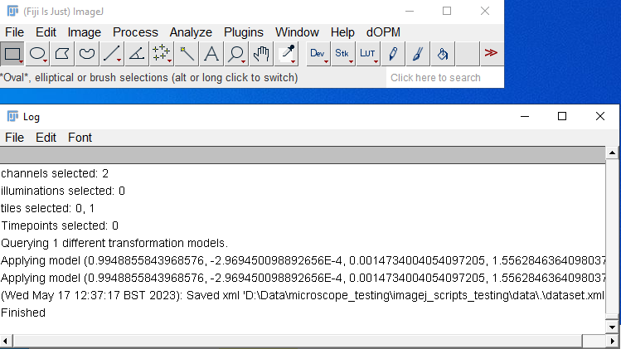

# Step 7 – Resave the MVR sample dataset as ‘.hdf5’ format for viewing with ‘Bigdataviewer’ to check quality of coregistration between dOPM view 1&2

* For the next step it is necessary to manually resave the data in hdf5 format, as this allows for fast visualisation of the data via the MVR application’s use of the ‘Bigdataviewer’ tool – see MVR documentation for details about Bigdataviewer.
* While for the bead data the dOPM script is setup to automatically transform raw data to hdf5 for fast viewing with Bigdataviewer, this is not done automatically for the sample data. This is because while the bead data will typically be a small, single time point dataset, the sample data could be huge, so converting to hdf5 will take a long time to process and fill up the storage space, so this step is not automatic.
* Follow the screenshot below to resave as hdf5.

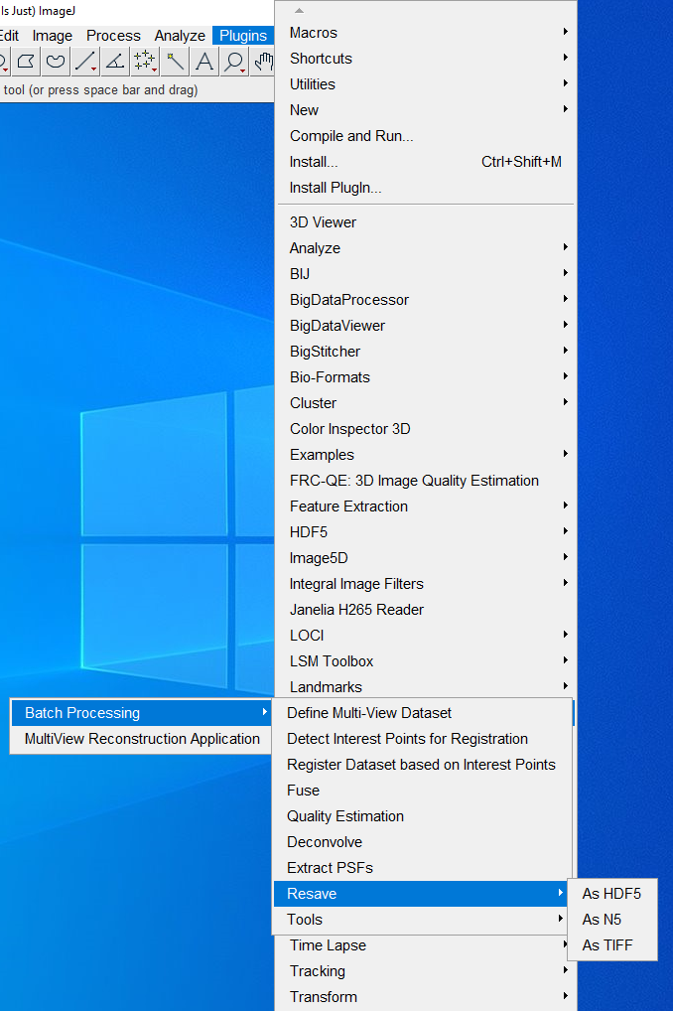

* The next dialog box that appears asks for location of data, go to the data folder, and click on the .xml file.
* Resave for all angles, channels, all dimensions, i.e. the entire dataset.

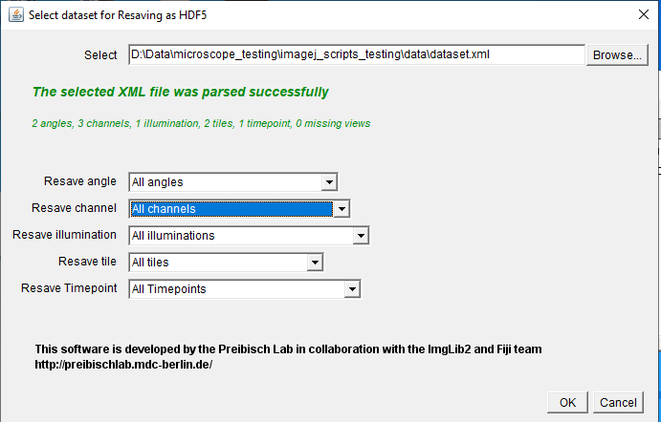

* Next use the default export settings, do not change anything – keep it same as the screenshot below.

# Step 8 - Visually inspect coregistration quality of sample data

* Now open the dataset as in Step 4. The dataset.xml now contains instructions to expect a hdf5 dataset instead of the raw dataset in the data folder. The data will be automatically shown in the ‘Bigdataviewer’ tool for visualisation.

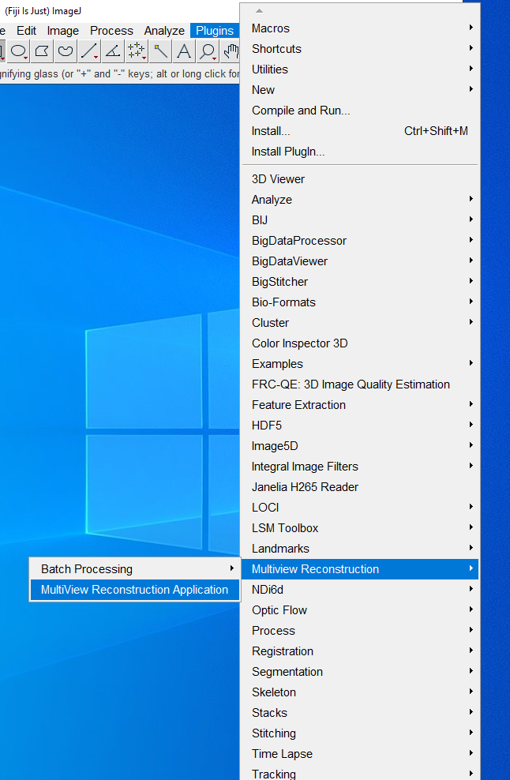

* Click on the dataset path and load once GUI dialog appears below appears.

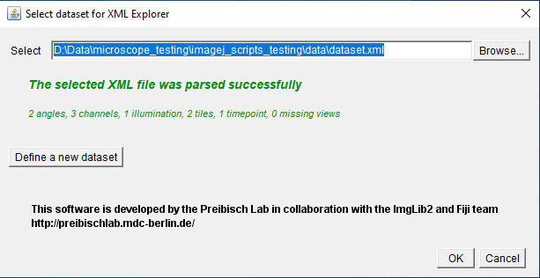

* It is worth remembering at this point that the affine transformations determined for the bead dataset – including deskewing and bead-based registration - were copied and applied to the sample data. If the alignment of the two views in the sample data is not as expected, then it might indicate that the sample data and bead data were not recorded under identical acquisition settings and optical alignment.
* The screen shot below shows the ImageJ MVR plugin application for viewing the data. Explore this tool and the online help to understand it better.

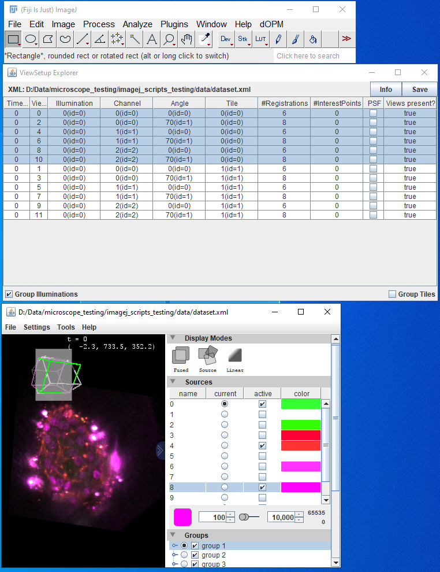

# Step 9, optional - Define a bounding box to crop out a sub-volume

* Click on the ‘define bounding box’ option.
* This step uses the MVR bead dataset that includes the ‘hdf5’ file for fast viewing with the ‘Bigdataviewer’ tool while defining a bounding box using a GUI with sliders for changing the bounding box dimensions and visualising the extent of the bounding box for cropping as a green wire frame. The purple shows the perspective of the plane being intersected from the current rendering of the 3D orientation.
* The screen shot below shows the ImageJ MVR plugin application for viewing the data while changing the bounding box for cropping. Explore this tool and the online help to understand it better.

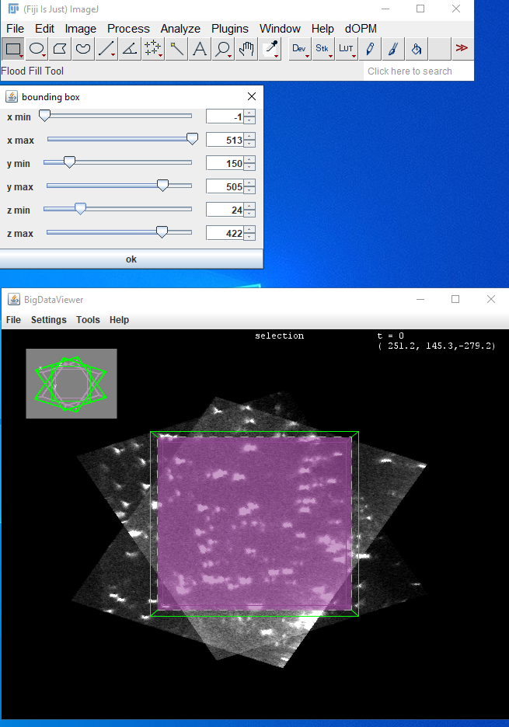

# Step 10 - Extract processed single view or fused datasets for downstream processing of 3D datasets

* Click on the ‘get deskewed dopm volumes’ option.

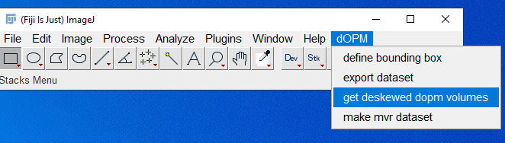

* The ‘how do you want to extract the tiff stacks’ question gives you the choice of exporting single view or fused data with all of the deskewing and other affine transformation steps applied as covered in Steps 1-4.
* Below is the fused option selected.

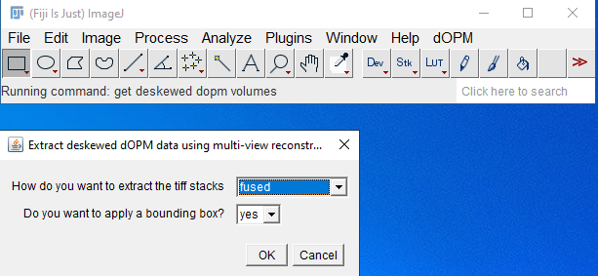

* Below is the single view option selected, you will see another prompt if chosen asking to specify which single view you want to export, i.e. dOPM view 1 or 2.

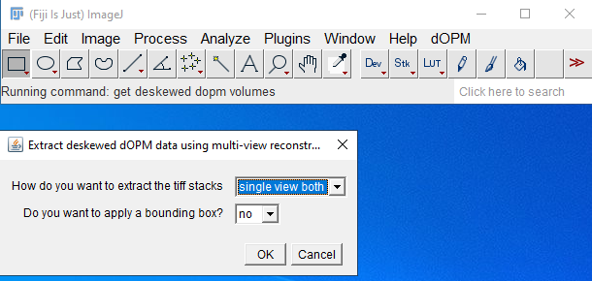

* If you have defined a bounding box as outlined in Step 9 above, you can apply it in this exporting step to reduce the data to just the volume cropped by this box – click ‘yes’ or ‘no’ in the ‘do you want to apply a bounding box option’. This will be ignored if a bounding box was not defined prior to Step 10.
* Regardless of single or fused volumes, you will see a prompt requesting a path to the dataset xml and a save path.
* Note you must create the save path manually before or during this step for this to work – it will not automatically create a new folder with the chosen name.
* Note the binning factor refers to the size of the exported tiff stack voxels. The exported data is isotropic in sampling in the x,y,z dimensions of the z-stack produced and is a function of the raw image datas pixel size and z-plane spacing. For example, a binning factor of 1 would generate a tiff stack with the highest spatial resolution and a factor of 2 would be half this resolution. Explore the MVR application and read online MVR wiki for further understanding of exporting MVR data in general.

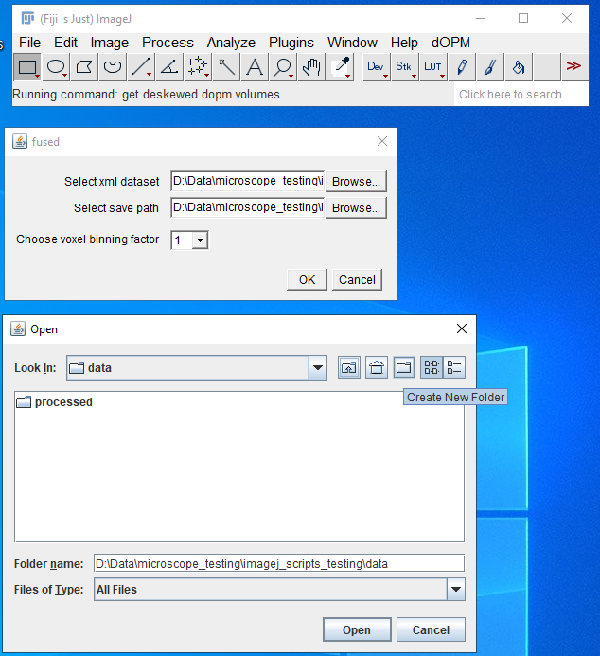

* Finally, the option to process a subset of tiles is given to allow the user to only process a fraction of the dataset. This can be useful if the dataset is large and only a subset is required for export, saving compute time and disk space.

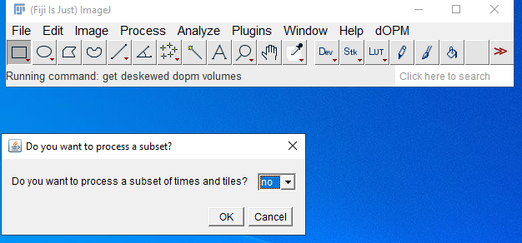

* Once the export process begins, the log box provides an indication of progress and the process is complete once the ‘DONE’ statement is shown.

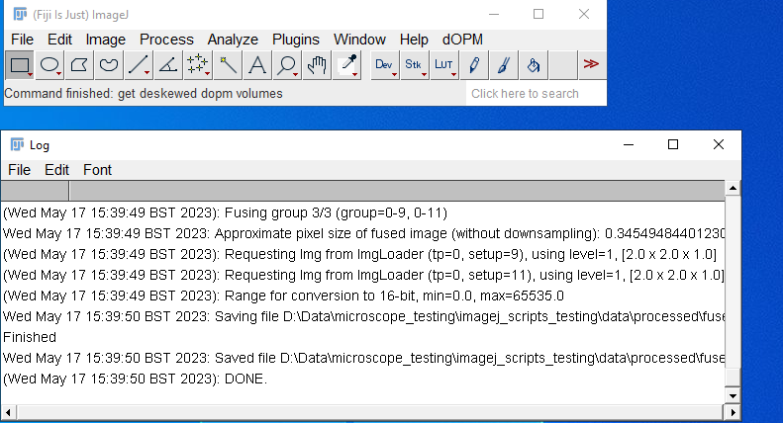

* Then you can browse the resulting tiff stacks in the chosen save folder and load them in ImageJ or similar.
* At this point the 3D image can then be transferred to another application or pipeline for visualisation or analysis.

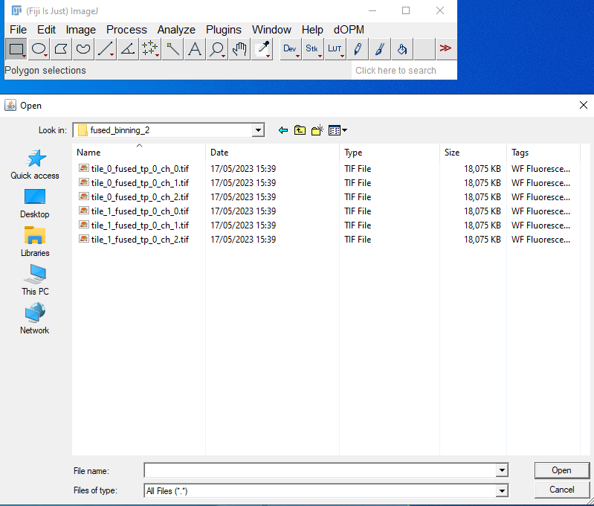

1. MVR paper
2. dOPM paper