User guide – dOPM Acquisition JOBS script

Hugh Sparks and Chris Dunsby

v1.00

25/05/2023

Prerequisites

* You are familiar with NIS-elements – use the help tool within NIS-Elements and the NIS-Elements manual.

Notes

* This script is based on a NIS-Elements template JOBS script.
* The NIS-Elements help tool helps explain how you can use JOBS scripts and gives examples of why they are useful.

Important note about the z-piezo logical device

The dOPM Acquisition JOBS script makes use of the z-piezo logical device within NIS-Elements to control the position of the dOPM scanning mirrors. The z-piezo logical device in NIS-Elements is intended by Nikon to be used to control a piezo-electric objective positioning device in conjunction with the conventional/main stepper-motor within the Nikon frame that controls the objective z-position. Therefore, NIS-Elements thinks that the Ti2 ZDrive and the z-piezo position should be summed to determine the overall position of the objective relative to the sample. However, we are not using the z-piezo logical device for its intended purpose and therefore care is required. With this in mind, it is important **to only use the z-piezo when acquiring dOPM image volumes**.

* **Any other operations involving z-positions, e.g. normal use of the microscope with the camera on the non-dOPM right-hand port, should be carried out with z-piezo set to the home position, which is zero.**
* For example, if we want to record a position list of interesting locations in the sample, we first make sure the z-piezo is set to zero (otherwise NIS-elements sets the target position as main (stepper-motor) z-drive value + z-piezo drive value, i.e. ZTotal = Z1 + Z2). This is not physically meaningful since the z-piezo drive (Z2) is not attached to the microscope objective. For any position list we always work with ZTotal = Z1.

Run dOPM Acquisition JOBS script

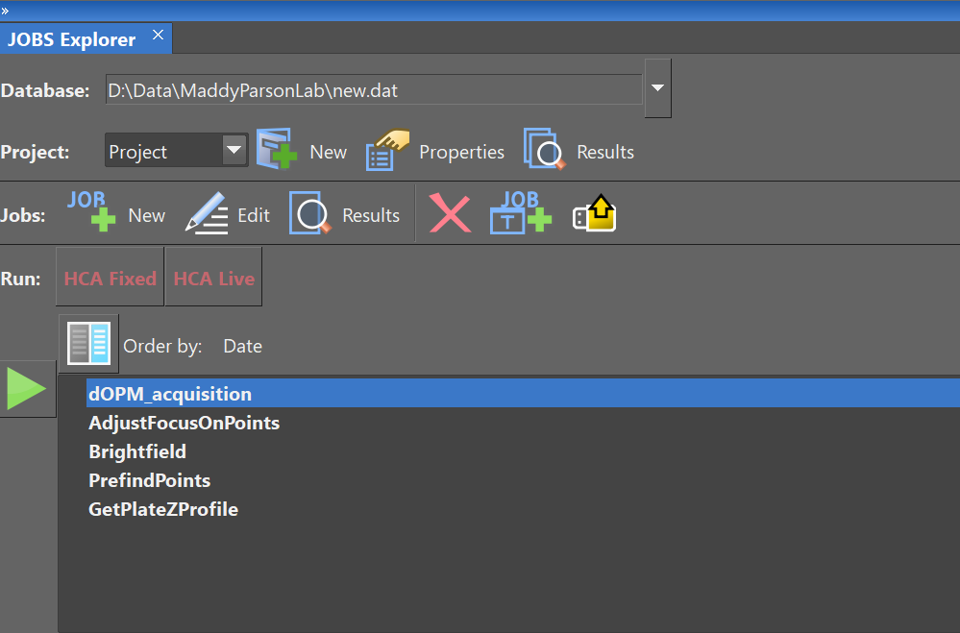

* Run the ‘dOPM_acquisition’ JOBS script.
* Use the NIS-Elements help tool to for help on how to use JOBS Explorer.

* Enter the zero-remote-refocus offset values for dOPM.

# Set z_retract parameter

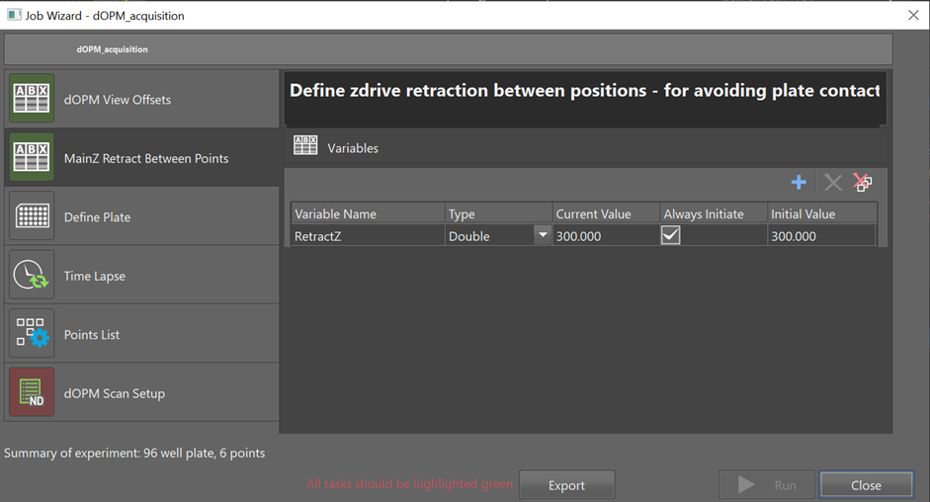

* The z_retract variable specifies how far the microscope objective is retracted from the Ti2 ZDrive value of the current position before moving to the next position in the position list.
* Set the z_retract variable to a number that avoids the chance of the objective colliding with the plate during stage movements. The value should be higher if you know that the base of the plate is not flat.
* We recommend a conservative value of 300 µm, but this depends on the plate being used – see JOBS script ‘GetPlateZProfile’ for a way to measure plate flatness.

# Select multi-well plate

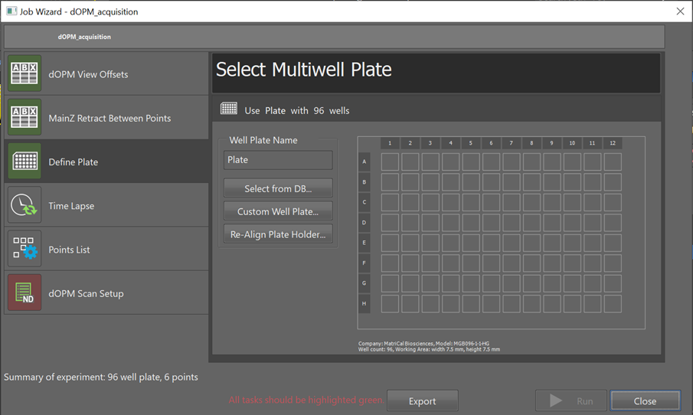

* Choose correct multi-well plate type definition.

Set time-lapse parameters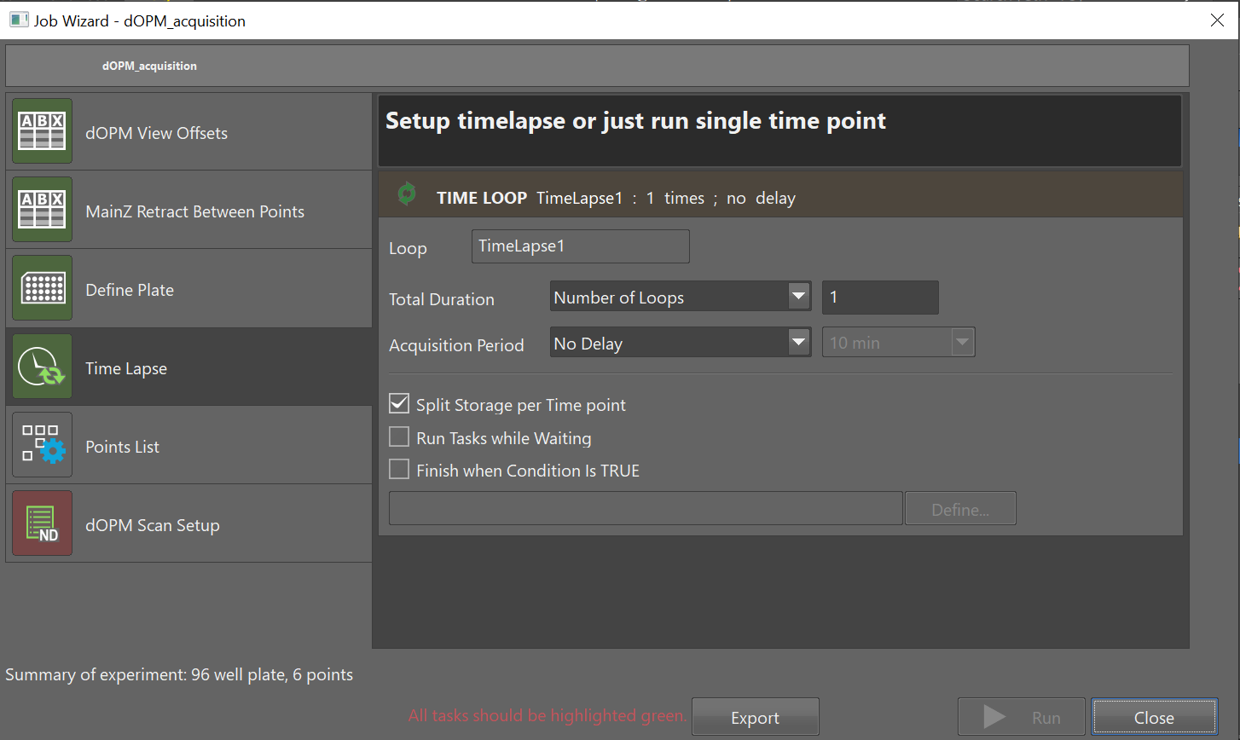

* Choose whether performing time-lapse imaging or not.
* If performing time-lapse imaging, select the desired time between images.
* Ensure that the time between images is longer than the time taken to image all positions in the position list.
* Use the NIS-Elements help tool to understand the timing requirements in timelapse imaging.

# Load position list

* Load a previously defined position list from a .xml or .csv file.

Define dOPM volume acquisition – spectral channels 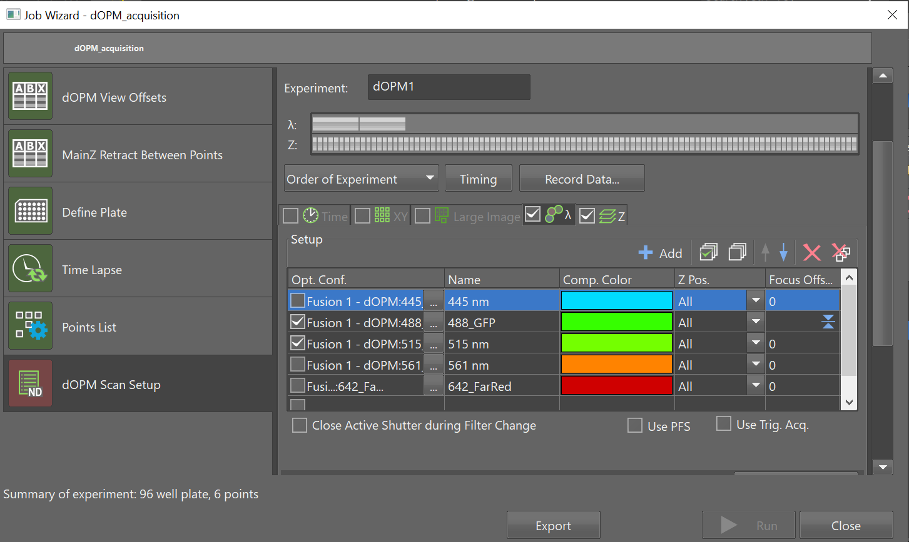

* Setup the dOPM ND acquisition parameters using the ‘lambda’ tab.
* Select suitable dOPM optical configurations.
* Using the ‘Advanced’ tab at the bottom, ensure that the following command boxes are ticked and filled in with:
  1. Execute command before capture ‘StgMovePiezoZ(dOPM_offset,0)’.
  2. Execute command after capture ‘StgMovePiezoZ(dOPM_offset,0)’.

# Define dOPM volume acquisition - z-scan settings

* Setup the dOPM ND acquisition parameters using the ‘z’ tab.
* **NOTE:** For the NDAcquisition, check the ‘λ’ and ‘Z’ tabs and leave the ‘Time’, ‘XY’ and ‘Large Image’ tabs unchecked.
* For the ‘z’ tab, set ‘z scanning device’ to either:
  1. NIDAQ piezo
     + The NIDAQ piezo is software timed. Provided that there is sufficient time for the dOPM mirrors to settle and the camera exposure time is sufficiently long then there will be no movement of the dOPM mirrors during image acquisition and so there will be no motion blur. The acquisition will be relatively slow.
  2. Triggered NIDAQ piezo
     + The triggered NIDAQ piezo is hardware timed. In this mode the dOPM mirrors are moved on the rising edge of the global exposure trigger output from the camera. This means that images are always acquired during motion of the mirrors. The motion of the mirrors depends on how the acquisition is configured. If the camera frame rate is sufficiently fast and/or the plane spacing is sufficiently large, then the mirror will move at an approximately constant velocity during the acquisition. If the camera frame rate is slow (long exposure time) and the plane spacing is small, then the mirror will settle into its new position early in the camera exposure time and the mirror will be approximately stationary during each camera frame. Otherwise, the mirror will be moving during the first part of each frame and settle during the frame. In summary the motion profile of the mirror and the amount of mirror motion during each camera frame is a function of the z-plane spacing, the speed of the piezo, and the exposure time. This triggering mode complicated and needs to configured carefully for a given situation.
* **NOTE:** Use option 1 above if unsure.

# Wizard completed

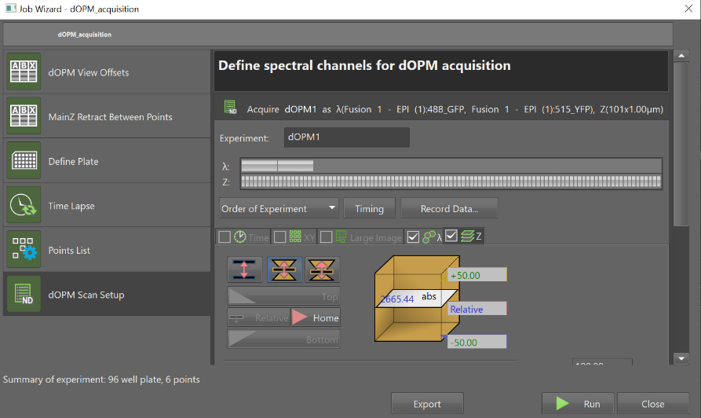

* Once all steps in the JOB script setup have been addressed the green button is enabled and the acquisition can be started.

# Run acquisition

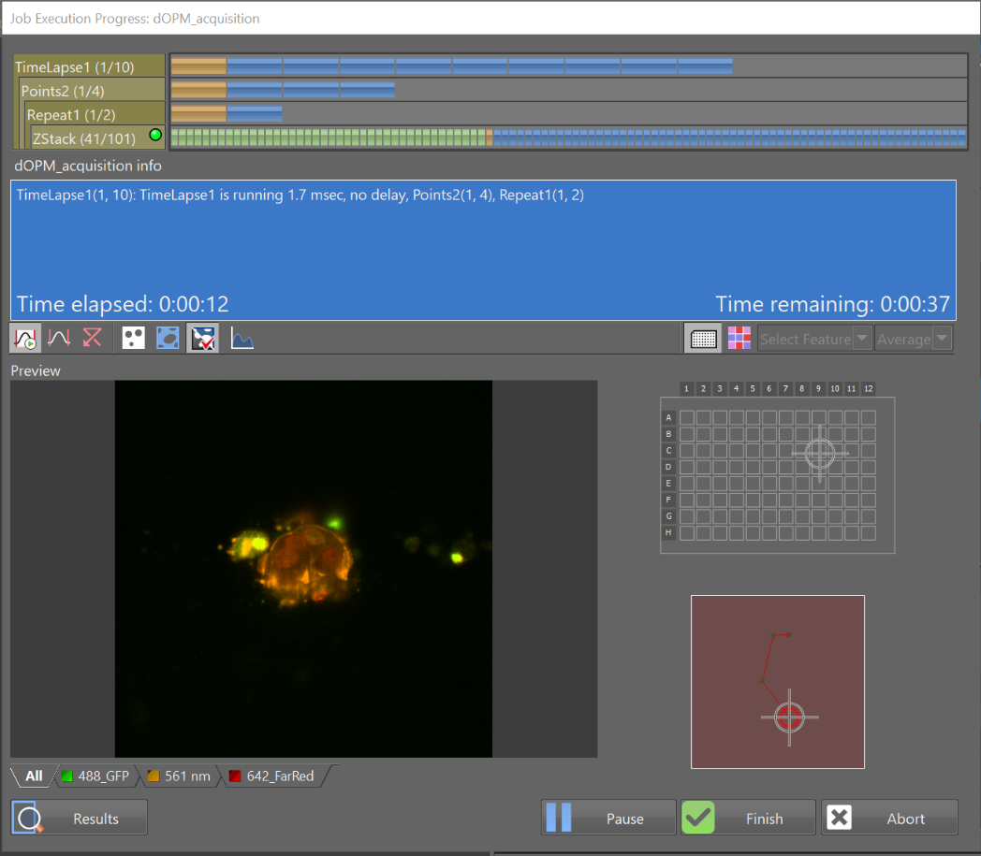

* Acquisition is initiated by pressing the green button. The progress bars at the top indicate the progress of the acquisition.
* In the example shown in the figure above, the acquisition is performing:
  1. Timelapse acquisition at x10 time points – shown by progress bar ‘Timelapse1’.
  2. Imaging 8 xyz – shown by progress bar ‘Points2’.
  3. Imaging both dOPM views – shown by progress bar ‘Repeat1’.
  4. A z-stack of 101 planes – shown by progress bar ‘ZStack’.

# Points to note

* **This script acquires data using both dOPM views.**
* **Remember to ensure that the well locations selected are compatible with the 60x objective and any water immersion cap that has been fitted on top**
  + **The 60x objective cannot typically reach the very edges of a plate.**
  + **Do not proceed with any 60x based experiment if this is not clear to user and ask for help.**
  + **When the water immersion cap is fitted then there will be further restriction on the outer regions of the plate that can be imaged.**