User guide – dOPM Acquisition JOBS script

Hugh Sparks and Chris Dunsby

v1.00

25/05/2023

Prerequisites

* You are familiar with NIS-elements – use the help tool within NIS-Elements and the NIS-Elements manual.

Notes

* This script is based on a NIS-Elements template JOBS script.
* This script uses a ‘Wizard’ that guides the user to define important parameters before the scripts is run.
* The NIS-Elements help tool helps explain how you can use JOBS scripts and gives examples of why they are useful.

# Introduction

This script loops over the position list that you intend to use for a dOPM acquisition and allows the user to refine the xyz values of each position in the list so that the region of interest (ROI) is centred in xyz on the right-hand port (RHP) wide-field camera. The dOPM optical path on the left-hand port (LHP) is aligned with the RHP; a dOPM image acquired with the z-piezo position set at zero images a plane in the specimen that intersects through the centre of the plane imaged by the camera on the RHP. Therefore, an object centred in xyz on the field of view of the RHP is also centred on both views of dOPM on the LHP.

* The main purpose of this script is to refine the xyz values generated using the course prefind carried out using the Prefind JOBS script with a low magnification 4x/10x/20x objective.
* This refinement is also carried out using the wide-field RHP camera, but is now done using the 60x water immersion objective used for dOPM imaging.
* At each position in the list, the user manually adjusts the focus for each point in the list.
* The script outputs a refined position list to the ‘NDacquisition’ modules point list tab.
* The list is then manually saved as an .xml or .csv file.

# Select 60x objective for dOPM acquisition

* At this point it is assumed you have completed setting up the acquisition in terms of using dry objectives i.e. prefind is done and plate is calibrated to stage.
* Now change the objective to the 60x water immersion objective used in the dOPM optical configuration.

# Run AdjustFocusOnPoints JOBS script

* Run the ‘AdjustFocusOnPoints’ JOBS script.
  + Use the NIS-Elements help tool for help on using JOBS Explorer.

# Set z_retract parameter

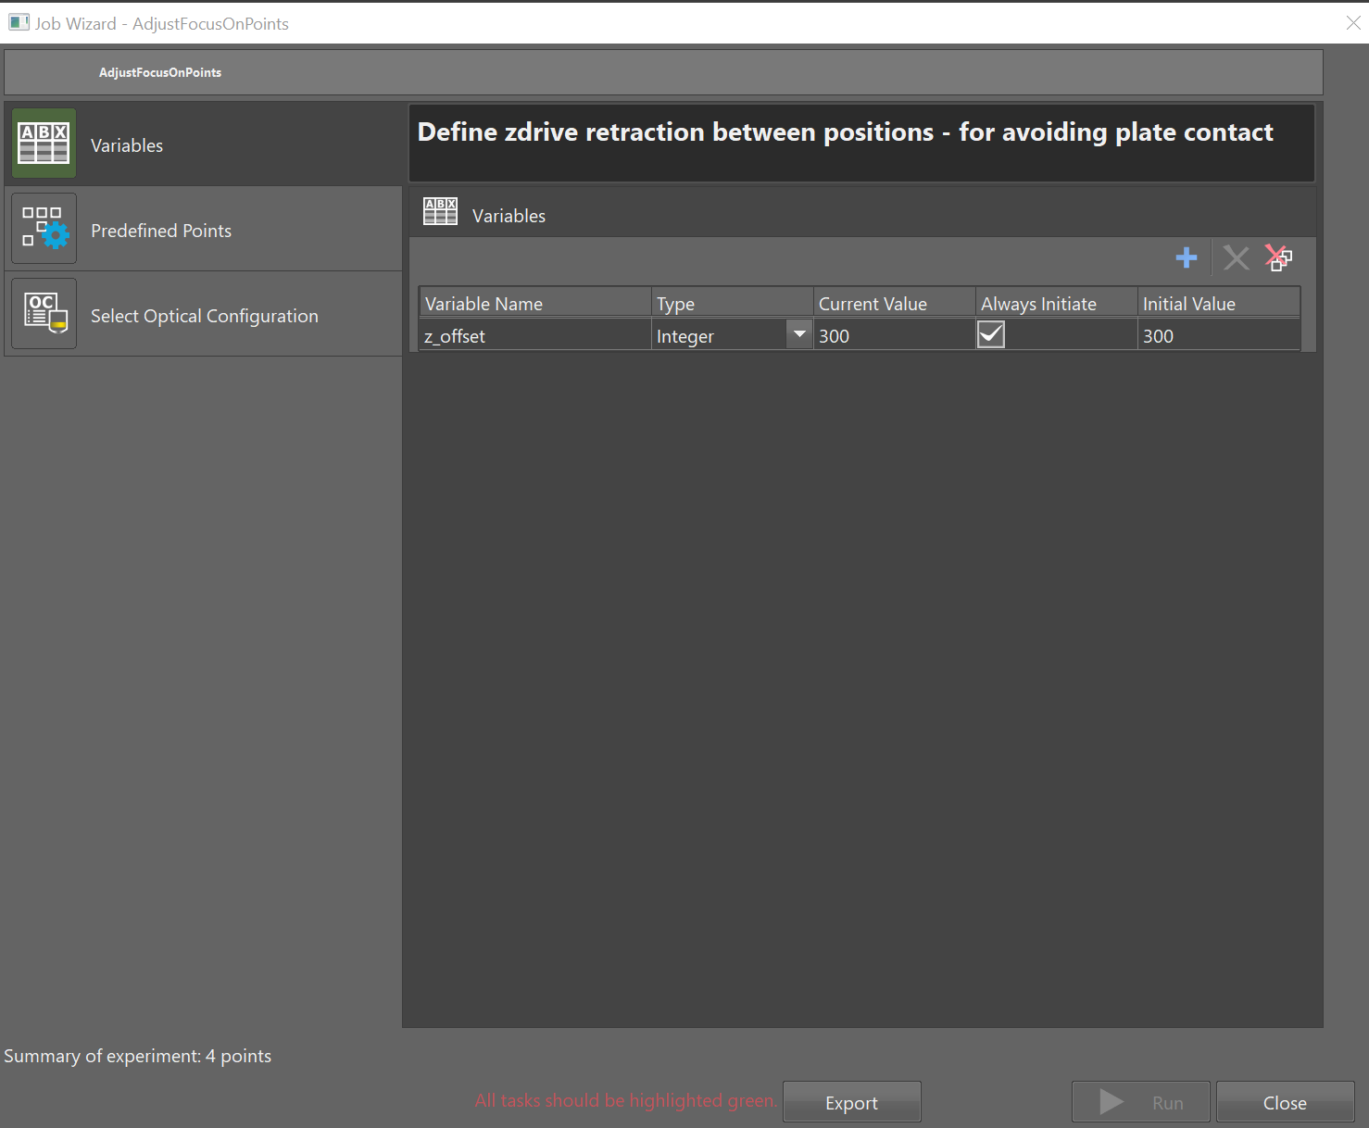

* The z_retract variable specifies how far the microscope objective is retracted from the Ti2 ZDrive value of the current position before moving to the next position in the position list.
* Set the z_retract variable to a number that avoids the chance of the objective colliding with the plate during stage movements. The value should be higher if you know that the base of the plate is not flat.
* We recommend a conservative value of 300 µm, but this depends on the plate being used – see JOBS script ‘GetPlateZProfile’ for a way to measure plate flatness.

# Load position list to iterate over

* The script assumes the user has already generated an xyz position list. Load this list using the wizard.
* Use the NIS-Elements help tool for help on how to use a position list.

# Define wide-field imaging

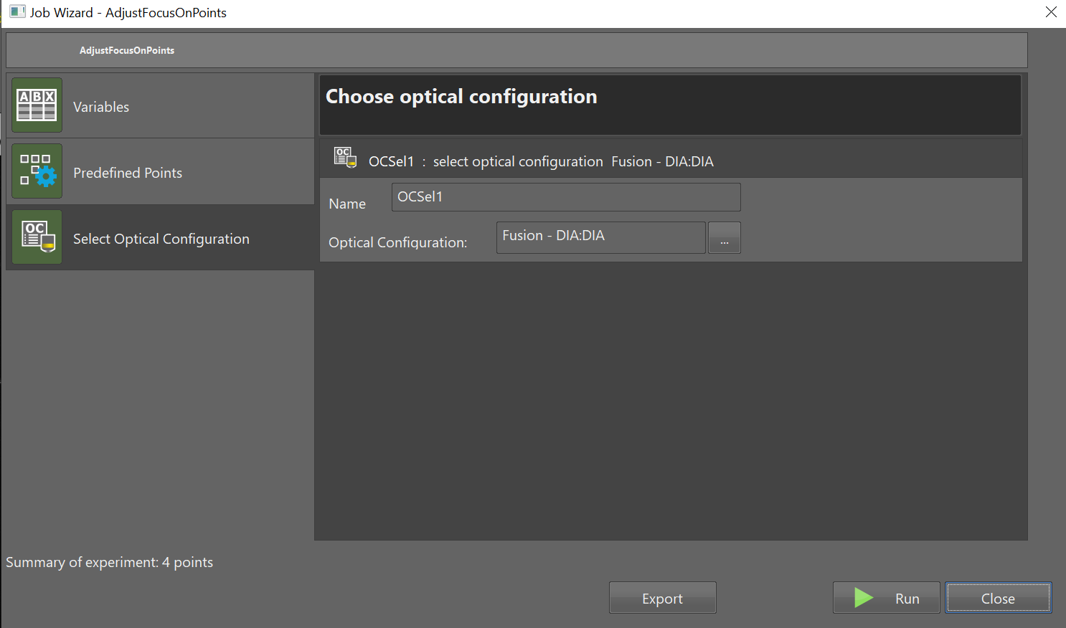

* Choose the wide-field imaging mode – in the example shown above it is brightfield transillumination (diascopic).

# Adjust focus with 60x dOPM objective

* Run the script. There are two buttons involved in adjusting the positions as you iterate through the list:
  + ‘update xyz’ – first recentre in xyz the view using the live image and then press this button. The script then applies the new position values to the current position in the list and moves onto the next entry.
  + ‘next position’ – press this button if the existing entry is adequate. In this case the entry remains unchanged, and the stage is moved to the next position.

# Manual saving of generated ‘NDAcquisition’ tab position list values

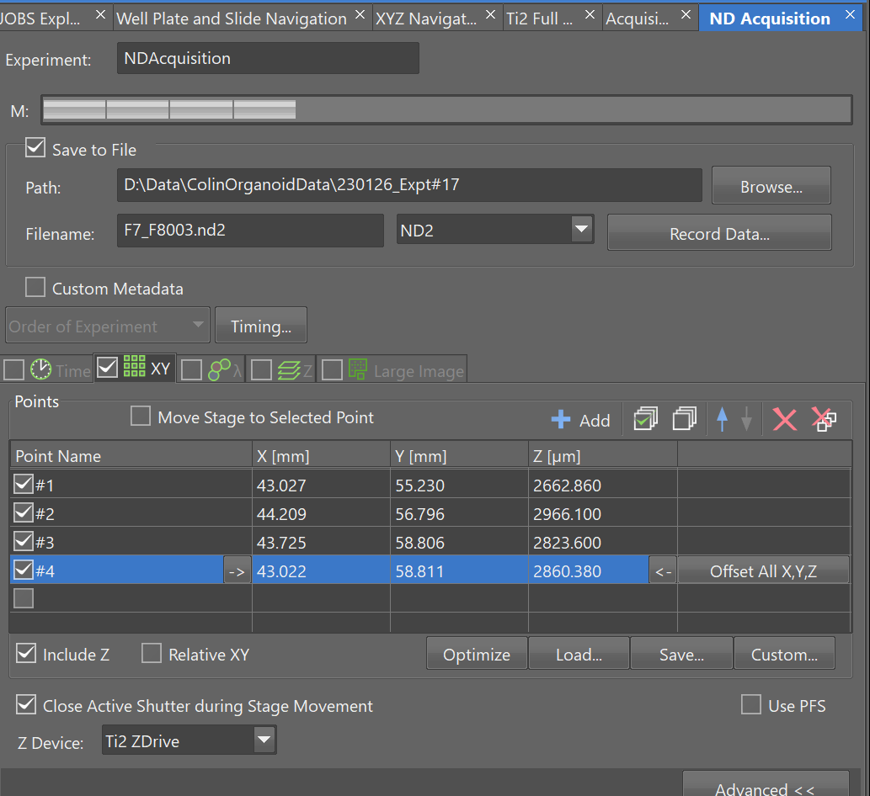

* Once you have iterated through the list, the script exports the updated position list to the ‘NDAcquisition’ modules point list.
* This list can be saved for later use by using the ‘save button’ in the NDAcquisition module.
  + Use the NIS-Elements help tool for help on the NDAcquisition module.

# Script Assumptions

* **The system is thermally stable during the position list refinement.**
* **You are happy to manually find and refine the position list – this solution is not scalable! Can work for a few hundred points…**
* **Positions to be updated are reasonably close to ideal value – i.e. correct to within the field of view of the 60x water immersion objective – otherwise you may end up refining the position to a different region of interest.**