User guide – Brightfield JOBS script

Hugh Sparks and Chris Dunsby

v1.00

25/05/2023

# Prerequisites

* You are familiar with NIS-elements – use the help tool within NIS-Elements and the NIS-Elements manual.

# Notes

* This script is based on a NIS-Elements template JOBS script.
* This script uses a NIS-Elements ‘Wizard’ that guides the user to define important parameters before the script is run.
* The NIS-Elements help tool helps explain how you can use JOBS scripts and gives examples of why they are useful.

# Introduction

This script loops over a previously defined position list and acquires brightfield images from a single z-plane at each position. This script could also be used to acquire epi-fluorescence images by choosing a different wide-field imaging mode within NIS-Elements. This can be used to achieve timelapse imaging of multiple sample positions. It is commonly used for acquiring wide-field images before and after dOPM timelapse imaging to obtain complementary brightfield information of each position in the sample.

Run Brightfield JOBS script

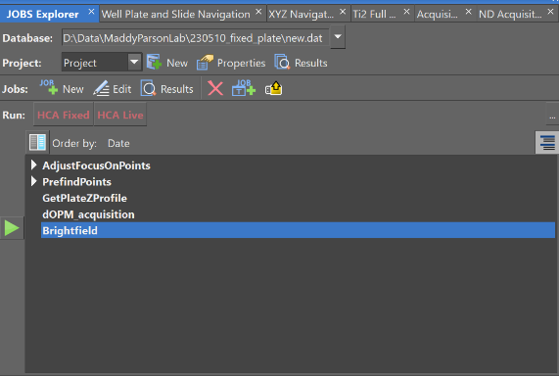

* Run the ‘Brightfield’ JOBS script
* Use the NIS-Elements help tool for help on:
  + Using JOBS Explorer

# Set z_retract parameter

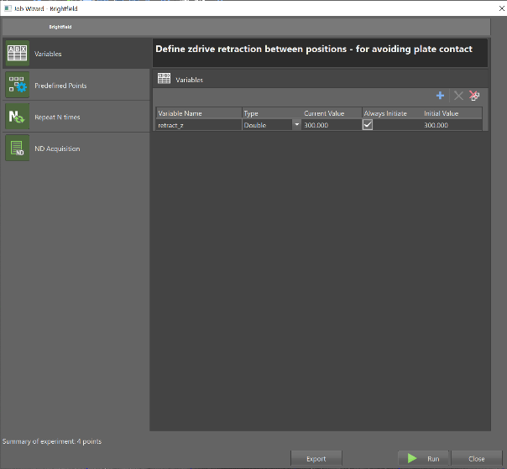

* The z_retract variable specifies how far the microscope objective is retracted from the Ti2 ZDrive value of the current position before moving to the next position in the position list.
* Set the z_retract variable to a number that avoids the chance of the objective colliding with the plate during stage movements. The value should be higher if you know that the base of the plate is not flat.
* We recommend a conservative value of 300 µm, but this depends on the plate being used – see JOBS script ‘GetPlateZProfile’ for a way to measure plate flatness.

# Load a position list to iterate over

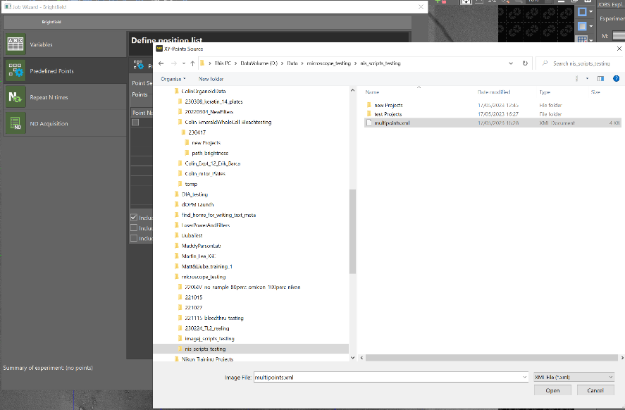

* Load a previously saved .xml or .csv file position list.

Set time-lapse parameters

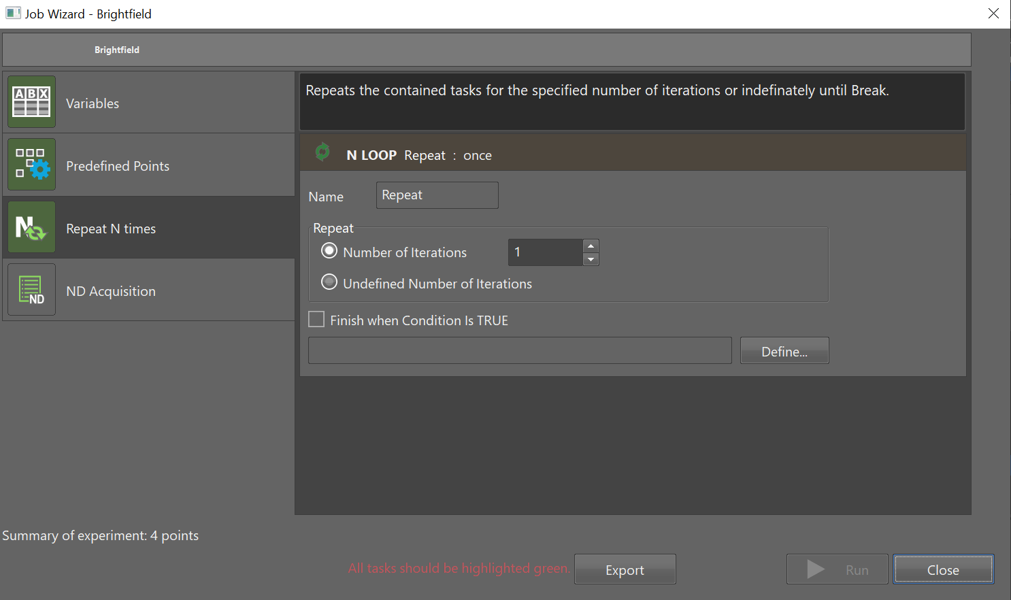

Choose whether to do time-lapse imaging or not.

If you choose time-lapse imaging, define the desired time between images in the time-series.

Ensure that the time between images is longer than time taken to image all positions in the position list.

Use the NIS-Elements help tool to understand timing requirements in time-lapse imaging.

# Define wide-field imaging

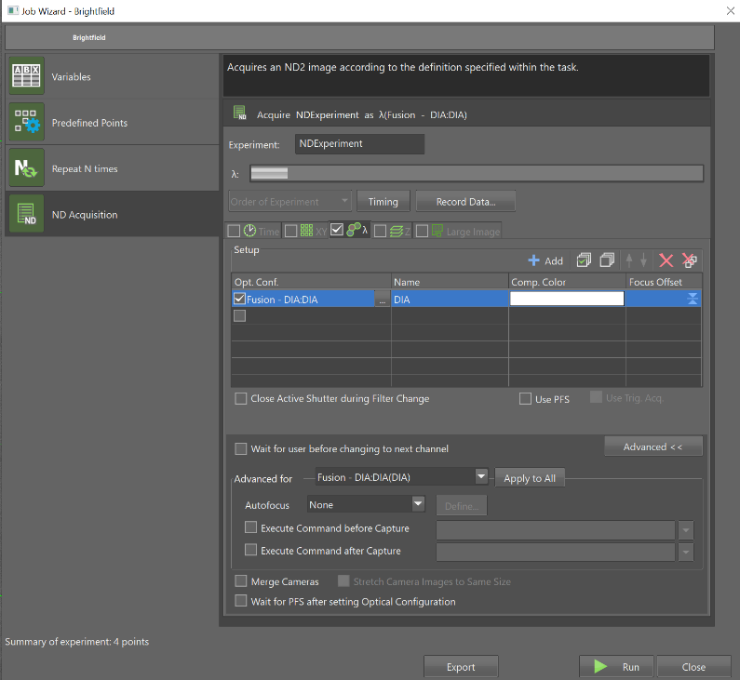

* An embedded ‘NDAcquisition’ is used to define the acquisition parameters at each position. The screenshot shown above shows the configuration for wide-field brightfield imaging, but this could be changed to something else if required.

# Run acquisition

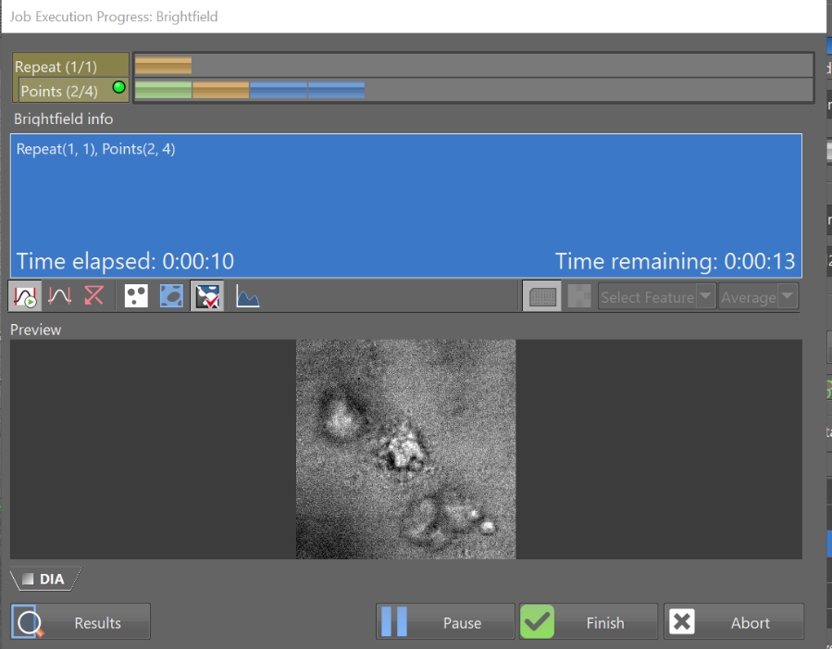

* Run the acquisition – this collects a single image from each xyz location.
* Typically, fast if brightfield and gives snapshot of of xyz position list and whether they match up with regions of interest.

# **Script Assumptions**

* **That a position list has already been defined and saved.**