User guide – GetPlateZProfile JOBS script

Hugh Sparks and Chris Dunsby

v1.00

25/05/2023

# Prerequisites

* You are familiar with NIS-elements – use the help tool within NIS-elements and the NIS-Elements manual.

# Notes

* This script is based on a NIS-Elements template JOBS script.
* This script uses a ‘Wizard’ that guides the user to define important parameters before the scripts is run.
* The NIS-Elements help tool helps explain how you can use JOBS scripts and gives examples of why they are useful.

# Introduction

The goal of this script is to acquire an image with the righthand port (RHP) wide-field camera in the centre of every well of a plate. The images are acquired with Nikon’s Perfect Focus System (PFS) module engaged and with a fixed perfect focus offset. The goal is to use the metadata associated with each acquired image to determine the height of each well – this is achieved by extracting the ‘Z’ value from the metadata of each image. The JOBS Viewer functionality can then be used to visualise the z value for each well overlaid on the plate map. This map can be used to check if the plate insert or plate is tilted or whether the plate is flat.

If a number of images are acquired within each well, this script can also be used to determine if the wells are curved, i.e. whether the profile of the coverslip within each well is concave, convex or flat over its area.

The amount of warping of the plate and the amount of curvature of the coverslip within the wells are both important factors for determining whether it is possible to use the short-working-distance 60x objective used for dOPM imaging.

# Select a long working distance 4x-20x objective that is known to work well with the perfect focus system

# Run the GetPlateZProfile JOBS script

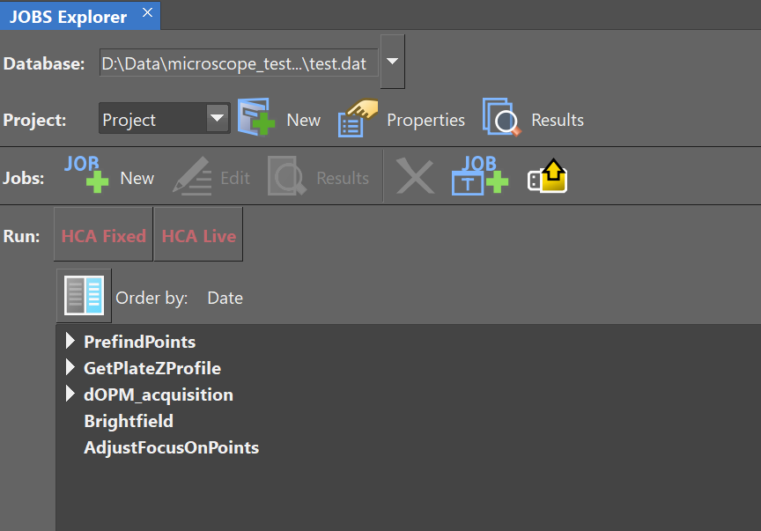

* Select the ‘GetPlateZProfile’ JOBS script from within the JOBS Explorer.
* Use the NIS-Elements help tool to provide more information on JOBS Explorer.

# Select multi-well plate

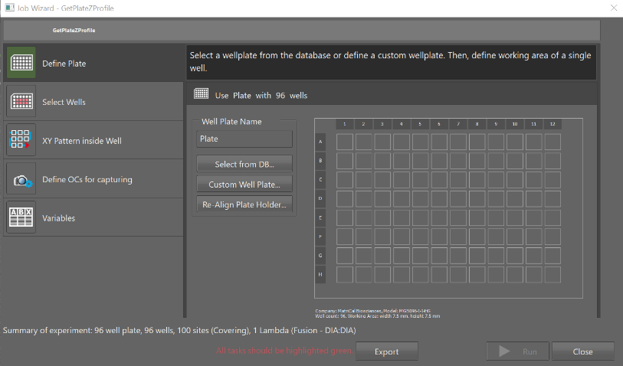

* Selected the plate you are working with, or create a custom design if it is not in the NIS-Elements plate database.
* Make sure that the stage is initialised and the plate has been calibrated with the Märzhäuser x-y stage.
* Use the NIS-Elements help tool for help on:
  + Initialising the stage
  + Calibrating the plate
  + Create a custom plate design

# Select wells

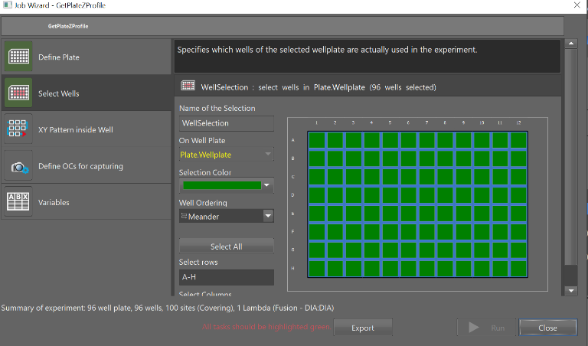

* The aim is to create a plate height map – select all the wells in the plate.

# Set well scan pattern

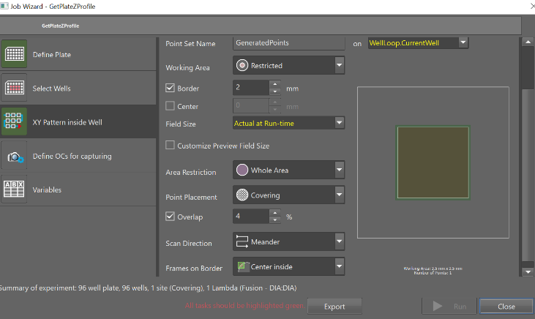

* Select the tile scan pattern to apply to each well.
* Use the NIS-Elements help tool for help on how the different parameters affect the ‘GeneratedPoints’ function, see screenshot above.
* The ‘GeneratedPoints’ function generates a list of relative points per well for tile scanning based on the plate you are using.

# Set widefield epi/trans-illumination mode

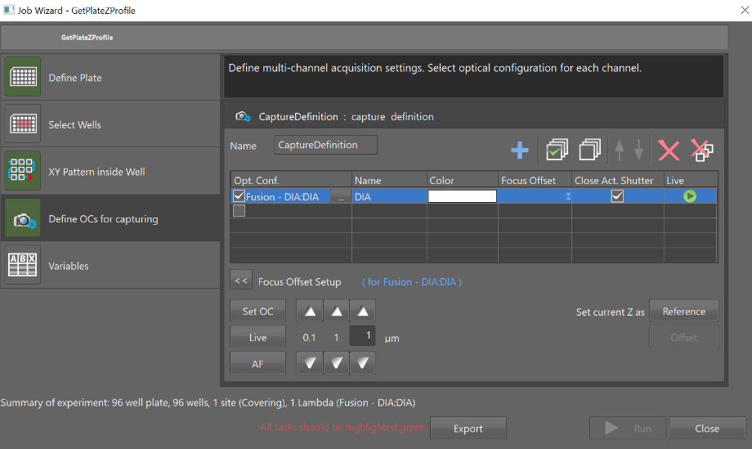

* Choose the wide-field imaging mode you want to use using NIS-Elements JOBS function ‘CaptureDefinition’.
  + For the purpose of this script it does not matter which mode – we recommend to choose a short exposure time brightfield image for fast acquisition.
  + Use the NIS-Elements help tool to help understand how the ‘CaptureDefinition’ function works.

# Set PFS offset

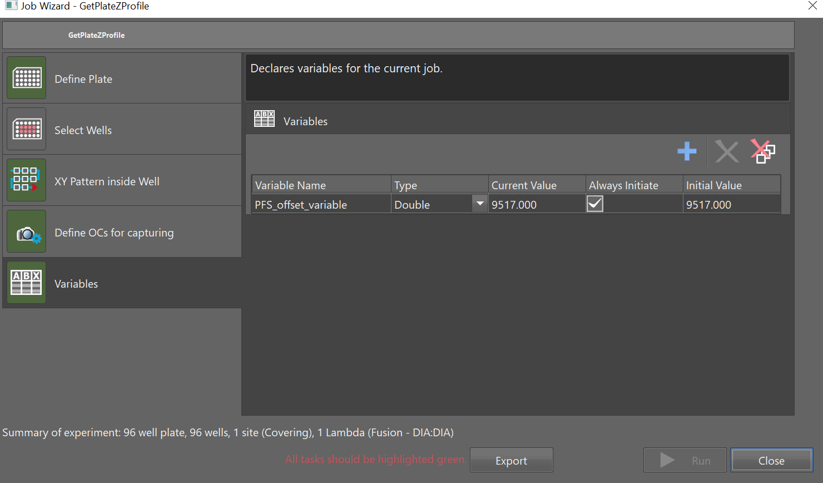

* This JOBS script uses Perfect Focus to acquire z-stacks relative to the plate bottom
* Make sure the Perfect Focus Offset is set to the bottom of the coverslip or the top of the coverslip/sample interface (depending on which one you have chosen as your reference).
* Use the NIS-Elements help tool to help understand:
  + Perfect Focus and Perfect Focus Offset

# Run acquisition

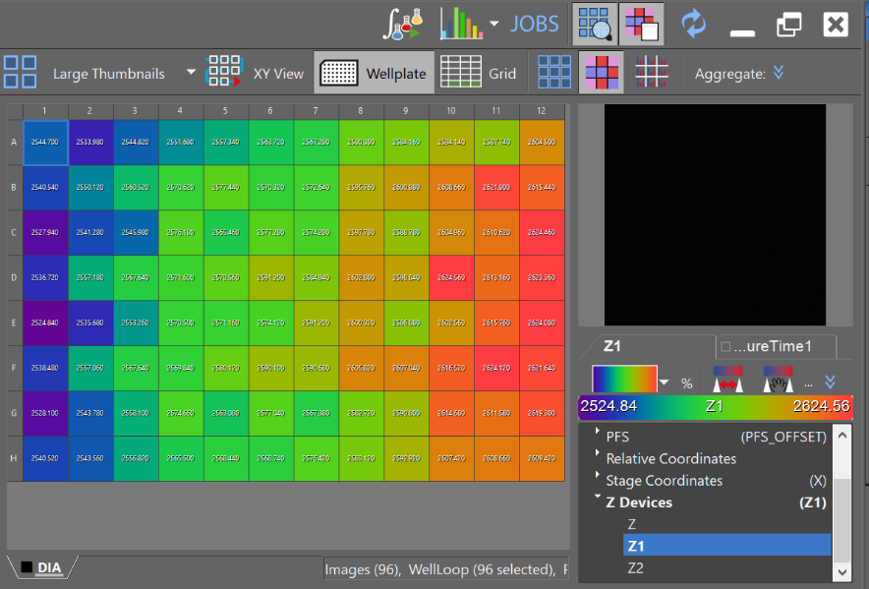

* Example of JOBS Results Viewing tool to get plate height map

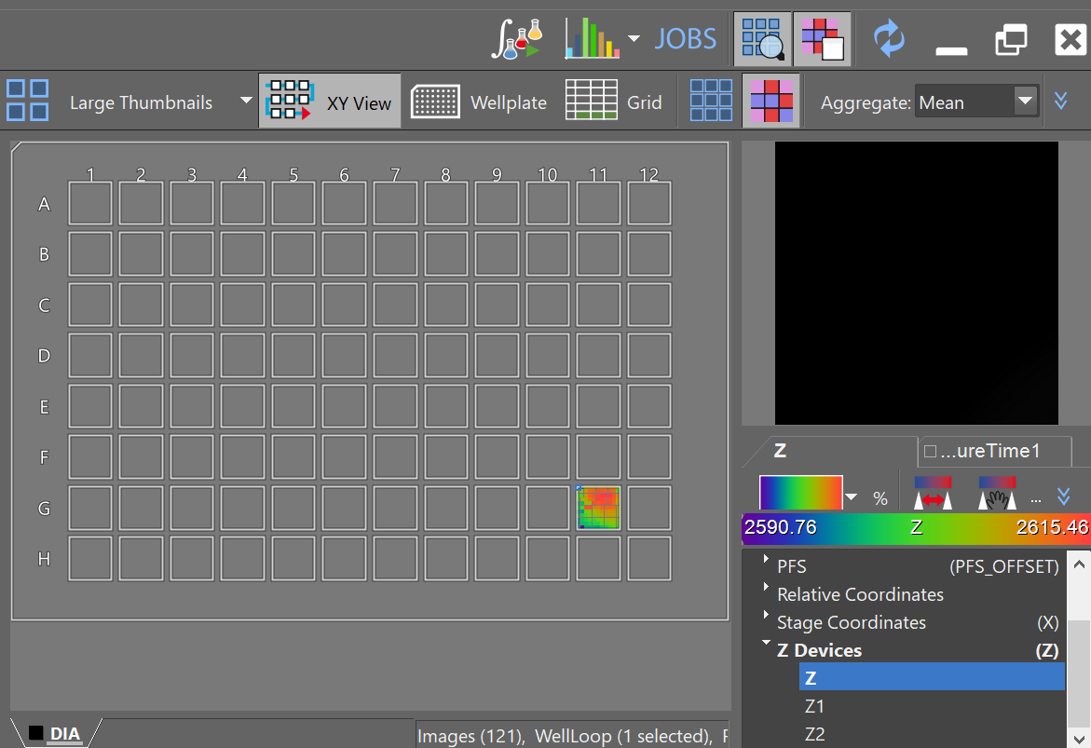

* Example of using the JOBS Results Viewing tool to show the plate height map for a single well.
* This data was acquired when:
  + Only selecting one well in the well selection step above.
  + Using the ‘set well scan pattern’ section to choose an array of points across a single well to get a profile of the well.
* The heatmap shows the well is concave.

# Assumptions

* **The ‘Perfect Focus Offset’ is set to a value that is coincident with the sample-side surface of the coverslip forming the bottom of the plate’s wells.**
* **Using a x4 to 20x air objective, not a short working distance high NA objective like a water immersion 60x**
* **The script needs to start with Perfect Focus System in range, i.e. that the perfect focus system can engage and track the top surface of the coverslip from the start of the script.**