**Prerequisites**

You are familiar with NIS-elements – use help tool within software and in the manual

Note this script is based on NIS-elements template JOBS scripts

Use the NIS-Elements help tool to work out how and why you would want to use JOBS scripts.

Contents

Prefind JOBs script – introduction 1

Select objective 2

Select script 2

Select plate type 2

Select wells 3

Set well scan pattern 4

Set widefield epi/trans-illumination mode 4

Set select z-scan pattern 5

Set PFS offset 5

Run acquisition 6

Postprocessing – stitch tiles 7

Navigate prefind data for manual selection 8

Manually select regions of interest in data 8

Use JOBS results viewer to navigate data 9

# Prefind JOBs script – introduction

* The purpose of this JOBS script is to scan the multiwell plate with a low magnification air objective such as a 4x/10x/20x.
* Typically, the area of interest across each well is larger than the field of view so we need to tile-scan
* Brightfield imaging or epifluorescence z-stacks are acquired with the right-hand port wide-field camera. Using brightfield is desirable as it is fast and low light-dose to the sample- depends on what you are looking for
* This script uses Nikon’s ‘Perfect Focus’ module that can fix the microscopes objectives z-position relative to the top of bottom surface of the plates bottom. This provides a reliable way to acquire z-stacks relative to these surfaces and in doing so ensure the regions of interest generated are within the working distance of the dOPM 60X objective.
* If regions of interest found with the air objective are beyond the working distance of the dOPM water immersion 60X objective then the objective will hit the plate.

# Select objective

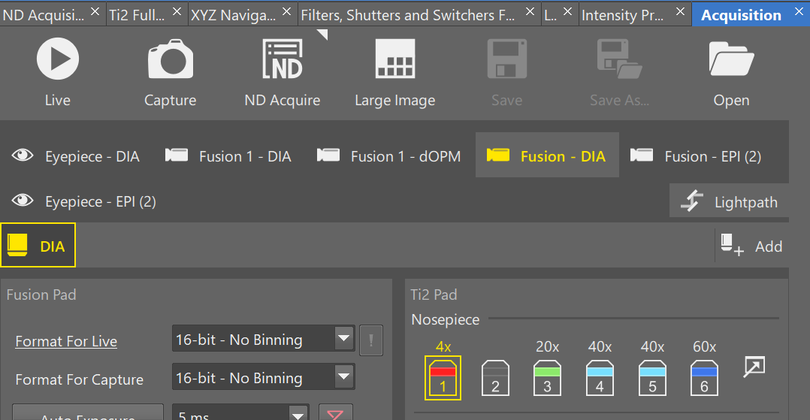

* Go to acquisition tab in nis elements and select suitable low mag air objective considering field of view and resolution requirements for prefind. The smaller the field of view the longer it will take to acquire the prefind.

# Select script

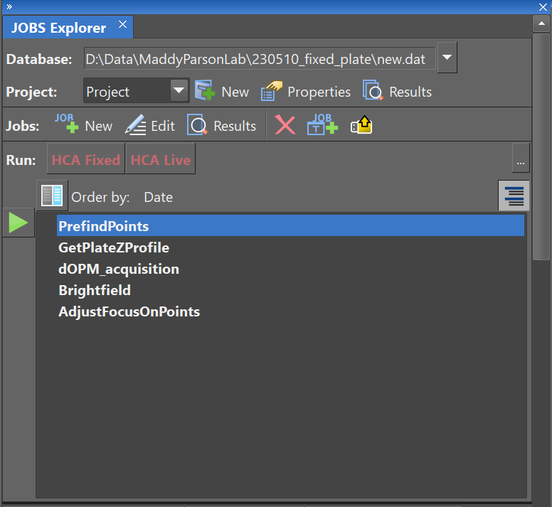

* Select the ‘PrefindPoints’ JOBS script from within the JOBS explorer
* Use the NIS-Elements help tool to work out how and why you would want to:
  + Use JOBS explorer
  + Creating and using JOBS scripts

# Select plate type

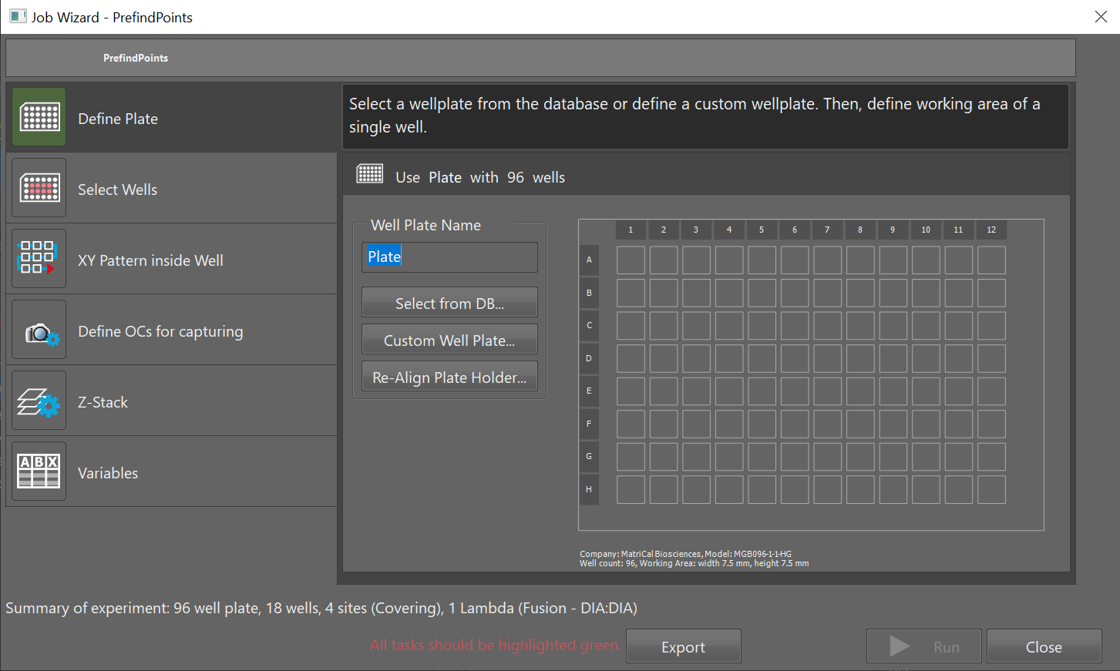

* Assuming the stage is initiated, and the plates have been calibrated with the stage
* Selected the plate you are working with or create a custom design if it is not in the NIS-Elements database
* Use the NIS-Elements help tool to work out how and why you would want to:
  + Initiate stage
  + Calibrate plate
  + Create custom plate design

# Select wells

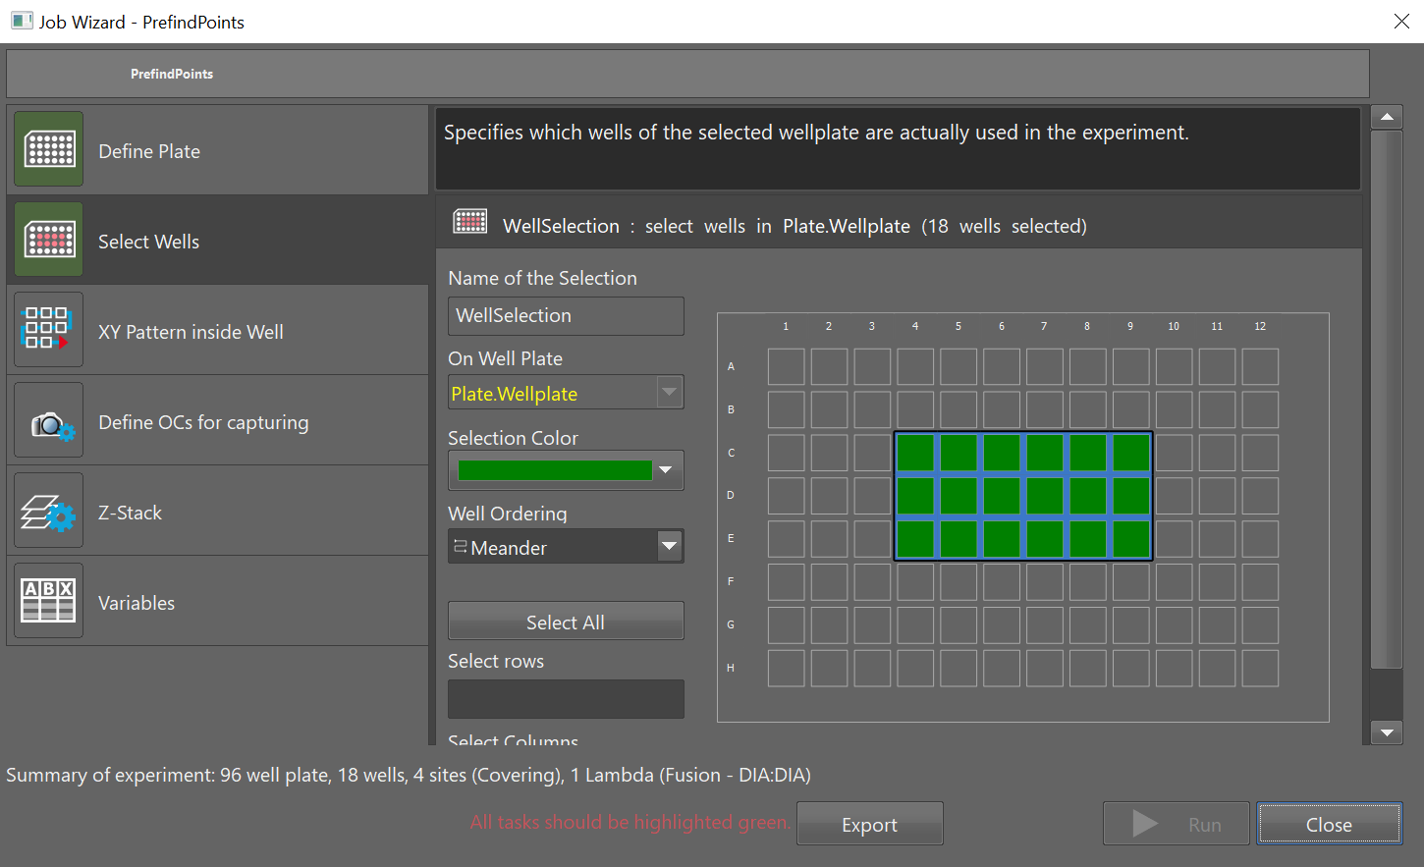

* Select the wells you plan to image i.e. you have a plate-map of seeded wells, you might select all of these wells for prefind

# Set well scan pattern

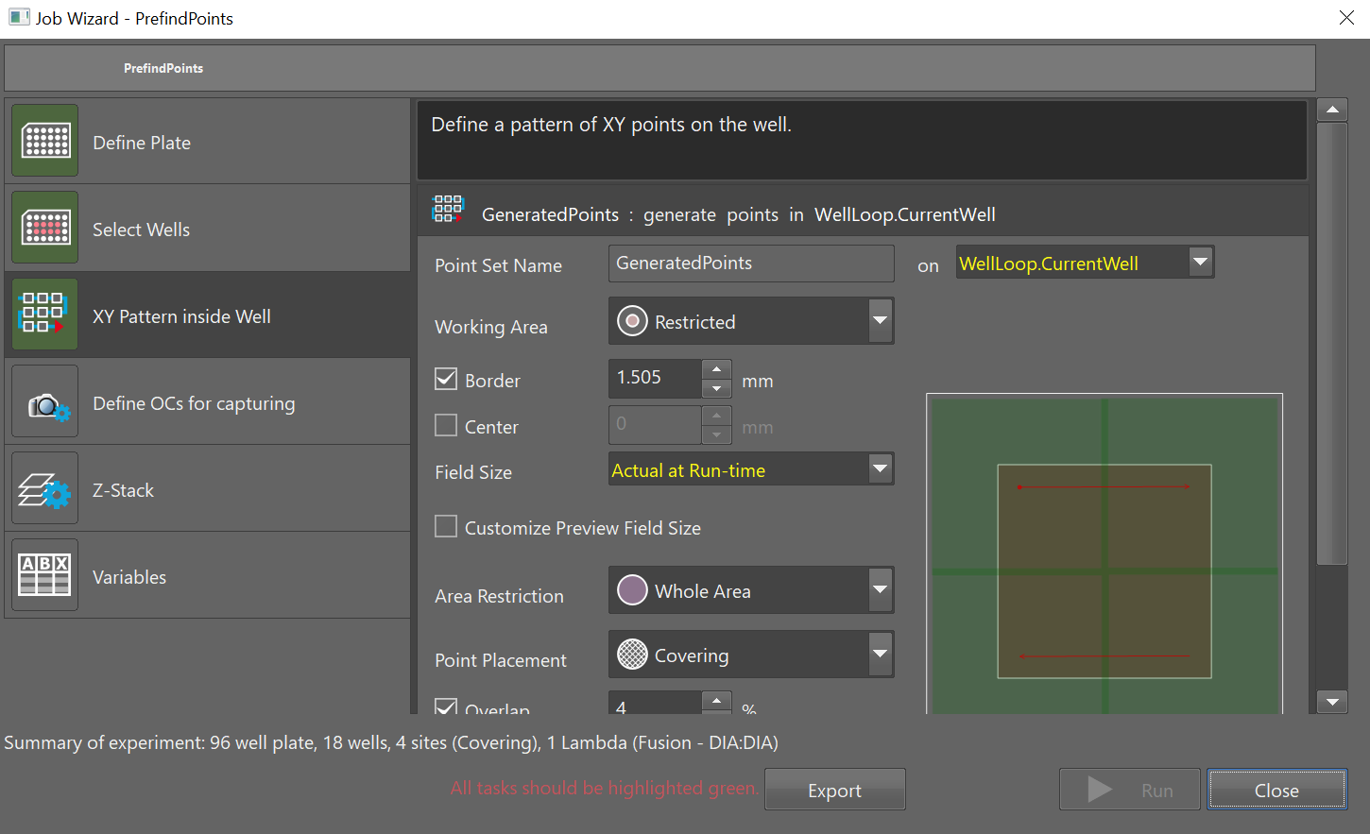

* Select the tile scan pattern to apply to each well.
* Use the NIS-Elements help tool to work out how and why you would want to:
  + Understand how the different parameters affect the ‘GeneratedPoints’ function in the above screenshot.
  + Essentially this function generates a list of relative points per well for tile scanning based on the plate you are using

# Set widefield epi/trans-illumination mode

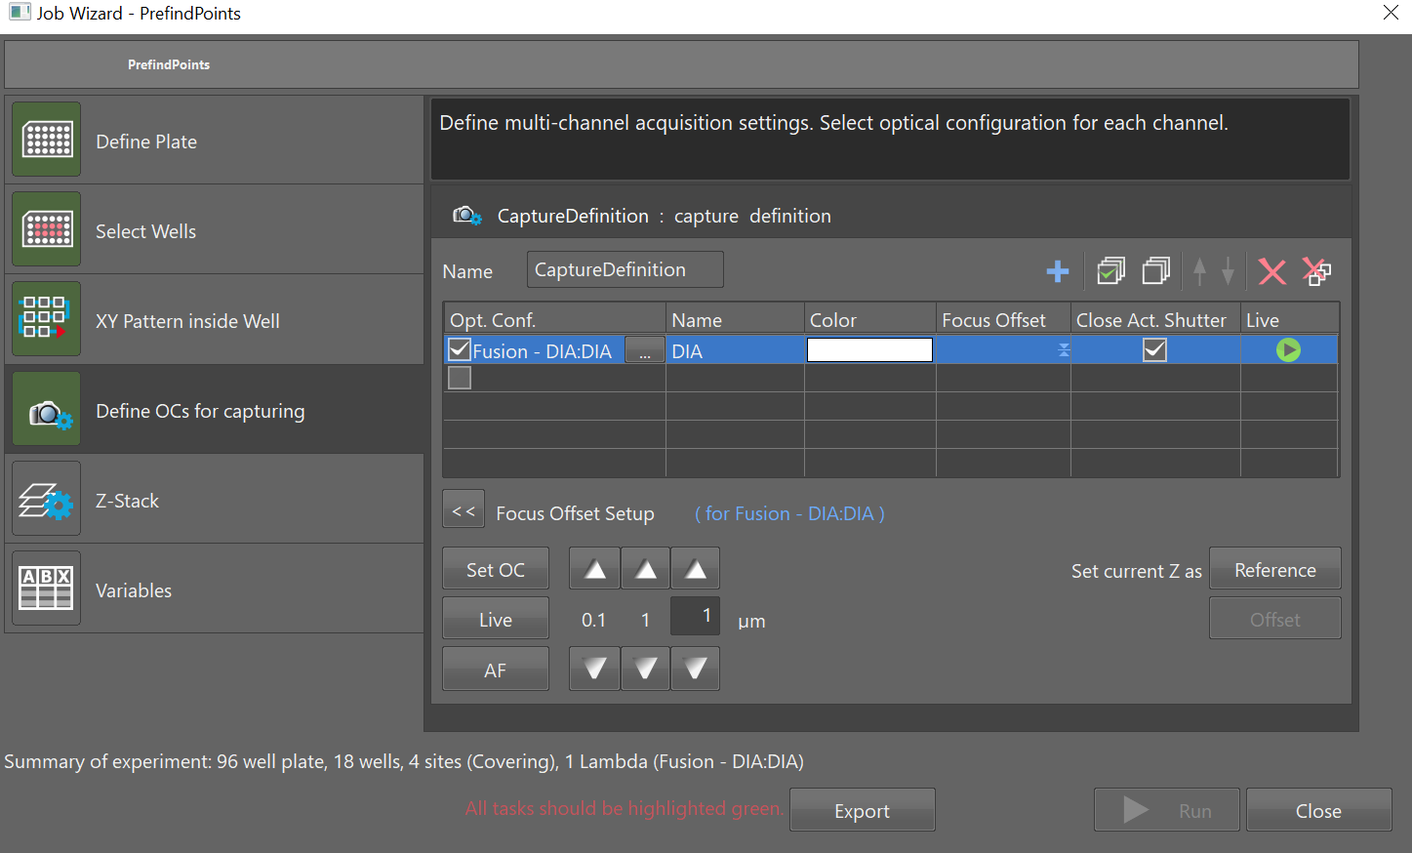

* Choose the type if wide-field imaging mode you want to use using NIS-Elements JOBS function ‘CaptureDefinition’
* Use the NIS-Elements help tool to work out how and why you would want to:
  + Understand how ‘CaptureDefinition’ function works

# Set z-scan pattern

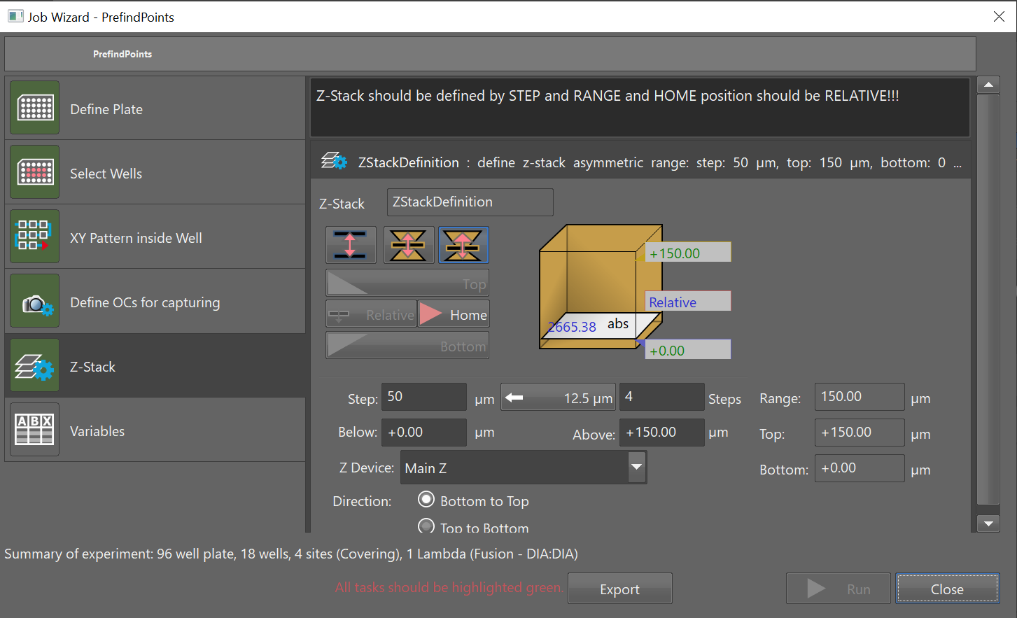

* Choose the z-scan pattern – typically less than 10 planes from 0 µm to less than 280 µm relative to the plate bottom/sample interface (see note below, 280 µm is the working distance of the 60X objective currently used in the dOPM system).
* **Note – for this particular flavour of prefind I use the Perfect Focus hardware to collect z-stacks relative to the** **plate bottom/sample interface. This ensures the prefind will only scan up to a certain depth relative to this point in the sample. This ensures that prefind data is restricted to depths less than the working distance of the 60X water immersion microscope objective used during dOPM acquisitions**

Use the NIS-Elements help tool to work out how and why you would want to:

* + Understand how the ‘ZstackDefinition’ function works
  + Perfect Focus

# Set PFS offset

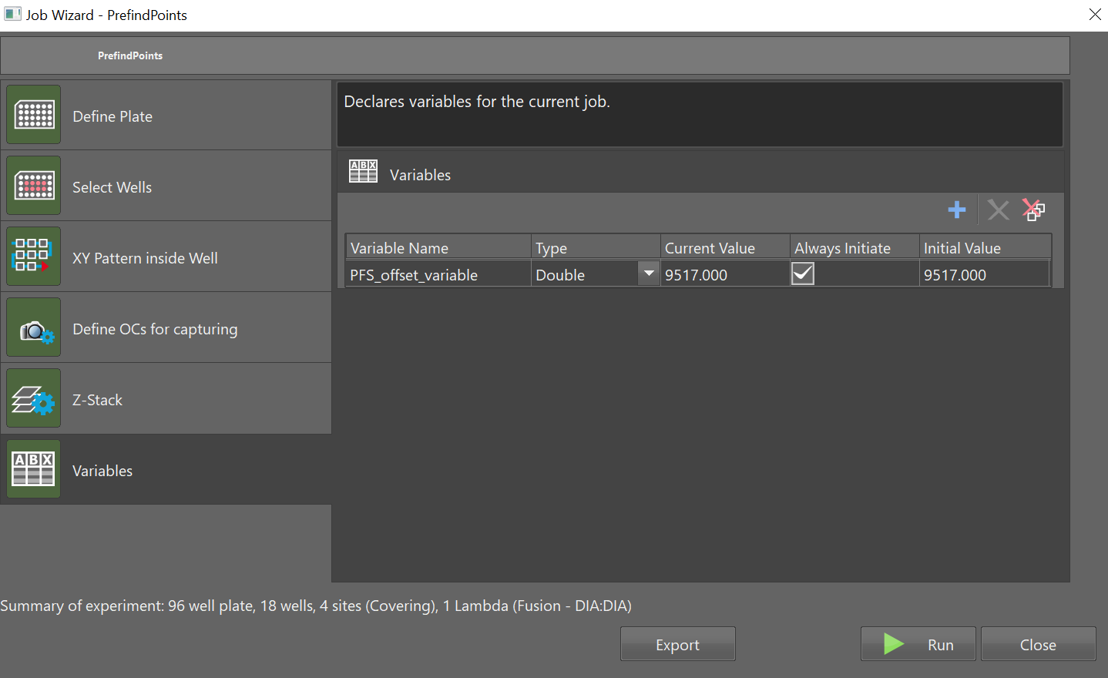

* This JOBS script uses Perfect Focus to acquire z-stacks relative to the plate bottom
* Make sure the Perfect Focus Offset is set to the bottom of the

Use the NIS-Elements help tool to work out how and why you would want to:

* + Perfect Focus and Perfect Focus Offset

# Run acquisition

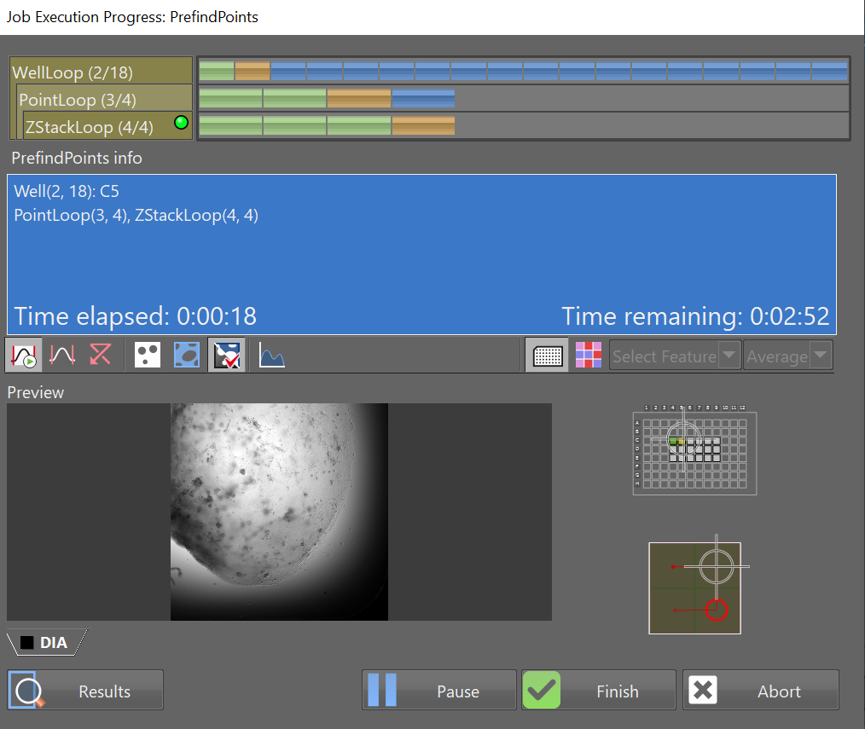

* Run the acquisition. Depending on the number of tiles, z-planes and spectral channels the acquisition will take some time. Fast brightfield imaging with 6 or less z-planes (e.g. 0, 150um in steps of 30 um) and 20x or 4x is usually the best choice in my experience.

# Postprocessing – stitch tiles

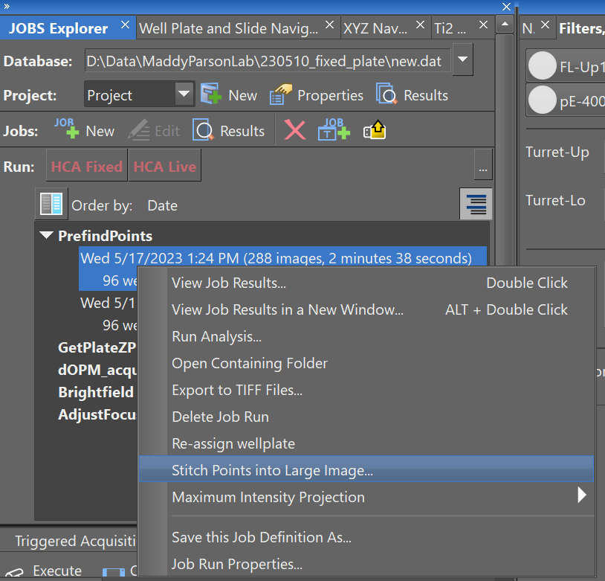

* Once the data is acquired right-click on the JOBS explorer event description and select the stitch points option

Use the NIS-Elements help tool to work out how and why you would want to:

* + Find out about JOBS explorer
  + Find out above stitching and other postprocessing options

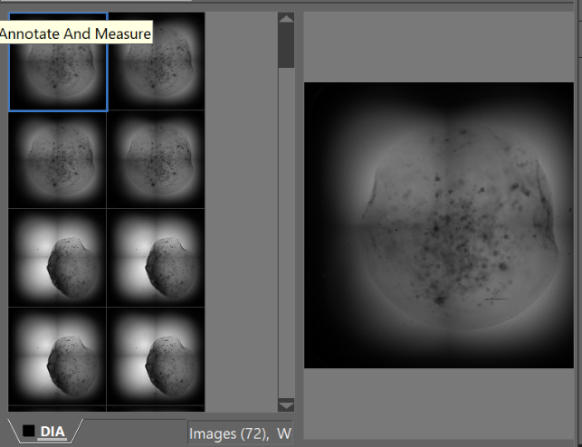

* Here is the output of some stitched brightfield data showing a blob of gel with organoids embedded – 4x data, 4 tiles stitched together, image size about 5 x 5 mm.

Use the NIS-Elements help tool to work out how and why you would want to:

* + Find out about functionality for exploring JOBS results further

# Navigate prefind data for manual selection

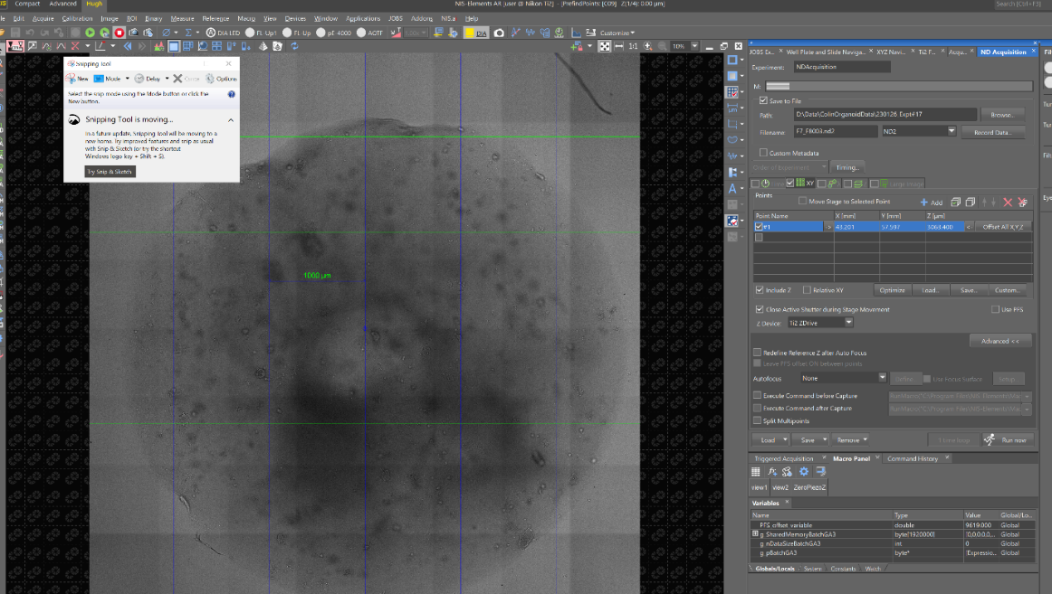

* Once the data has been acquired and stitched you can manually located objects in xyz using the stitched data
* Here a grid has been placed on the image to help keep track of sampling
* On the right hand side a position list can be populated. This position list is part of the ‘NDacquisition’ tab – xyz position lists can be generated, imported and, saved from this tab

Use the NIS-Elements help tool to work out how and why you would want to:

* + Find out about NDacquisition

# Manually select regions of interest in data

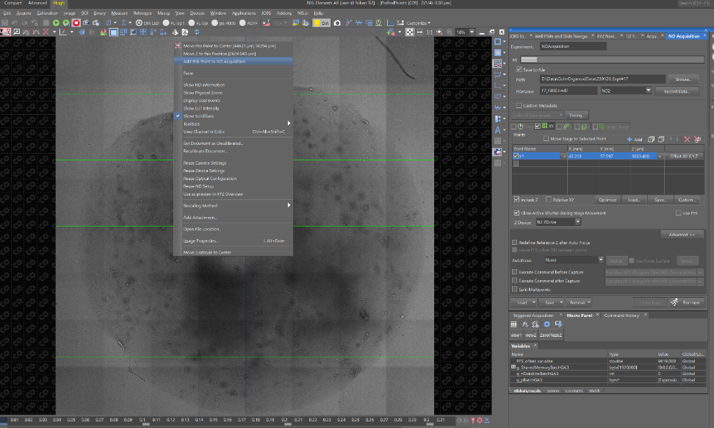

* Try right-click on the stitched data – it will show options to ‘add this point to ND acquisition’
* We use this to populate the ‘NDacquisition’ tab position list on the right hand side

Use the NIS-Elements help tool to work out how and why you would want to:

* + Find out about NDacquisition

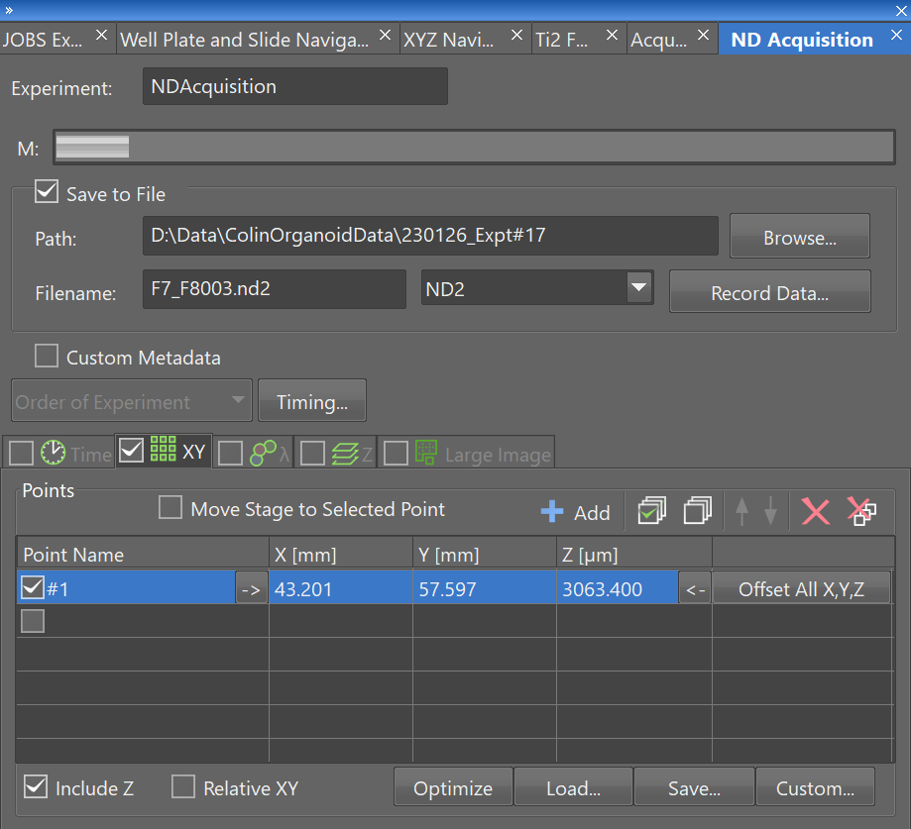

* This just shows the ‘NDacquisition’ tabs position list – only one point in list.
* Note that you can load and save lists as xml or csv files
* In particular csv files can be used to generate position lists from third part software tools which could be useful for custom acquisition routines

# Use JOBS results viewer to navigate data

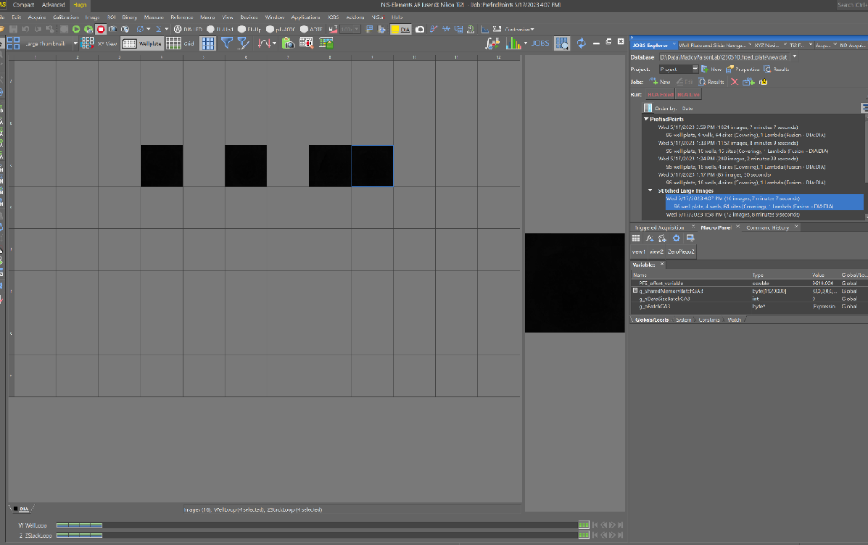

* JOBS viewer presents the acquired data in interesting ways that can help nagivation

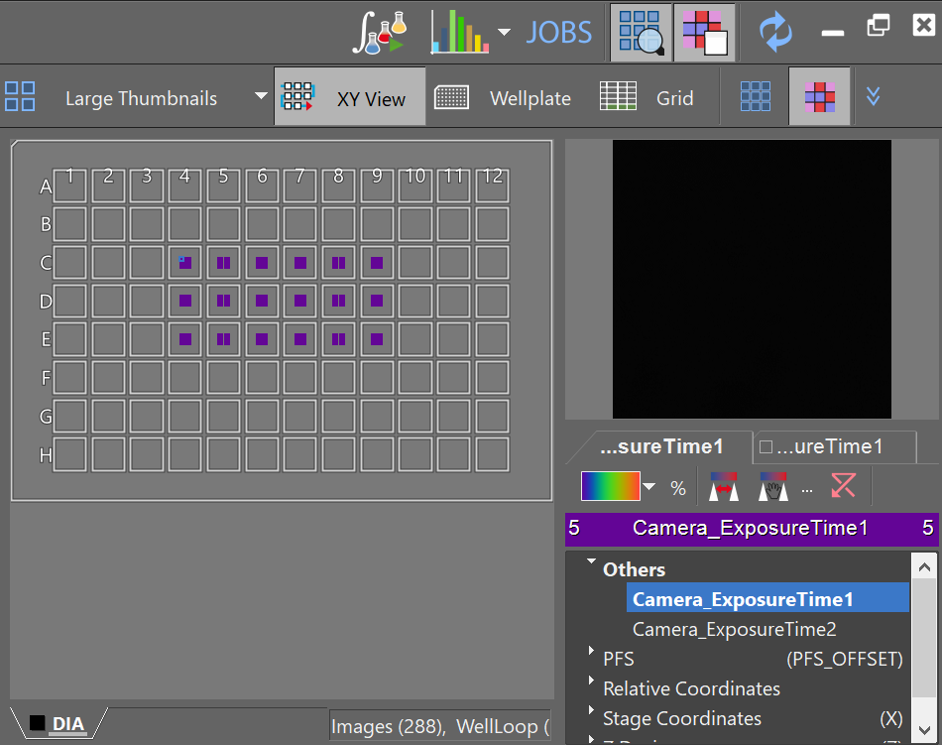

* JOBS results viewer can show properties of data superimposed on the plate which can be useful for navigating and getting summary information about an acquisition

Use the NIS-Elements help tool to work out how and why you would want to:

* + Find out about JOBS results viewer

**Assumptions**

* **The ‘Perfect Focus Offset’ is set to a value that is coincident with the sample side surface of the bottom of the plate’s wells.**
* **The user accounts for well surface curvature and plate curvature when working out what is possible to image in the well without the 60X objective hitting the plate**
* **The script needs to start with perfect focus in range i.e. perfect focus can engage and track from the start of the script**