

**TRIBHUWAN UNIVERSITY**

**INSTITUTE OF ENGINEERING**

**PURWANCHAL CAMPUS**

**A Minor Year**

**Project Proposal**

**On**

**RFID Based Attendance System Using IoT**

**Submitted By:**

ABC

**Submitted To:**

DEPARTMENT OF ELECTRONICS AND COMPUTER ENGINEERING

PURWANCHAL CAMPUS

DHARAN

July 2019

2. **ACKNOWLEDGEMENT**:

In preparing this proposal, we had to take the help and guideline of some respected persons, who deserve our greatest gratitude. The completion of this proposal gives us much pleasure. We would like to show our gratitude to **Department of Electronics and Computer Engineering, Purwanchal Campus**for giving us a good guideline for proposal throughout numerous consultations and lectures.

We would also like to expand our deepest gratitude to all those who have directly and indirectly guided us in writing this proposal. Many people, especially our classmates and team members itself, have made valuable comment suggestions on this proposal which gave us an inspiration to improve our project proposal. We thank all the people for their help directly and indirectly to complete our proposal.

1. **ABSTRACT**:

Radio-frequency Identification (RFID) is one method of Automatic Identification and Data Capture (AIDC). It is a technology that uses radio waves to transfer data from an electronic tag, called RFID tag, attached to an object, through a reader for the purpose of identifying and tracking the object. RFID technology has been widely deployed by various organizations as part of their automation systems. In this study, an RFID based system has been built in order to produce a time-attendance management system. This system consists of two main parts which include: the hardware and the software. The hardware consists of the motor unit and the RFID reader. The RFID reader, which is a low-frequency reader (125 kHz), is connected to the host computer via a serial to USB converter cable. The Time-Attendance System GUI was developed using visual basic.Net. The Time-Attendance Management System provides the functionalities of the overall system such as displaying live ID tags transactions, registering ID, deleting ID, recording attendance and other minor functions. This interface was installed in the host computer.

**Key Words:**

Radio-frequency identification (RFID), RFID Reader, RFID Tags, radio waves.

**TABLE OF CONTENT:**

**I**. **ACKNOWLEDGEMENT**: I

**II**. **ABSTRACT**: II

**TABLE OF CONTENT:** III

**1.** **INTRODUCTION:** 1

**1.1** **Problem Statement:** 1

**1.2** **OBJECTIVES**: 1

**2.** **LITERATURE REVIEW:** 2

**3.** **METHODOLOGY:** 3

**3.1** **Block Diagram:** 3

**3.2** **Working Principle:** 3

**3.3** **Flowchart:** 4

**3.4** **System Requirement:** 5

3.4.1. Arduino: 5

3.4.2. Liquid Crystal Display (LCD) 5

3.4.3. RFID Reader: 6

3.4.4. WIFI Module: 6

**4.** **EXPECTED OUTPUT:** 7

**5.** **PROJECT APPLICATION:** 7

**6.** **PROJECT BUDGET ESTIMATION:** 8

**7.** **PROJECT SCHEDULE:** 8

**REFERENCES:** 9

2. **INTRODUCTION:**

Today in most institution professors take attendance by calling out names or passing a sheet of paper. Both way have respective drawbacks. For this reason college needs to create a system to monitor student’s attendance. This project is to simplify attendance recorder system by using RFID. Radio-frequency Identification (RFID) is one method of Automatic Identification and Data Capture (AIDC). It is a technology that uses radio waves to transfer data from an electronic tag.

RFID chips contain a radio transmitter that emits a coded identification number when queried by a reader device. Some RFID tags can be read from several meters away and beyond the line of sight of the reader. The application of bulk reading enables an almost-parallel reading of tags. This small type is incorporated in consumer products, and even implanted in pets, for identification.

* 1. **Problem Statement:**

Automation is what today’s era demands is. And automation in taking attendance is the need of the institutes and organizations employing various manpower. The traditional way of taking attendance manually is really time consuming and is more prone to errors. Also in case of supermarkets there are chances of frauds and stealing which can be minimized This paper elaborates the implementation of Radio Frequency Identification (RFID) based Student Attendance Management System using Open Source Software in a multi-user environment. Main concept behind Radio Frequency Identification (RFID) based attendance system is to take the attendance of students or employees in any college or university or company.

This system can be used to allow access for student in school, college, and university. It also can be used to take attendance for workers in working places.

* 1. **OBJECTIVES**:
* To uniquely identify and to make security for a person.
* To automatize the attendance system.
* To record data for working hours of an employee.
* To update the employee and employer about the attendance.
* To analyze the individual attendance and group trends in employee attendance system.

1. **LITERATURE REVIEW:**

**Daniel M Dobkin et. al (2005):** Every RFID system consists of at least one interrogator, more commonly known as a reader, which uses a radio link to communicate with at least one transponder. The tag generally contains one or more integrated circuits, and a unique identifying number stored in non-volatile memory. The reader is often (though not always) integrated into a network in order to make efficient use of the identification data it collects. There are three key architectural parameters that determine the type of RFID system in use: the frequency (practically equivalent to the mode of coupling), the means of powering the tag, and the communications protocol employed.

**Mulla and Chandrashekara (2006):** Application of RFID in Library for physical Information security-A view International Convention CALIBER-2006,500-506 ]:Radio Frequency Identification (RFID) tags come in takes asset tracking to the next level, with smart intelligent tags embedded in the package, the information on the tag can be scanned and updated automatically by readers. RFID technology provides an automated method to collect product or transaction information. The RFID system works using ―smart‖ tags, with inbuilt silicon chips that store data, a reader that scans information from the tags, and the infrastructure to store and analyse the data.

**Ahuja Sanjay and Potti Pavan (2010) :** RFID is still in a developing phase and more is in the pipeline in terms of new applications. Among applications already developed, RFID tags are being used in clothing for billing and security purposes. RFID tags are embedded inside animals for tracking purposes. RFID tags embedded in uniforms can be used to know the number of hours an employee spends to complete a particular task. There are several associations that are protesting against the use of RFID to track people fearing the impact on people’s social life and privacy.

1. **METHODOLOGY:**
   1. **Block Diagram:**

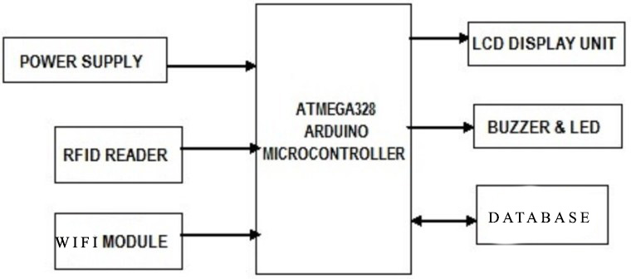

Fig: Block Diagram of RFID based Attendance System.

* 1. **Working Principle:**

The admin of the system will upload the unique tag number and information of the employee in the database .On the other side when RFID card is shown to RFID reader it detects the unique tag. This unique tag is compared with the tag information uploaded by the admin in the database. When the two tag number matches then the attendance becomes successful and the attendance is updated in the system. The recorded attendance can be viewed by individual employee by logging in with their own login id whereas the overall attendance system can only be accessed by admin.

* 1. **Flowchart:**

START

RFID TAG SENDS DATA TO

RFID READER

READER GETS THE

MESSAGE AND SENDS TO

THE ATTENDANCE

APPLICATIION

ATTENDANCE SYSTEM

CHECKS DATA AND

COMPARES WITH

DATABASE

DOES DATA MATCH WITH DATABASE?

RECORD THE TIME AND

DISPLAY THE

INFORMATION

ATTENDANCE IS NOT

TAKEN

YES

NO

STOP

SCAN THE RFID TAG

* 1. **System Requirement:**

Software Used:

* Arduino IDE
* XAMPP
* Sublime text

Hardware Used:

3. 4. 1. Arduino:

Arduino is an open-source electronics platform based on easy-to-use hardware and software. Arduino Boards are able to read inputs - light on a sensor, a finger on a button and turn it into an output - activating a motor, turning on an LED. You can tell your board what to do by sending a set of instructions to the microcontroller on the board. To do so one uses the Arduino Programming language and the Arduino Software (IDE), based on Processing.

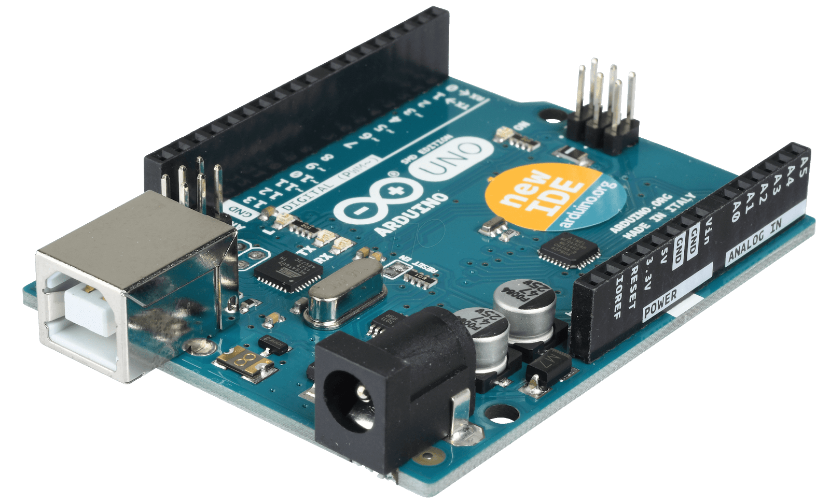

Fig: Arduino UNO ATmega328

* + 1. Liquid Crystal Display (LCD)

LCD which is commonly known as Alphanumeric Display can display Alphabets, Numbers as well as special symbols thus alphabets. Graphic display has embedded controller for controlling different modes. Special feature of this LCD module is it allows reading of data bytes stored in RAM. We have used 16 x 2 Alphanumeric Display which means on this display we can display two lines with maximum of 16 characters in one line.

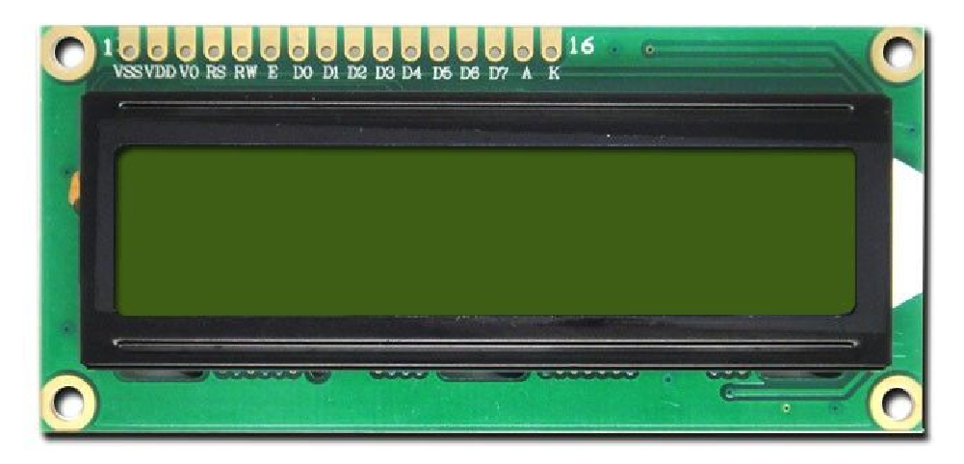

Fig: Liquid Crystal Display (LCD)​

* + 1. RFID Reader:

A radio frequency identification reader (RFID reader) is a device used to gather information from an RFID tag, which is used to track individual objects. Radio waves are used to transfer data from the tag to a reader. RFID reader induces enough power into tag and synchronizes clock to tag. It also acts as a carrier for return data from the tag.



Fig: RFID Reader

* + 1. WIFI Module:

The ESP8266 Wi-Fi Module is a self-contained SOC with integrated TCP/IP protocol stack that can give any microcontroller access to your Wi-Fi network. The ESP8266 is capable of either hosting an application or offloading all Wi-Fi networking functions from another application processor. Each ESP8266 module comes pre-programmed with an AT command set firmware. The ESP8266 module is an extremely cost effective board with a huge, and ever growing, community.

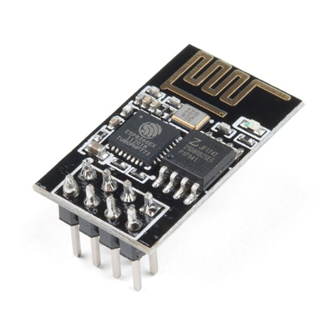

Fig: Wi-Fi Module

1. **EXPECTED OUTPUT:**

The admin of the system will upload the unique tag number and information of the employee in the database. RFID card is shown to RFID reader it detects the unique tag which is compared with the tag information in the database. As the two tag number matches then the attendance becomes successful and the attendance is updated. Recorded attendance can be viewed by individual employee by logging in with their own login id whereas the overall attendance system can only be accessed by admin.

1. **PROJECT APPLICATION:**

The proposed projects have many applications. It helps in tracking attendance of the employee. This system can also be used in many other institutional fields like schools, hospital, etc. This project helps in easy tracking and monitoring the attendance. Along with this rapid and accurate identification make this project more applicable in various fields where attendance is mandatory.

1. **PROJECT BUDGET ESTIMATION:**

|  |  |  |  |
| --- | --- | --- | --- |
| S.N | Material | Quantity | Cost |
| 1. | Arduino | 1 | 1000/- |
| 2. | Wi-Fi Module | 1 | 800/- |
| 3. | Power Supply | 1 | 200/- |
| 4. | Buzzer | 1 | 40/- |
| 5. | Bread board | 1 | 350/- |
| 6. | RFID sensor | 1 | 900/- |
| 7. | RFID access card | 5 | 50/- |
| 8. | LCD | 1 | 750/- |
| 9. | Miscellaneous | - | 1000/- |
| 10. | Total | - | 5090/- |

1. **PROJECT SCHEDULE:**

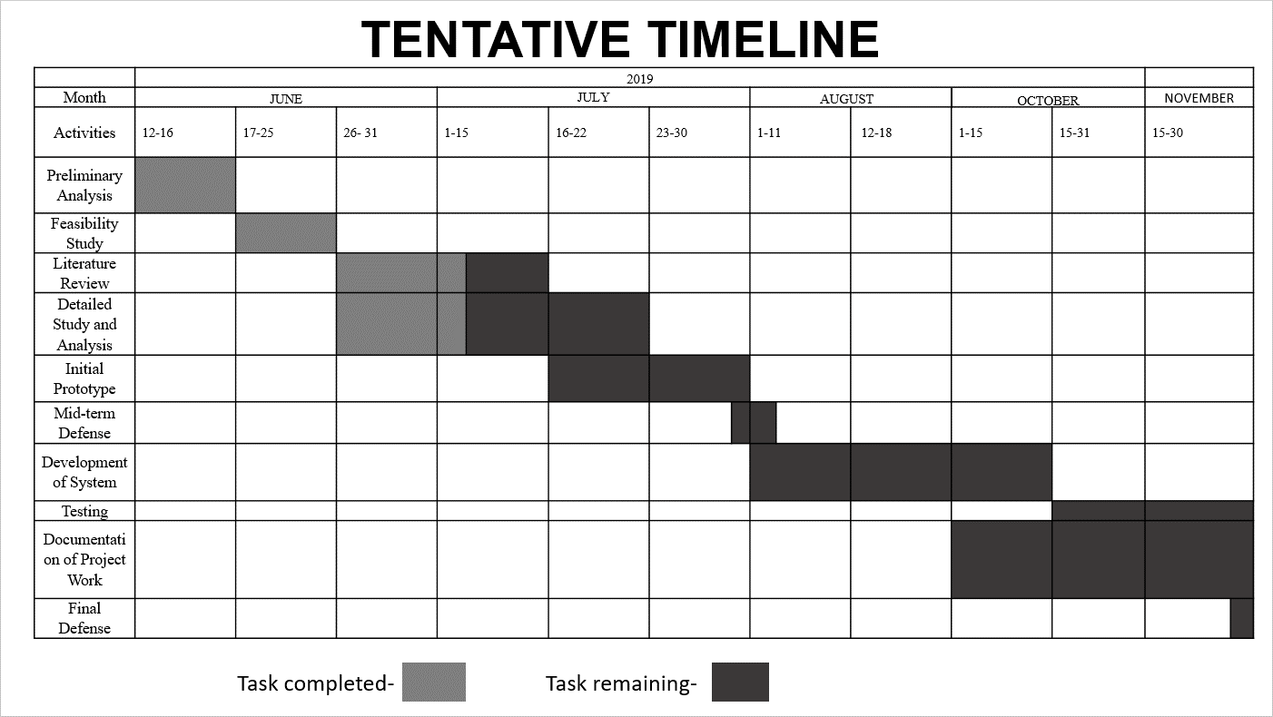

# **REFERENCES:**

[1] Al-Naima, Fawzi & Ameen, Hussein. (2016). Design of an RFID-based Students/Employee Attendance System. Majlesi Journal of Electrical Engineering. 10. 23-33.

[2] Saparkhojayev, Nurbek & Guvercin, Selim. (2012). Attendance Control System based on RFID-technology. International Journal of Computer Science Issues. 9.

[3] Yuru, Z., Delong, C., & Liping, T. (2013). The Research and Application of College Student Attendance System based on RFID Technology. International Journal of Control and Automation, 6(2), 273-282.

[4] Baban, M. H. M. (2014). Attendance checking system using quick response code for students at the University of Sulaimaniyah. Journal of Mathematics and Computer Science (JMCS).

[5] M.Praveen Kumar and B.Mani Kumar. (2015). RFID based Attendance monitoring system Using IOT with TI CC3200 Launchpad. International Journal & Magazine of Engineering, Technology, Management and Research, 2(7), pp. 1465-1467.

[6] D. Miorandi, S. Sicari, F. De Pellegrini, and I. Chlamtac, “Internet of things: Vision, applications and research challenges,” Ad Hoc Netw., vol. 10, no. 7, pp. 1497–1516, 2012.