Getting the files

1. Visit the url <https://github.com/Impreshin/Impreshin-Docs>
2. 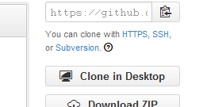Click the “Clone in desktop” button
3. Install the application (it downloads a downloader installer.. 500 odd kb that downloads the main installer of around 41mb)
4. 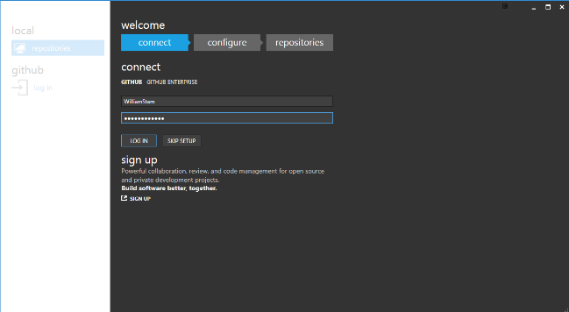Sign into github for windows and click login
5. Add your name and email address and click continue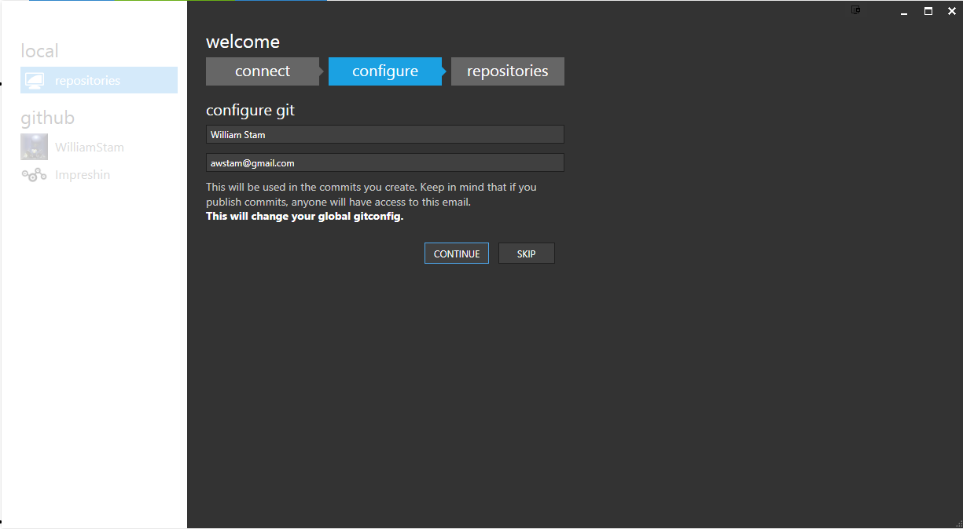
6. Click skip under repositories
7. 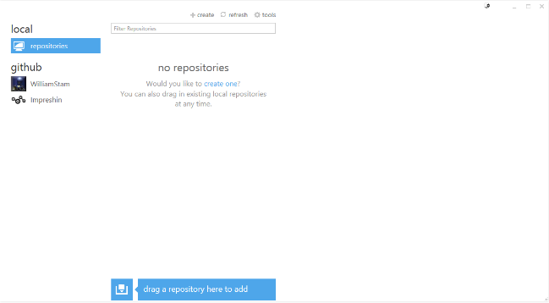You should have a window like
8. Click on impreshin on the left under github
9. 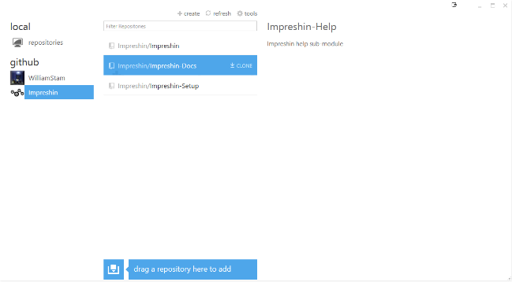Click Impreshin-Docs
10. Click “clone”
11. 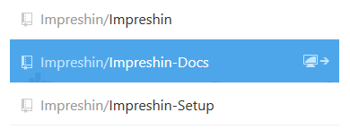should result in it changing to this
12. 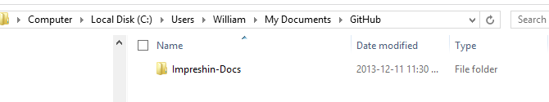Now go to your “My Documents” folder or “C:\Users\<username> \Documents\GitHub”
13. 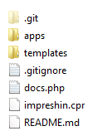Inside the folder you should have some files and folders

Making changes to the files and adding new files

Look inside the “apps” folder inside Impreshin-Docs.

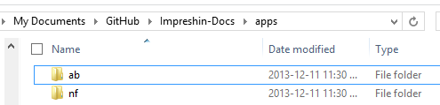

Inside each app folder you will find a structure like



The docs.php file is the main brains for the whole documentation site. You can open it in dreamweaver / notpad++ etc

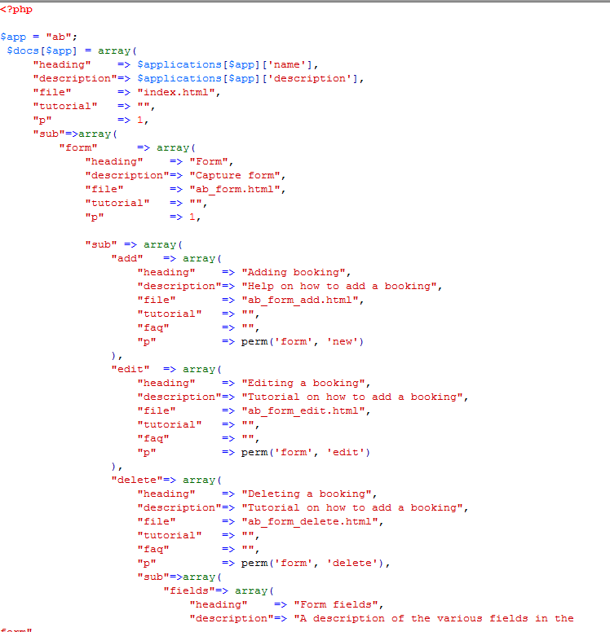

The idea around this file is

If you go to the url “/app/ab/documentation/form/edit” it will load the form->edit part

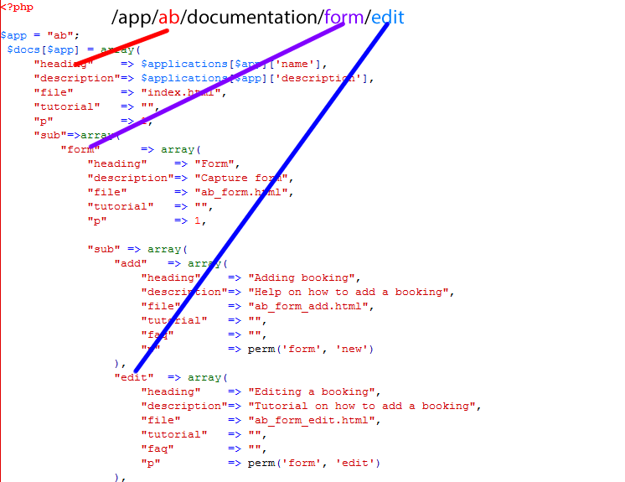

Each new sub page gets added to the “sub” of the parent.. so if you want a page “/app/ab/documentation/form/edit/something”

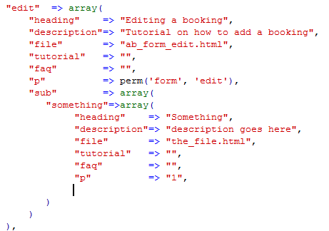Your docs.php page will look like

Each “page” needs a corresponding item in the array

url_piece => array(

“heading” => “Heading for the page”,  
"description" => "Quick description of the page",  
"file" => "filename.html",  
"tutorial" => "",  
"p" => “1”

)

The url_piece is the /urlpiece in the url. No spaces and no special characters

File => goes into the files folder. This is the html page that gets loaded when you navigate to the url that gets built up using the url piece. Don’t include the <head> tags. This must ONLY be the content html. (you can add styles to it inline)

“p” => “1” in the above eg shows that this record must be visible to the user. Using perm('form', 'edit'), it would check if the user has a form -> edit privilege before displaying the page / item in the list. For a list of permissions use this url <https://github.com/Impreshin/Impreshin/blob/master/apps/ab/permissions.php>

If you want to only show the page if the user has “check” privilege enabled.. your perm() would look like perm(“details”,”actions”,”check”)

The html files and images…..

All images in the html files must go into the “images” folder inside “html”. The img src must point to /docs/apps/ab/html/images/image_filename.png simply putting it in as images/image_filename.png wont work

So for instance <img src="/docs/apps/ab/html/images/ab_bookings.png" width="600" height="575" class=”img”/>

Also include the images width and height

To add a “glow” to the image (used for inline images) add class=”glow” to the   
<img src=”…” class=”glow img” width=”…” height=”…” />

Wrap steps in <article> tags

So for instance

<article>

<h4>Step 1 <small>Getting to the form page</small></h4>

On the top toolbar click the

<img src="/docs/apps/ab/html/images/form_new_btn_navbar.png" alt="Plus" width="41" height="18" class="glow" style="width: 41px; height: 18px;">. This will take you to the application form.

<div class="clearfix"></div>

<img src="/docs/apps/ab/html/images/form/top_nav.fw.png" alt="Top Nav Bar" width="271" height="25" class="glow img" style="width: 271px; height: 25px;">

</article>

Notice that the heading is h4 and there is a <small> tag inside it. It would render as so



Done editing.. Now to upload

Open github for windows

On the left you should have “Local”. Click “repositories” under it. Then click on Impreshin-Docs

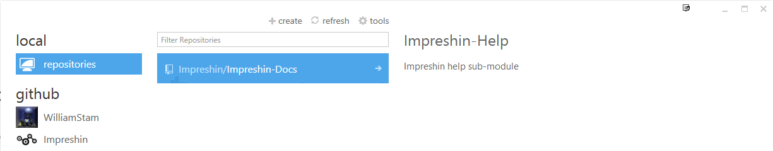

Click the arrow on the Impreshin-Docs button to get the following screen

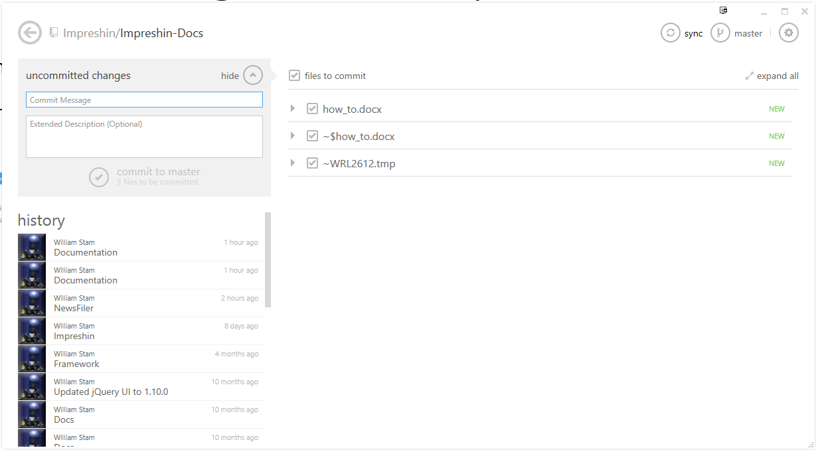

All the changed files / added files should show on the right.

On the left enter a commit message of “Documentation”

In the extended description include a description of your change. Then click “Commit to master”

Notice how it adds the “unsynced commits” to the left hand side.

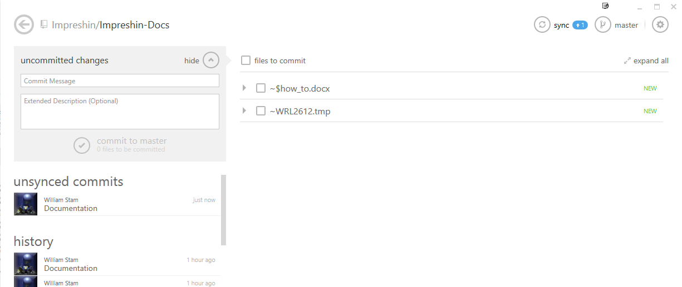

Click “sync” on top to upload the files to github (WARNING: once you click sync the files will be sent to all impreshin installs. So make sure you are ready to upload before doing so)

To view your changes.. go to [http://www.impreshin.com/](http://www.impreshin.com/update) and log in. then click the help button along the bottom of the page