Wrocław, 10.04.2013

Artur Bilski 203806
Marcin Bogusz 203811
Andrzej Dudek 142420
Konrad Kocik 164132

Report
KNIME plugin for data anonymisation

- Plugin overview

A lot of institutions keep huge amount of personal data (surnames, address, credit cards ID). That information can be used for some purposes (statistics, business). It can be good hacking target too. So what we can do to ensure the best security without losing worth and information? How let another company makes analysis on that data without breaking private terms? All this problems resolves operation known as anonymisation.

“Anonymisation is process that removes or replaces identity information from a communication or record. Communications and records may be made pseudonymous, in which case the same subject will always have the same replacement identity but cannot be identified as an individual.” (www.encyclopedia.com)

That operation is main function of KNIME plugin for data anonymisation. It can translate one set of data to another with the same structure as origin and encrypt important information. To provide security, symmetrical translation (encryption and decryption) and constant output for the same input data (very important in anonymisation) KNIME plugin uses key base encryption algorithm (Blowfish).
- Case scenario

  - Non functional behavior

      - Columns are marked with star (*) if they resemble anonymised data
      - Columns that resemble anonymised data, are automatically added to marked columns table

  - Data anonymisation

      - User places anonymisation node on project board and connects clear data on input pin
      - User selects data columns from list in configuration window, which he wants to anonymise, by marking them and adding to affected columns list or removing preadded columns from marked column
      - User selects provider of cryptographic key file:
        - from disk
        - create new and select it for use
      - User confirms the settings

  - Data deanonymisation

      - User places anonymisation node on project board and connects anonymised data on input pin
      - User selects data columns from list in configuration window, which he wants to deanonymise, by marking them and adding to affected columns list or removing preadded columns from marked column
      - User selects provider of cryptographic key file:
        - from disk
        - create new and select it for use – although available for selection, this option will not deanonymise data
      - User confirms the settings

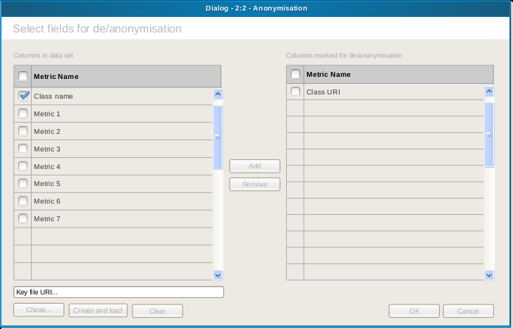
Pic. 1. Configuration dialog wireframe
- Example of a symmetric-key algorithm

  - Brief history of Data Encryption Standard (DES)

In 1972 National Bureau of Standards (presently National Institute of Standards) started a program for securing computers and data transmissions. Part of this program was to create standard and universal cryptographic algorithm for data security.

On May 15th 1973 National Bureau of Standards published in Federal Register a public request for elaborating an algorithm, which fulfills the following criteria:

- High level of security.
- Easy to understand.
- Security based on a cryptographic key.
- Available for all users.
- Flexible for different applications.
- Possible for electronic implementation.
- Effective in use.

Many solutions was delivered, but each and every one of them had very poor quality. Unfortunately all of them was rejected.

On August 27th 1974 National Bureau of Standards once again published a public request in Federal Register. But this time a promising candidate appeared – an algorithm based on IBMs Lucifer. This new proposition was complicated but lucid enough. It used only simple logic operations on small groups of bits, so it was very easy for hardware implementation.

On November 23rd 1976 Data Encryption Standard (DES) was announced as a federal standard and authorized for encrypting all non-confidential government data.

  - Description

DES is a block cipher in which data is encrypted by 64 bit blocks – algorithms input is a 64-bit long plain text and its output is a 64-bit long encrypted text. Also the same algorithm is used for encrypting and decrypting messages. Entire security of this algorithm is based on secrecy of its key.

Any 56-bit long number can be a DES cryptographic key. Few of them are considered to be weak, but they can be easily skipped.

DES algorithm on its lowest level of abstraction is a simple combination of mixing and scattering. DES consists of 16 cycles, in which plain text is subjected to combination of both mentioned technics and cryptographic key:
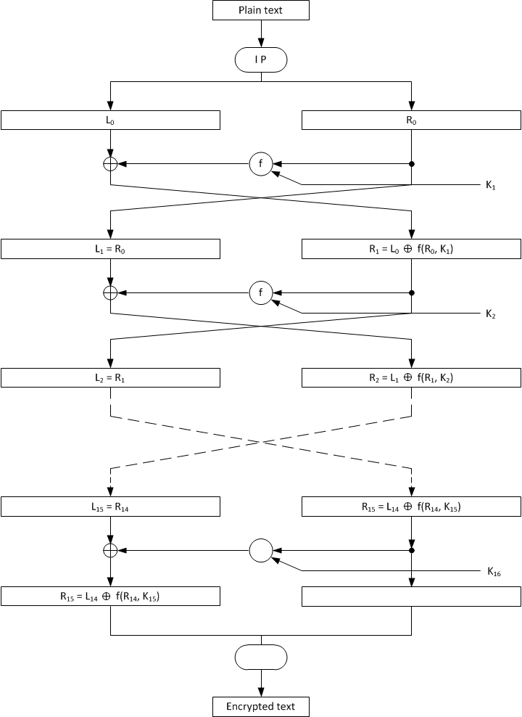

Pic. 2. DES block diagram
DES works on 64-bit long blocks of plain text. After initial permutation input block is divided into two parts (left and right), 32-bit long each. Then, in so-called f-function, data is combined with cryptographic key. F-function is repeated 16 times and after that left and right part is merged together. Eventually a final permutation (inverse of initial permutation) is performed.

  - Cycle

In each cycle key bits are shifted, and 48 bits are selected from all 56 bits. Right part of data is extended to 48 bits using extended permutation, then modulo 2 sum with shifted and permutated key is performed. After that this block of data is sent through 8 S-blocks – additional 32 new bits are generated – and then final permutation is executed. This operations creates the f-function, and its output string is modulo 2 summed with left part of data. This way a new left part of data is created and the old left part becomes a new right part.

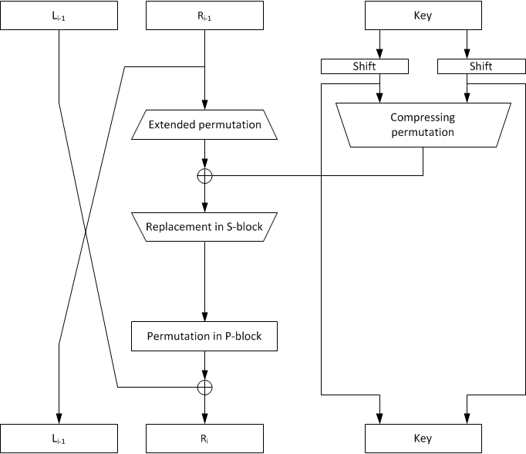
Pic. 3. DES cycle diagram

All steps presented above forms one cycle of DES algorithm, which can be described with two equations:

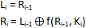

where:

L_{i}, R_{i} – left and right part of data
K_{i} – 48-bit long cycle key
f – the f-function

  - Decryption

Decryption of DES algorithm is very easy – it’s almost the same as its encryption. The only difference is, that the cryptographic keys must be used in reversed order. So, if the encryption keys where used in order K₁, K₂, K₃, …, K₁₆ the decryption keys usage must look like this: K₁₆, K₁₅, K₁₄, …, K₁.

  - 3DES algorithm

To improve DES algorithm security level in some implementations DES is used tree times – then DES is called Triple DES, or 3DES.

Because DES is not creating a group, text encrypted with 3DES algorithm is much more difficult to break with exhaustive search method – it will require 2¹¹² attempts instead of 2⁵⁶ attempts.

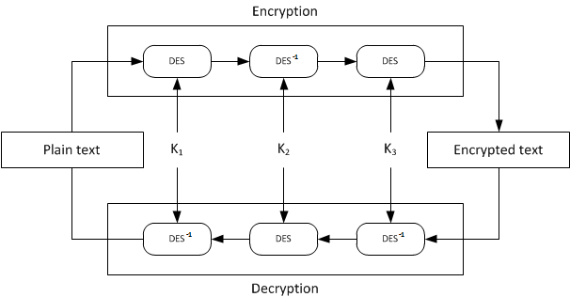

Pic. 4. 3DES algorithm

  - Summary

DES algorithm is very commonly used in many systems. It has very long history of usage and guarantees an acceptable level of security for transferring or storing non-critical data. Its capability to encrypt and decrypt messages with the same cryptographic key is very useful in systems, which needs to encrypt and decrypt same text several times.

- Process of algorithm selection

  - Selection criteria

In process of searching proper symmetric encryption algorithm we were guided by the following criteria (listed from most important to least important):

- Speed of encrypting and decrypting.
- Ease of use (available Java libraries).
- Security level.
- Popularity and recognition.

Short description of the reasons that influenced the selection criteria and determining their weights:

- Speed – to ensure, that work with our plugin will be comfortable and smooth, and in the face of an unknown amount of data which will be anonymised, selecting speed as the main criterion is obvious.
- Ease of use – it was necessary to select algorithm, which was already implemented in some Java library, to avoid necessity of writing it manually.
- Security – the main reason of using anonymisation at all. However, it wasn’t placed as the main criterion because data, which will be encrypted, is not seen as critical (for example it doesn’t contain any personal information).
- Popularity – it is very important, that selected algorithm will not be innovative or unpopular. In this way it will be easy to convince customers to the chosen solution.

  - Candidates

During the search process the following candidates were selected:

- DES (3DES)
- AES
- Blowfish

  - DES (3DES) description

Extended description of the DES algorithm can be found in the chapter “Example of a symmetric-key algorithm”.

  - AES description

Successor of DES, adopted by NIST as FIPS-197 standard. Winner of the competition, which was started due to insufficient strength of the DES algorithm.

Depending on the length of the key, this algorithm performs 10 (128-bit key), 12 (192-bit key) or 14 (256-bit key) encryption cycles. Each cycle consists of a preliminary substitution, matrix permutation and modification with a key. Substitution is equipped with a mechanism, which protects it from known linear differential cryptanalysis attacks.

Modernly, this algorithm is considered as a one of the safest symmetric-key ciphers.

  - Blowfish description

Block algorithm developed in 1993 by Bruce Schneier (author of "Applied Cryptography"). It was created as a free alternative to the available ciphers.

Block in this cipher is 64-bit long and the length of the key can be from 32 to 448 bits. Just as DES cipher it consists of 16 cycles. It is based on Feistel cipher and uses the so-called S-Boxes (which are key-dependent).

This algorithm is known for its high-speed processing and very good level of security.

  - Algorithms evaluation

- 3DES (main advantage: popularity)

Criterion | Rating | Weight | Weighted rating
Speed | 1 | 0.4 | 0.4
Ease of use | 2 | 0.3 | 0.6
Security level | 1 | 0.2 | 0.2
Popularity | 3 | 0.1 | 0.3

Final score: 1.5

- AES (main advantage: security)

Criterion | Rating | Weight | Weighted rating
Speed | 2 | 0.4 | 0.8
Ease of use | 2 | 0.3 | 0.6
Security level | 3 | 0.2 | 0.6
Popularity | 2 | 0.1 | 0.2

Final score: 2.2

- Blowfish (main advantage: speed)

Criterion | Rating | Weight | Weighted rating
Speed | 3 | 0.4 | 1.2
Ease of use | 2 | 0.3 | 0.6
Security level | 2 | 0.2 | 0.4
Popularity | 1 | 0.1 | 0.1

Final score: 2.3

After evaluation of all 3 algorithms Blowfish proved to be the best. Slightly worse was AES, and 3DES was the least attractive.

  - Blowfish security level

There are not any known examples of the cryptanalysis against Blowfish cipher. To be absolutely sure, that its usage is safe, it must be executed with a full amount of cycles.

Currently, the only known way to break the Blowfish cipher is a brute force attack (successive checking every possible combination of characters). For example, while using 128-bit key, the time needed to break this algorithm using one million computers (if every each of them could check one billion samples per second) would be:

2¹²⁷ * 10⁻⁶ * 10⁻⁹ = 11 billion years

As we can see, the Blowfish cipher, which will use a sufficiently long key, can be regarded as very safe and successfully used in areas, where confidentiality of important data is necessary.

- Project risks analysis
In this chapter are describe risks which project is connected. Because of application is
study-project , so there are not financials risks. Most important and the one value what team can manage is time. It is aim of risk analysis. Below table shows marks of risk.

Scale | Definition | Description
Scale | Definition | Developing stage | Operation stage
1 | Insignificant | 1 day delay in developing schedule. | Several minutes disruptions in application working
2 | Small | 2-3 day delay in developing schedule. | Up to 30 minutes disruptions in application working
3 | Important | 3-7 day delay in developing schedule. | More than 30 minutes disruptions in application working.
4 | Large | 1-3 week delay in developing schedule. | Up to 1 day application disable.
5 | Very large | More than 3 week delay in developing schedule | More than 1 day application disable.
Risks mark scale – time results

It is impossible analyze risk without known chances of appear. Exactly value cannot be calculate so must be estimate. Helpful can be following table.

Scale | Definition | Description  (Relative to project live time)
1 | Rare | <10%
2 | Unlikely | <25%
3 | Possible | <50%
4 | Likely | <75%
5 | Almost sure | ≥75%
Chances Scales

Project risks about anonimisation problem are:
- Not knowing to use Application
- Broken anonimisation algorithm
- Disable project manage system (GravityDev)
- Not enough knowledge of team participants
In below table are described project risks.

Risk | Description
Not knowing to use Application | Tool will be unclear or too hard in use.
Broken anonimisation algorithm | Cipher algorithm can be broken in medium class computer.
Disable project manage system (GravityDev) | Service will be closed and and product backlog and raport will be lost.
Not enough knowledge of team participants | Not enough knowledge of team participants about project (Java language, Knime tool etc.)
Project risks

When mark scale and appear chances are known, is possible to make risk registry and risk map. Compare two methods is below.

Risk | Chance | Time effect | Importance
Not knowing to use Application | Possible (3) | Large (4) | 12
Broken anonimisation algorithm | Rare (1) | Small (2) | 2
Disable project manage system (GravityDev) | Possible (3) | Important (3) | 9
Not enough knowledge of team participants | Unlikely(2) | Important(3) | 6
Risk registry

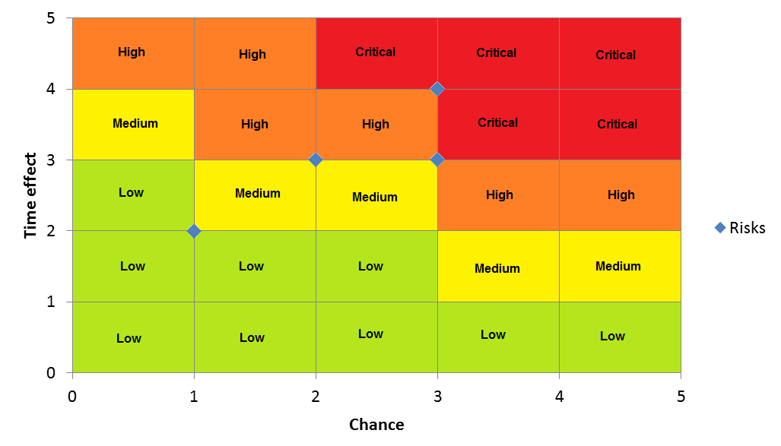Pic. 5 Risk map

Good practice is planning reaction for all risks in project. Duty is prepare team on risks from areas “High” and “Critical”. Following table shows example reactions.

Risk | Reaction
Not knowing to use Application | Risk reduction– Will be write document about using application (help) and implemented possible simple UI.
Broken anonimisation algorithm | Risk acceptance(Passive)– algorithm ensure secure for few years. There is no need to do something.
Disable project manage system (GravityDev) | Risk reduction – every task is sending to owner making something like backlog. Also is recommended make archiving product backlog to pdf or other format on local drive.
Not enough knowledge of team participants | Risk Reduction – SCRUM methodology provide good communication and interdisciplinary. Every problems are solve during daily stand up or by someone else from team.
Reaction for risk appear

- Development infrastructure
  - Eclipse
Because project KNIME which our plugin is creating for it's a product based on eclipse specific infrastructure our chose of IDE where obvious - Eclipse.
Eclipse connect three things :
1. Platform Integration
2. Environment to creating Application in Java
3. Society of Eclipse programmers and sponsors

Eclipse is a platform that based on CPL license which allows commercial use of this software, access of source code and distribution of any country or territories you want. It's very flexible license and it's suitable for Open Source products. The Platform integrate many kind of programming tools in one, big common environment. That allows working on different components of the project without constantly changing application, converting data source for adjust exchange of information between them. Eclipse is highly configurable Integrated Development Environment, on the internet we have many plugins create by the wide society of Eclipse programmers.

Eclipse is a united project of 10 top company. In 2001 year they introduce this project to the world. From the beginning Eclipse have good opinion. This IDE revolutionized the approach of software development. They realize that open and accessible product may be very powerful tool and also may gain profits from this. There was a lot of positive opinion about this approach and Eclipse society capabilities grows immediately.
  - Travis CI
Travis is hosted service for Continuous Integration process execution. It supports toolchain and environment setting, code compilation, and unit testing. It has powerful scripting capabilities that can be utilized for application Deployment.
  - Base Classes
mockito
junit
criptix
  - Gravity
For project management we decided use Gravity, application supports selected by as methodology Scrum for software development. The first feature that are useful is Google authorization, is no need to register, we can just login by Google account.
This tool allows to define specyfic task to the Interation, and the right order of task describe priority. The application for 1 privete project and 5 participants is for free, that supply all our needs. We dedided use version available on-line in the internet

  - GitHub
GitHub is a hosting service that use the Git (one of most popular version control system). Actually integrate about 3,5 millions users and have 6 million repositories. This means that is a very good and powerful tool for share repositories.

  - Pencil
Pencil is a versatile wireframing tool for visualizing interface designs.

  - other…

- Roles in projects
  - Developer Team
    - Duties:
      - Coding
      - Implementing Unit Tests
    - Principals
      - Artur Bilski
      - Marcin Bogusz
      - Andrzej Dudek
      - Konrad Kocik
  - Scrum Master
    - Duties
      - Respecting scrum rules
      - Explaining scrum rules
      - Resolving teams problems
      - Organizing scrum tools
    - Principals
      - Marcin Bogusz
  - Project Owner
    - Duties
      - Giving briefing
      - Accept/Dismiss Stories
    - Principals
      - Dr hab. Inż. Lech Madeyski
  - Repository coordinator
    - Duties
      - Giving “Pull request”
      - Watching around repository of team
    - Principals
      - Andrzej Dudek
Literature

[1] Schneier B., Kryptografia dla praktyków. Wyd. 2. Warszawa: Wydawnictwa Naukowo-Techniczne, 2002.
[2] www.encyclopedia.com
[2] http://pl.wikipedia.org/wiki/Advanced_Encryption_Standard
[3] http://www.cmmsigma.eu/products/crypto/crs_avr030x.pl.html
[4] http://docs.oracle.com/javase/6/docs/technotes/guides/security/StandardNames.html#AlgorithmParameterGenerator

