User’s Guide: Blue Wedge
Last Updated 20/01/2026

Software:
- Open Scilab:
  - Go to ...\src\config\default\X2CCode\X2CModel\
  - Right click on initProject.sce and select execute in scilab. the model should open.
  - 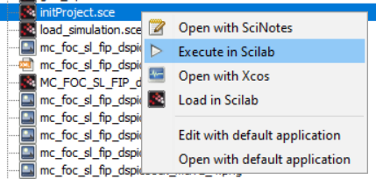
  - Double Click on Start Communicator.
  - 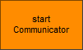
  - If the connection is established in X2C, then double click on transform model and push to communicator, if the model is successfully transformed, there should be name of the model on the X2C window.
  - 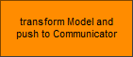
- 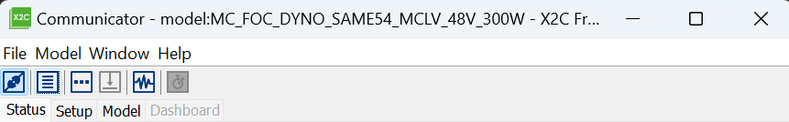
  - If the connection is not established, check the serial port setting (COM-Port 7 should be selected) (appropriate Com-port is selected) on X2C as well as the physical connection on hardware and try to connect again on X2C.
  - From scilab model, torque profile could be changed for demonstration.

- Establish the physical connection Navigate to the src folder and execute the relay_process_start.cmd script to establish a physical connection between the edge device and SA Studio.!!!

- Open Visual studio code:
  - click on stream analyze extension.
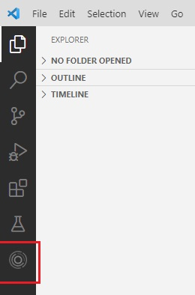
  - Open the command line by ctrl + shift + p, and connect the edge to local federation by command SA Engine: Connect to federation
  - 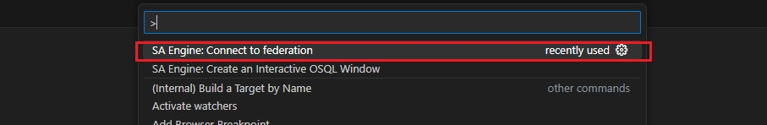
  - Create an interactive osql window by running SA Engine: Create ab interactive OSQL window as shown below.
  - 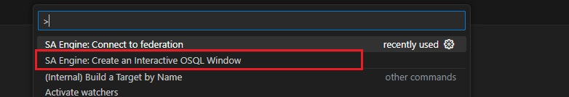
  - Go to …\stream_analyze\apps\ and open Microchip-simple-demo.osql in VS code.
  - Place the cursor online start_nameserver(“ns”);
  - 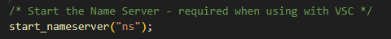
  - Press Shift + Enter, this will execute the command and if everything goes well, you will see, as shown below:
  - 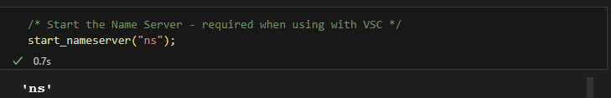
  - Setting is done, to verify, run the commad edge_cq("edge1","1+1");
  - Simply by placing the cursor on the command and press Shift + Enter to execute. As output you should see “2”
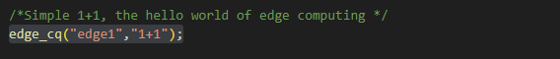
  - Start the final command, which will start the line graph 📈. (Shift + Enter on the command.)
  - 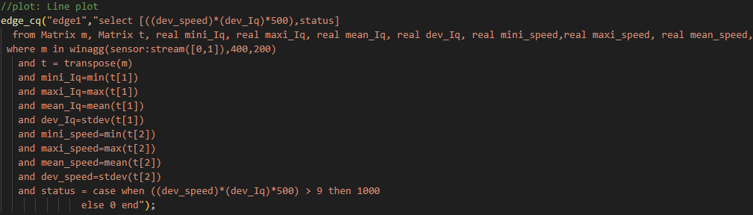

Hardware:

- Connect the mikroBUS and connect the power cable as shown in the picture below and please remove it before leaving or packing the demo:
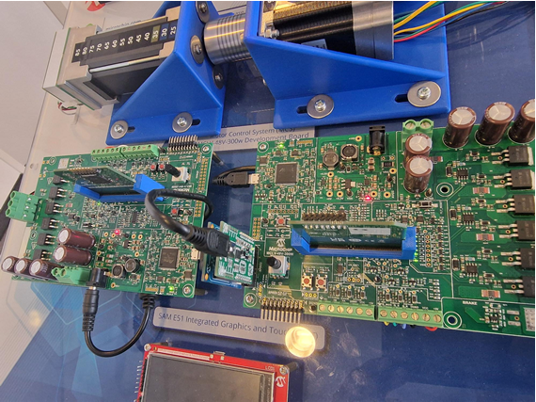

- Once all the software part is done, press the S2 Switch on the motor side to start the motor. This should turn on the PWM LEDs on the motor side and wait untill the motor starts to spin as shown in picture above.
- In the model go to Dyno as shown in image below:
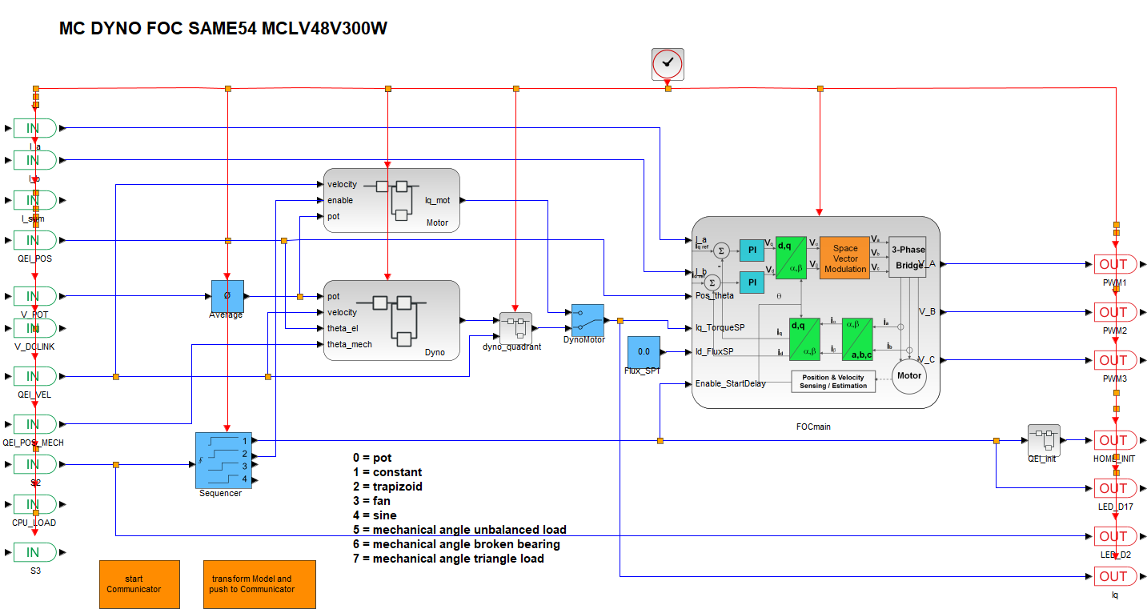
- Double click on torque mode and select the torque profile with the description:
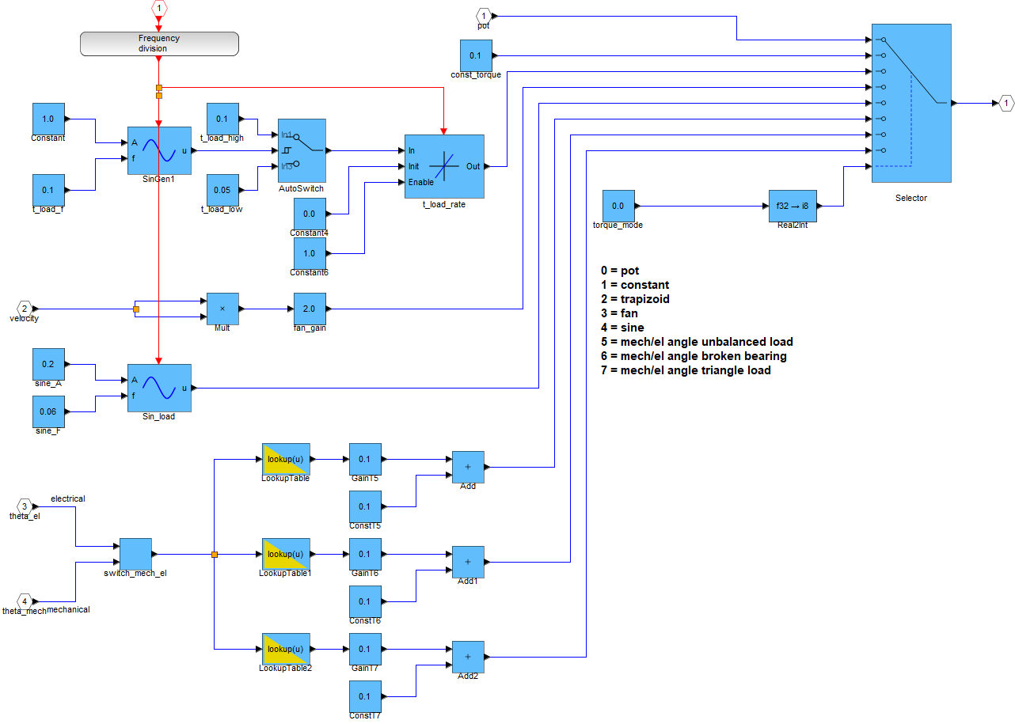
- To demonstrate Predictive maintenance, select either: 0 Constant torque or 5 Mechanical unbalanced load and press enter to set the value in run time mode.
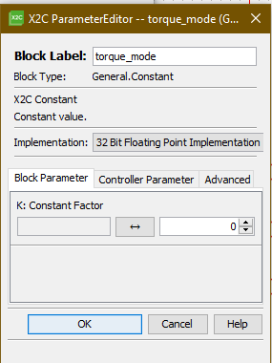

Firmware Settings:

1. Rapid Prototyping model in Scilab based on dsPIC33CK on motor side:
1. Select project mc_foc_sl_fip_dspic33ck_mclv48v300w as main project and open MCC
2. once MCC is open, Go to X2C from project resources, as shown in the image below.
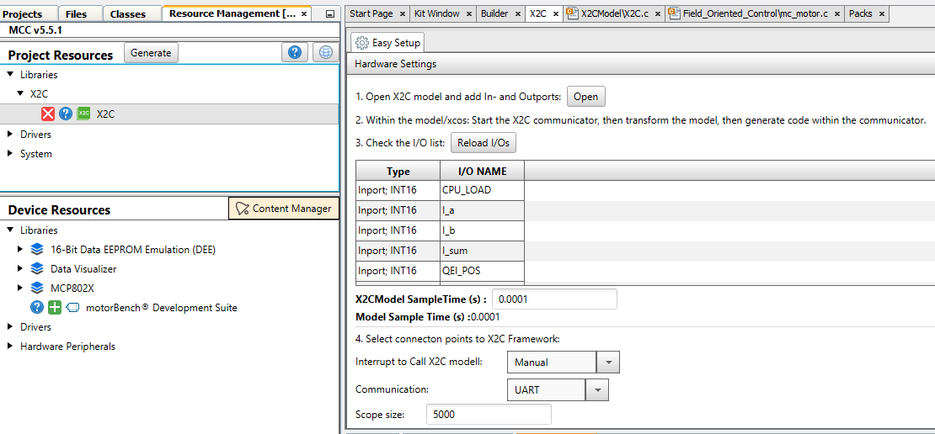

3. Press the Open button (Only once !!)
4. This will open Scilab and initiate the Model
5. In the main model, Double Click on Start Communicator.

6. If the connection is established in X2C, then double click on transform model and push to communicator, if the model is successfully transformed, there should be name of the model on the X2C window.


- If the connection is not established, check the serial port setting (COM-Port 5 should be selected) (appropriate Com-port is selected) on X2C as well as the physical connection on hardware and try to connect again on X2C.

To restore Wedge: In case things are not working as mentioned earlier, Please restore the Bluewedge.
It sound hard but its very simple

This is used by the Windows demo PC ("wedge") to restore the Blue Wedge firmware/demo workspace if needed. The restore is a simple batch script that unzips RestoreWedge/BlueWedge_firmware.zip to the demo user's Desktop. The zip holds the firmware projects, models, and Stream Analyze assets used by the demo.
navigate yourself to desktop and look for a batch file called RestoreWedge-Shortcut.
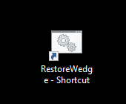

Double click on it, it will start the Restoring process….
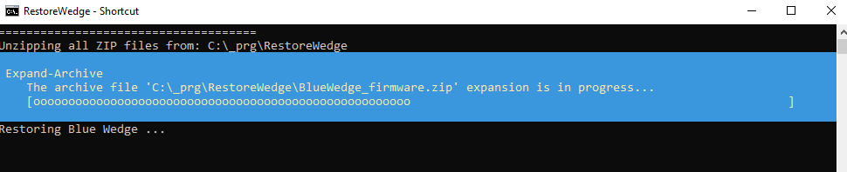
Do not close this window until you see the message Done Restoring Blue Wedge.
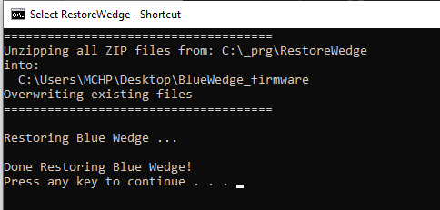

How RestoreWedge works in a nutshell
- SOURCE_DIR is C:\_prg\RestoreWedge and DEST_DIR is C:\Users\MCHP\Desktop\BlueWedge_firmware.
- Creates DEST_DIR if it does not exist.
- For each *.zip in SOURCE_DIR, runs PowerShell: Expand-Archive -LiteralPath <zip> -DestinationPath <DEST_DIR> -Force
- Pauses so the operator can see the "Done Restoring Blue Wedge!" message.
Override behavior and result
- Destination is C:\Users\MCHP\Desktop\BlueWedge_firmware.
- Expand-Archive -Force overwrites existing files with the same path.
- Files already in the destination that are not in the zip are not deleted.

What the restore payload contains
RestoreWedge/BlueWedge_firmware.zip expands into C:\Users\MCHP\Desktop\BlueWedge_firmware and includes:
- .git/: git metadata from the captured snapshot (not required for the demo).
- .~lock.User_Manual.docx#: temporary lock file from LibreOffice; safe to ignore.
- 33ak_MCLV48V300W_FOC_PLL/: dsPIC33AK FOC + PLL motor control project; docs in docs/README.pdf.
- AIoT_mclv48V300W_same54/: AIoT firmware for SAME54; includes libs and predictive_maintenance_mc with relay_process_start.cmd and connect.osql.
- AIoT_mclv48V300W_same54.zip: zipped snapshot of the AIoT project.
- MC_FOC_DYNO_SAMe54_MCLV48V300W/: SAM E54 motor control dyno project; includes X2C Scilab model initProject.sce.
- Predictiv_maintenance_dsPIC33CK/: master thesis artifacts for dsPIC33CK anomaly detection and knowledge packs.
- README.md: minimal readme inside the payload.
- RestoreWedge.bat: older template pointing to C:\Users\MCHP\Downloads; not used for wedge restore.
- SAME54-48V300W-Qspin-FOC/: QSpin FOC project for SAME54 (nested .X and src).
- anomaly-detection-mclv-48v-300w.X/: MPLAB X project for anomaly detection on dsPIC33CK/MCLV-48V-300W.
- gfx_apps_sam_d5x_e5x/: empty placeholder folder (nested empty folder).
- masterthesis-add_newApproach@c295d48f2ed.zip: zipped research snapshot.
- mc_foc_sl_fip_dspic33ck_mclv48v300w_Melody/: dsPIC33CK motor control project generated via MCC/X2C; see its readme.md for tools/hardware.
- motorBench_ZSMT_dspic33ck_act57blf_48V300W.X/: motor bench project and configs for the ACT motor.
- motorbench_FOC_PLL_dsPIC33CK_MCLV_48_300_ACT57BLF02.X/: motor bench FOC PLL project (nested .X).
- predictive_maintenance_mclv48v300w_same54/: predictive maintenance demo; OSQL scripts, relay_process_start.cmd, connect.osql, and an MPLAB project.
- predictive_maintenance_mclv48v300w_same54_PKOB_Serial.zip: zipped snapshot of a predictive maintenance variant.
- src/: standalone Harmony source tree for ATSAME54P20A (QSpin + X2Cscope), used as a base firmware project.
- stream_analyze-feat-MCLV-48v-300w_longhurst/: Harmony Stream Analyze repo with docs and apps (including Microchip-simple-demo.osql).

Reproduce this setup on another PC
- Create the folder layout:
  - C:\_prg\RestoreWedge (or edit the batch file if you must use a different path).
- Copy the payload and script from this repo:
  - RestoreWedge/BlueWedge_firmware.zip -> C:\_prg\RestoreWedge\BlueWedge_firmware.zip
  - RestoreWedge/RestoreWedge.bat -> C:\_prg\RestoreWedge\RestoreWedge.bat
- If the new PC has a different Windows user, update DEST_DIR in RestoreWedge.bat (default is C:\Users\MCHP\Desktop\BlueWedge_firmware). You can use TextEdit or VScode for that.
- Create a desktop shortcut that points to C:\_prg\RestoreWedge\RestoreWedge.bat and name it RestoreWedge-Shortcut.
- Install software dependencies: Scilab, X2C, MPLAB….
- Restore once and verify:
  - Run the batch file.
  - Try the files
Updating the restore image
- On a working wedge, zip the full C:\Users\MCHP\Desktop\BlueWedge_firmware folder.
- Replace C:\_prg\RestoreWedge\BlueWedge_firmware.zip with the new zip.
- Re-run RestoreWedge.bat to validate.
Troubleshooting
- If restore fails, check PowerShell availability and permissions for C:\_prg and the Desktop destination.
- If SA Engine will not connect, update COM port in connect.osql and ensure the USB serial device is present.
- If X2C will not connect, verify the COM port and motor-control USB connection.

RestoreWedge.bat script:
@echo off

REM ====================================
REM Define your source and destination
REM paths here. Change them as needed.
REM ====================================
SET "SOURCE_DIR=C:\Users\MCHP\Downloads\zip"
SET "DEST_DIR=C:\Users\MCHP\Downloads\"

REM ----------------------------------------------------
REM Unzips all zip files from %SOURCE_DIR%
REM into %DEST_DIR%, overwriting any existing files.
REM ----------------------------------------------------

echo =====================================
echo Unzipping all ZIP files from:
echo %SOURCE_DIR%
echo into:
echo %DEST_DIR%
echo Overwriting existing files
echo =====================================
echo.

REM 1) Create the destination folder if it doesn't exist
if not exist "%DEST_DIR%" (
echo Creating folder: %DEST_DIR%
mkdir "%DEST_DIR%"
echo.
)

REM 2) Loop through each ZIP file in the source directory
for %%z in ("%SOURCE_DIR%\*.zip") do (
echo Extracting %%~nz.zip ...
powershell.exe -NoProfile -Command ^
"Expand-Archive -LiteralPath '%%~fz' -DestinationPath '%DEST_DIR%' -Force"
)

echo.
echo Done extracting all ZIP files!
pause

