NGForms
Software Design Document
v1.0



Drexel CS Senior Design 2009-2010
Dan DeCamillo
Hung Dinh
Julian Lico
Raymond Ross, Jr.
Trung Tran

Contents
1 Introduction 4
1.1 Purpose 4
1.2 Scope 4
1.3 Document Usage 4
1.4 Definitions 4
2 Design Overview 5
2.1 Description of Problem 5
2.2 Technologies 5
2.3 Architecture 5
2.3.1 General Design 5
2.3.2 Architecture Characteristics 6
2.3.3 Benefits of Design 7
2.3.4 Disadvantages of Design 7
2.3.5 User Interface / Business Layer Separation 8
2.3.6 Testing 8
3 Requirement Traceability 8
4 Components 8
4.1 Core 8
4.1.1 NgForm 9
4.1.2 NgFormSection 9
4.1.3 INgFormField 10
4.1.4 INgFormInput 10
4.1.5 IFieldValidator 10
4.1.6 INgFormWriter 11
4.1.7 INgFormReader 11
4.2 FormGenerator 11
4.2.1 INgFormGenerator 12
4.2.2 ToolboxPresenter 12
4.2.3 IToolboxView 12
4.2.4 FormGeneratorPresenter 12
4.2.5 IFormGeneratorView 12
4.2.6 MockNgFormInput 13
4.3 FormBrowser 13
4.4 NgFormServer Application 17
4.4.1 NgFormServer 17
4.4.2 NgFormHandler 17
4.4.3 NgFormSerialization 17
4.5 .FORM XML Schema File 18
4.5.1 Header 18
4.5.2 Body 18
4.5.3 Footer 18
4.5.4 Example 18
5 References 18

Introduction

Purpose
The purpose of this document is to outline the software design of the NGForms System described in the NGForms Requirements Document. The NGForms system is a general purpose form filling application that will be developed for the Red Cross. The system will leverage 4th generation smart phones to allow forms to be filled out by alternative types of inputs.

Scope
This document aims to be a guide for developers to implement the prospective NGForms system. The software will consist of three major components: the application that creates a form specification file, an application that runs on a smart-phone which will allow the user to fill out the form, and a server application that processes the completed forms.

Document Usage
Although this document will go into some detail about interface specifications and implementation details, developers are encouraged to use their best judgment when making implementation decisions. As such, the UML diagrams that are contained in this document do not attempt to specify the low level details of each class, i.e. private attributes, user interface events, etc. Instead the document intends to specify enough detail for the classes that a developer can implement it. The authors feel that this should be appropriate for this document.

Definitions
.FORM file – A file that specifies the definition of the form.
Form page – A single screen on the smart-phone that displays an input field.
Form generator – A desktop application that builds a .FORM file through a drag and drop environment. This application is intended for managers who produce the forms.
Form browser – A smart-phone application that runs the .FORM file and renders the form. This application will be implementation specific for each smart-phone. This application is intended for users who fill out the forms.
Android – An operating system for mobile applications. This is the targeted platform of the "Form browser".
AltInputs – Alternative inputs that can be used to fill out a form field. This includes speech, handwriting, GPS, etc.
Form field – A single input that can be a dropdown, text-field, date-time field, fill-in field, etc.
Form Field Type – Field types such as text fields, drop down fields, date fields, state location fields, etc.
Form Submission Server – Daemon application that accepts TCP connections. Form browsers will submit forms to this application for processing.

Design Overview

Description of Problem
The Philadelphia Red Cross emergency services provide on-site assistance for disaster victims. The Red Cross assist victims with food, shelter, and money. Before assistance can be distributed, the Red Cross require Red Cross volunteers to fill out forms about the victims and the disaster. Currently, this process involves paper forms that are completed by hand, returned to headquarters, and validated by hand. The current process takes around three days to complete. The NGForms system aims to automate the Red Cross's current workflow by digitalizing the forms, which will decrease the turnaround for assistance from days to minutes. The NGForms system consists of applications to build the forms, fill them out on-site via smart-phones, validate the forms in real-time, and submit the forms back to Red Cross headquarters for processing.

Technologies
For the actual implementations, we will be using the Android SDK for the mobile application and the .NET platform for the desktop and server components. The reason we have chosen the Android platform is because of its ease of development and large selection of existing APIs for the mobile platform. In turn, we have chosen the .NET platform for the desktop and server applications. The reasons are because: the Red Cross is 100% Windows based, .NET is easily deployed on the Windows platform, and developers have existing experience with the platform.

Architecture

General Design
The NGForms has four distinct components:
- .FORM XML document
- FormGenerator - creates .FORM XML document
- FormBrowser - renders and fills out .FORM XML document
- Server Application - Receives and processes the .FORM XML document according to business rules

Red Cross Managers will use the FormGenerator application to generate the .FORM document. The .FORM document describes everything about the form, the input types, owner, fields, etc. The FormBrowser application loads the .FORM document following the .FORM document's specification as best is it can - much like how a web browser will render an HTML document. Although there is a common set of features that many browsers share, there will be some inconsistencies The user will use the FormBrowser to fill out the form and send the document to the NGForms Server component for processing. When the NGForms Server receives the completed form, it will process the form according to the business rules of the organization. For the Red Cross, this will mean that the XML will be inputted into a central database.
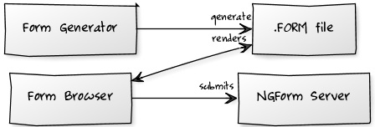
Figure 1: High Level Overview of Component Interaction
The following is a detailed sequence diagram that further describes the component and actor interactions.
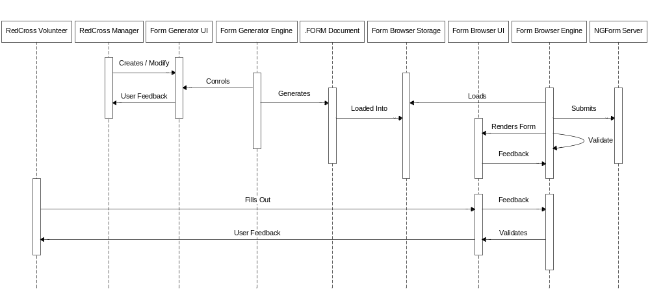
Figure 2: NGForms Sequence Diagram

Architecture Characteristics

Modularity
The four components are significantly independent from each other. This allows for independent development and little coupling. Components can also be replaced or redeployed in the system with little effect to the system as a whole.

Interface Dependency
The system is insulated from change because it only depends on the well defined interfaces that will remain relatively constant throughout the system's lifetime. That is, our design separates the components that are prone to change (the implementations) from the interface. The system that we will build for the Red Cross will be an implementation of our "interface" components.
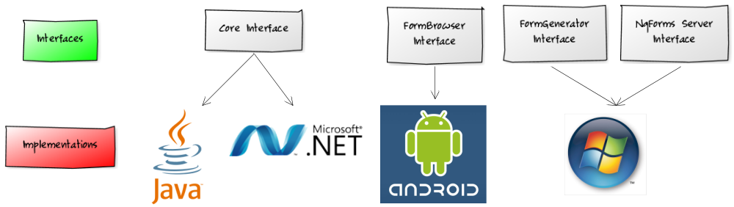
Figure 3: Interface and Implementation Separation for NgForms Red Cross System

Separation of Concerns
The UI and Business Logic are not coupled. This allows for components to be easily tested, mocked out in tests, and reused later in development if needed.

Advantages of Design
There were a few motivations our purposed architecture that we believe makes this a sound architecture:
- Simplicity - This system is intended to be easily understood by both developers and Red Cross managers. When we surveyed other types of architectures we found little to no benefits from using more robust and "popular" architectures such as Service Orientated Architecture. We did not feel to introduce any unnecessarily complexity to a simple problem.
- Designed for change - The system decomposes the components into loosely coupled parts that each serves only one purpose. In the future, if we decide to replace or update a component there will be little change needed. For instance, if we decide to move the FormBrowser from the Android platform to the iPhone platform, this would have minimal effect on the system.

Disadvantages of Design
- .FORM files are preloaded into a device. In other words, they remain static until the device is reloaded with new forms. If we allowed forms to be hosted remotely, we could dynamically update the form.
- The Core Interface is implemented for each language. There is some repeated development. For instance, for the implementation for the Red Cross, we will code the core interface in .NET and Java. When considering this disadvantage, we decided that to design it this way because
- the advantages of a having a clear interface and implementation separation outweighed the advantages of couple NgForms with one language/platform.
- The Core Interface is quite lightweight, any repetition is negligible.

User Interface / Business Layer Separation
The NGForms system involves a significant amount of user interface and business logic intermixed. As such, our design needs to separate the user interface from the business logic. The two main advantages that this brings is testing and reuse. Our UI design uses the MVP architecture. The MVP architecture makes sure that the business logic only interacts with a GUI "interface". That is, the Presenter (the business layer) works only with a generic view (the GUI layer). This forces the GUI layer to be swappable.
The other benefit of the MVP architecture for our system is that we can test the components much better. This is because our business logic is completely separate from the GUI tests which are easier to write.

Testing
While developing our system, the developer should be reminded that good tests are crucial to the system's success. When implementing the components, the developer should always ask - is this component easily tested? Testing is as an important client of the class as the actual implementation.

Requirement Traceability
Requirement | Description | Design Document Reference
3.2.1.* | Entry Methods for Form Filling | 4.3.1.3
3.2.2.1.* | Form Characteristics | 4.5
3.2.2.2.* | Form Validation when filling out document | 4.3.1.2
3.2.2.3. | Producing the Form XML Document (UI) | 4.2
3.2.2.4 | Loading and Editing the Form XML Document | 4.2
3.2.3.* | Rendering the Form XML Document on the Smart-phone | 4.3.1.7-4.3.1.13
3.2.4.* | Archiving the Form on the Smart-phone | 4.3.1.1 & 4.3.15
3.2.5.* | Form Browser submits form to the Server | 4.3.1.6
3.2.6.* | Non-Functional Installation Requirement | n/a (not a design issue)
3.3.1.* | Metadata on the Form XML Document | 4.5.3
3.3.2.* | Metadata on the Form XML Document | 4.5.3
3.4.1.* | Form Browser UI Description | 4.3.1.7-4.3.1.13
3.4.2.* | Form Generator UI Description | 4.2
Figure 4: Requirement Traceability Table

Components

Core
This Core component handles the low level interfaces that deals with reading, writing, representing, and validating forms. Both the Form Browser and Form Generator components will have an implementation of this component. That is, there will be separate .NET and Java implementations for these classes. Please note the implementation class names may be different for each application. For instance, INgFormXmlWriter is called AndroidXMLHandler in this document.
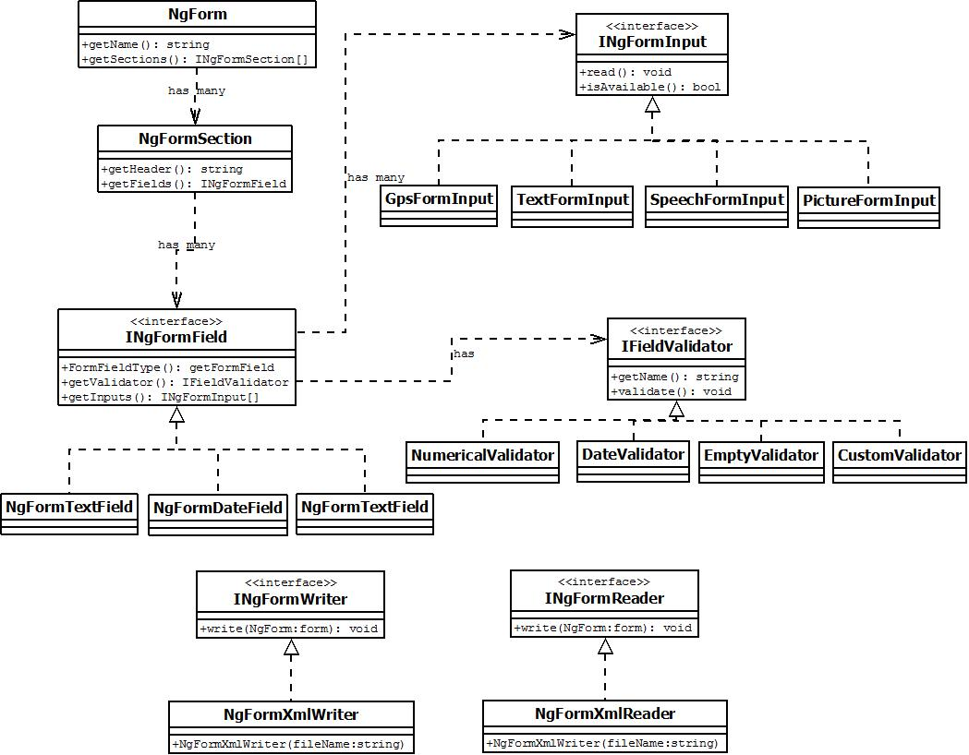
Figure 5: Core Component UML diagram (ngforms.core)

NgForm
Class that represents a form. It contains and manages a collection of NgFormSections.
string getName()
Output | Name of form
Description | Gets the name property of a form

INgFormSection[] getSections()
Output | All sections of a form
Description | Gets the sections of a form

NgFormSection
string getHeader()
Output | Header of section
Description | Gets section header

INgFormField[] getFields()
Output | All Input fields of section
Description | Gets fields of a section

INgFormField
FormFieldType getFormField()
Output | Type of field
Description | Allows for caller to determine what type of field it is without looking at class type. This is appropriate if the implementation language do not have a Type system.

IFieldValidator getValidator()
Output | Validator of form field
Description | Each form IFormField has a validator. Validators are aggregated using the Decorator Pattern. Caller can call the field validator such as: formField.getValidator().validate();

INgFormInput[] getInputs()
Output | All supported form inputs.
Description | Gets supported inputs that are allowed to fill out field. Instantiated by all supported input types. Note that a field can have multiple types of inputs.

INgFormInput
These are input types for a form field. Examples: TextFormInput, SpeechFormInput, GpsFormInput, etc.
void read()
Output | None
Description | Reads input using specific form. Command pattern.

bool isAvailable()
Output | Is input supported (on device)?
Description | Set by the Form Browser depending on the device. Caller will invoke isAvailiable before read() to verify input is supported.

IFieldValidator
Interface that validates form. Examples: NumericalValidator, DateValidator, EmptyValidator, CustomValidator. It uses the Decorator pattern to aggregate IValidators.
string getName()
Output | None
Description | Writes .FORM output. Implemented by NgXmlFormWriter.

INgFormWriter
Interface that writes a .FORM file.
void Write()
Output | None
Description | Writes .FORM output. Implemented by NgXmlFormWriter.

INgFormReader
Interface that reads and parses the .FORM file.
NgForm read()
Output | Parsed .FORM file
Description | Reads and Parses .FORM file

FormGenerator
The FormGenerator application creates and edits .FORM files through a user interface. For the Red Cross system, we are implementing the interface using Windows Forms.
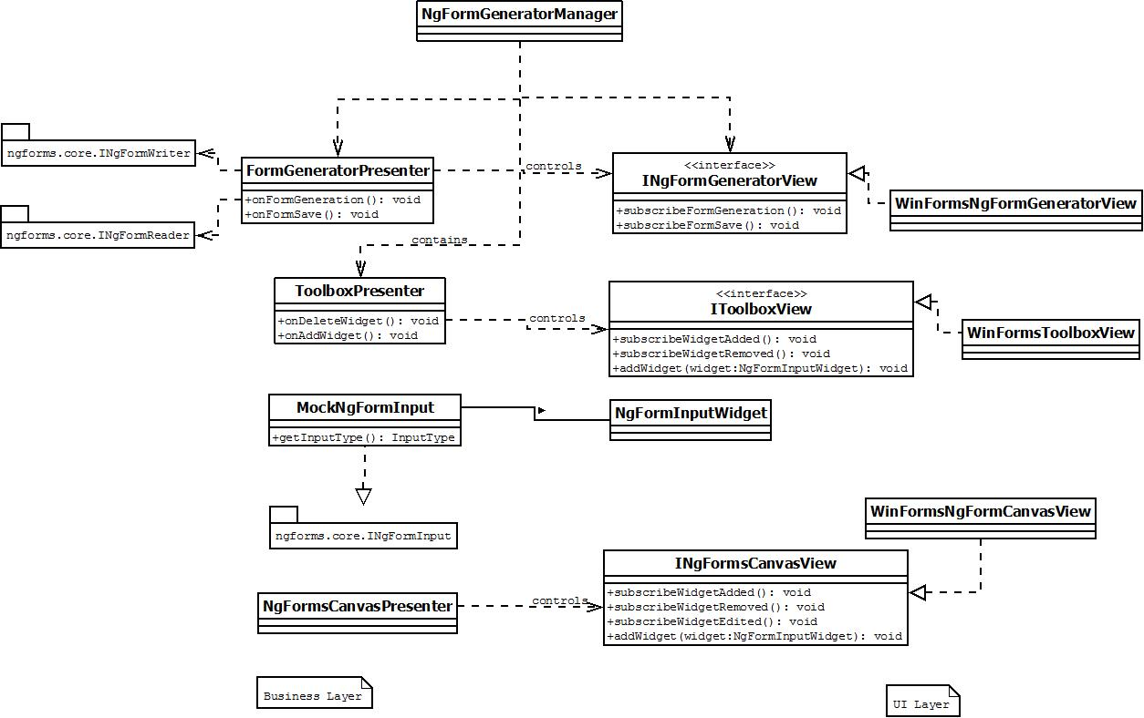
Figure 6: Form Generator UML diagram (ngforms.formgenerator)

INgFormGenerator
The INgFormGenerator interface will build a .FORM file and prepares it for processing by INgFormWriter.
void generator(string form)
Output | None
Description | Generates a .FORM file

ToolboxPresenter
Controls a IToolboxView
void onDeleteControl()
Output | None
Description | Handles view when a control is deleted

void generator(string form)
Output | None
Description | Handles view when a control is added

IToolboxView
UI interface that contains a list of FormWidgets that can be dragged to INgFormsCanvasView.
void addWidget(NgFormInputWidget widget)
Input | Widget to add to Toolbox collection
Description | IToolboxView keeps a collection of widgets. It simple renders the widgets by the order it is added.

FormGeneratorPresenter
Controls IFormGeneratorView. Generates and Saves form. Uses INgFormWriter to produce the form. INgFormReader to load a form.
void onFormGeneration()
Description | Handles a view's form generation event. Creates a .FORM file.

void onFormSave()
Description | Handles a view's form save event. Saves a .FORM file.

void onFormLoad()
Description | Handles a view's form load event. Loads a .FORM file.

IFormGeneratorView
UI interface that displayers Form Generator. Fires Generate and Save events to subscribers.
void subscribeFormGeneration()
Description | Adds subscriber to list of observers to FormGeneration event. Event fires when the user invokes form generation action.

void subscribeFormSave()
Description | Adds subscriber to list of observers to FormSave event. Event fires when user saves the form.

void subscribeFormLoad()
Description | Adds subscriber to list of observers to FormSave event. Event fires when user loads form.

MockNgFormInput
Because the FormGenerator application doesn't handle form input. A MockNgFormInput translates an "input" into an xml section. This is the command pattern. The FormGeneratorPresenter simply calls MockNgFormInput's read method to produce each the input's xml tag.
void read() (from INgFormInput interface)
Description | Produce the input's xml schema.

FormBrowser
The FormBrowser is the application that will fill out for the form. The application for the Red Cross will run on the Android OS. Note the Business layer class make heavy use of existing Android API calls (No need to reinvent the wheel!).
Business Layer
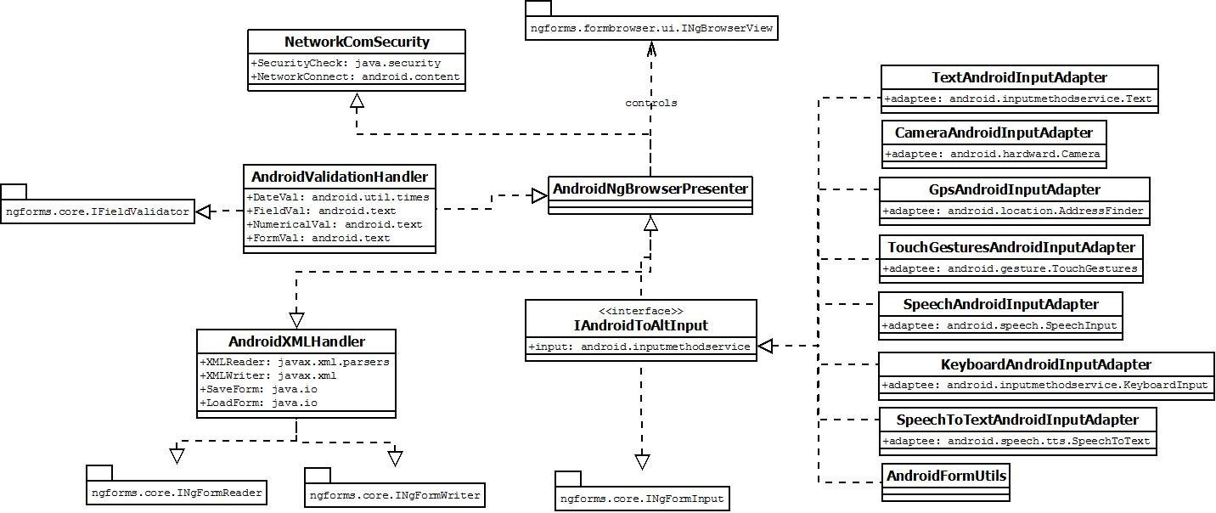
Figure 7: Form Browser Business Layer UML diagram (ngforms.formbrowser)

AndroidNgBrowserPresenter
Does most of the "heavy lifting" in the form processing, validation, and storage. In the MVP pattern this class is the presenter for INgBrowserView.

NetworkComSecurity
Encrypts form for transmission to server
SecurityCheck
Description | Implements java.securtiy to correctly encrypt the form data.

NetworkConnect
Description | Implements android.content to pass data to the carrier.

AndroidValidationHandler
Implementation of IFieldValidator interface. Essentially this class maps NgForms validation methods to existing android API calls.
DateVal
Description | Implements android.util.times to validate the time.

FieldVal
Description | Implements android.text to validate the field characters.

NumericalVal
Description | Implements android.text to validate the numerical characters.

FormVal
Description | Implements android.text to validate the form values.

IAndroidToAltInput
Base interface class that provides the implementation classes some common methods. Take note that the implementation classes use the Adapter pattern to map from supported NgForms AltInput to existing Android API classes. This table lists the map from AltInputs (REQ 3.2.1) to android APIs.
Typing | android.inputmethodservice.KeyboardInput
GPS | android.location.AddressFinder
Voice Recognition | android.speech.SpeechInput
ImageScanning | android.hardware.Camera
Handwriting Recognition | android.gesture.TouchGestures
Figure 8: AltInputs Android API mappping

AndroidXMLHandler
Class of the Java implementation of ngforms.core.INgFormReader and ngforms.core.INgFormWriter.

Form Submission / Network Layer

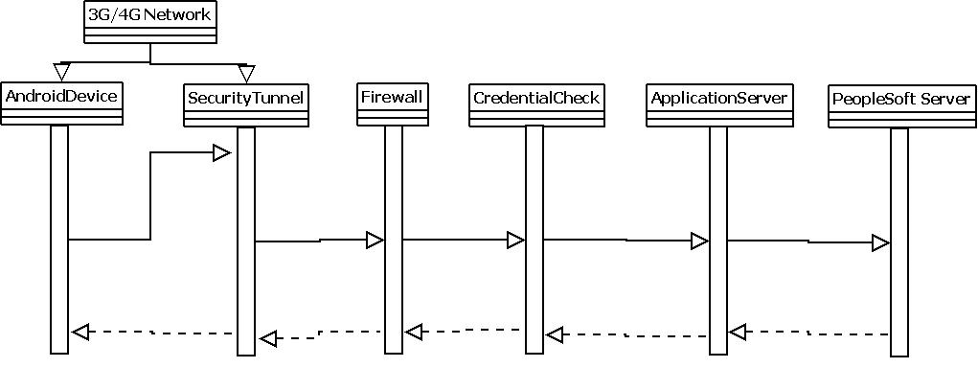
Figure 9: Network Sequence Diagram
The Networking component will consist of the standard built in data features within the Android API. After being filled out, the .FORM file will be saved with the appropriate information that was filled out. There will be a file validation process within the Android App. Once the submit option is chosen a secure tunnel will be established across the network via either a VPN or secure credential connection with the Application Server at the Red Cross. Once this is established the file will be encrypted and sent to the application server. Upon reaching the Application server it will be decrypted and the data will be properly merged with the PeopleSoft Application.

UI Layer

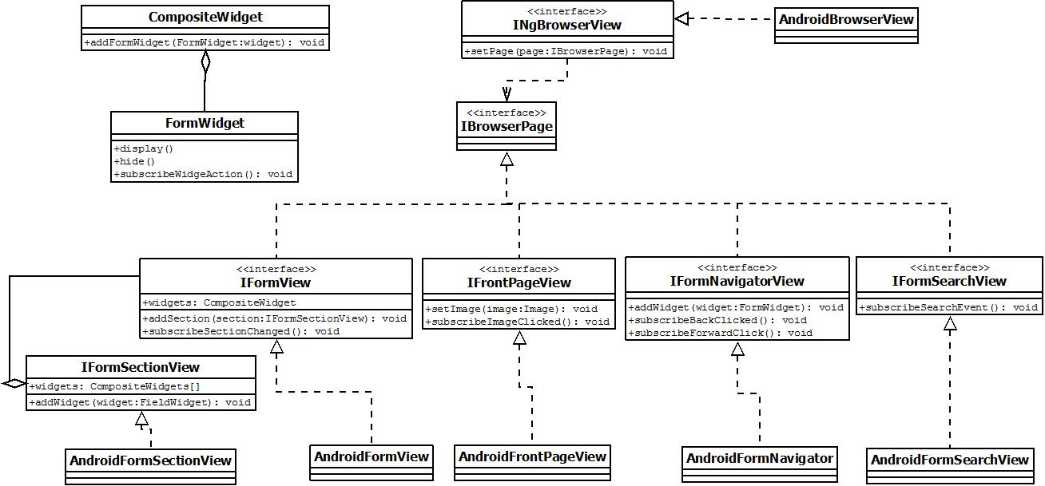
Figure 10: Form Browser UI Layer UML Diagram (ngforms.formbrowser.ui)

INgBrowserView
This interface is a container class that holds and displays an IBrowserPage. The Android Application will always use this classes for the UI, this class is responsible for which page to display. Note: This class is controlled by the AndroidNgBrowserPresenter class in the Red Cross system.
void setPage(IBrowserPage page)
Input | The current page to render
Description | Sets the IBrowserPager to display to the user.

IBrowserPage
Base class that displays a page. Dependent on by INgBrowserView.

IFormView
Used by NgFormPresenter to displays a NgForm document. Only exposes an addSection method so that it can remain "dump" (yeah MVP pattern!).
void addSection(IFormSectionView)
Input | Section to add
Description | Adds more sections to display

IFormSectionView
Displays a section of the NgForm document.
void addWidget(FormWidget widget)
Input | Widget to add
Description | Adds more widgets to display

FormWidget
Lowest level UI Widget. Can be Text, Fieldbox,etc.

CompositeWidget
A group of FormWidgets. Uses composite pattern.

IFrontPageView
Displays image to user.
void setImage(Image image)
Input | Image to display
Description | Sets image

IFromNavigatorView
Allows form to be navigator (controlled by NgFormPresenter)
void subscribeBackClicked()
Description | Fires when back button is clicked.

void subscribeNextClicked()
Description | Fires when next button is clicked.

IFormSearchView
Displays UI for searching feature. (controlled by NgFormPresenter)
void subscribeSearchEvent()
Description | Fires when User searches for a text.

NgForms Server
The Server application accepts form submission form the FormBrowser's network layer. See section: Form Submission / Network Layer.
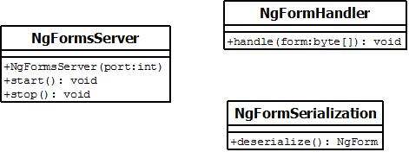
Figure 11: NgForms Server UML diagram (ngforms.server)

NgFormServer
Opens a server port and listens for form submission by FormBrowser.
void start()
Description | Starts a server

void stop()
Description | Stops a server

NgFormHandler
Handles raw form submission.
void handle(byte[] form)
Input | byte[] form
Description | Handles the form according to Business Rules

NgFormSerialization
void deserialize()
Output | NgForm class object (from ngform.core)
Description | Deserializes a raw byte[] form into a NgForm object.

.FORM XML Schema File

Header
The header of the .FORM schema starts with the standard XML declaration followed by the xs:schema that define a schema.

Body
The body contains the Form Sections. Form Sections will contain many Form Fields. A Form Field will describe the field input, type, name, and UI widget information.

Footer
The Footer will be used for the security metadata that is mentioned in REQ 3.3.1 in the Requirements Document. It will contain fields for the MAC address and GPS location.

Example
<?xml version="1.0" encoding="ISO-8859-1" ?>
<xs:schema xmlns:xs="http://www.w3.org/2001/XMLSchema">
<xs:form ID:="7789" xsi:Name="AmericanRedCross901.form">
<xs:formsection>
<xs:formfield name = “First_name” type = “xs:string”>
<forminput>TextInput</forminput>
<forminput>SpeechInput</forminput>
</xs:formfield>
<xs:formfield name = “Last_name” type = “xs:string”>
<forminput>TextInput</forminput>
<forminput>SpeechInput</forminput>
</xs:formfield>
<xs:formfield name="Address" type="xs:string "/>
<forminput>GPSInput</forminput>
<forminput>TextInput</forminput>
<forminput>SpeechInput</forminput>
<forminput>PictureInput</forminput>
</xs:formfield>
</xs:formsection>

<xs:formsubmissions>
<xs:formfiled device="andriod" Macaddress="xxx,xxx,xxx,xxx,xxx" submit= "yes"/>
<xs:formfiled device="andriod" GPS="xxxxxxxxxxxxxxx" submit= "required"/>
</xs:formsubmissions>
</form>
</xs:schema>

References

NgForms Requirements Document: http://www.cs.drexel.edu/~tvt26/NGForms/index.html
MVP architecture: http://msdn.microsoft.com/en-us/magazine/cc188690.aspx

