1. Introduction
1.1 Purpose
This *** system is a general media rich form generator that allows forms to accept different alternative methods of input. The system is intended to replace the Red Cross existing paperwork forms. This document is intended to be an overview and roadmap of the ***.
1.2 Intended Audience
This document is intended to be read by developers, testers, Red Cross managers and Red Cross staff. This document expresses all agreements and features of the ideal system between both parties as well detail limitations and the scope of the project.
1.3 Definitions
Form generator - Desktop application that builds a .form file through a drag and drop environment
.form file - Flat file that specifies the definition of the form.
Form page - A single screen on the smartphone that displays an input field
"Form browser" - a smartphone application that runs the .form file and renders the form. This application is implementation specific for each smartphone
Android - operating system for mobile application. This is the target of the "Form browser"
"AltInputs" - Alternative inputs that can fill out a form field. Includes Speech, Handwriting, GPS, etc.
Form field - a single input. Can be dropdown, textfield, DateTime, fill-in etc.
Form Field Type - For example, text fillable field, drop down field, date field, State location field
2 Overall Description
2.1 Product Prospective
The Philadelphia Red Cross emergency services provides immediate on site recovery for victims after disasters. Currently, the process relies heavily on paper forms, which have to be filled out by Red Cross personnel, phoned to Red Cross employees, and then mailed back to headquarters for archiving. Obviously this process involves tedious paperwork that delays the time it takes for assistance to get from the Red Cross to the victims.
Data-form creation is certainly a topic that has been heavily developed for a number of years. Although plenty of applications allow the end users to fill out electronic forms, few have involved the current generation of technology which is available to us with the advent of smartphones.
*** is a generic form generation application that allows easy integration of alternative media rich inputs. Instead of simple text fields, which may be more difficult to use for non computer savvy users, *** allows a form to be populated with speech, pictures, or handwriting. These alternative inputs will enable users to fill out the forms in faster and intuitive way. The delivered system to the Red Cross will consist of two applications:
1) A data form generation application which will be used to duplicate their current paper version of forms.
2) An mobile phone application that will run the generated form and will send the forms from the Red Cross.
(Diagram of what the system consist of here)
2.2 User Classes and Characteristics
2.2.1 Primary Target: Red Cross Volunteers assisting in the field
The mobile application will be used primarily by Red Cross volunteers on the field.
- Tend to be 50-75 years of age
- Limited computer experience
- Will have some preliminary training of the system beforehand

2.2.2 Secondary Target: Red Cross Personnel
The form generation will be used solely by the Red Cross personnel.
- Computer literate and knowledgeable of workflow
- Usually trained for disaster situations for 5 plus years
- Have to prepare for insurance scams
2.3 Real world system environment
2.3.1 Disaster Area
- Highly hectic and unstable area
- Oftentimes limited or no internet connection
- The more recent the disaster, the better it is to get down the information
2.3.2 Victims
- Oftentimes, will not have identification
- May lack information to field out many fields
2.4 Use Case
2.4.1 Disaster Area form completion
Smartphone is loaded with the Form application beforehand. When the mobile device starts up, user is instructed for the operator's name and CRN number. The next screen gives the user a selection of forms to fill out. The user fills out the form and submits the form back to Red Cross Philadelphia headquarters for processing.
(Use Case diagram here)
2.4.2 Case filing and archiving
When a disaster case is received, it is sent to headquarter servers for processing. The case is added to the case database which is hosted on Red Cross Philadelphia headquarters. The System is Windows 2000 Server running Microsoft SQL Server 2003 and PeopleSoft. Red Cross personnel can use a desktop application to query for the record they want...
(Use case diagram here)
3. Specific Requirements
3.1 Priorities
Priority Level Description
Priority 1 Essential requirement for a successful system
Priority 2 Desirable requirement
Priority 3 Non-essential requirement, but nice to have
3.2 Functional Requirements
3.2.1 Entry Methods
3.2.1.1 Typing
Fields can be field by either physical or virtual keyboard. Priority 1
3.2.1.1 GPS
GPS information can be used to fill out a field. Priority 1
3.2.1.2 Voice Recognition
Fields can be filled by recognizing user's voice. Priority 1
3.2.1.3 Image Scanning
Images can be taken by smartphone's camera and stored. Priority 1
3.2.1.4 Handwriting Recognition
Field can be field by hand writing. Priority 2
3.2.2 .Form Files (Form characteristics)
3.2.2.1 Form fields of type time can to have narrow the list of selected locations based on GPS
3.2.2.2 ...more...

3.2.2 Form Generator
3.2.2.1 Form Page Editing
Adding Pages
3.2.2.1.1 The software shall show all available Entry methods in a "Entry method" panel
3.2.2.1.2 The software shall display a main canvas that displays a sequential list of "form pages"
3.2.2.1.3 The software shall allow each "form page" to display only a single data field.
3.2.2.1.4 The software shall allow an "AltInput" icon to be dragged into a "Form page".
3.2.2.1.5 The software shall set the "Form page" entry method when the entry method is dragged over
3.2.2.1.6 The software shall allow each field to have the capability to have multiple "AltInputs"
3.2.2.1.6 The software shall allow each field to have specify a default value
3.2.2.1.7 The software shall display the page number on the bottom right corner of each "form page"
Editing Pages
3.2.2.1.6 The software shall allow the "AltInput" option to be changed when the option is selected
3.2.2.1.7 The software shall change the option when the Change button is selected
3.2.2.1.7 The software shall allow pages to be moved up and down in the sequence
3.2.2.1.7 The software shall allow pages to be removed
3.2.2.1.7 The software shall show a confirm popup when the a page is removed
Save Load
3.2.2.1.8 The software shall be able to save the "From project" to a .form file
3.2.2.1.9 The software shall load a previously saved .form file into the project.
3.2.2.1.10 The software shall allow each field to have a validation method
3.2.2.1.11 Validation methods
3.2.2.1.11a. Numerical Range - Field must be numerical and between min and max
3.2.2.1.11b. Date Range - String must be in a date format, and between min and max
3.2.2.1.11b. Can be Empty - Field must be non-empty (yes or no)

3.2.3 Form Browser
3.2.3.1 The software shall show splash screen that displays a user-set logo when the application starts
3.2.3.2 The software shall present the user with a "Start new Session" and "Open old Session" buttons
3.2.3.3 The software shall display a list of form types when "Start new Session" is pressed which are clickable buttons
3.2.3.4 The software shall display a list of previously internally saved sessions that are clickable buttons when "Open old Session" is pressed
3.2.3.6 The software shall display the last used "Form" at the top of the session display
3.2.3.7 The software shall allow the user to search for a form by full world search
3.2.3.9 The software shall render each "Form page" on a single screen display
3.2.3.10 The software shall display navigation buttons on the bottom, as well as "super navigation buttons"
3.2.3.11 The software shall go back one page number when the back button is selected, and go forward one page number when the forward button is selected
3.2.3.12 The software shall go back five page numbers when the super back button is selected, and go forward five page numbers when the super forward button is selected
3.2.3.13 The software shall display the page number on the bottom
3.2.3.14 The software shall skip pages which have no fields to fill in (pre-filled)

3.2.4 Form Validation (mobile application) (see 3.2.2.1.11) (may delete)
3.2.4.1 The software shall invalidate empty fields marked as required
3.2.5 Archiving
3.2.5.1 The software shall save the form session into an .form file after each page is filled
3.2.5.2 The software shall store all .form file in a "forms" folder on the device
3.2.5.3 The software shall store the user's current page number when in the .form file
3.2.5.4 The software shall proceed to the .form page number when a form is opened.

3.2.6 Form Submission
3.2.6.1 The software shall present the user with a confirmation window when form is completed
3.2.6.2 The software shall not submit form when cancel button is pressed
3.2.6.3 The software shall submit the form to headquarters when OK is pressed.

3.2.7 Deployment
3.2.7.1 The form generation software will be installed with a Windows installer
3.2.7.2 The form generation software will be added into the Start Menu

3.3 GUI (Mobile Form Reader Application & Form Generator Application)
3.3.2 Mobile Form Reader Application.
3.3.2.1. The main interface will be presented to users after all the checking are done to make sure there is a stable connection enough to maintain the application online, if not it will turn on the offline mode and still let the user enter the information and save it to send out these information later when there is a stable connection.
Note: The current user interface is still in the very early beta version, There is a possibility it would change during the develop process.

Figure 1: The application in its initial state.

3.3.1.2. There are two different views of the application depend on which environment the user launch the application, one for laptop and one for mobile phone.
3.3.1.3. The user will have the options to either open a new case file (Figure 2) or looking up an old case file form archive (Figure 3).
3.3.1.4 When a new form is open, some of the fields like address, name of person who will fill out the form, case number, etc… will be automatic filled out based on given location by GPS or by Data Center at base.

Figure 2: New case files Figure 3: Look up old case files
3.4.1 Forms
3.4.1.1 General
3.4.1.2 There will be the total five forms for this current application
3.4.1.3 Each form will have the same layout, but the background color will be different correspond to the (Figure 2).
3.4.1.5 There are three main control buttons for each form at the bottom.
3.4.1.6 Home Button will bring the user back to the initial state (Figure.1)
3.4.1.7 Forms Button will bring the user to back to forms selection menu (fig. 2)
3.4.1.8 Exit Button will allow user to exit the application, it will prompt the user to save the current form if the user already fill out some fields in the form.
3.4.1.4 Each form consists of the following elements

3.4.2.1 Form Header
3.4.2.2 The form title is located at the top of the Form
3.4.2.3 The form title has a maximum of 30 characters.
3.4.2.4 The from title use the font Verdana 12 points

3.4.3.1 Form Body

3.4.3.2 The form body is using the font Verdana 10 points.
3.4.3.3 The form body using a list of control fields:
3.4.3.3.1 Text box
3.4.3.3.2 Rich text box
3.4.3.3.3 Drop-Down List Box
3.4.3.3.4 Combo Box
3.4.3.3.5 Date Picker
3.4.3.3.6 Check box
3.4.3.3.7 Repeating table,
3.4.3.3.8 Repeating section and Button
3.4.3.4 The form will also have the option for the user to sign his/her signature by moving their finger around or with a pen at the signature field.
3.4.3.4 At the end of each form, there will be an addition of two buttons

3.4.3.4.1 Submit button will submit the form back to the data center to process, there is also a checking mechanism that reminds the user if they missed out any important fields. The user can only submit the form once these fields are correctly filled.

3.4.3.4.2 Saving button allow user to finish the form later, mostly use in the offline mode.

3.4.3.4.3 The general of the form layout can be seen on (Figure 4).

Figure 4: Form 901

3.5.1 Form Generator Application.

3.5.1.1 General.

3.5.1.1.1. The main user interface is the first screen will be display when the application is launch, see (figure 5) for the illustration.

Note: The current user interface is still in the very early beta version, There is a possibility it would change during the develop process.

3.5.1.1.2. The main interface runs in the resolution mode of 580W x 540H at all times.

3.3.1.1.3. The main interfaces can be break down into 3 sections toolbar, tabs, and button:

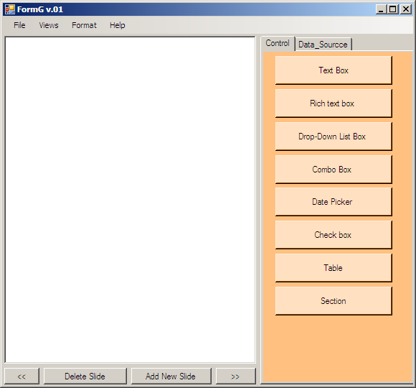

Figure 5: The application in its initial state.

3.5.1.2 Toolbar
3.5.1.2.1 The toolbar is locate at the top left of the main interface.
3.5.1.2.2 The toolbar is use the font Microsoft Sans Serif, size 8.
3.5.1.2.3 The toolbar contains of the following four menu items: File, Views, Format, and Help, see (figure 6) to see all these option expand.

3.5.1.2.4 File menu item

3.5.1.2.4.1 The size of the File menu item is 35W x 20H.
3.5.1.2.4.1 The File menu consists of 6 options to choose from: Created New Form, Open Form, and Save Form, Save as, Most Recently Use, and Exit option.

3.5.1.2.5 Views

3.5.1.2.5.1 The size of the view menu items is the same as File menu item.
3.5.1.2.4.2 The File view menu consists of 3 options to choose from:
3.5.1.2.4.2.1 General Mobile Device view
3.5.1.2.4.2.2 Android view see (figure 4).
3.5.1.2.4.2.3 Iphone view.

3.5.1.2.6 Format

3.5.1.2.6.1 The size of the format menu items is the same as File menu Item
3.5.1.2.6.2 The format menu consists of 3 options to choose from:
3.5.1.2.6.2.1 Font
3.5.1.2.6.2.2 Layout.
3.5.1.2.6.2.3 Background.

3.5.1.2.7 Help

3.5.1.2.7.1 The size of the format menu items is the same as File menu item.

3.5.1.3 Tabs

3.5.1.3.1 The tab is located at the right of the main interface.
3.5.1.3.2 The tab size is 215W x 485H.
3.5.1.3.3 The tab consists of 2 elements.

3.5.1.3.4 Control

3.5.1.3.4.1 The control tab contains a list of items you can drag and drop in the form field, consist of Text box, Rich text box, Drop-Down List Box, Combo Box, Date Picker, Check box, table, and section.

3.5.1.3.4.2 The Data Source Tab contains of which type of input data you want the form to interact with, there will be Simple text input, GPS input, voice Recognition, see (Figure 7).

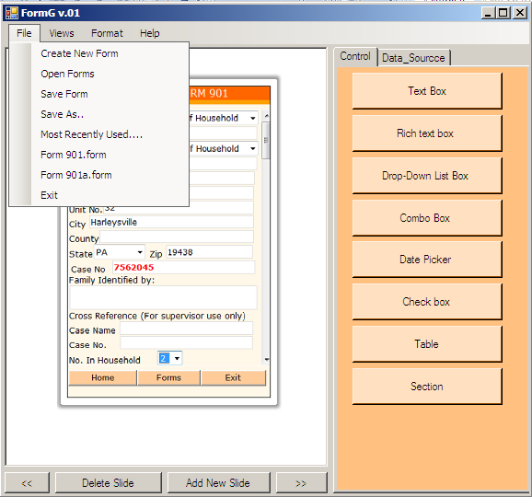

Figure 6: Load file
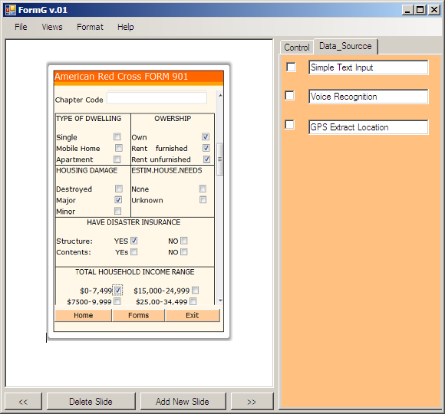

Figure 7: Data Source tab showing on the right side
3.5.1.4 Buttons.

3.5.1.4.1 There are total 4 buttons to help the user to moving the form around.
3.5.1.4.2 Delete Slide button will delete the current form on the application; the program will ask the user to save the form, if it’s not a blank form.
3.5.1.4.3 Add new Slide button will add a new slide to the current form on the application.
3.5.1.4.4 “<<” button will allow user go back to the previous slide of the form.
3.5.1.4.4 “>>” button will allow user go to the next slide of the form.

4. Non-Functional Requirements
4.1 Hardware Requirements
The system requires the following hardware specifications
- Device capable of running Android OS
- Each alternative input is device dependent
- Internet connectivity, preferably 3G
4.2 Ease of Use
1. The look and feel of the system should mark the instructional text distinct from the regular controls so that the user can distinguish an instruction.
2. Each page of the form should have very few options so that user is not overwhelmed by choices.
3. Controls should be large and obvious. Icons should represent real world examples.
4.3 User Feedback
1. The system should detect when a user is submitting abnormal data
2. At times when fields can be inferred they should be automatically filled in. For instance, if GPS detects disaster is in Philadelphia Region, the City field should be prefilled with "Philadelphia"
4.4 Reliability Requirements
The system needs to ensure every form is submitted back to Red Cross servers. If the message can not be sent the system needs to notify the user trying to send the form and send the form whenever the system regains internet connection. A crash in the system should only effect the system itself and not other processes running. That is, a crash of the system should not warrant for a restart of the device.

