Module ‘Launcher’

Description:
This Module contains Shortcuts to commonly used Apps and Folders, during the Packaging process.
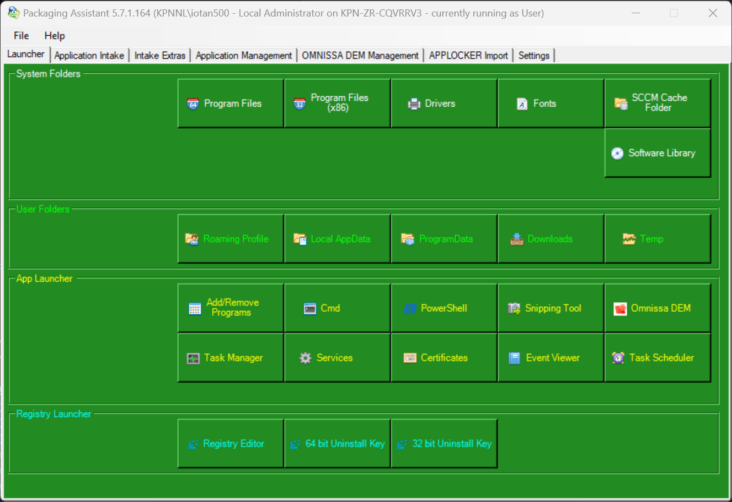

Features:
- System Folders: This Feature contains Shortcuts to commonly used System Folders.

- User Folders: This Feature contains Shortcuts to commonly used User Folders.

- App Launcher: This Feature contains Shortcuts to commonly used Applications and Consoles.

- Registry Launcher: This Feature contains Shortcuts to commonly used RegistryKeys, like the Uninstall Keys.

