IMRAAN NORDIEN
ST10434419
INSY7213
ASSIGNMENT 2
VARSITY COLLEGE
2025

CONTENTS
Question 1 ...................................................... Pg. 3
Question 2 ...................................................... Pg. 11
Question 3 ...................................................... Pg. 12
Question 4 ...................................................... Pg. 14
Question 5 ...................................................... Pg. 15
Question 6 ...................................................... Pg. 17
Question 7 ...................................................... Pg. 19
Question 8 ...................................................... Pg. 23

Question 1
Create Tables
CREATE TABLE customer (
customer_id NUMBER PRIMARY KEY,
first_name VARCHAR2(50),
surname VARCHAR2(50),
address VARCHAR2(100),
contact_number VARCHAR2(15),
email VARCHAR2(50)
);

CREATE TABLE employee (
employee_id VARCHAR2(10) PRIMARY KEY,
first_name VARCHAR2(50),
surname VARCHAR2(50),
contact_number VARCHAR2(15),
address VARCHAR2(100),
email VARCHAR2(50)
);

CREATE TABLE donator (
donator_id NUMBER PRIMARY KEY,
first_name VARCHAR2(50),
surname VARCHAR2(50),
contact_number VARCHAR2(15),
email VARCHAR2(50)
);

CREATE TABLE donation (
donation_id NUMBER PRIMARY KEY,
donator_id NUMBER,
donation_name VARCHAR2(100),
price VARCHAR2(20),
donation_date DATE,
FOREIGN KEY (donator_id) REFERENCES donator(donator_id)
);

CREATE TABLE delivery (
delivery_id NUMBER PRIMARY KEY,
delivery_notes VARCHAR2(100),
dispatch_date DATE,
delivery_date DATE
);

CREATE TABLE returns (
return_id VARCHAR2(10) PRIMARY KEY,
return_date DATE,
reason VARCHAR2(100),
customer_id NUMBER,
donation_id NUMBER,
employee_id VARCHAR2(10)
);

CREATE TABLE invoice (
invoice_num NUMBER PRIMARY KEY,
customer_id NUMBER,
invoice_date DATE,
employee_id VARCHAR2(10),
donation_id NUMBER,
delivery_id NUMBER
);
Populate tables
CUSTOMER Table
INSERT INTO customer VALUES (11011,'Jack','Smith','11012','0877277521','jsmith@isat.com');
INSERT INTO customer VALUES (11012,'Pat','Hendricks','18 Water Rd','0863257857','ph@mcom.co.za');
INSERT INTO customer VALUES (11013,'Andre','Clark','101 Summer Lane','0834567891','aclark@mcom.co.za');
INSERT INTO customer VALUES (11014,'Kevin','Jones','55 Mountain Way','0612547895','kj@isat.co.za');
INSERT INTO customer VALUES (11015,'Lucy','Williams','5 Main rd','0827238521','lw@mcal.co.za');

EMPLOYEE Table
INSERT INTO employee VALUES ('emp101','Jeff','Davis','0877277521','10 main road','jand@isat.com');
INSERT INTO employee VALUES ('emp102','Kevin','Marks','0837377522','18 water road','km@isat.com');
INSERT INTO employee VALUES ('emp103','Adanya','Andrews','0817117523','21 circle lane','aa@isat.com');
INSERT INTO employee VALUES ('emp104','Adebayo','Dryer','0797215244','1 sea road','aryer@isat.com');
INSERT INTO employee VALUES ('emp105','Xolani','Samson','0827122255','12 main road','xosam@isat.com');

DONATOR Table
INSERT INTO donator VALUES (20111,'Jeff','Watson','0827172250','jwatson@ymail.com');
INSERT INTO donator VALUES (20112,'Stephen','Jones','0837865670',NULL);
INSERT INTO donator VALUES (20113,'James','Joe','0878978650','jj@isat.com');
INSERT INTO donator VALUES (20114,'Kelly','Ross','0826575650','kross@gsat.com');
INSERT INTO donator VALUES (20115,'Abraham','Clark','0797656430','aclark@ymail.com');

DONATION Table
INSERT INTO donation VALUES (7111,20111,'KIC Fridge','R599',TO_DATE('01-MAY-2024','DD-MON-YYYY'));
INSERT INTO donation VALUES (7112,20112,'Samsung 42inch LCD','R1299',TO_DATE('03-MAY-2024','DD-MON-YYYY'));
INSERT INTO donation VALUES (7113,20113,'Sharp Microwave','R179',TO_DATE('03-MAY-2024','DD-MON-YYYY'));
INSERT INTO donation VALUES (7114,20115,'6 Seat Dining room table','R1599',TO_DATE('05-MAY-2024','DD-MON-YYYY'));
INSERT INTO donation VALUES (7115,20114,'Lazyboy Sofa','R799',TO_DATE('07-MAY-2024','DD-MON-YYYY'));
INSERT INTO donation VALUES (7116,20113,'JVC Surround Sound System','R1199',TO_DATE('09-MAY-2024','DD-MON-YYYY'));

DELIVERY Table
INSERT INTO delivery VALUES (511,'Double packaging requested',TO_DATE('10-MAY-2024','DD-MON-YYYY'),TO_DATE('15-MAY-2024','DD-MON-YYYY'));
INSERT INTO delivery VALUES (512,'Delivery to work address',TO_DATE('12-MAY-2024','DD-MON-YYYY'),TO_DATE('15-MAY-2024','DD-MON-YYYY'));
INSERT INTO delivery VALUES (513,'Signature required',TO_DATE('12-MAY-2024','DD-MON-YYYY'),TO_DATE('17-MAY-2024','DD-MON-YYYY'));
INSERT INTO delivery VALUES (514,'No notes',TO_DATE('12-MAY-2024','DD-MON-YYYY'),TO_DATE('15-MAY-2024','DD-MON-YYYY'));
INSERT INTO delivery VALUES (515,'Birthday present wrapping required',TO_DATE('18-MAY-2024','DD-MON-YYYY'),TO_DATE('19-MAY-2024','DD-MON-YYYY'));
INSERT INTO delivery VALUES (516,'Delivery to work address',TO_DATE('20-MAY-2024','DD-MON-YYYY'),TO_DATE('25-MAY-2024','DD-MON-YYYY'));

RETURNS Table
INSERT INTO returns VALUES ('ret001',TO_DATE('25-MAY-2024','DD-MON-YYYY'),'Customer not satisfied with product',11011,7116,'emp101');
INSERT INTO returns VALUES ('ret002',TO_DATE('25-MAY-2024','DD-MON-YYYY'),'Product had broken section',11013,7114,'emp103');

INVOICE Table
INSERT INTO invoice VALUES (8111,11011,TO_DATE('15-MAY-2024','DD-MON-YYYY'),'emp103',7111,511);
INSERT INTO invoice VALUES (8112,11013,TO_DATE('15-MAY-2024','DD-MON-YYYY'),'emp101',7114,512);
INSERT INTO invoice VALUES (8113,11012,TO_DATE('17-MAY-2024','DD-MON-YYYY'),'emp101',7112,513);
INSERT INTO invoice VALUES (8114,11015,TO_DATE('17-MAY-2024','DD-MON-YYYY'),'emp102',7113,514);
INSERT INTO invoice VALUES (8115,11011,TO_DATE('17-MAY-2024','DD-MON-YYYY'),'emp102',7115,515);
INSERT INTO invoice VALUES (8116,11015,TO_DATE('18-MAY-2024','DD-MON-YYYY'),'emp103',7116,516);

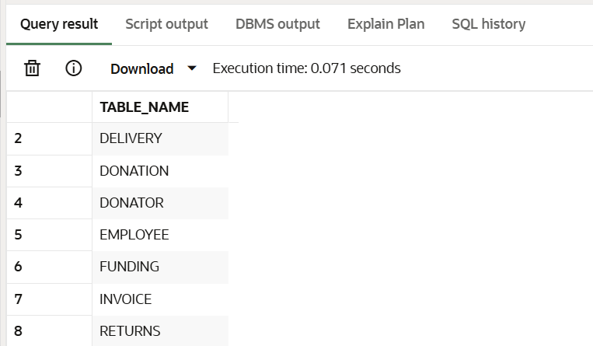
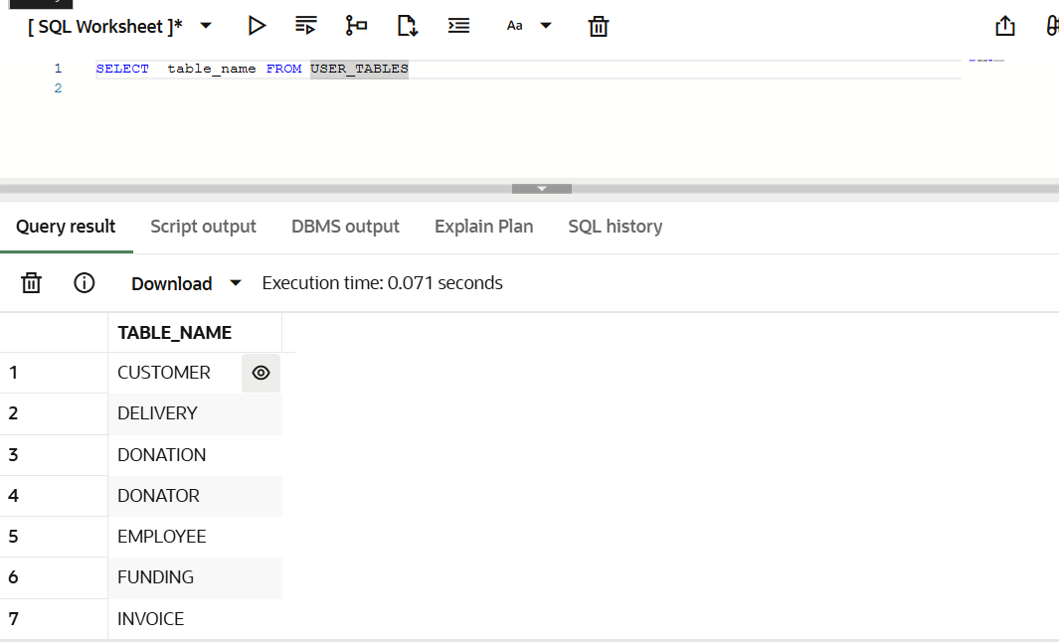
Tables

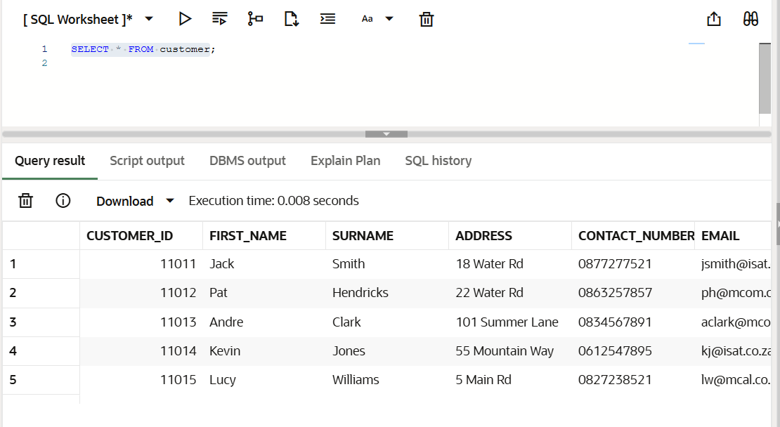
Data in CUSTOMER table

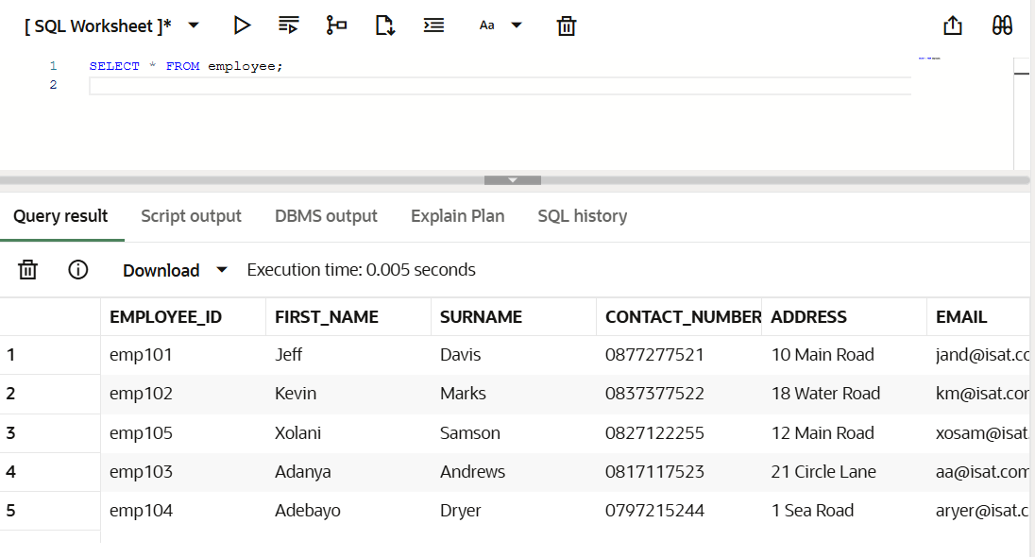
Data in EMPLOYEE table

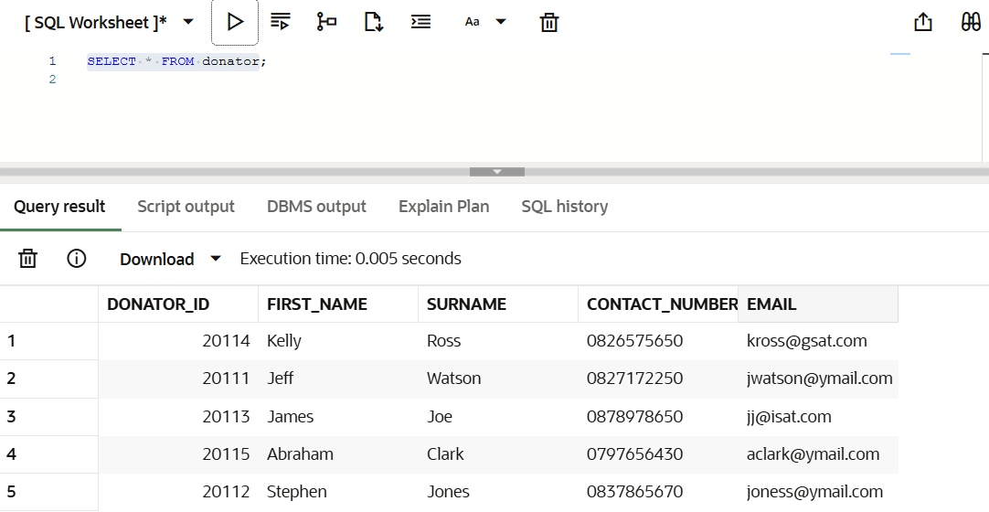
Data in DONATOR table

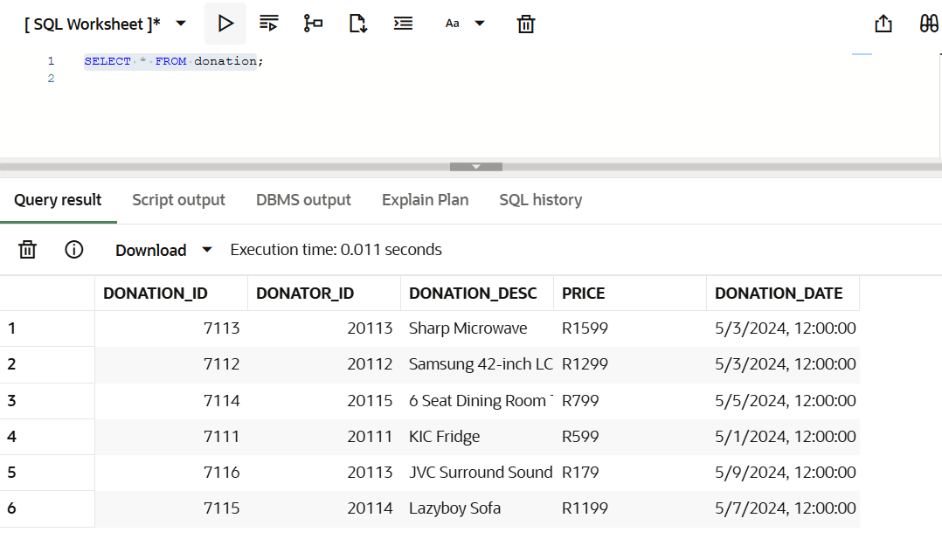
Data in DONATION table

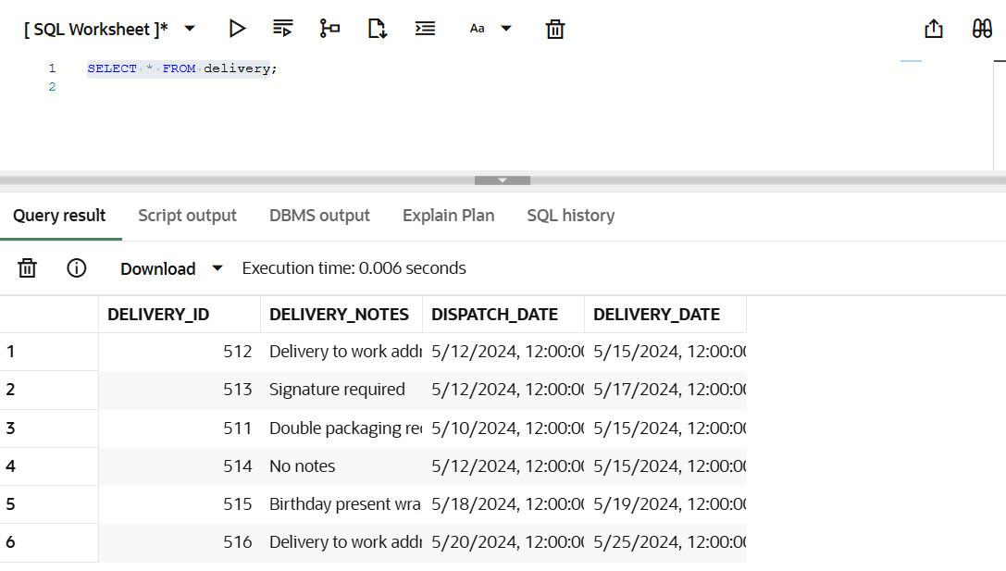
Data in DELIVERY table

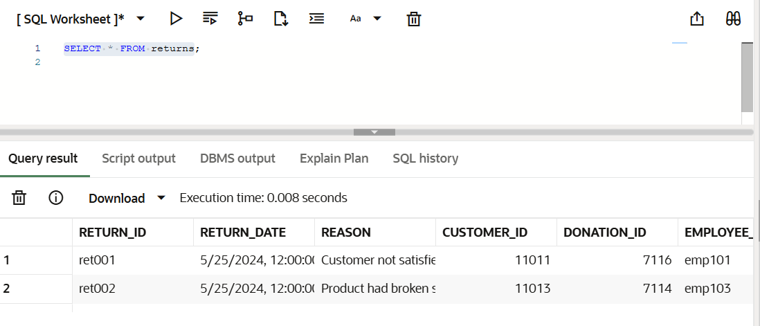
Data in RETURNS table

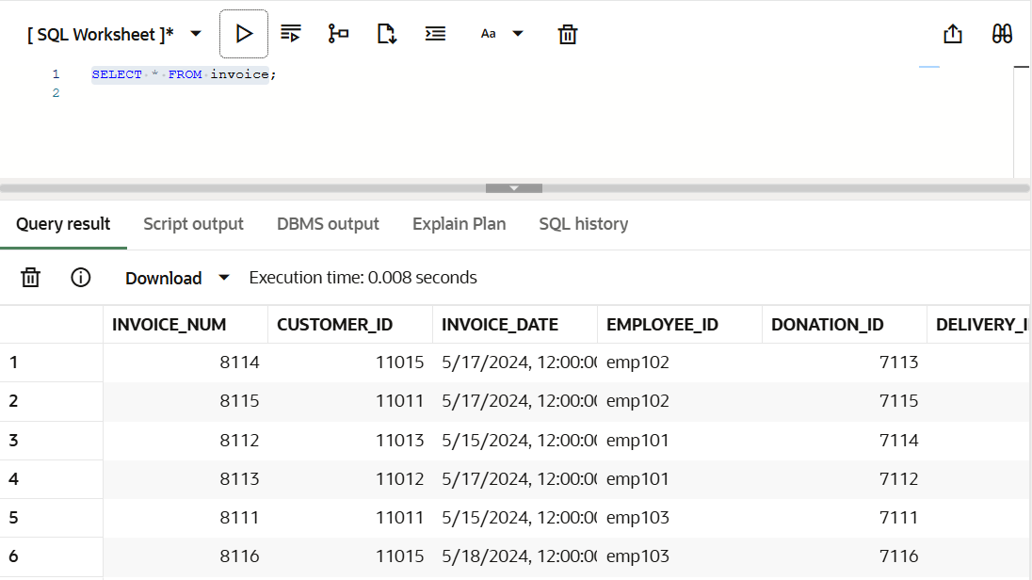
Data in INVOICE table

Question 2
SELECT
c.FIRST_NAME || ', ' || c.SURNAME AS CUSTOMER,
i.EMPLOYEE_ID,
d.DELIVERY_NOTES,
dn.DONATION_DESC AS DONATION,
i.INVOICE_NUM,
TO_CHAR(i.INVOICE_DATE, 'DD/MON/YY') AS INVOICE_DATE
FROM
INVOICE i
JOIN CUSTOMER c ON i.CUSTOMER_ID = c.CUSTOMER_ID
JOIN DELIVERY d ON i.DELIVERY_ID = d.DELIVERY_ID
JOIN DONATION dn ON i.DONATION_ID = dn.DONATION_ID
WHERE
i.INVOICE_DATE > TO_DATE('16-May-2024', 'DD-Mon-YYYY');
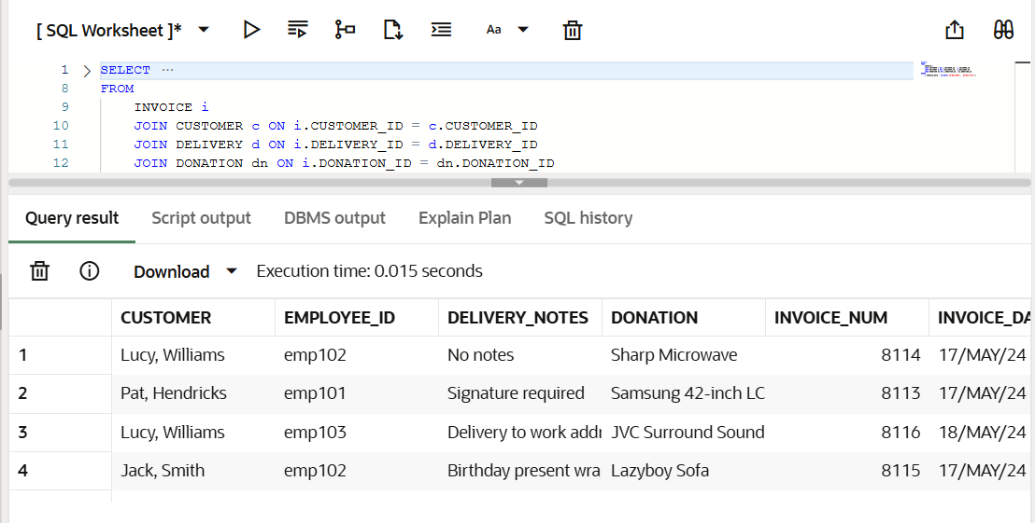

Question 3
Create the FUNDING table
CREATE TABLE FUNDING (
FUNDING_ID NUMBER PRIMARY KEY,
FUNDER VARCHAR2(100),
FUNDING_AMOUNT NUMBER(10,2)
);

Create a sequence to auto-generate unique IDs
CREATE SEQUENCE FUNDING_SEQ
START WITH 1
INCREMENT BY 1;

Create a trigger to automatically insert FUNDING_ID values
CREATE OR REPLACE TRIGGER FUNDING_BI
BEFORE INSERT ON FUNDING
FOR EACH ROW
BEGIN
:NEW.FUNDING_ID := FUNDING_SEQ.NEXTVAL;
END;
/

Insert sample records (no need to include FUNDING_ID)
INSERT INTO FUNDING (FUNDER, FUNDING_AMOUNT)
VALUES ('CapeTown Community Trust', 25000.00);

INSERT INTO FUNDING (FUNDER, FUNDING_AMOUNT)
VALUES ('Africa Aid Foundation', 40000.00);

INSERT INTO FUNDING (FUNDER, FUNDING_AMOUNT)
VALUES ('Helping Hands SA', 15000.00);

View results
SELECT * FROM FUNDING;

Justification Comment
The above solution uses an Oracle sequence and trigger to automatically generate unique funding IDs whenever a new record is inserted. This ensures that FUNDING_ID values are unique and prevents NULL insertion errors, while also avoiding manual ID management.
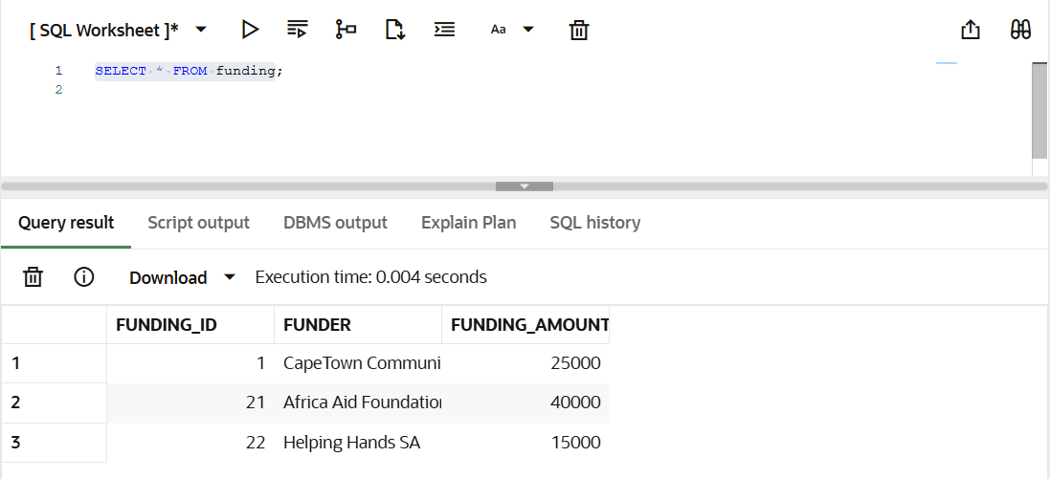

Question 4
SET SERVEROUTPUT ON;

BEGIN
FOR rec IN (
SELECT
c.FIRST_NAME || ', ' || c.SURNAME AS CUSTOMER_NAME,
d.DONATION_DESC AS DONATION_PURCHASED,
d.PRICE AS PRICE,
r.REASON AS RETURN_REASON
FROM
RETURNS r
JOIN CUSTOMER c ON r.CUSTOMER_ID = c.CUSTOMER_ID
JOIN DONATION d ON r.DONATION_ID = d.DONATION_ID
)
LOOP
DBMS_OUTPUT.PUT_LINE('CUSTOMER: ' || rec.CUSTOMER_NAME);
DBMS_OUTPUT.PUT_LINE('DONATION PURCHASED: ' || rec.DONATION_PURCHASED);
DBMS_OUTPUT.PUT_LINE('PRICE: R' || rec.PRICE);
DBMS_OUTPUT.PUT_LINE('RETURN REASON: ' || rec.RETURN_REASON);
DBMS_OUTPUT.PUT_LINE('-----------------');
END LOOP;
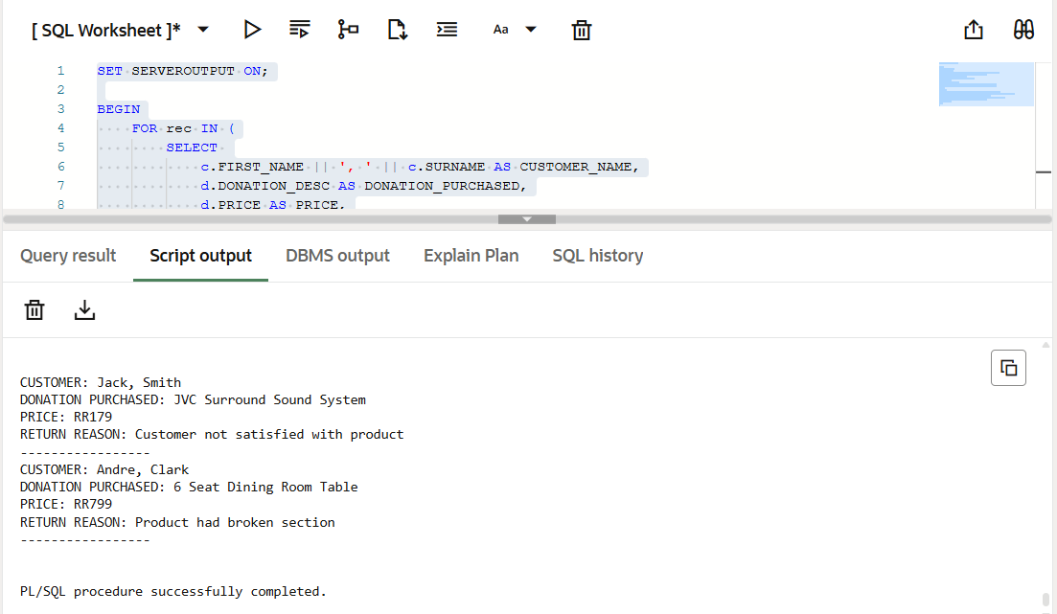
END;
/

Question 5
SET SERVEROUTPUT ON;

BEGIN
FOR rec IN (
SELECT
c.FIRST_NAME || ', ' || c.SURNAME AS CUSTOMER_NAME,
e.FIRST_NAME || '. ' || e.SURNAME AS EMPLOYEE_NAME,
d.DONATION_DESC AS DONATION,
del.DISPATCH_DATE,
del.DELIVERY_DATE,
(del.DELIVERY_DATE - del.DISPATCH_DATE) AS DAYS_TO_DELIVERY
FROM
INVOICE i
JOIN CUSTOMER c ON i.CUSTOMER_ID = c.CUSTOMER_ID
JOIN EMPLOYEE e ON i.EMPLOYEE_ID = e.EMPLOYEE_ID
JOIN DONATION d ON i.DONATION_ID = d.DONATION_ID
JOIN DELIVERY del ON i.DELIVERY_ID = del.DELIVERY_ID
WHERE
c.CUSTOMER_ID = 11011
ORDER BY del.DISPATCH_DATE -- ensures earliest dispatch appears first
)
LOOP
DBMS_OUTPUT.PUT_LINE('CUSTOMER: ' || rec.CUSTOMER_NAME);
DBMS_OUTPUT.PUT_LINE('EMPLOYEE: ' || rec.EMPLOYEE_NAME);
DBMS_OUTPUT.PUT_LINE('DONATION: ' || rec.DONATION);
DBMS_OUTPUT.PUT_LINE('DISPATCH DATE: ' || TO_CHAR(rec.DISPATCH_DATE,'DD/MON/YY'));
DBMS_OUTPUT.PUT_LINE('DELIVERY DATE: ' || TO_CHAR(rec.DELIVERY_DATE,'DD/MON/YY'));
DBMS_OUTPUT.PUT_LINE('DAYS TO DELIVERY: ' || rec.DAYS_TO_DELIVERY);
DBMS_OUTPUT.PUT_LINE('-----------------');
END LOOP;
END;
/
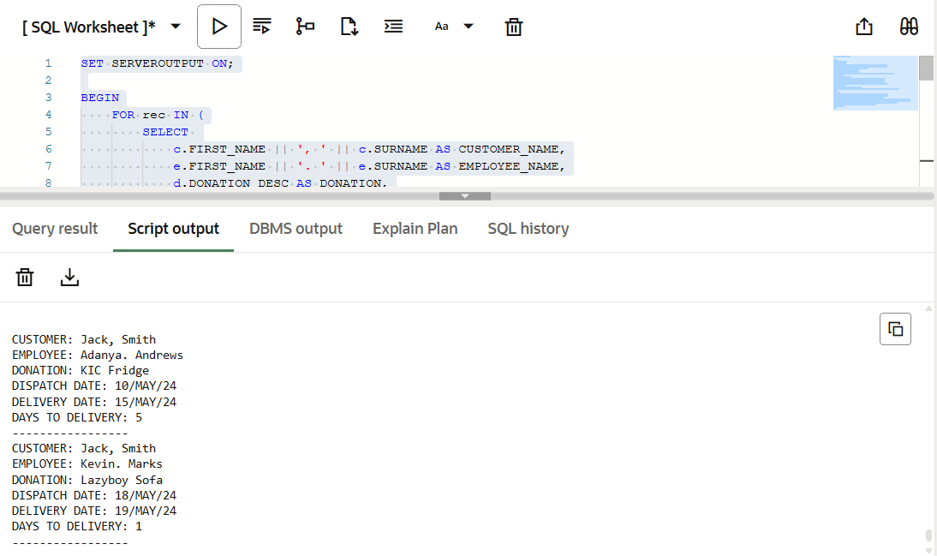

Question 6
SET SERVEROUTPUT ON;

DECLARE
v_first_name VARCHAR2(50);
v_surname VARCHAR2(50);
v_total_amount NUMBER;
BEGIN
FOR rec IN (
SELECT
c.first_name,
c.surname,
SUM(TO_NUMBER(REPLACE(d.price, 'R', ''))) AS total_amount
FROM customer c
JOIN invoice i ON c.customer_id = i.customer_id
JOIN donation d ON i.donation_id = d.donation_id
GROUP BY c.first_name, c.surname
ORDER BY CASE c.first_name
WHEN 'Jack' THEN 1
WHEN 'Pat' THEN 2
WHEN 'Lucy' THEN 3
WHEN 'Andre' THEN 4
END
) LOOP
v_first_name := rec.first_name;
v_surname := rec.surname;
v_total_amount := rec.total_amount;

DBMS_OUTPUT.PUT_LINE('FIRST NAME: ' || v_first_name);
DBMS_OUTPUT.PUT_LINE('SURNAME: ' || v_surname);
DBMS_OUTPUT.PUT_LINE('AMOUNT: R' || v_total_amount ||
CASE WHEN v_total_amount >= 1500 THEN ' (***)' ELSE '' END);
DBMS_OUTPUT.PUT_LINE('-----------------');
END LOOP;
END;
/

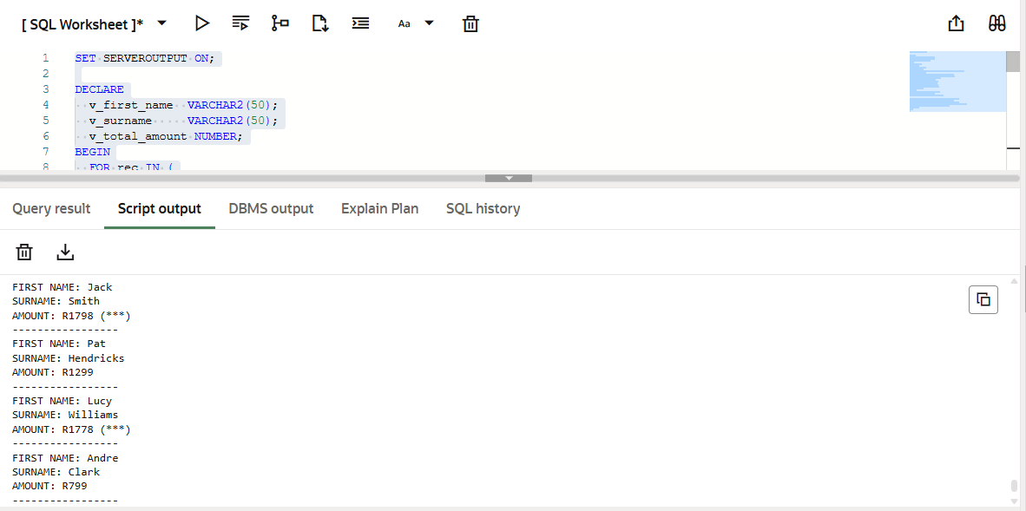

Question 7
7.1.
SET SERVEROUTPUT ON;

DECLARE
v_first_name customer.first_name%TYPE;
v_surname customer.surname%TYPE;
BEGIN
v_first_name := 'Jack';
v_surname := 'Smith';
DBMS_OUTPUT.PUT_LINE('First Name: ' || v_first_name);
DBMS_OUTPUT.PUT_LINE('Surname: ' || v_surname);
END;
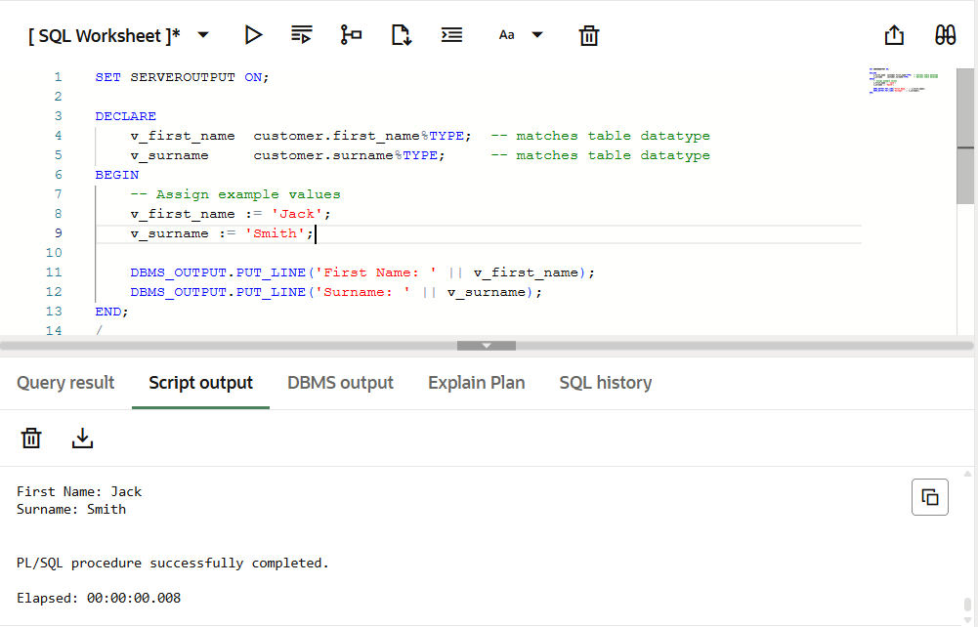
/

7.2.
SET SERVEROUTPUT ON;

DECLARE
v_employee_record employee%ROWTYPE;
BEGIN
SELECT * INTO v_employee_record
FROM employee
WHERE employee_id = 'emp102';

DBMS_OUTPUT.PUT_LINE('Employee ID: ' || v_employee_record.employee_id);
DBMS_OUTPUT.PUT_LINE('Name: ' || v_employee_record.first_name || ' ' || v_employee_record.surname);
DBMS_OUTPUT.PUT_LINE('Email: ' || v_employee_record.email);
END;
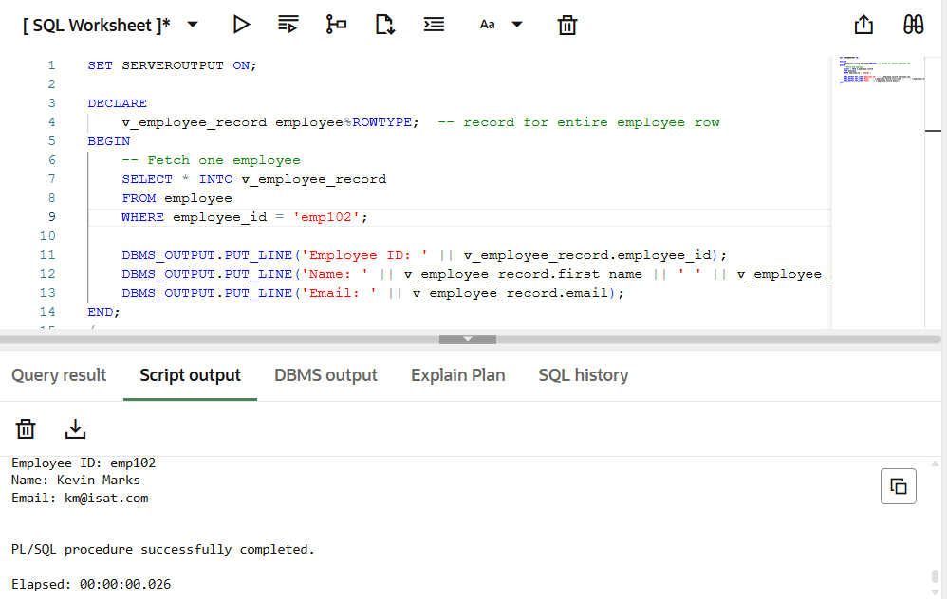
/

7.3.
SET SERVEROUTPUT ON;

DECLARE
v_cust_id customer.customer_id%TYPE := 999; -- non-existing ID
v_first_name customer.first_name%TYPE;
e_no_customer EXCEPTION;
BEGIN
BEGIN
SELECT first_name INTO v_first_name
FROM customer
WHERE customer_id = v_cust_id;
EXCEPTION
WHEN NO_DATA_FOUND THEN
RAISE e_no_customer;
END;
EXCEPTION
WHEN e_no_customer THEN
DBMS_OUTPUT.PUT_LINE('Error: Customer with ID ' || v_cust_id || ' does not exist.');
END;
/

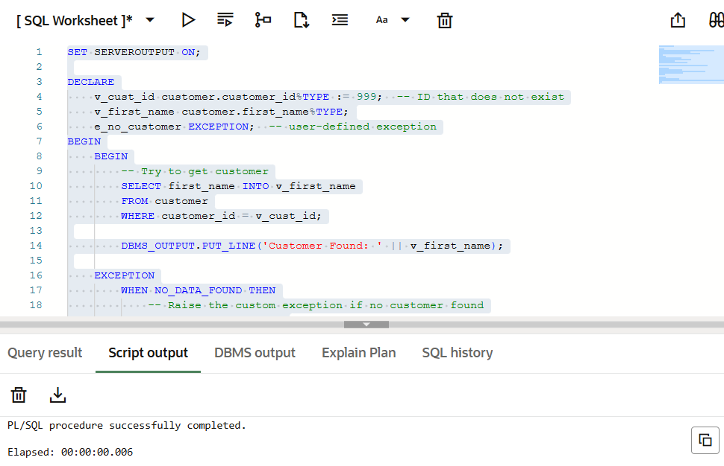

Question 8
SELECT
c.first_name,
c.surname,
'R' || SUM(TO_NUMBER(REPLACE(d.price, 'R', ''))) AS amount,
CASE
WHEN SUM(TO_NUMBER(REPLACE(d.price, 'R', ''))) >= 1500 THEN '***'
WHEN SUM(TO_NUMBER(REPLACE(d.price, 'R', ''))) BETWEEN 1000 AND 1400 THEN '**'
ELSE '*'
END AS customer_rating
FROM customer c
JOIN invoice i ON c.customer_id = i.customer_id
JOIN donation d ON i.donation_id = d.donation_id
GROUP BY c.first_name, c.surname
ORDER BY
CASE c.first_name
WHEN 'Jack' THEN 1
WHEN 'Pat' THEN 2
WHEN 'Lucy' THEN 3
WHEN 'Andre' THEN 4
END;

