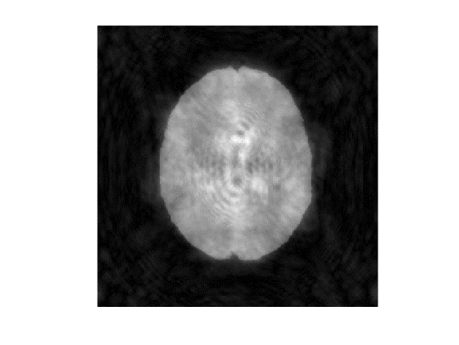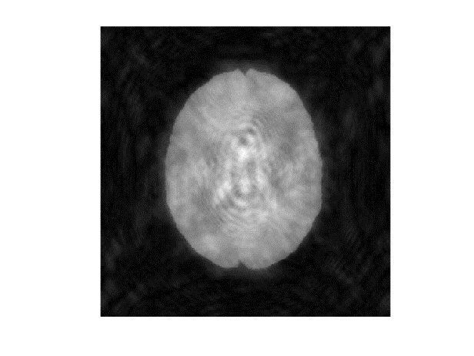

…

…

…

i = n

i = 1

Time i

Signal (arbitrary units)

One voxel

Rest of voxels

Rest of voxels

Voxel of i = n

Voxel of i = 1

i = n

i = 1

i = n

i = 1

Repeated n times

Temporal incoherence

Pseudo-random parameter interrogating sequence

Spatial

incoherence

Read-out undersampled trajectory