TOPIC 1 – CODE GENERATION
Code generation allows users to generate a source code. There are a lot of advantages of using a code generation. It lessens the possibility of a developer to commit mistakes like wrong syntax, typos or unintentional omissions. Code generation minimizes your time and effort in coding because it automatically creates the code for you.
Using Code Templates
Eclipse offers a lot of features like creating templates or snippets. Code templates help reduce typing time and effort by inserting code into the editor. Each code template can be selected by typing its literal into the editor window and pressing Ctrl + Space.
Typing “switch” into the editor and pressing Ctrl + Space show the code templates that were associated with “switch” (See figure 1). Another useful code literal is sysout which is used to insert the System.out.println() method call (See figure 1.1).
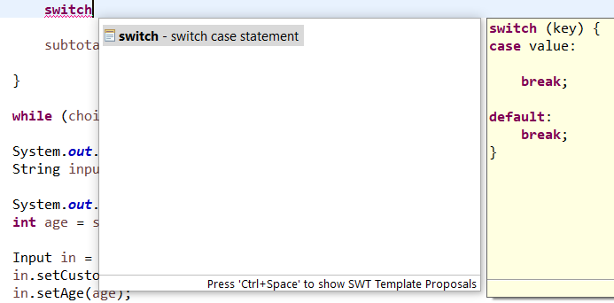
Figure 1: switch literal (shortcut for switch statement)
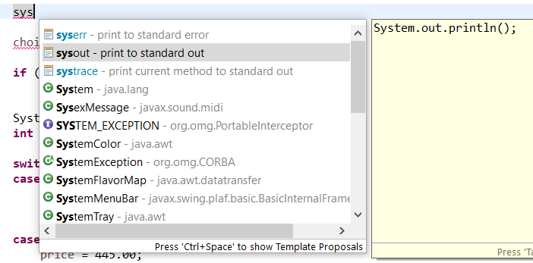
Figure 1.1: sysout literal (shortcut for System.out.println())

Modifying or Adding Code Templates
In Eclipse you can easily add code templates or snippets using the Preference dialogue box. Open the Preference dialogue box by clicking on the windows menu and selecting Preference. To open template page type template in the search box provided (See figure 1.2). Here you can see the lists of code templates with their literals.
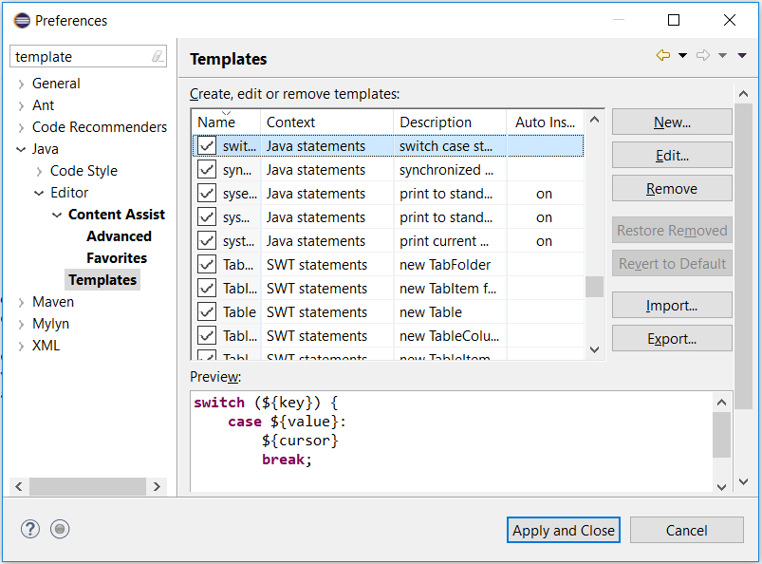
1.2: Template Page
Eclipse can also generate getters and setters, delegate methods, hash code, toString, and constructors. To generate getters and setters click Source in the menu bar and select Generate Getters and Setters. After that, you have to select the variable/s you want to create a getter and setter. It will automatically create a blocks of code for you which makes it easier, faster and avoid errors when coding.
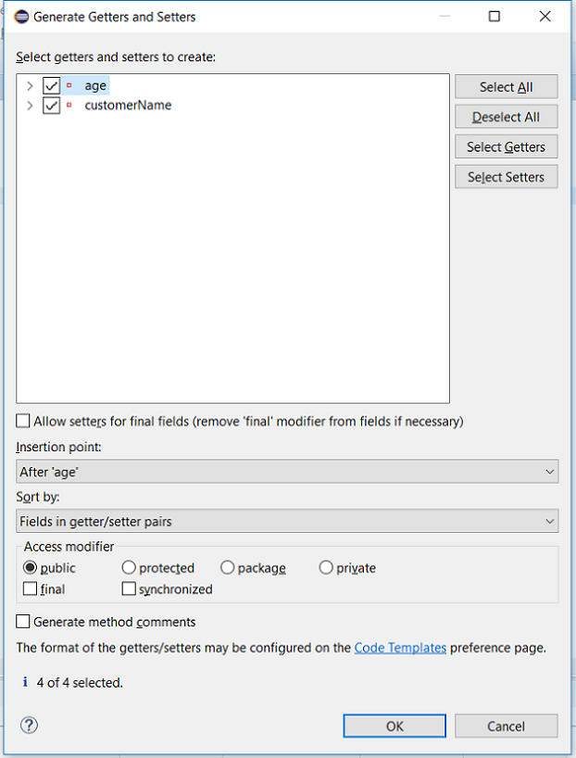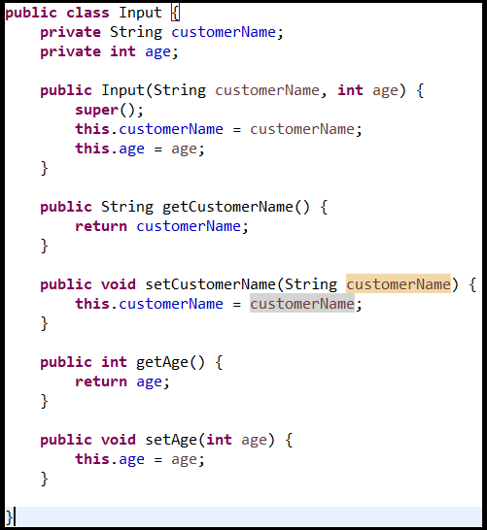
Figure 1.3: Generate getters and setters Figure 1.4: code generated

TOPIC 2 – CODE REFACTORING
Refactoring is a disciplined process for restructuring an existing code that does not change its external behavior. Refactoring covers alteration and improving up of a source code. Refactoring is used in many different programming languages.
Why you should use Refactoring?
A lot of software fails when it becomes so complicated that it can no longer provide the additional features needed. By removing duplex codes, you lessen the amount of codes. The lesser the codes that you have, the easier for you to understand and modify. Code refactoring can help you understand the code of other developers. It also minimizes complex conditional logic.
Refactoring Using Eclipse
We are intended to do some ways of refactoring using Eclipse IDE. There are a lot of option in refactoring and you can see that by clicking on refactor at the menu bar. First is to rename a variable method and a class. Next is to extract a class to minimize a complex code and for it to be easily understood. And lastly is to extract a local variable.
Alt + Shift + T is a shortcut that allows you to use refactoring operations.
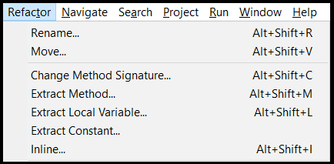
Figure 2: refactor options
Renaming a Variable Method and a Class
Renaming methods and variable have become easier because of refactoring. Choose and highlight the method or the variable that you want to rename/replace. Type the name you want to replace and press Enter and it will automatically implement it to the code.
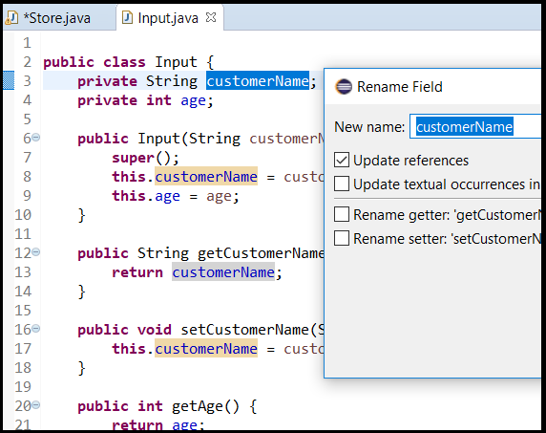
Figure 2.1: Renaming Variable: Highlight the chosen variable and click on the refactor and select rename or simply use the shortcut key
Alt + Shift + R.

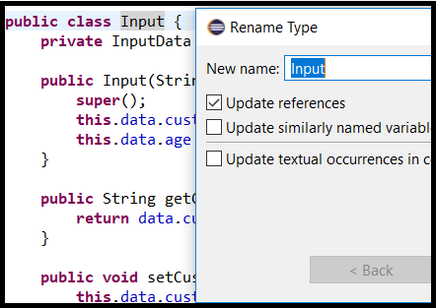
Figure 2.2: Renaming Class: Highlight the chosen class and click on the refactor and select rename or simply use the shortcut key
Alt + Shift + R.

Extracting a Method
Method extracting will allow you to create a new method by extracting a blocks of code. Using extract method will make your code shorter, more readable, less code duplication, and isolate independent part of code.
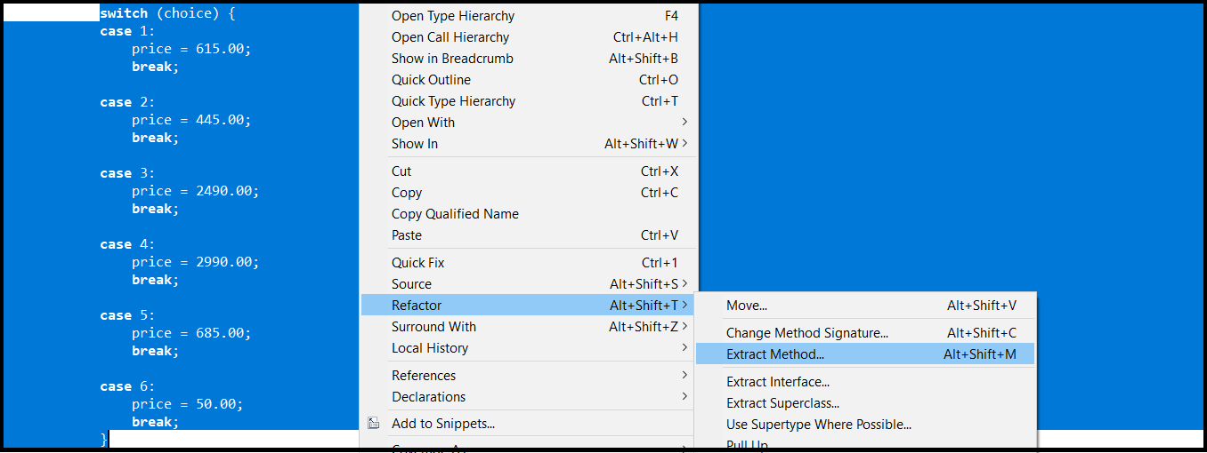
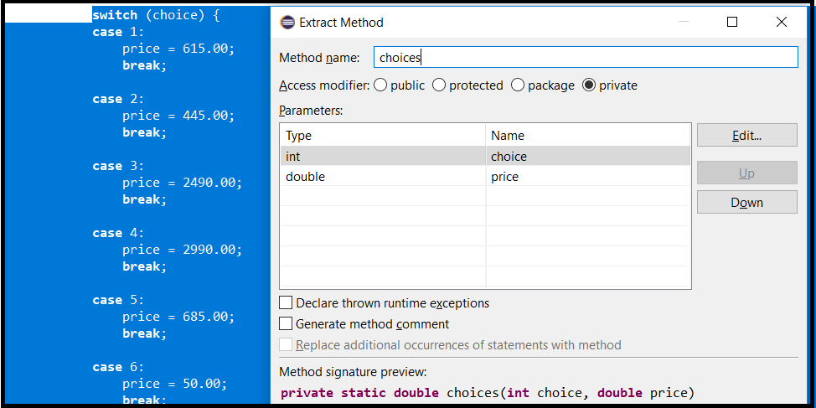

Figure 2.3: Extract a method Figure 2.4: Input method name Alt + Shift + M
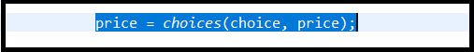
Figure 2.5: Extracted method
Inline Method
Inline method replaces the extracted method into its original structure. Select the method name then right click > refactor > Inline or simply press Alt + Shift + I.

TOPIC 3 - DEBUGGING
Debugging is the process of locating errors within the program that prevents it from generating the correct output and then resolving those errors to get the correct output from the program. Debugging is used to examine how the contents of the variables work inside the program.
Overview
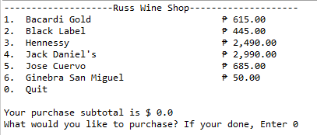
- For this example, we are going to have a simple demonstration on how to use the debugger of Eclipse. First, we need to have a running program.

Figure 3.1 Running Program
*This program like a wine shop where it lets customer order wine and prints out the order, payment, name, and age of the customer after ordering.
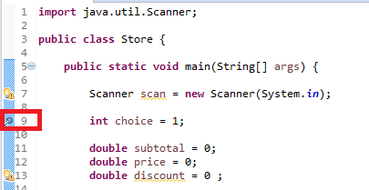
- Next, we need to set a breakpoint. A breakpoint is a pausing place in a program used for debugging purposes. In this example, I will set the breakpoint at the start of my program after the instantiation of the scanner. To set breakpoints, just double click on the left margin on the line that you want to set a breakpoint.

Figure 3.2 Setting breakpoint
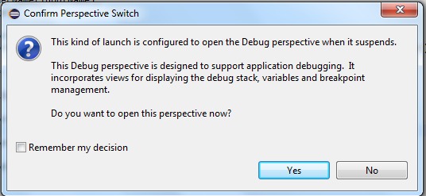
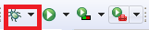
- Next, click on the debug icon to start debugging your program. Then you will be prompt to switch in to debug perspective, click Yes to switch your perspective in debug mode.

Figure 3.3 Debug Icon

Figure 3.4 Switch perspective

- You can now use the debugging options to debug your program. You can click on the buttons or you can use the shortcuts.

Figure 3.5 Debug Options
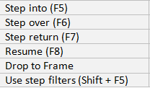

Figure 3.6 Debug shortcuts

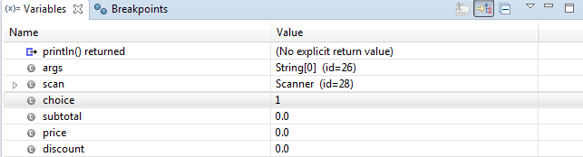
- As you debug your program, you can see the changes happening in the Variables view. You can use this to examine the contents of the variables thoroughly in the program.

Figure 3.7 Variables view

TOPIC 4 – GRAPHICAL USER INTERFACE (GUI) DESIGN
Graphical User Interface or also known as GUI are used by users to interact with the computers. To start designing your GUI in Eclipse, you need to install first the Java WindowBuilder (GUI Designer Plugin). If you don’t know how to install the WindowBuilder go to https://www.youtube.com/watch?v=oeswfZz4IW0 and watch the tutorial.

OVERVIEW
- After you installed the WindowBuilder, you can now design your GUI for your program. Press Ctrl + N to open the Swing application window.
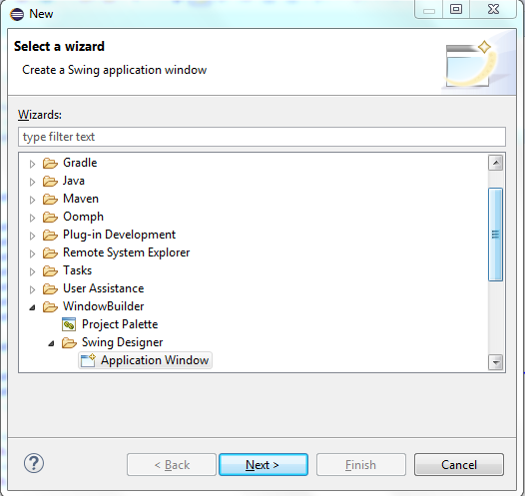

Figure 4.1 Swing Application Window
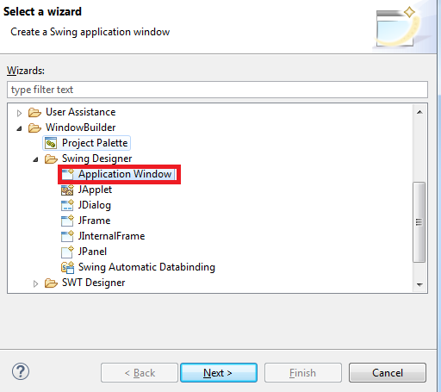
- Then go to WindowBuilder > Swing Designer, click on Application Window and click on Next.

Figure 4.2 Application Window

- Then, you name your Swing Application and click on Finish. In this example, I named it InputGUI because I want to create a GUI that gets the name and age of the customer.
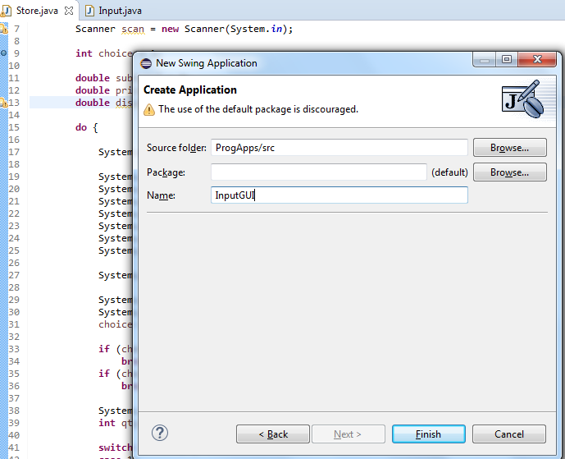

Figure 4.3 Naming Swing Application
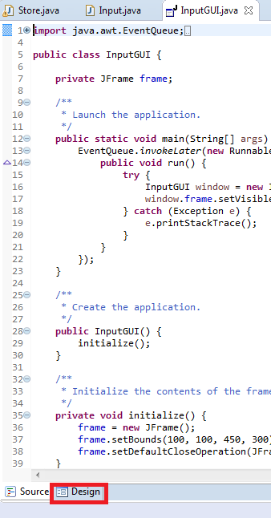
- Then, click on Design tab to start designing you own GUI.

Figure 4.4 Design Tab
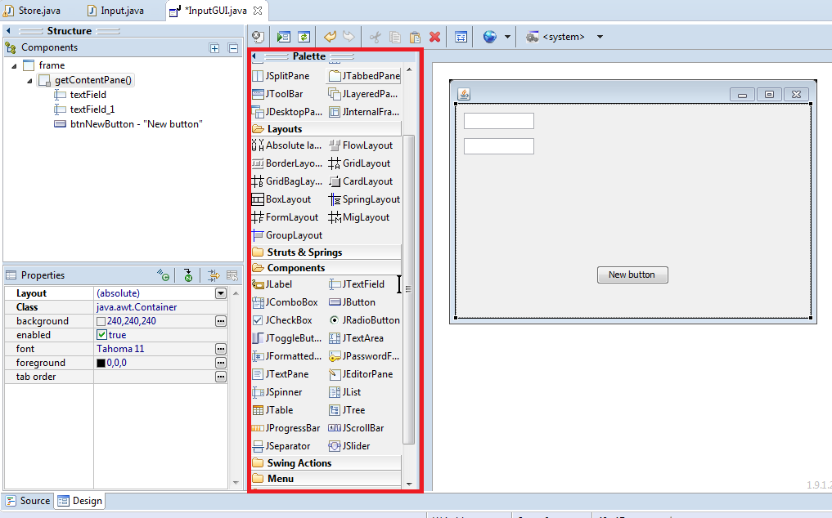
- After clicking on the Design tab, you can now create your own GUI for your program. You can use Palette Tool to design your frame. It is a click and drop style which makes it more convenient to use.
Figure 4.5 Palette Tool for designing GUI
References:
Kramar, T. (2015, August 27). Effective Eclipse: Dont write the code, generate it - DZone Java. Retrieved April 15, 2018, from https://dzone.com/articles/effective-eclipse-dont-write-c
Tutorials Point. (2018, January 08). Eclipse Code Templates. Retrieved April 15, 2018, from https://www.tutorialspoint.com/eclipse/eclipse_code_templates.htm
What is dynamic analysis? - Definition from WhatIs.com. (n.d.). Retrieved April 15, 2018, from http://searchsoftwarequality.techtarget.com/definition/dynamic-analysis
Tutorials Point. (2018, January 08). Eclipse Code Templates. Retrieved April 15, 2018, from https://www.tutorialspoint.com/eclipse/eclipse_refactoring.htm
Point, T. (2017, August 15). Static Testing. Retrieved April 15, 2018, from https://www.tutorialspoint.com/software_testing_dictionary/static_testing.htm

SOFTWARE DEVELOPERS TOOLBOX
9402A 10:00 – 11:00 TF

Group 7
Topic 1 – Code Generation
Topic 2 – Code Refactoring
Topic 3 – Debugging
Topic 4 – Miscellaneous Activities (Design)

Submitted by:
LAGAO, RONALD CARBONEL
PALABAY, NATHANIEL ANGELO SORIANO
PUGYAO, SEAN CONROY TITIWA
SALIO-AN, RUSSELL CANAO
POSADAS, AHLEA ROSE FONACIER
Submitted to:
Mr. Roderick Makil

