TOPIC 2 – CODE REFACTORING
Refactoring is the process of altering the design and structure of a code, but without changing its functionalities. Factoring is done “little by little”. With each every small step, excess and unneeded codes are removed or eliminated, and in return, readability is enhanced and memory demand is reduced. Enhanced readability does not only allow for a better understanding of the code, but results to easier modification as well.
Refactoring Using Eclipse IDE
Refactoring: Extracting a Method
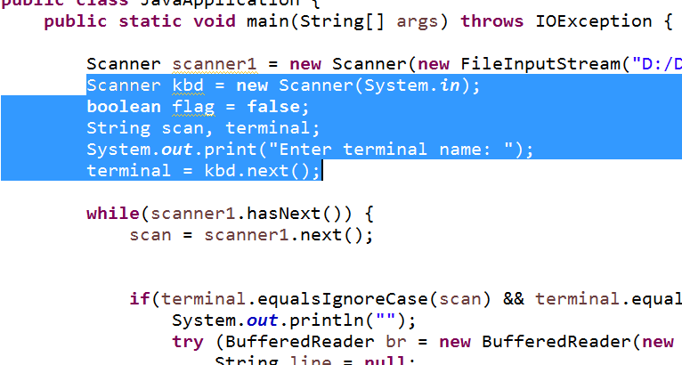
This refactoring technique transforms a block of code into a method. This will prevent code duplication, making your program shorter and allowing better readability, understanding, and maintainability.
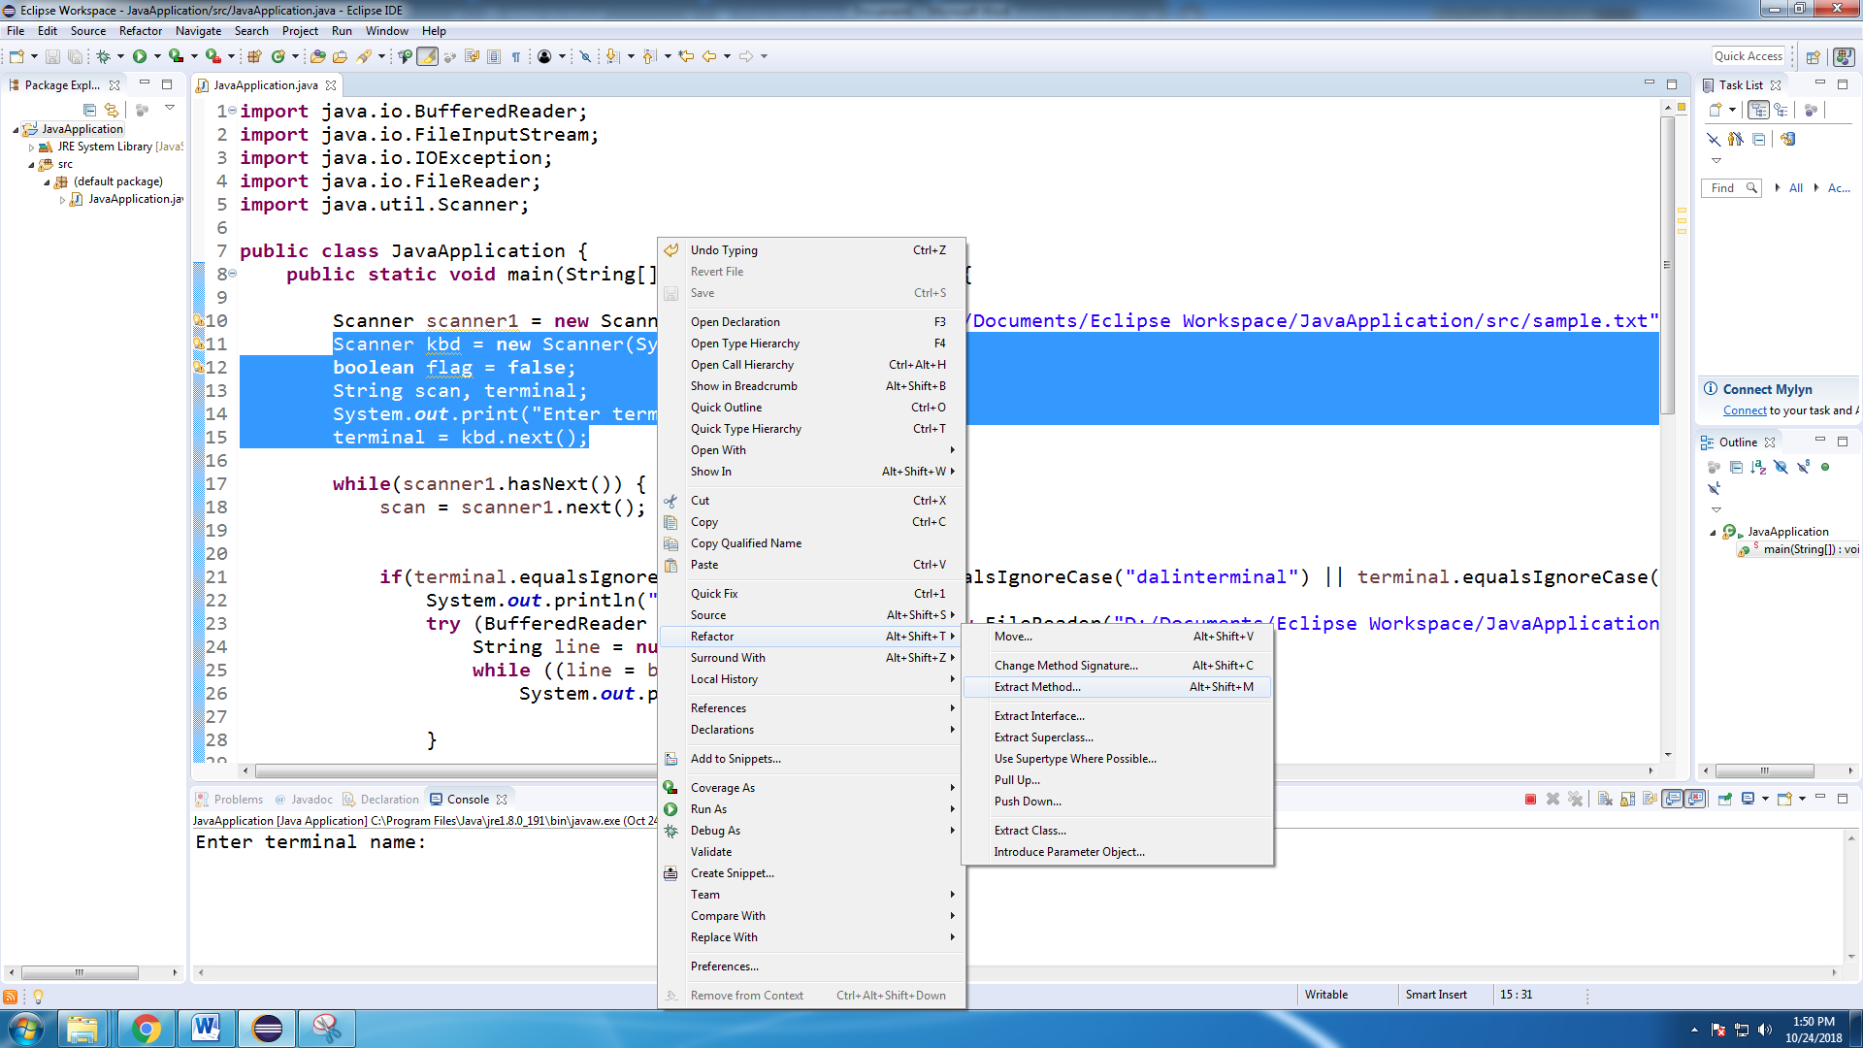
Highlight the block of code which you want to transform into a method. In this demonstration, the block of code that asks/takes input from the user is selected.

Right-click while the codes are highlighted to see available options. Go to “Refactor”, or simply do the keyboard shortcut Alt+Shift+T, and choose “Extract Method”. Alternatively, you can directly go to this refactoring technique by typing the keyboard shortcut Alt+Shift+M. You will then be prompted to type a name for the method.
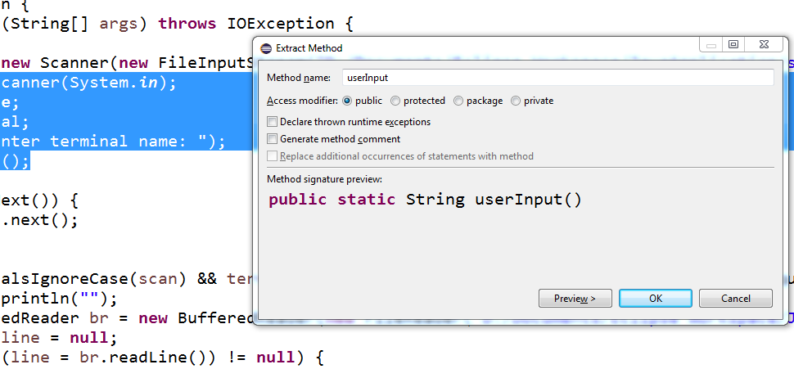
Clicking on “OK” will now extract the block of code that was chosen into a method.
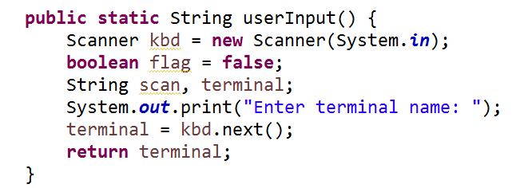

Refactoring: Inline Method
The opposite of extract method is inline method.
Highlight the name of the method that you wish to refactor. Go to the refactoring options, then choose “Inline…”. In Eclipse IDE, the keyboard shortcut for inline method is Alt+Shift+I.

Using inline method, the userInput() method that was created using the extract method technique was more or less reverted back to its original form.
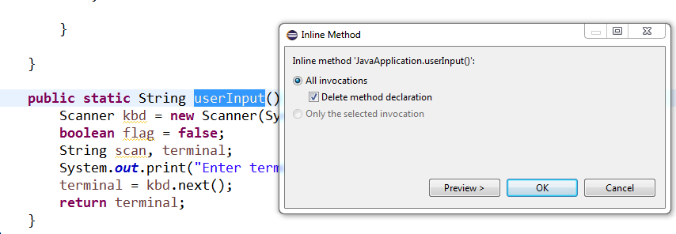
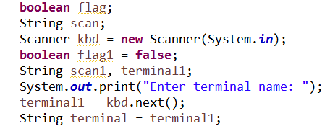
Refactoring: Renaming
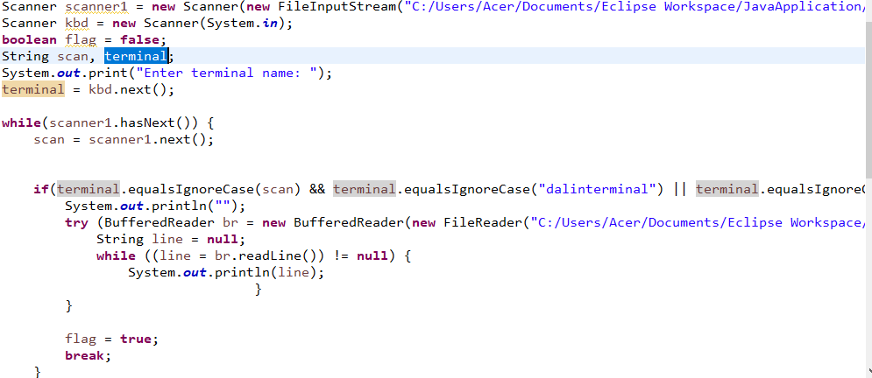
Renaming is probably the most used refactoring technique. This technique can be very useful in a large program where variables and methods are used multiple times.
Highlight the name of the variable/method which you wish to rename. Right-click and choose “Rename…” in the refactoring options, or directly go to this refactoring technique using the keyboard shortcut Alt+Shift+R.

Choose a new name for the variable/method that you wish to rename. This will also automatically update all instances in which that certain variable/method has been called within your program.
