Server & DB management

Usefull document on IDB Dashboard
Here is the link https://www.enterprisenewton.com/Dashboard/CompanyPolicy.aspx
--------------------------------------------------------------------------------------------

Install and Configure SQL Express
Deployment Checklist
Site Migration Protocol
Std. Config for New Server

Backup policy
Primary Backup – un-scrubbed backup
Offsite Backup – scrubbed backup

Backup Assurance Service

Restore and Recovery

Super flexible S/W

Security Policy

Customizing a Security Policy
Virus and Worm Attacks
SQL Injection Attacks

SQL Server (With Store Procedures)

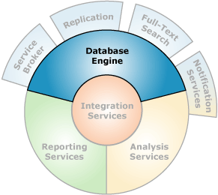

Introduction to SQL Server
http://msdn.microsoft.com/en-US/library/ms345154(v=SQL.90).aspx

System database (master, model, msdb, tempdb) and User Database

Writing Transact-SQL
http://msdn.microsoft.com/en-US/library/ms166585(v=SQL.90).aspx

Connect to Database
Create Database
(MDF file/Log file)
Attach/Restore Database
Create Table/View/SP/Fucntion

