This is a server based Online app. Using this app a person easily find a donor and contact with them .Can see their Location ,search nearBy Hospital .User can also see the distance between corresponding donor and him/her.

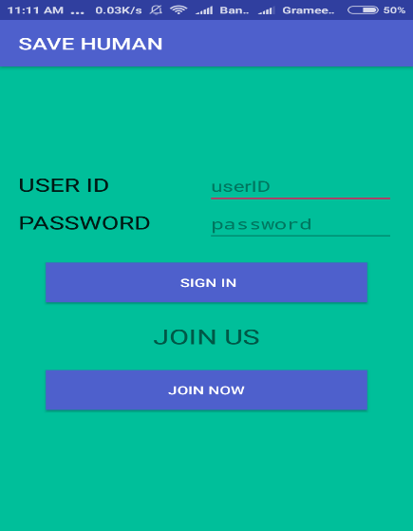

A user should be sign in to access this app with user id and password.

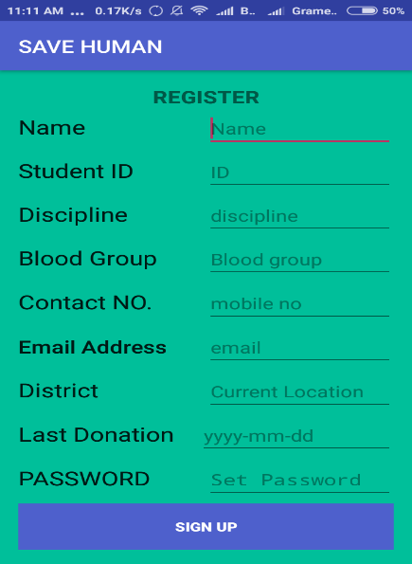

User have to go register activity and fill the all criteria for sign up.

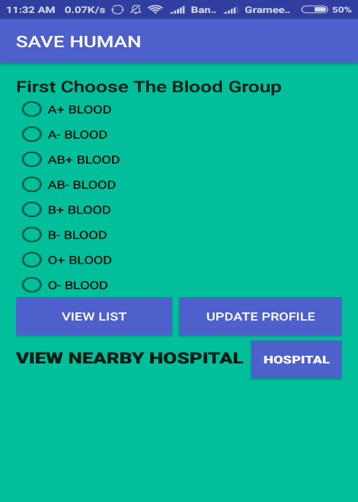

If user can sign in successfully then user can see this activity first.And select the searching blood group from here

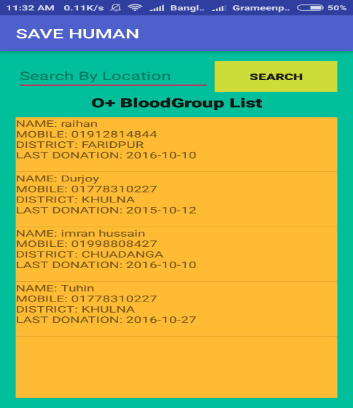

When user select the blood group and select view list then user can see the list of the selected blood group donor from list view.

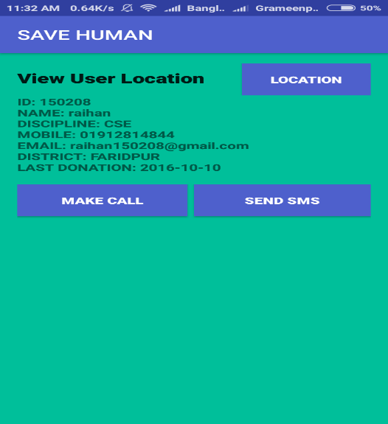

User can see all the information of a individual donor and make a call from this activity.

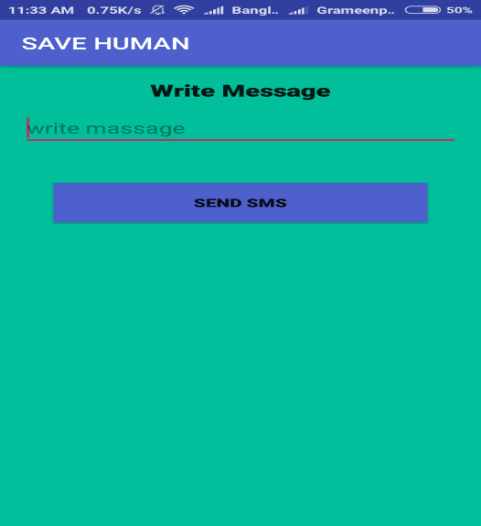

User can message a donor from this activity

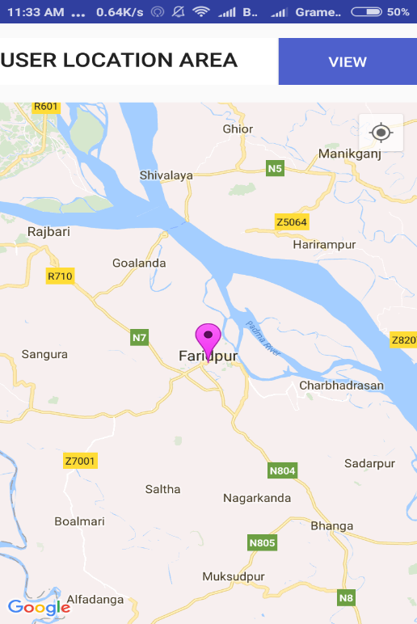

User can view the donor location from this map activity.

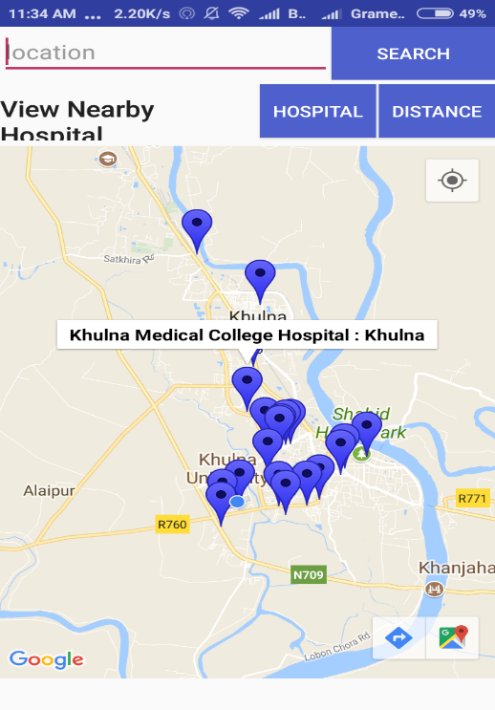

User search all the near by hospital from their current location.

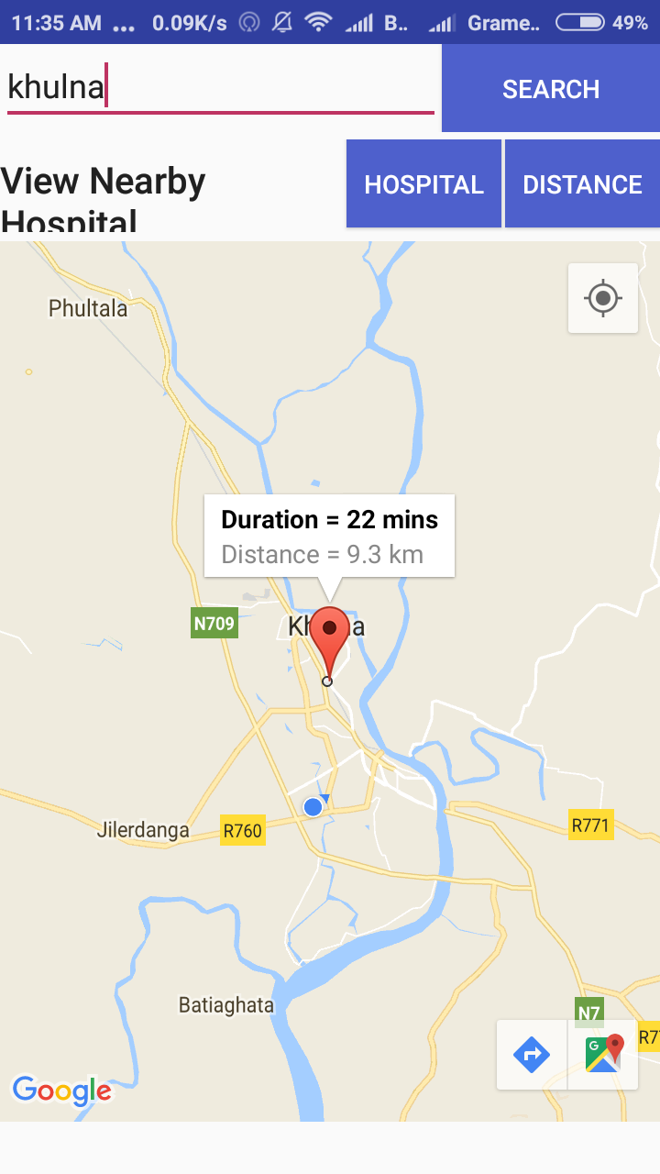

User can see the duration and distance from a donor from anywhere.

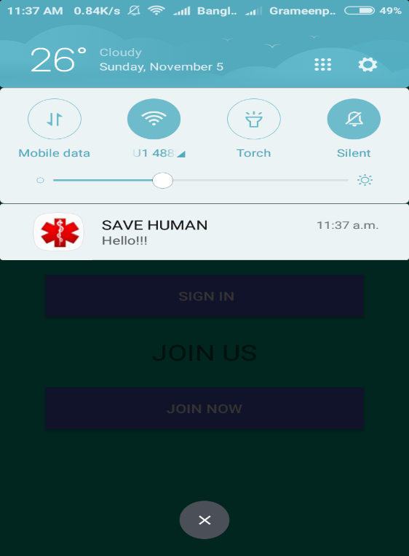

Developer can send notification from their project to user.