The COVASIM model simulates the variable changes of state over a simulated amount of time. The various changes a person may go through include healthy (Normal not in hospital), diagnosed, infection (Has COVID-19), sever (Has COVID-19 & in hospital), critical (Has COVID-19 & in ICU / Critical Care), death.   
  
The COVASIM model focuses on one particular type of calculation, being the probability that a person will change from one state to another. These probabilities have been calculated by the rate of infection, rate of transmission as well as various NPI’s that affect community and household transmission such as lockdowns, school closures, workplace closures, and masking.

The design architecture of the COVASIM model follows a process as follows;

* First the necessary simulation parameters are loaded and validated to check for any inconsistencies or syntax that may be irregular,
* next the necessary data feed files are loaded. This data feed file is a time series data file that includes the cumulative number of cases as well as cumulative number of deaths from the start day of simulation to the current real time date (see **figure 1**)
* Consequently, a simulated population is created including age, sex and cormobities for each agent. This is done by loading in the location specific data into Covasim. This location based data is case sensitive when **peramatizing** the model ex; “Canada” and not “canada”. See **figure 2 line 59**.
* While populating the necessary location data, manual insertion of the total population as well as simulated population is required. For example in the original COVASIM model the overall population of the UK was studied with a focus on a specific area. See **figure 2 line 36/37**
* Furthermore, selection of population types is required. For this simulation a hybrid network was used however for more advanced work a synth pops network may be used but requires further calibration and additional software not used in this model. Additionally, a base infected population is needed, this means the initial seed of population that have been exposed to COVID-19 in some form to begin the simulation. See **figure 2 line 40**
* While choosing interventions that may be included in the simulation, types of interventions such as tracking and enhanced testing may be implemented as well as contact tracing, lockdown strategies, and cohorting. If a single value is entered for example; contact tracing is used in Covasim, COVASIM will assume that this value remains the same for all months included in the simulation. However this can be applied for multiple months by noting the change in value and applying this to the intervention section of the simulation. See **figure 4.**
* Lastly as seen in **figure 2 line 41** a baseline beta value must be selected, this is the rate at witch transmission occurs and can be later on modified throughout the months of simulation or through interventions such as masking.
* Next the Covasim model will begin to loop through the various interventions as well as parameters that have been placed into the model. This will follow an order of operations including applying the health system constrains, updating the disease progression overtime as well as including important events that have been listed in the model, these can include border closures, increased transmission etc…
* When interventions are applied, the calculation of disease transmission as well as infectious agents in the contact network will also be applied. Within the Covasim model it is important to note that there are four (4) contact layers; Community, School, Household and workplace networks where transmission will occure. A feature include in COVASIM is the probabilities to changes in transmission within these network laters during a specific time. Thus for example we can model for specific NPI’s being used or enacted during a specific time and analyze their effective before the NPI was enforced and while the NPI was enforced to test its effectiveness.
* Finally, an exported data file will be created with the following tables and columns listed in **Figure 3**  
    
    
    
    
    
    
    
    
    
    
    
    
    
    
    
    
    
    
    
    
    
    
    
    
    
    
    
    
    
    
    
    
    
    
    
    
    
    
    
    
    
    
    
    
    
    
    
    
    
    
    
  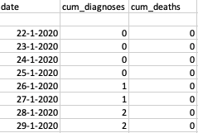  
    
    
    
    
    
    
  **Figure 1**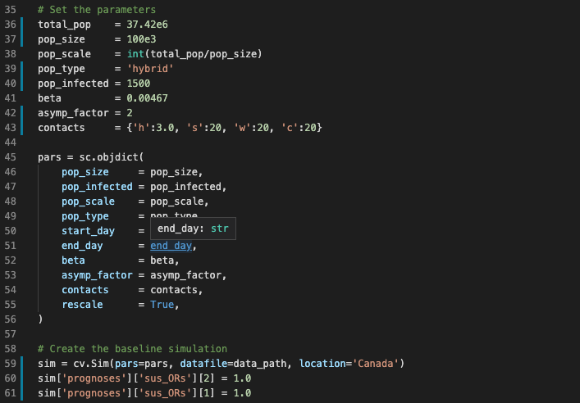  
  **Figure 2   
    
  Figure 3  
    
    
  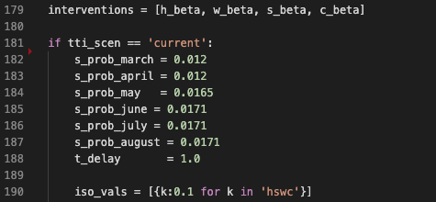  
  Figure 4**