**IELTS (International English Language Testing System)**

IELTS is jointly managed by the British Council, IDP and Cambridge English, and was established in 1989. IELTS is one of the major English-language tests in the world.

The IELTS exam measures your proficiency in four key areas: Listening, Reading, Writing, and Speaking.

**Types and Categories**:

* IDP and British Council (Cambridge create the test and these agencies conduct) (Both are same)
* Academic and General Training.
* Both versions have four components: Listening, Reading, Writing, and Speaking. The Listening and Speaking sections are the same for both versions.
* Paper and Online (recommended go for paper)

**Scoring:**

* Bands is a name of scoring system created by ielts (Cambridge)
* You will get any score from 1-9
* Bands and CEFR (common European framework as a reference for language)

- There are three levels in CEFR: A1 and A2, (Basic) B1 and B2, (Intermediate) C1 and C2 (Advanced)

**Books:**

* The Official Cambridge to IELTS
* For Practice: Cambridge Practice tests for IELTS Series
* There is series from 1-14: (start from 9 - 14)

**Test Frequency:**

* Academic: 48 times a year
* General Training: 24 times a year

Don’t go immediately for tests, if you didn’t get the desired score.

**Modules:**

* There are four modules in ielts.

1. **Listening (4 Parts — 40 questions)**

* Recordings of conversation and monologues will be played. Then you will be required to answer a few multiple-choice questions related to the recordings played to you.
* 30 minutes listening audio and 10 minutes for transferring answers to answer sheet.
* Audio will be played once.
* Various accents: British, Canadian, American etc. But 85 to 90% will be British Accent, for a reason this test is created in Cambridge University which is in UK.

Two reasons to not get 9 bands:

* Non-native Speakers
* Not engrossed with the language
* Listening: English Poetry [Link](https://www.youtube.com/playlist?list=PLkXex0-Sjz1vGijXaVFNYsNuVzB8uJUQL) [Link](https://www.youtube.com/playlist?list=PLcEMh_JPjriZlEkvgBJi3owpvGQQ4bqAg)

40 Questions, 4 Sections, Break between Sections

* Difficulty level increases with every section. (speed, distractions, Types of questions, in the last sections no breaks within the section)
* Why sections: To test your listening in various contexts.
* **Section 1:** You will be listening a conversation between two people. (keep the volume a little bit higher in this section)
* **Section 2:** A Monologue – a single person is talking about an everyday social context. (MCQs, short Q and A, Sentence completion, Diagram Labeling etc.)
* **Section 3:** Difficult, mainly MCQs – an academic context, more than 2 persons involved.
* **Section 4:** A monologue: a professor talk about research, no break, 7-8 minutes of audio, difficult to concentrate, Mainly summary completion and MCQs are rare and it is academic context

**Introduction to the Accents:**

* Various accents in Listening. Possibly (British accent, American accent, Australian, Indian, Russian)
* Need to understand the audio.
* Pronunciation (how you pronounce word) vs Accent (style of speaking)
* Alphabets: a -> aye, I -> ia
* Numbers: You may listen for pin code and phone numbers:
* 0 -> naught or nought , null, zero, Oh
* Note down the numbers in the mini pause: 635 623 6295
* Pronunciation: Best source: [Link](https://dictionary.cambridge.org)
* 5000 most commonly used English words, keep searching these words on the website.

**Listening Modules:**

**Form completion:** To fill the form while listening to information.

* Always in section 1
* Two people talking on call (low volume – on the other side of the phone) (keep the volume a little bit higher) (spelling mistake make it incorrect)
* Pointers, Instruction, Prediction, Sequence, Units and names
* Audio is played in sequence with the questions
* Watch out for unit: if it is provided, don’t include it. (if it is not provided, please include it) (if name is included. They will dictate it.) (If it is dictated probably it is an answer.)
* Please write the answers as quick as possible in question paper.

**Table Completion:**

* Similar to sentence completion but… it is in the form of table.
* Pointers: are tips and tricks, to find answers quickly.
* Rows and columns are important.
* Units: From unit you can guess what would be the answer, don’t write unit again.

**Sentence Completion:**

* Fill in the blanks
* Read before the audio and predict the answers. Reading help you to listen for the information which you required.
* Synonyms: Sentence can be paraphrased, Answers have to be exact words. You cannot provide words as synonyms.

**Multiple Choice:**

* You will be given 3 options to choose from
* Difficulty is at higher level if it is in section 3.
* Why it is difficult: Lot to read and listen at the same time.
* Pointers (Tips):
  + Speed Reading
  + As there is too much to read, learn to do it
  + Read in your mind
  + If you get time to read questions from 31 to 40 and there are mcqs from 31 to 35. Just read the questions not the options

**Short Answers:**

W-questions

* Not that difficult
* Pointers:
  + Listen to understand, not listen to reply
  + Stay ahead of the audio: immediately jump to another question if you get answer for one.
  + Most sentence are paraphrased in the audio.
  + They will be using synonyms of words.
  + Spelling mistake = incorrect answer

**Map Labeling:**

* Listen to the directions
* Not that difficult, after practice it become easier.
* Types : two listening for map
* Questions in the image
  + It will always go in the sequence.
* Questions outside the image.
  + Not in sequence
* Pointers:
* Never ever miss the origin or starting point
* Always recognize the starting point
* Most common mistake: instead of looking at the picture: Follow using a instructions

Landmarks: are guiding points in images.

Basic Direction Related to Vocabulary:

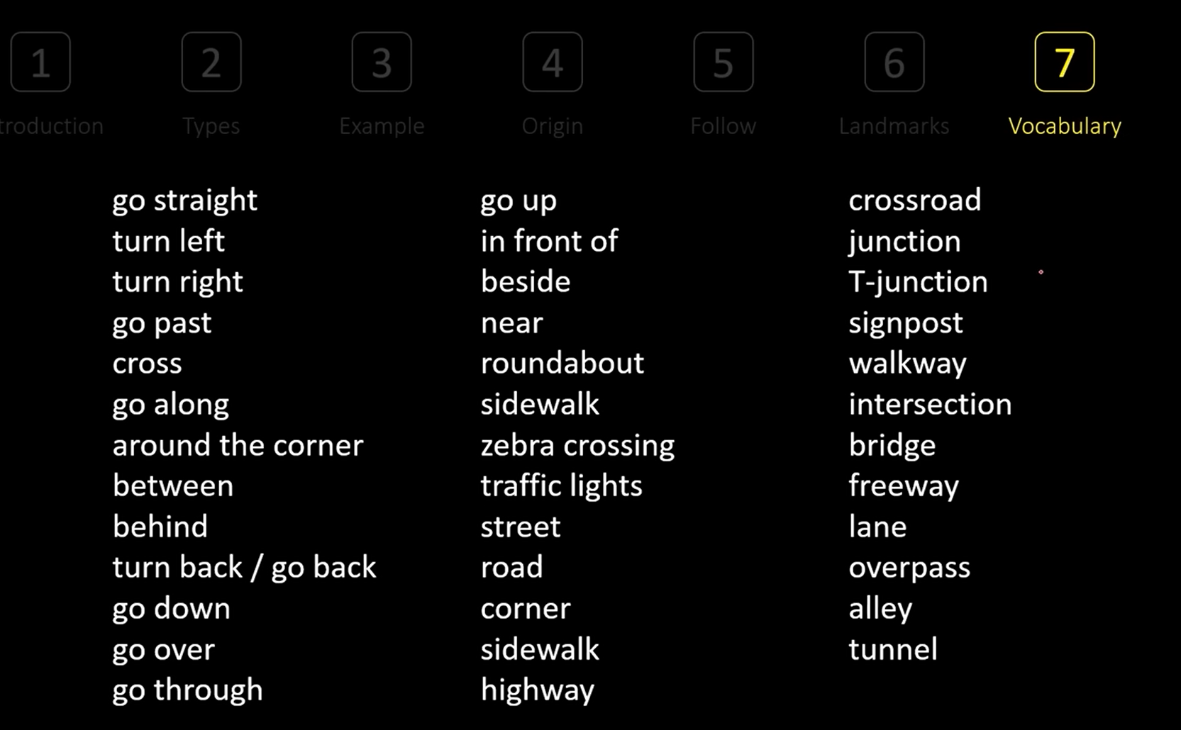

**Flow Chart:**

* Information in a sequence.
* Section 2 or section 3
* Read the title and heading the break
* Helps to understand the flow chart
* Sequence: most important
* Follow the speaker, even when there are no blanks
* Predicting the answer, based on the blank

**Matching:**

* Little bit tricky, because of its types
* Matching the given options with the subject.
* Types:
  + Options will repeat,
  + Options will not repeat
* Always and always: underline the probability, possibility and certainty.
* Understand the sequence: Sequence will be followed in the questions not in options.
* Listen to the both speaker, if they have them.
* Don’t forget to read the questions
* Write the options as answers.
* Understand the sequence: in questions
* In case of doubt, keep two answers.

1. **Reading(3 Parts — 20 mins each, 60 mins in total)**

* Academic and general reading passages will be provided to you followed by questions that will test your ability to understand the content and vocabulary.
* Develop effective reading strategies such as skimming for main ideas, scanning for specific information
* Skim and Scanning

Total # questions: 40, Total Time: 60 minutes

Academic: Divided in three sections - Content: academic context

General Training: Divided in 5 passages - 5 passages

* Biggest trouble: time
* Difficulty level increase with sections: and it is random
* If your answer is grammatically correct, word count is correct and spelling correct; then you will get 1 point for one question.
* Read the question one time and then read the passage.
* Remember the verb.

**Question Types:**

**Matching Heading:**

You have to read a passage full of paragraphs.

* You have to understand the information, you have to concise it
* Provide title or heading from the options.

Pointers:

* Always solve this type first
* Because you kind of remember the passage.
* Read the paragraph first.
* Glue and connectivity of information: give you more idea

**True, False and Not Given** and **Yes, No and Not Given:**

You will be getting a statement and you have to match the statement and confirm it according to the passage.

* True, False and Not Given vs Yes, No and Not Given : these are not same
* When the paragraph of passage about the fact: then always use T, F and NG.
  + For example: The sun rises in the east; True
* When the passage about an opinion they are talking about: Y, N and NG
  + For example: Are you hungry; No
* Never write just: T, F and NG or Y, N or NG
* Do in the last.
* In any language if you wanna remember sentence, the verb method will be applicable.
* Expect synonyms and paraphrases.

**Matching Features:**

Match a set of statements to a list of options

The options are a group of features from the text.

* Always understand the question first, then move to the passage.
* One question go to the passage find answer and then 2nd question.
* More than one sentence might be needed to find an answer.
* Eliminate the obvious options.

**Table Completion:**

* Similar to listening one.
* Pointers: To know the word count, read the instruction.
* Understand the table: Using the titles and headings
* Rows and Columns: Provides plenty of information.
* Predict: Using the rows and columns and other cells.
* Sequence is always maintain: Answers appear in the same sequence as the question
* Grammar and Spelling.

**Flow Chart Completion:**

* A series of boxes or steps linked by arrows, to show a sequence of events.
* Word Count
* Heading/title: provide idea about the flowchart.
* Predictions
* Sequence is always maintained as compared to the passage.
* Short phrases
* Spellings have to be correct.

**Multiple Choice:**

One question or statement and some options

* Type 1: Four Options and One answer
* Type 2: Four+ Options and One+ Answers
* Always read the question first. Then move to the passage.
* Never read the options first.
* Paraphrasing should be expected in options.

**Summary Completions:**

Summary of a section of the passage.

* Passage equal to many paragraphs.
* Single paragraph of the passage is taken as summary.

Types:

* 1. Summary completion without list of words or phrases
* Summary completion with list of words or phrases

- Instructions are important

- Single paragraph is important, not two or three.

- Predict the answers.

- Paraphrasing: Expect next level of paraphrasing

- But no change in meaning and sequence.

**Sentence Completion:**

Single sentence with a blank.

* Instructions
* Verb method: to remember the blanks
* Prediction
* If there are many blanks find first and last blank, the answers for remaining will be in between of that in passage.

1. **Writing(2 Parts — 20 mins for first task, 40 mins for second task)**

* In this section, you will be required to write an essay or a paragraph on two topics one belonging to academics while the other a general prompt given by the examiner.
* Different types of writing tasks, include describing a graph or chart, expressing an opinion on a given topic, or analyzing an argument.
* Writing opinion essay template – Asad yaqub channel

1. **Speaking (3 Parts — 15 mins in total)**

* This is a very crucial round and is often considered difficult by candidates. In this section, a one-on-one interview takes place between the examiner and the candidate to test the overall communication skills of the candidate.

**Result:**

* After 13 days you will get your score: Online and on Hardcopy will take time.
* Passport must for Registration of IELTS
* Set aside dedicated time each day to complete timed writing tasks under exam conditions.
* Cultivate a habit of reading English newspapers, magazines, and academic articles.
* It all depends on how focused you are during the exam than the actual knowledge in English. IELTS is a very tricky and you need to know the strategies to get a good score.
* On the big day, stay calm, and remain focused. Listen carefully during the Listening section, skim and scan efficiently during Reading, organize your thoughts before writing essays, and speak clearly and confidently during the Speaking section.
* Before you get started with your IELTS preparation take a practice test to begin with. Taking this practice test will help you identify your strengths and weaknesses.
* Listen to podcasts
* Focus on building your vocabulary and grammar skills. A wide range of vocabulary will allow you to express your ideas more effectively while using appropriate grammatical structures.
* Your English speaking skills are measured on a scale of 1–9. This scale or these scores are known as ‘bands’.

(The Reading and Writing modules are taken on the same day, while the Speaking and Listening modules are taken on a different day. The duration of the exam can vary between 2 hours 45 minutes and 4 hours, depending on the modules selected.)

**Resources:**

Official IELTS websites, Websites like the British Council and Cambridge English offer free IELTS preparation resources.

<https://www.youtube.com/watch?v=Jzps8q2es7c>

IELTSx course: university of Queensland

Ieltsonlinetest.com // Cambridge books: those who want to give paper focus on book and for online test focus on website

Youtube Channel: Asad Yaqub