1. A) expand energy, enjoy groups

b) converse energy, enjoy one-on-one

1. A) interpret matters literally, rely on common sense

B) look for meaning and possibilities, rely on foresight

1. A) logical, thinking, questioning

b) empathetic, feeling, accommodating

1. A) organized, orderly

b) flexible, adaptable

1. A) more outgoing, think out loud

b) more reserved, think to yourself

1. A) practical, realistic, experiential

b) imaginative, innovative, theoretical

1. A) Candid, straight forward, frank

b) tactful, kind, encouraging

1. A) plan, schedule

b) unplanned, spontaneous

1. A) Seek many tasks, public activities, interaction with others

b) seek more private, solitary activities with quiet to concentrate

1. A) standard, usual, conventional

b) different, novel, unique

1. A) firm, tend to criticize, hold the line

b) gentle, tend to appreciate, conciliate

1. A) regulated, structured

b) easy-going, “live” and “let live”

1. A) external, communicative, express yourself

b) internal, reticent, keep to yourself

1. A) consider immediate issues, focus on the here-and-now

b) look at the future, global perspective, “big picture”

1. A) tough-minded, just

b) tender-minded, merciful

1. A) preparation, plan ahead

b) go with the flow, adapt as you go

1. A) Active, initiate

b) reflective, deliberate

1. A) Facts, things, seeing “ what is”

b) ideas, dreams, seeing “ what could be” philosophical

1. A) matter of fact, issues-oriented, principled

b) sensitive, people-oriented, compassionate

1. A) control, govern

b) latitud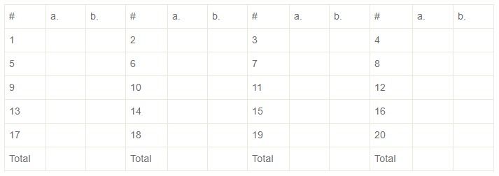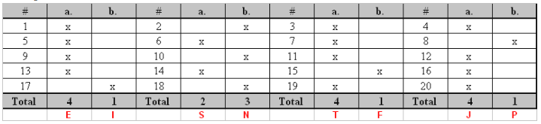e , freedom

