### Liu Jun Yi Jerald 232312N

### Title: Assignment on Nanotechnology for Drug Delivery Systems

### Table of Contents

1. Introduction
2. Technology
3. Advantages / Enhanced Features
4. Challenges
5. Conclusion
6. References

### 1. Introduction

The implementation and advancement of drug delivery systems have made significant improvements towards the effectiveness of the medicinal drugs patient take. You may have asked, why we would want to use nanotechnology for drug delivery, and well, there are flaws in the conventional drug delivery system, which are that highly toxic drugs cause harsh side effects due to decomposition during delivery to the targeted site in the body and rate of release at destination not well controlled leads to decrease in efficiency of the drug. Using nanotechnology, this drug delivery systems has various types of nanoparticles to help treat illness such as our long-dreaded enemy, cancer, and diseases like cardiovascular diseases (Sim and Wong, 2021). The implementation of nanotechnology in drug delivery systems allowed for medicinal purposes like precision medicine which calls for the development of treatment that is catered towards the patient rather than to a generalised group of patients (Mitchell M. J., et al., 2021). In this assignment I will be talking about the technologies that drug delivery systems use, the advantages of nanotechnology in drug delivery systems and challenges of implementing it.

### 2. Technology

Nanotechnology in drug delivery systems uses multiple types of nanoparticles, each with different usage and purposes in medicine. The two types of nanoparticles that I am going to talk about in this assignment are, Liqid-based Nanoparticle and Polymeric Nanoparticles. Firstly, Liqid-based Nanoparticles are mostly spherical and are known to be simple, biocompatible, high bioavailability and have many more useful functionalities and properties (Mitchell M. J., et al., 2021). An example of these is liposome. It is a nanoparticle that can hold many types of medicinal drugs and be delivered into the patient’s body with surface modification, like adding more protein to the surface, available to cater to the patient’s needs which increases the medicinal drugs versatility (Mitchell M. J., et al., 2021). Secondly, there are polymeric Nanoparticles that can be made from natural or synthetic materials (Mitchell M. J., et al., 2021). They good options for drug delivery into the patient’s body as they enclose the medicinal drugs in the nanoparticles causing the drugs that were previously known to have problems traveling in the human body to have a protection before it reaches its intended location and it can accommodate medicinal drugs of varying weight (Mitchell M. J., et al., 2021). An example of polymeric nanoparticle are Dendrimers which are spheroid or globular Nanostructures that are precisely engineered to carry molecules encapsulated in the interior void spaces or attached to the surface. They are highly bioavailable and biodegradable, with varies applications in drug delivery as its properties are transformable too, both physically or chemically (Sim and Wong, 2021). Drugs stored within dendrimers can be transported to specific sites for therapeutic healing, making it very useful.

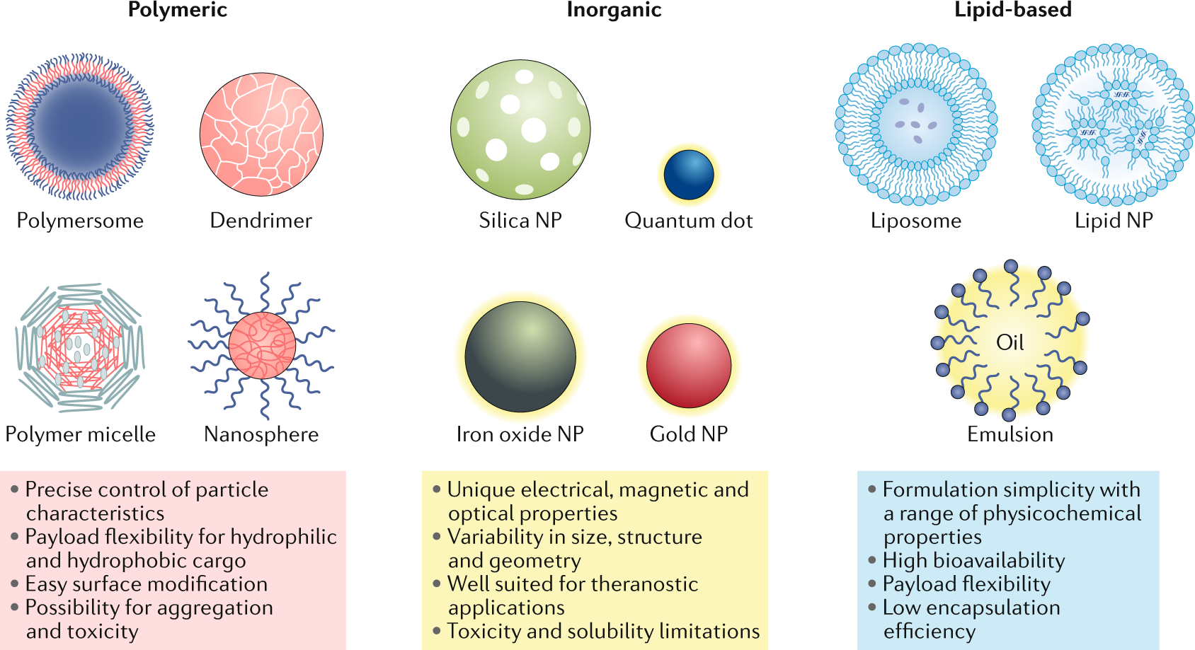

From: [Engineering precision nanoparticles for drug delivery](https://doi.org/10.1038/s41573-020-0090-8) Fig.2

### 3. Advantages / Enhanced Features

Nanoparticle-based drug delivery systems provide several enhanced features over traditional methods. One of the primary benefits is the ability to achieve targeted delivery, which reduces drug toxicity and enhances efficacy by concentrating the therapeutic agents at the disease site (Sim and Wong, 2021). Additionally, nanoparticles can improve the solubility and stability of drugs, increasing their bioavailability and prolonging their circulation time in the bloodstream. The versatility of nanotechnology also allows for the combination of diagnostic and therapeutic functions within a single platform, enabling simultaneous disease diagnosis and treatment (Mitchell et al., 2021).

### 4. Challenges

Despite the significant advantages, several challenges remain in the development and implementation of nanoparticle-based drug delivery systems. One of the major challenges are the production of nanotechnology in the drug delivery field may be challenging are they are for now made lab and are costly, which would lead to the technology not widely available to everyone. Another challenge of these is that if the made incorrectly it could lead it to be more dangerous and toxic rather than using the conventional drug delivery system (Sim and Wong, 2021). These challenges may prove to be a bigger hurdle to solve then making the treatment itself to the diseases.

### 5. Conclusion

Nanotechnology-based drug delivery systems represent a significant advancement in the field of medicine, offering targeted, efficient, and multifunctional medical options. While the technology holds great promise, addressing the associated challenges is crucial for its successful translation from the laboratory to clinical practice. Continued innovation and rigorous evaluation and regulations will pave the way for the development of safer and more effective nanoparticle-based therapies, ultimately improving patient outcomes and transforming the landscape of healthcare.

### 6. References

Sim, S., & Wong, N. K. (2021). Nanotechnology and its use in imaging and drug delivery (Review). Biomedical Reports, 14(5), 42. <https://doi.org/10.3892/br.2021.1418>

Mitchell, M. J., Billingsley, M. M., Haley, R. M., et al. (2021). Engineering precision nanoparticles for drug delivery. Nature Reviews Drug Discovery, 20, 101–124. <https://doi.org/10.1038/s41573-020-0090-8>