**VISVESVARAYA TECHNOLOGICAL UNIVERSITY**

**“JnanaSangama”, Belgaum -590014, Karnataka.**



**LAB REPORT**

**On**

**ARTIFICIAL INTELLIGENCE**

**Submitted by**

**IMRAN WADRALI (1BM21CS077)**

**in partial fulfillment for the award of the degree of**

**BACHELOR OF ENGINEERING**

**in**

**COMPUTER SCIENCE AND ENGINEERING**



**B.M.S. COLLEGE OF ENGINEERING**

**(Autonomous Institution under VTU)**

**BENGALURU-560019**

**Oct 2023-Feb 2024**

**B. M. S. College of Engineering,**

**Bull Temple Road, Bangalore 560019**

**(Affiliated To Visvesvaraya Technological University, Belgaum)**

**Department of Computer Science and Engineering**



CERTIFICATE

This is to certify that the Lab work entitled **“ARTIFICIAL INTELLIGENCE”** carried out by **IMRAN WADRALI (1BM21CS077)**, who is bonafide student of **B. M. S. College of Engineering**. It is in partial fulfillment for the award of **Bachelor of Engineering in Computer Science and Engineering** of the Visvesvaraya Technological University, Belgaum during the year 2022-23. The Lab report has been approved as it satisfies the academic requirements in respect of Artificial Intelligence Lab - **(22CS5PCAIN )**work prescribed for the said degree.

**Swathi Sridharan** **Dr. Jyothi S Nayak**

Assistant Professor Professor and Head

Department of CSE Department of CSE

BMSCE, Bengaluru BMSCE, Bengaluru

Table of Contents

|  |  |  |
| --- | --- | --- |
| **SL No** | **Name of Experiment** | **Page No** |
| 1 | Implement Tic –Tac –Toe Game | 1-7 |
| 2 | Implement 8 puzzle problem | 8-12 |
| 3 | Implement Iterative deepening search algorithm. | 13-17 |
| 4 | Implement A* search algorithm. | 18-23 |
| 5 | Implement vaccum cleaner agent. | 24-30 |
| 6 | Create a knowledge base using prepositional logic and show that the given query entails the knowledge base or not . | 31-34 |
| 7 | Create a knowledge base using prepositional logic and prove the given query using resolution | 35-40 |
| 8 | Implement unification in first order logic | 41-48 |
| 9 | Convert a given first order logic statement into Conjunctive Normal Form (CNF). | 49-56 |
| 10 | Create a knowledge base consisting of first order logic statements and prove the given query using forward reasoning. | 57-63 |

**1.Implement Tic –Tac –Toe Game.**

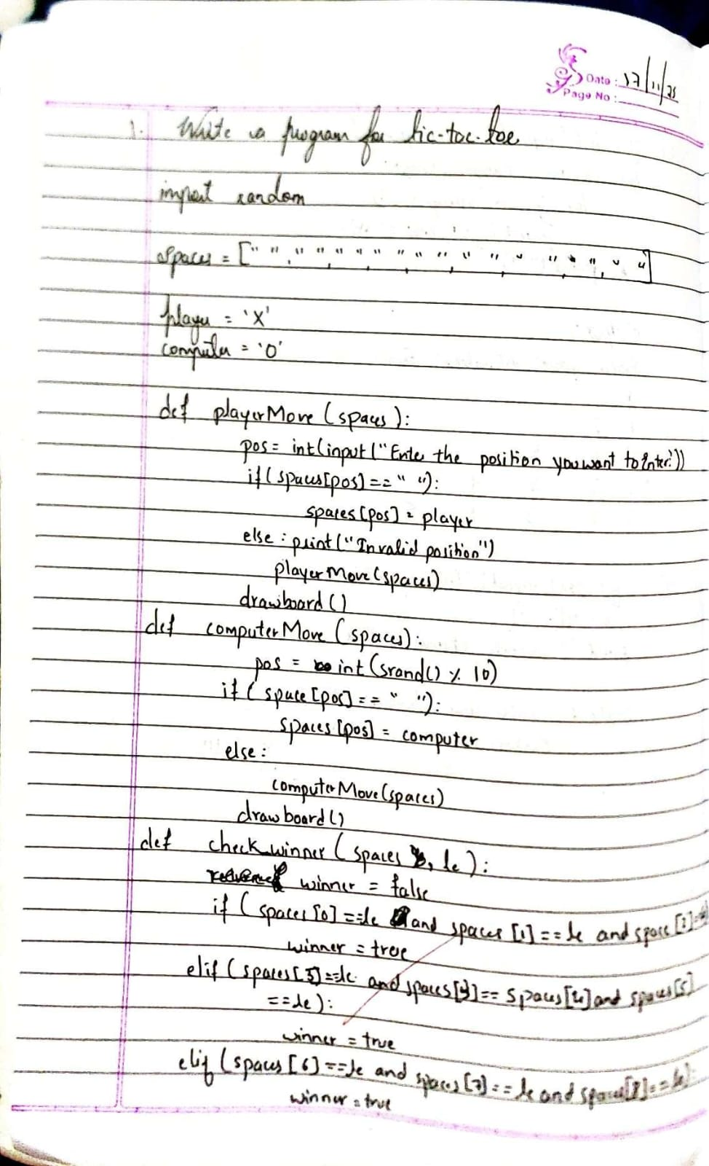

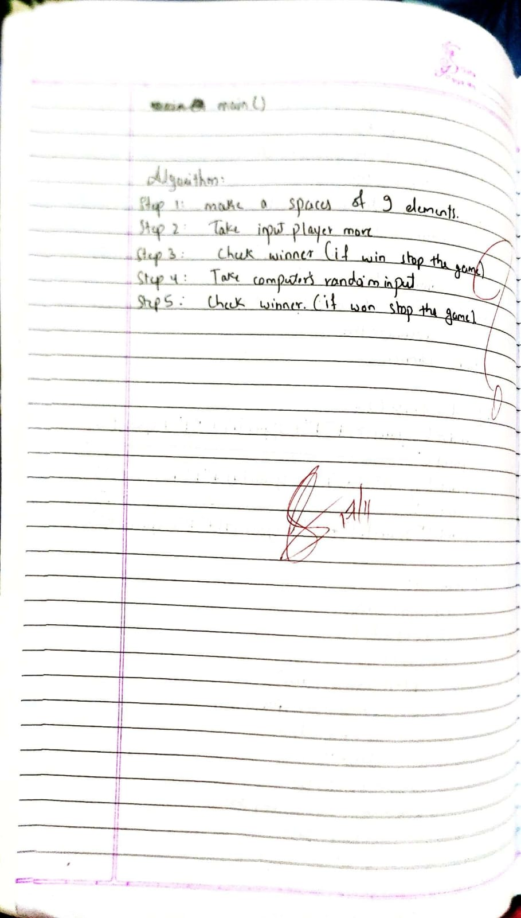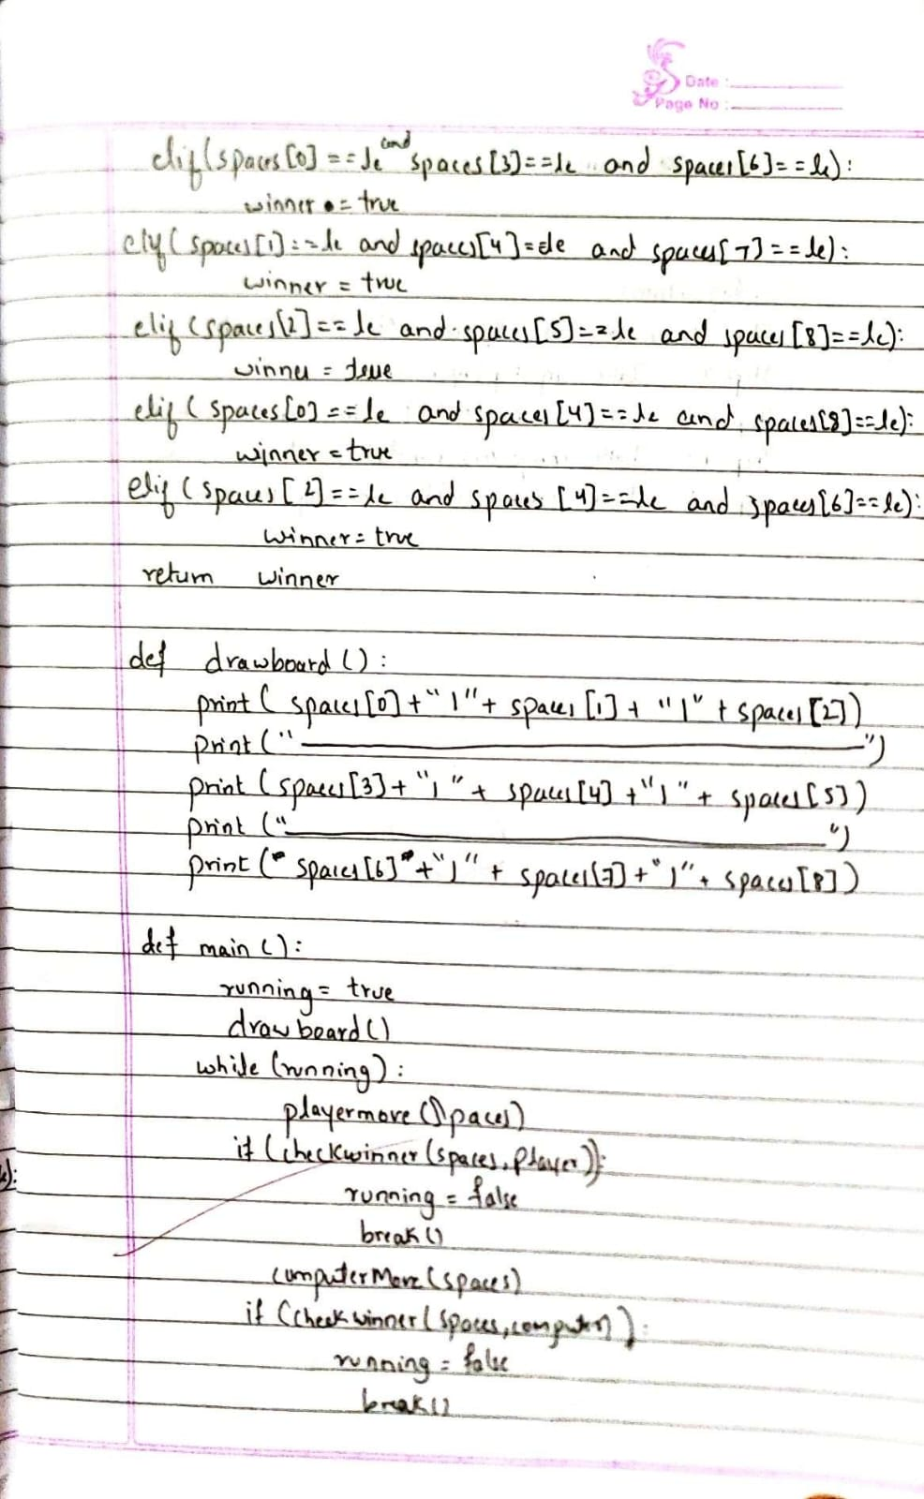

**2 .Solve 8 puzzle problems.**

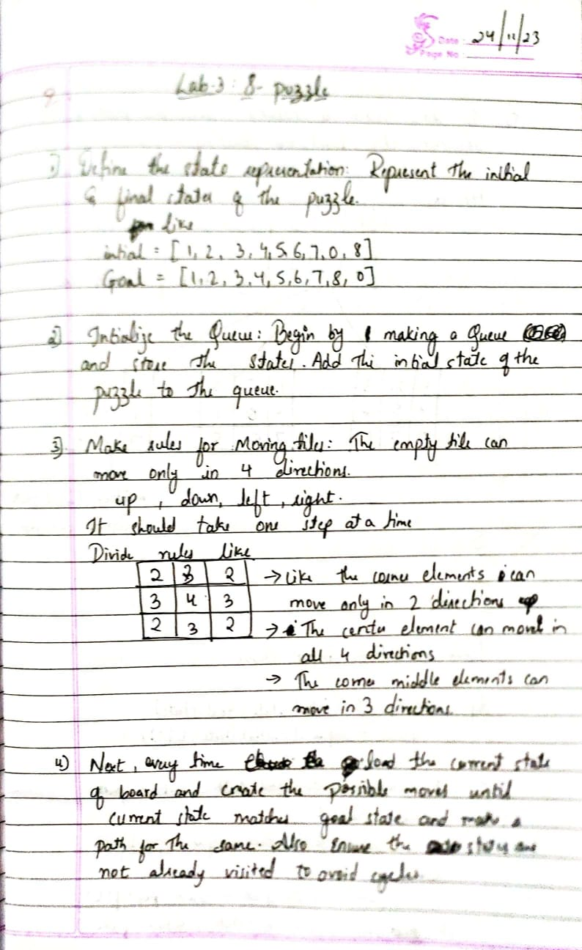

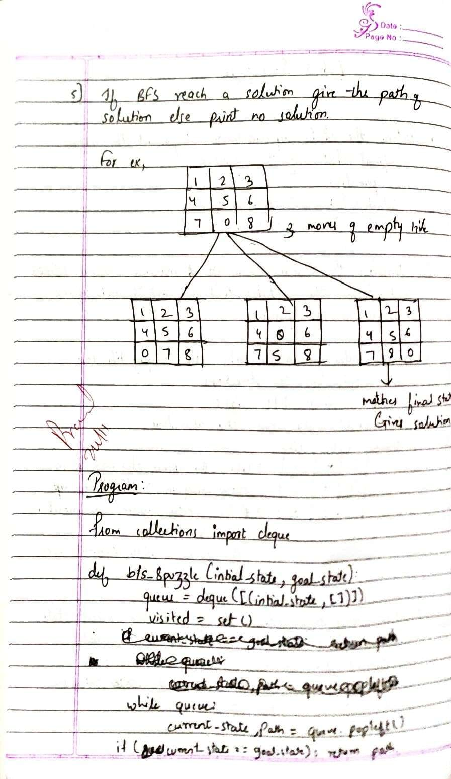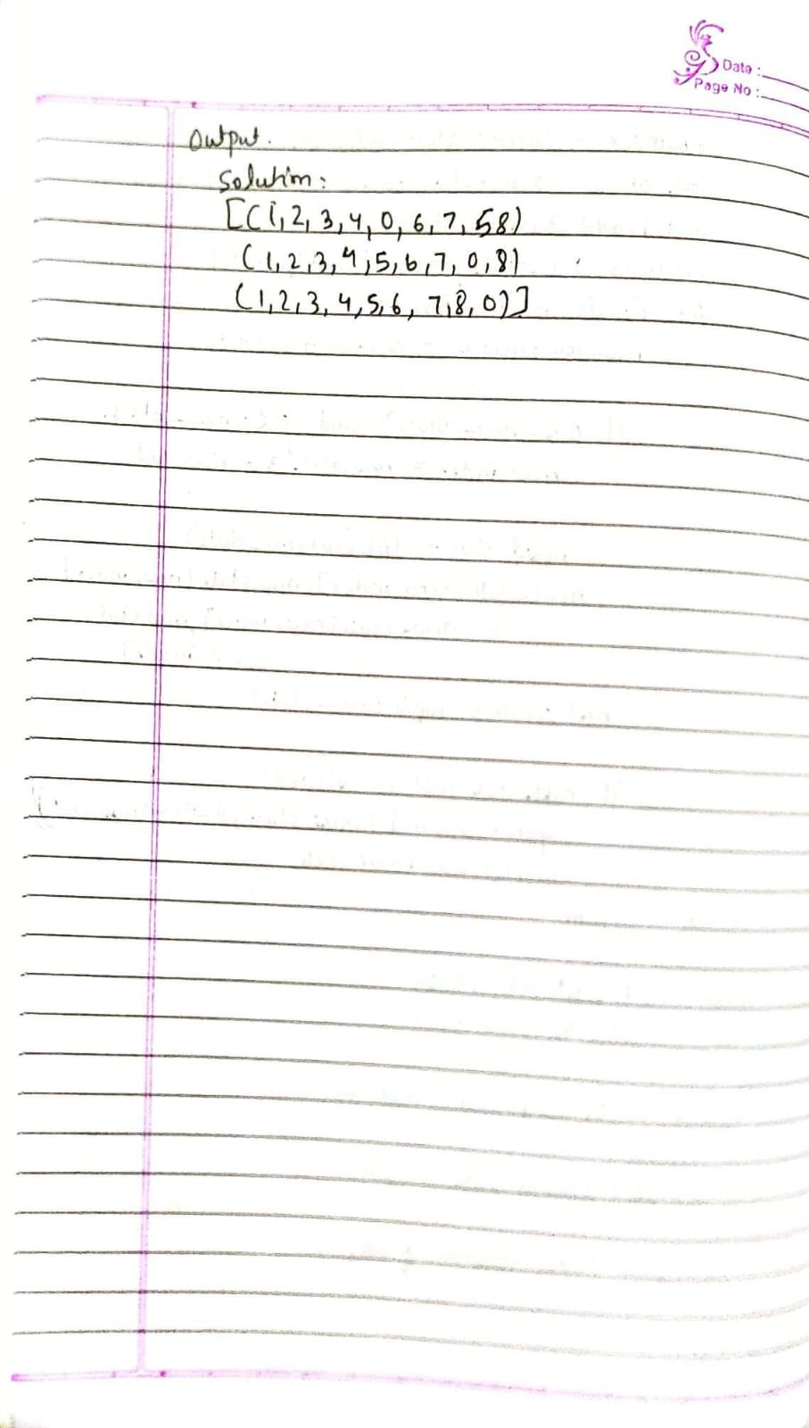

**3. Implement Iterative deepening search algorithm.**

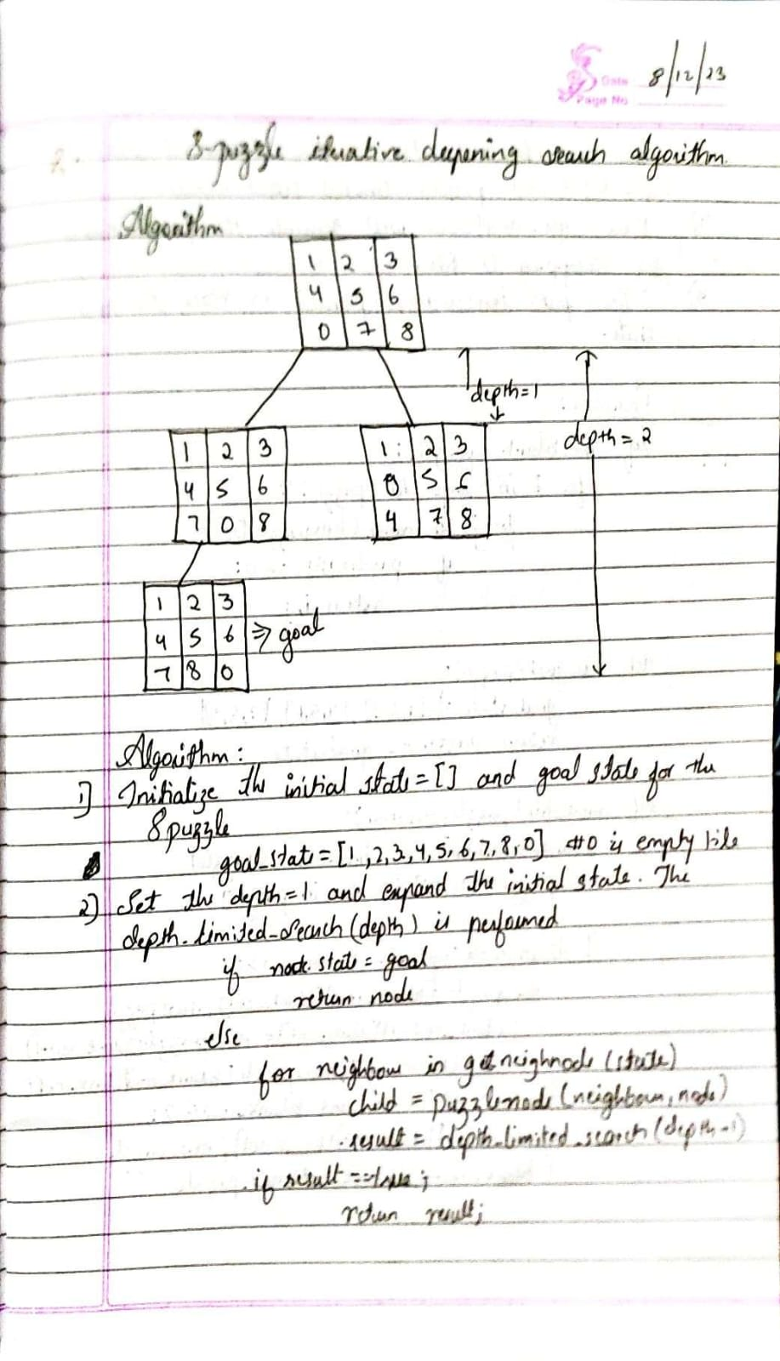

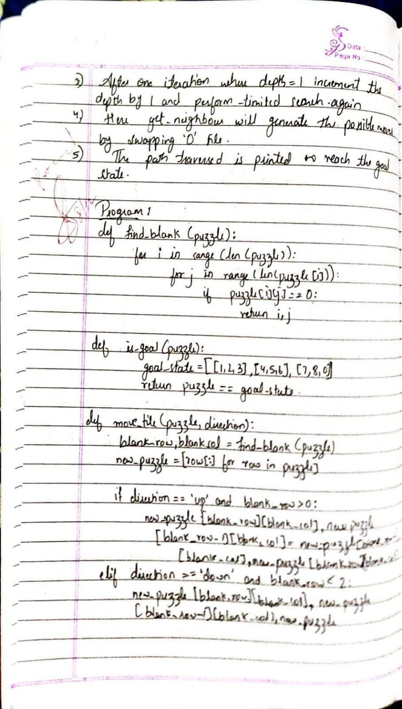

**4. Implement A* search algorithm.**

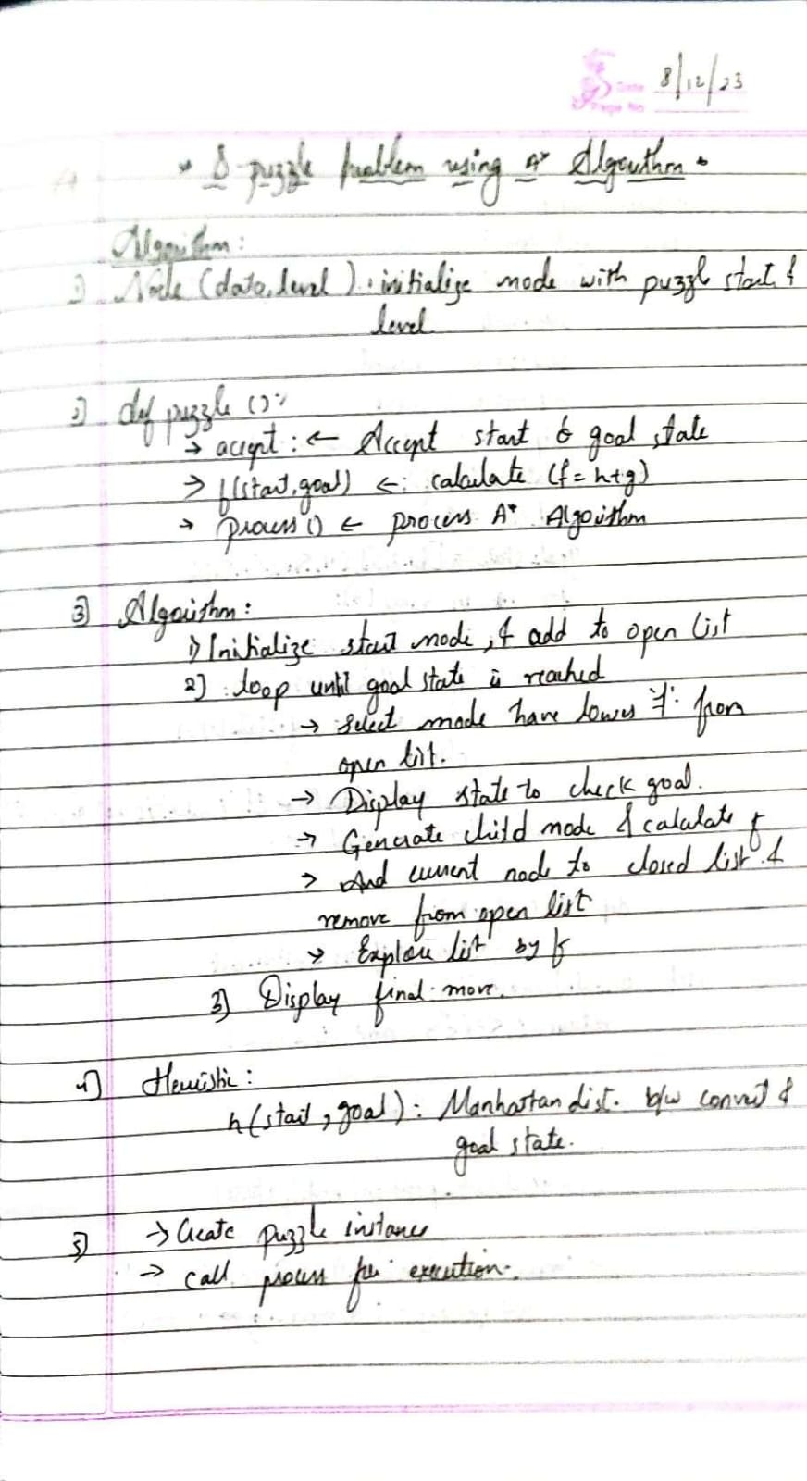

**5. Implement vaccum cleaner agent.**

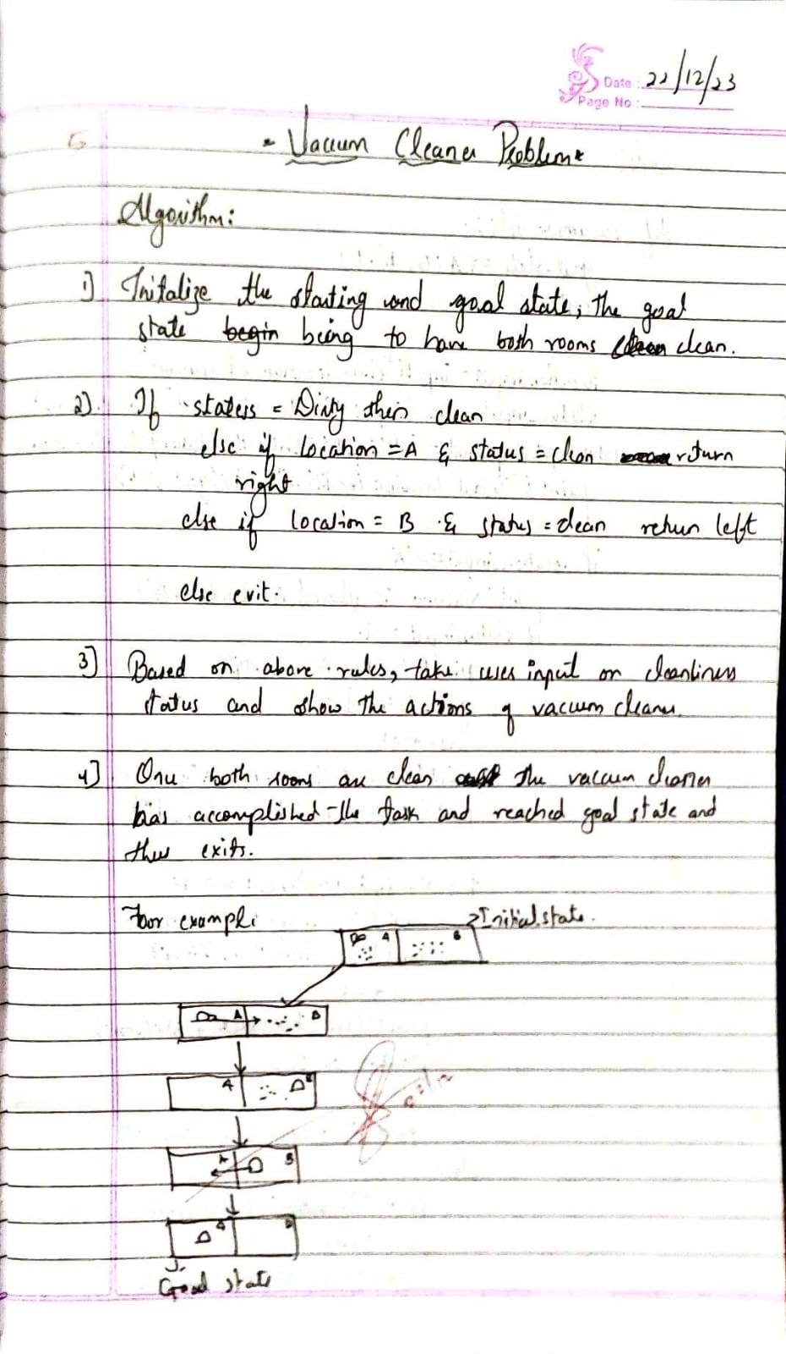

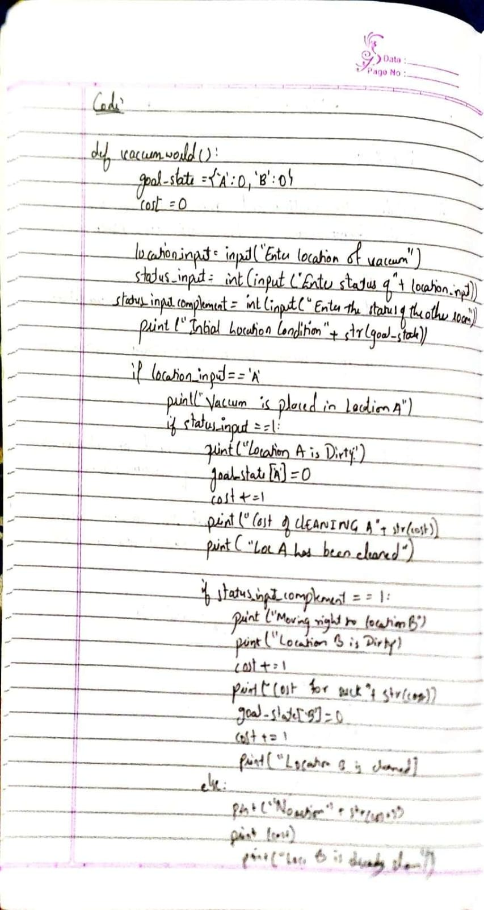

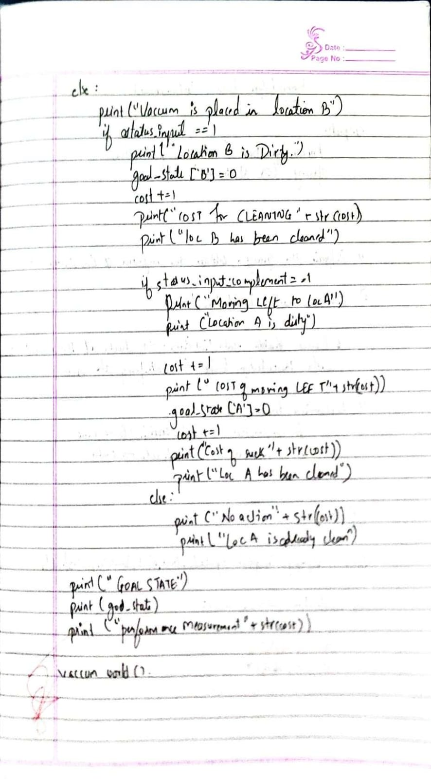

**6. Create a knowledge base using prepositional logic and show that the given query entails the knowledge base or not .**

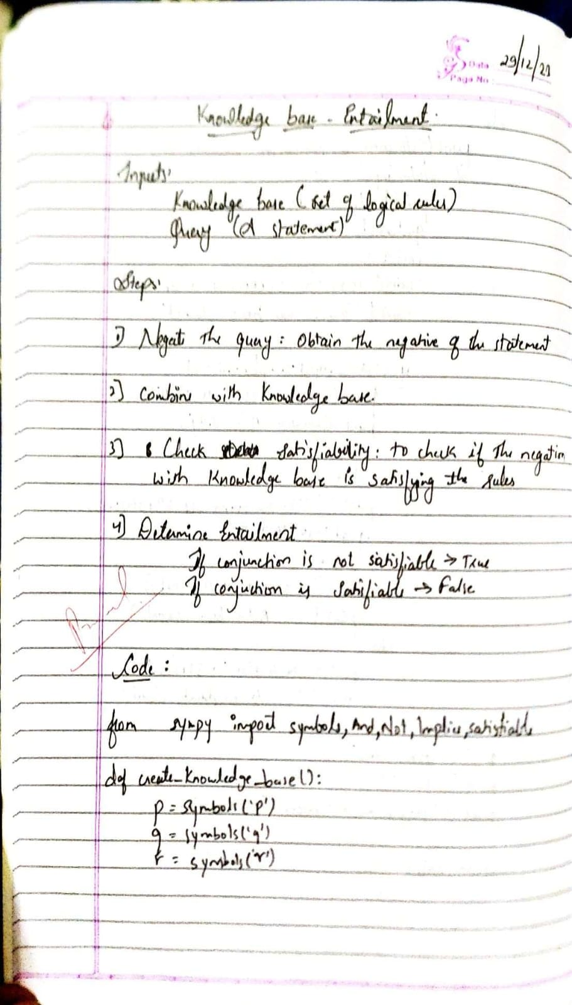

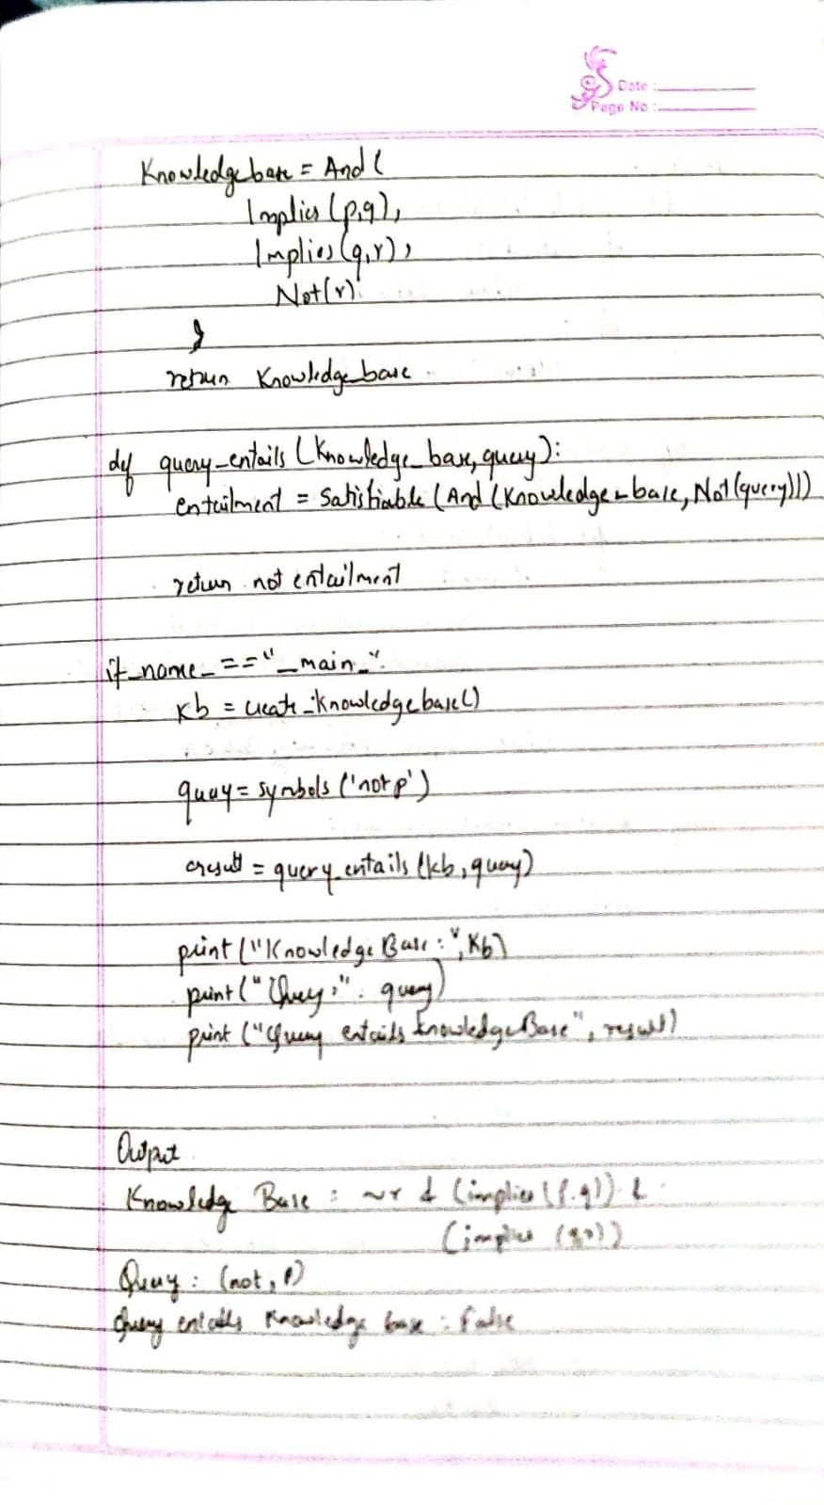

**7. Create a knowledge base using prepositional logic and prove the given query using resolution**

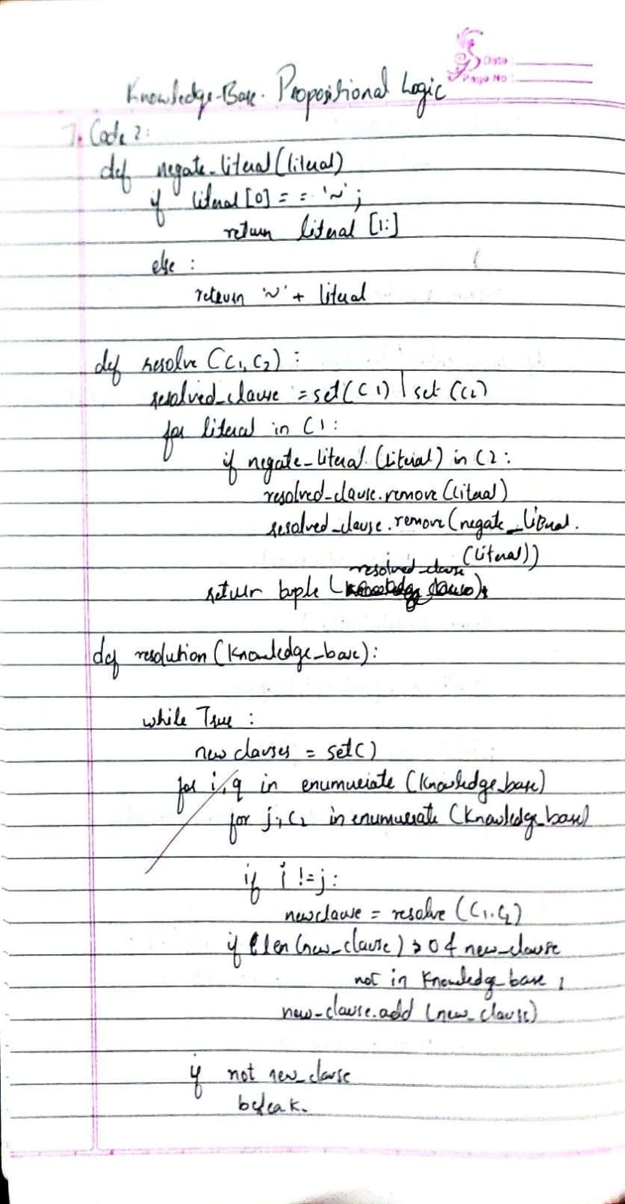

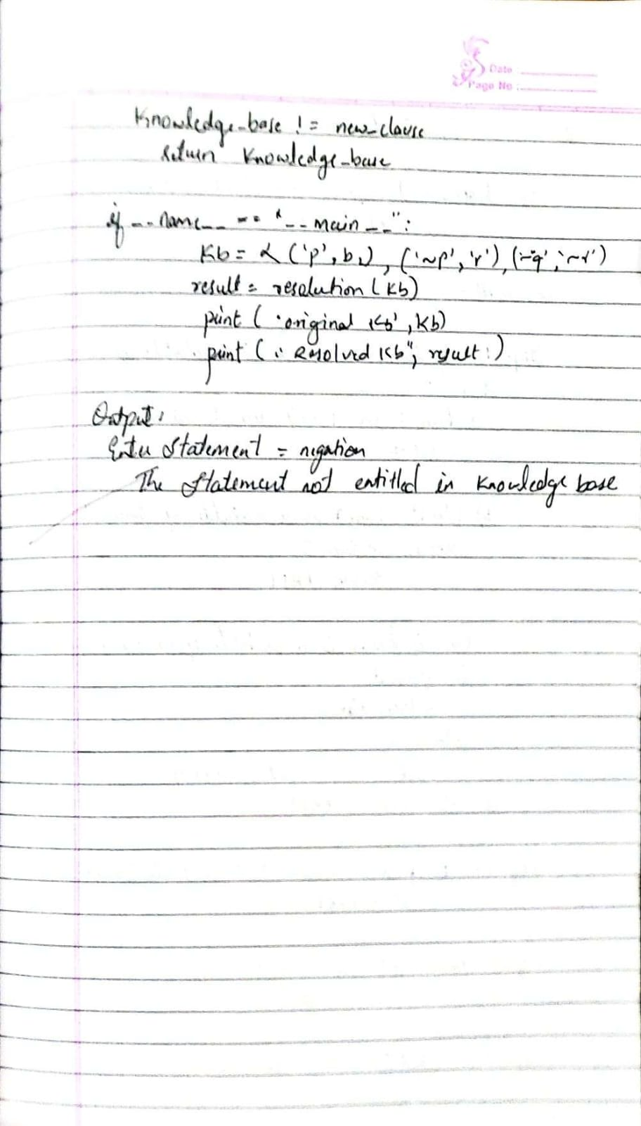

**8. Implement unification in first order logic :**

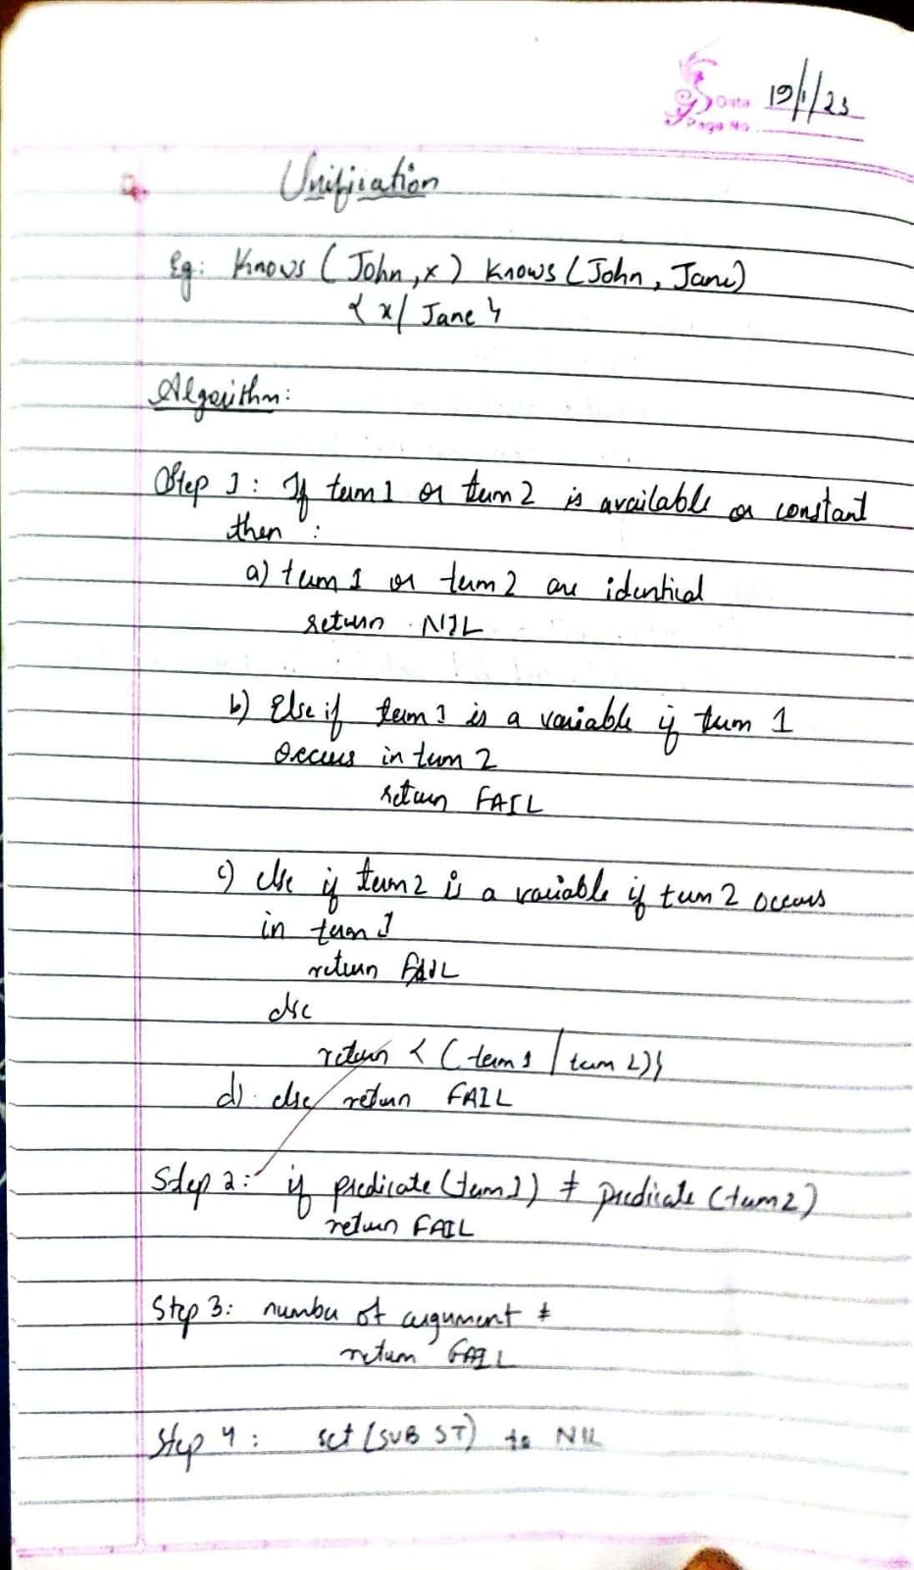

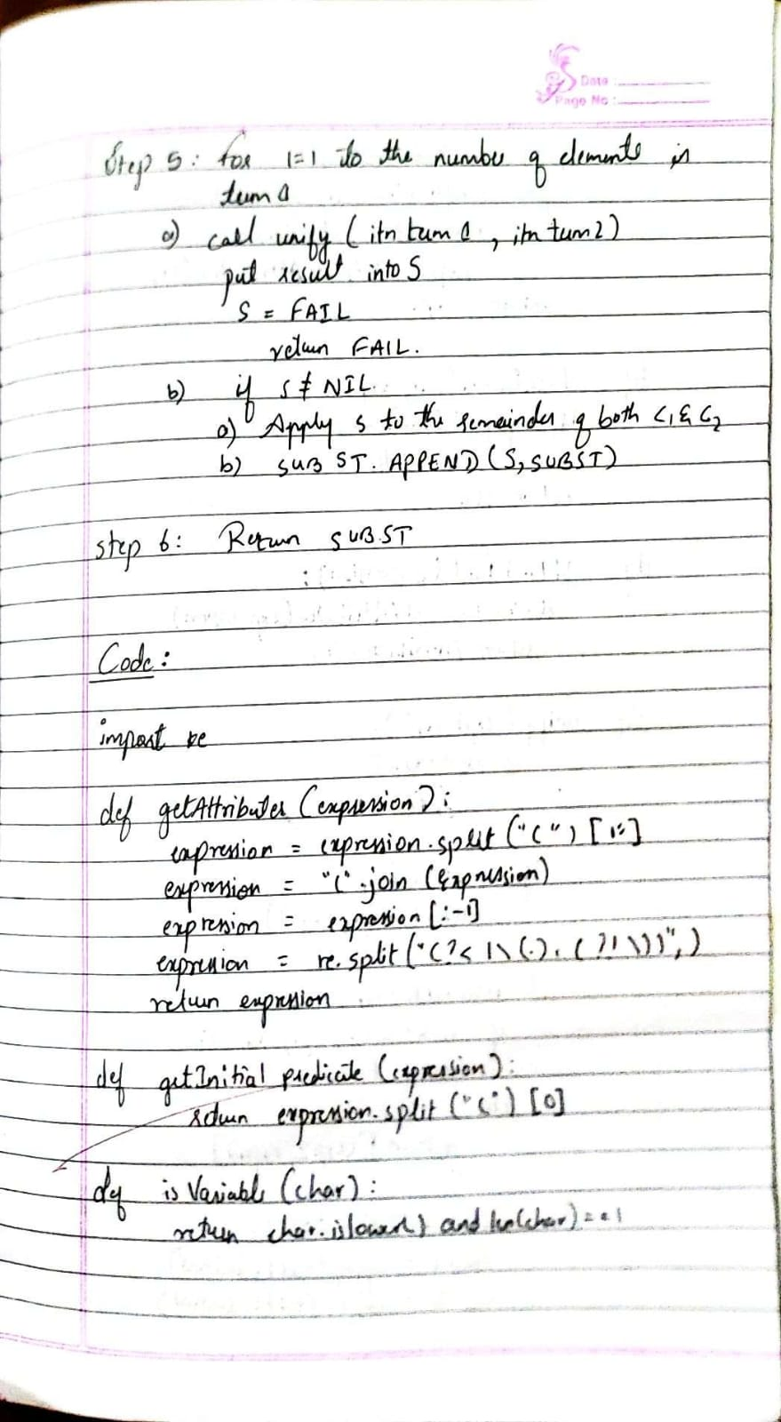

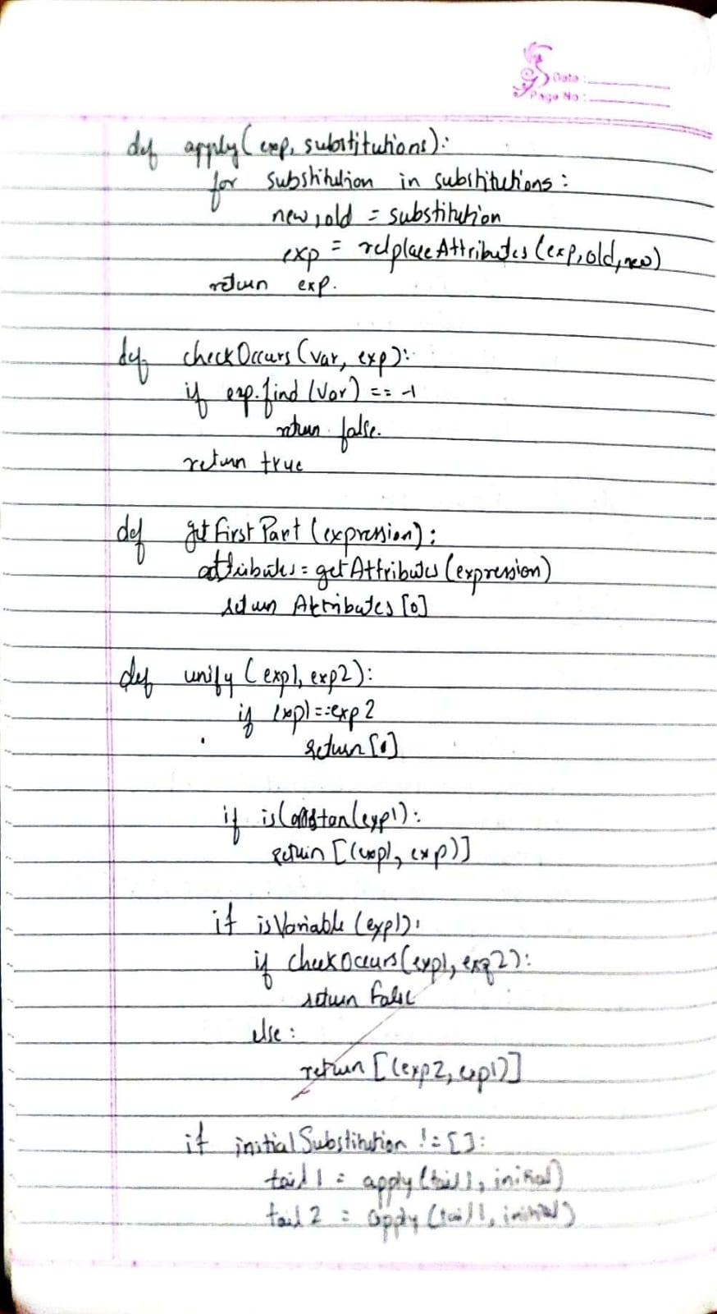

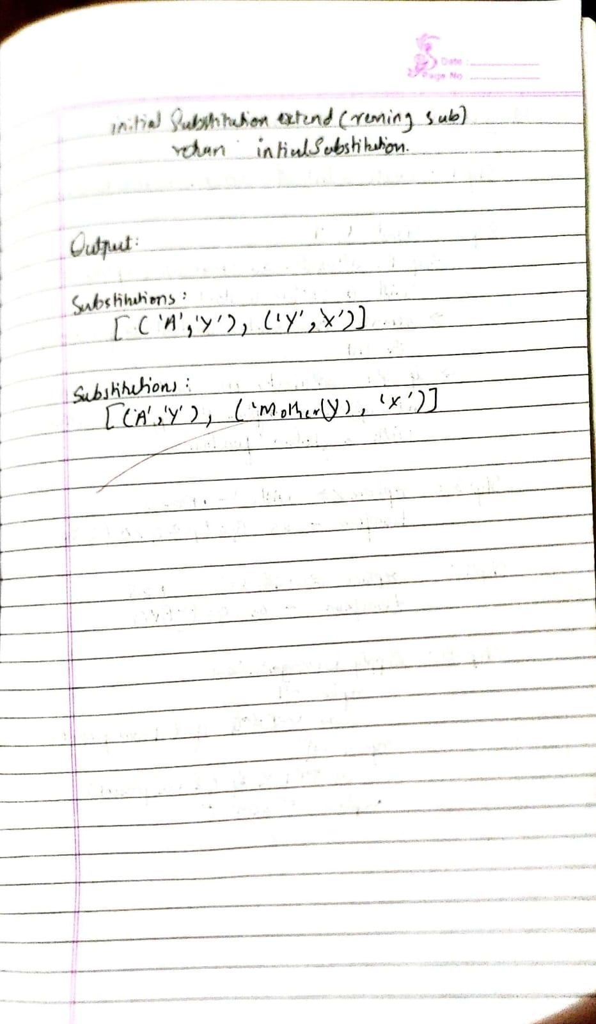

**9.Convert a given first order logic statement into Conjunctive Normal Form (CNF).**

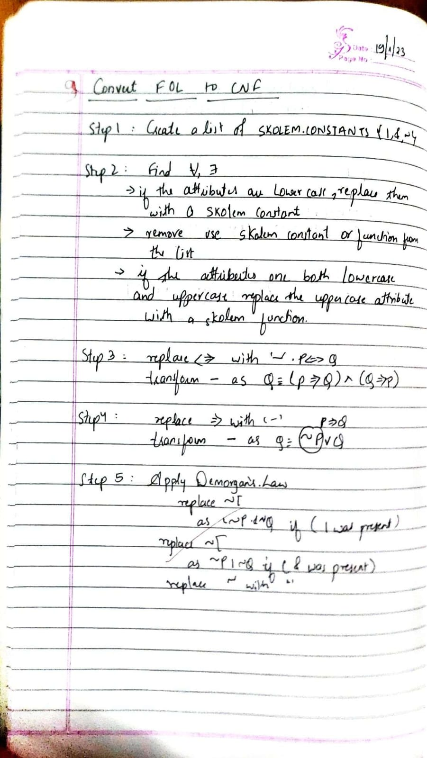

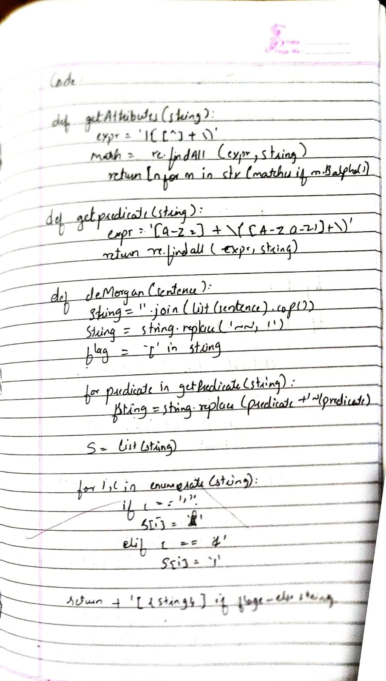

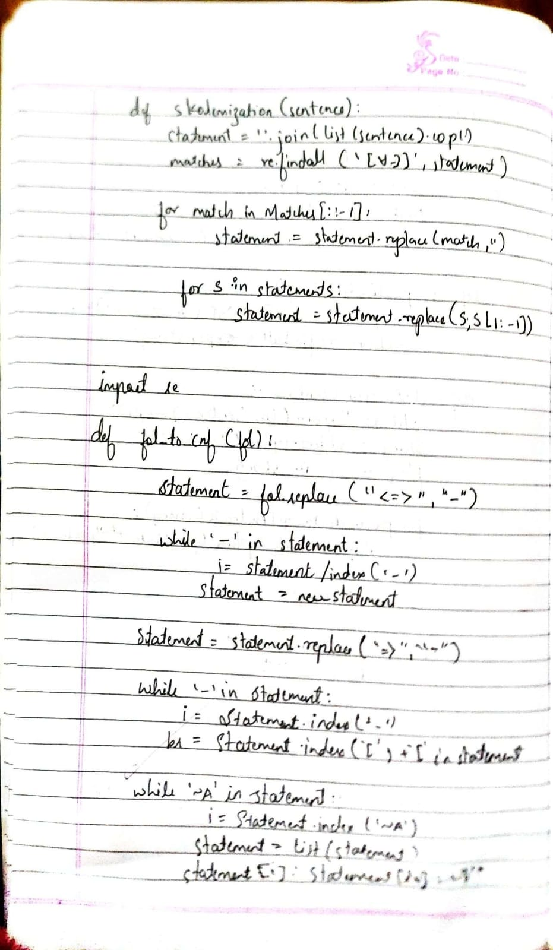

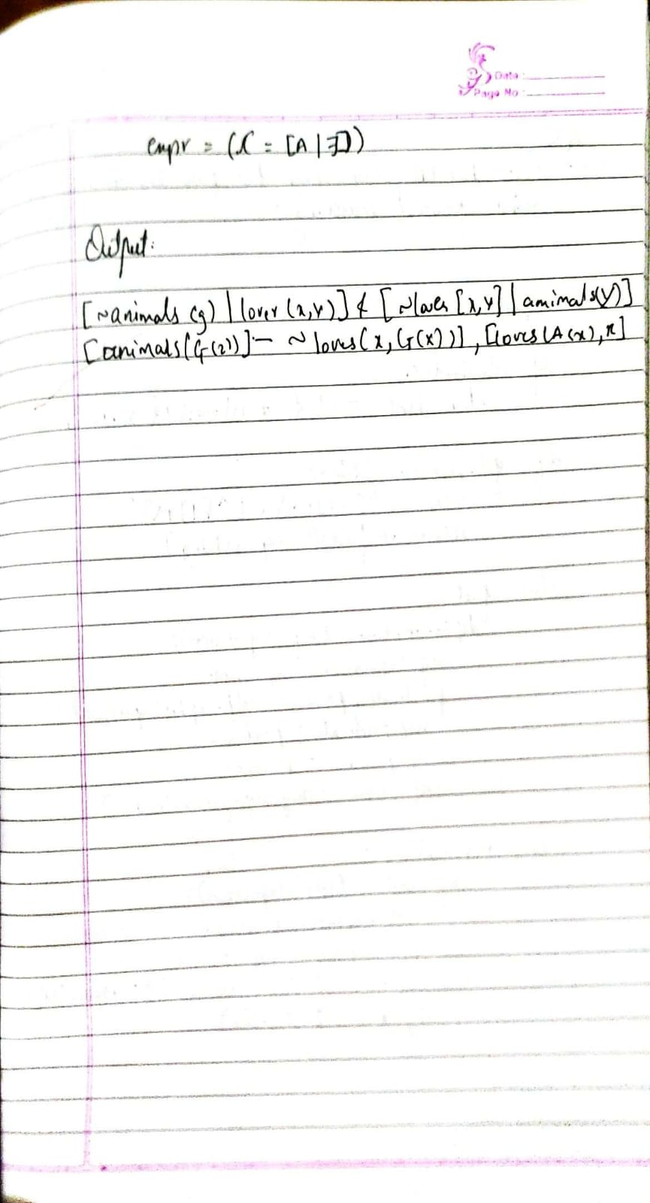

**10. Create a knowledge base consisting of first order logic statements and prove the given query using forward reasoning**

