Password Length and Frequency Concentration in Differentially Private Releases
A Reproducible Reanalysis with Controlled Generation Baselines
Imran Zakirov
UVK “Prioritet”
ABSTRACT
Length expands the support of independently random passwords, but length alone does not identify their generation distribution. Published anonymous password spectra permit concentration analysis while withholding the identities and structures needed to evaluate realistic guessing. We reanalyzed the LinkedIn differentially private release, comprising 64 source-defined length groups with 174,296,614 units of released Account Mass, and a separate Yahoo spectrum with 69,301,337 units. Exact weighted ranks, conditional and pooled frequency-oracle curves, tie bounds, tail diagnostics and mechanism-specific conditional sensitivity calculations were combined with 26,700 frozen synthetic feature records and 36 local verifier-cost cells. Across LinkedIn lengths 6–16, Spearman association between length and released frequency was −0.335 under account-mass weighting and +0.041 under distinct-bin weighting; the latter reversed under tail filtering. Conditional top-10,000 coverage was 35.65%, 9.39% and 31.09% at lengths 6, 13 and 16. A revised diagnostic excluded each held length before defining its training frequency threshold; cubic logistic reduced held-length mean log loss by only 0.149% relative to linear logistic. Pooled top-10,000 exposure among source lengths at least 16 was 13.12%. These results describe concentration under a released-spectrum oracle, not observed compromises or causal benefits from adding characters. Uniform and explicit patterned generators show why equal length permits different known entropy. Historical recovery, unresolved length coding and the length-15 anomaly, privacy perturbation, and unavailable human structural covariates limit generalization. Independent replication of the length association and operational guessing remain unavailable.
Keywords: password length; frequency concentration; differential privacy; anonymous frequency spectrum; controlled generation; verifier cost; reproducibility.

1. Introduction
Length is an attractive password-policy variable because it is easy to communicate and measure. For a password sampled independently and uniformly from an alphabet of size N, adding one character multiplies the number of possibilities by N. This mathematical result does not establish how often users select each possible string. A long repeated pattern and a long sequence of independent choices may have identical displayed lengths while following very different distributions.
Current NIST guidance combines minimum length with compromised-password blocklists, rate limiting, and suitable password storage. It requires at least 15 characters for centrally verified single-factor passwords and permits a minimum of eight for passwords used only with MFA. These requirements operate within the standard's stated scope; they are not statements that every compliant string has a particular guess rank. [1]
The empirical question is therefore conditional: under a stated distribution and ordering assumption, how does length relate to the portion of observations concentrated near the beginning of that order? Prior work already demonstrates that length policies, human patterns, and evaluation budgets interact. This study contributes a reproducible reanalysis and a methodological examination of weighting and source limitations, rather than claiming discovery of the basic distinction between length and randomness. [2]
The primary contribution is an auditable secondary analysis of a published differentially private release: contrasting two weightings, retaining nonmonotonic groups, exposing threshold sensitivity and separating identified release statistics from missing behavioral or attack evidence. The study does not claim a new password-guessing algorithm or population estimator. Its secondary controls illustrate how generator assumptions and verification costs change the question being answered.

2. Research Questions and Hypotheses
RQ1 — Released concentration: How does source-defined length associate with released frequency and conditional/pooled oracle concentration, under Account Mass and Distinct Anonymous Bin weighting?
RQ2 — Generation assumptions: At equal nominal length, how do released conditional concentration and explicitly uniform or patterned generation distributions differ?
RQ3 — Sensitivity and marginal length: How do observed adjacent groups and long-group thresholds differ, and what marginal gain follows analytically from adding an independent random choice?
RQ4 — Descriptive transformations: What occurrence differences exist in the fixed public teaching panel, and which population or causal conclusions remain unidentified?
RQ5 — Source and evaluation scope: What does a separate historical spectrum corroborate, and which structural, operational-guessing or temporal evaluations can the inputs support?
The original question about whether human structure dominates length after adjustment is not answerable with these inputs. Human length-plus-structure and interaction models are DATA UNAVAILABLE. The focused questions are descriptive or analytic; no confirmatory hypothesis test, participant-level p-value or population confidence interval is justified. An expectation of lower concentration in longer groups is explored against all observed groups, including counterexamples. Uniform-generator entropy identities are mathematical statements, not empirical human hypotheses. New revision analyses were fixed before their own execution but after the original results were known; they are exploratory and not preregistered.

3. Related Work
Password-policy experiments provide stronger causal evidence about assigned policies than observational length bins can provide. Kelley et al. evaluated study passwords under multiple policies and showed the importance of training and test conditions. Shay et al. studied longer policies, including easily guessed subsets and stronger tails. Our adjacent-length comparisons do not reproduce those policy interventions. [3], [2]
Bonneau developed statistical analysis of anonymous password-frequency distributions. Blocki, Datta, and Bonneau released sanitized Yahoo frequency lists. Harsha et al. released a differentially private LinkedIn corpus partitioned by length while investigating information revealed by length. Our use of those releases follows their privacy-preserving design; no underlying credential database was acquired. [4], [5], [6]
Random-word assignment is also distinct from writing an ordinary sentence. Earlier passphrase work examined assigned phrases and usability, rather than establishing that every natural sentence has word-list entropy. Our EFF comparison isolates independent sampling from a known vocabulary; it does not model human language. [7], [8]
A separate literature review contains 17 primary research papers and current official guidance, with datasets, methods, limitations, and relevance. This focused review is not an exhaustive systematic review.
Composition-policy studies and empirical metric studies already examine interactions between policy, structure and measured strength. University-password work provides a real institutional context, while probabilistic and neural-model studies show that training distribution and evaluation assumptions affect measured ranks. These are prior findings, not experiments performed in this reanalysis. [9], [10], [11], [12], [13]
The closest statistical prior, Blocki and Liu's rigorous analysis of empirical datasets, distinguishes empirical frequency curves from population-aware guessing quantities and derives bounds under stated data assumptions. The present descriptive DP-release calculations do not replace that work or identify an unobserved population oracle. The contribution is a reproducible source-specific audit and controlled diagnostic extension, rather than a claim of methodological priority. [14]
The accompanying novelty matrix compares datasets, methods, findings and the limited incremental contribution of this study. A literature search is not a proof of priority; no “first study” claim is made.

4. Data and Ethical Scope
Table 1. Dataset inventory. Account Mass is the sum of released counts; Distinct Anonymous Bins counts entries in the released anonymous spectrum. Neither is an exact count of distinct people or a verified count of original password strings. Length-partitioned and full LinkedIn lists are separate noisy releases of the same underlying source.
Source | Evidence | Account mass | Anonymous bins | Length groups | Terms | Strings
LinkedIn v2 full | DP empirical aggregate | 174,292,189 | 57,431,283 | 0 | CC0 | none
LinkedIn v2 summed length lists | DP empirical aggregate | 174,296,614 | 57,431,558 | 64 | CC0 | none
Yahoo v1 all | DP empirical aggregate | 69,301,337 | 33,895,873 | 0 | CC0 | none
HIBP fixed public panel | API empirical counts | — | 8 | 3 | official API documentation | eight user-provided teaching examples
Local synthetic controls | controlled synthetic observations | — | 26,700 | — | project license | not retained
EFF vocabulary | generation vocabulary | — | 7,776 | — | CC BY 4.0 EFF policy | ordinary words, not credentials

The exact aggregate releases and licensing are linked in the [15] and [16]. The LinkedIn compromise occurred in 2012; a fuller corpus surfaced in 2016. Our input is the scholarly aggregate release, not that raw breach. Yahoo is an authorized research collection. Repository metadata and archive hashes were retained. Source collection, release privacy parameters, and known discrepancies are documented in the dataset audit.
An additional bounded search examined researcher-published human-study resources, the CUPS/Password Guessability Service ecosystem, and public research repository metadata. Candidate provenance, consent/access, license, plaintext/identifier presence, frequency, feature availability, representativeness and redistribution were checked. Public documentation or repository visibility alone was not treated as permission to process credentials. The inspected alternatives comprised document-only/meter-score studies, qualitative strategy tables, assigned-random typing records, or access-controlled resources; none verified a reusable human-choice feature table joined to genuine empirical frequency or independent operational outcomes. This search does not establish that no suitable dataset exists. For this revision, the required structural validation dataset remains DATA UNAVAILABLE. Candidate-level evidence and exact retrieval records accompany the dataset audit.
No raw breached credential corpus was acquired. No restricted human-password dataset was locally analyzed or redistributed. Yahoo is retained as a separate overall-concentration comparator; it supplies no length covariate. The LinkedIn full and length-partitioned releases are related outputs from the same underlying source and are not independent validation datasets.

5. Methodology

5.1 Data sources and analysis configuration
The original source snapshot and analysis configuration are preserved. Primary lengths are 6–16; all 64 supplied lengths are retained for pooled spectra and extended descriptive checks. Fixed oracle budgets are 10, 100, 1,000, 10,000, 100,000 and 1,000,000 wherever supported. The original “long and early” definition is length at least 16 and pooled top 10,000. The post-result revision reports the complete grid of minimum lengths 12, 14, 15, 16, 20, 24 and 32 at all six budgets, retaining the original cell. These are sensitivity scenarios, not optimized thresholds.

5.2 Preprocessing
Each frequency-of-frequency row is a pair (f,m): m distinct anonymous bins each have released frequency f. Account Mass is A=Σfm; Distinct Anonymous Bins is U=Σm. Account-mass weighting assigns fm weight to a row, whereas distinct-bin weighting assigns m. These terms and denominators are kept separate throughout. The parser rejects noninteger, nonpositive, or malformed rows, combines repeated frequency rows, and sorts frequencies descending. It does not expand millions of bins into strings or users.
The aggregate pipeline is: archive integrity checks → schema validation → frequency-row aggregation → source-length assignment → weighted distribution/rank calculation → derived histograms and summaries. There are no strings to normalize or deduplicate. Multiplicity already represents distinct anonymous bins. Parsing line endings changes file syntax only. Source Unicode handling, whitespace handling, normalization, and exact length units remain unknown.
The separate synthetic pipeline preserves case, Unicode code points, and literal whitespace. Its tests distinguish precomposed and decomposed Unicode, byte length, and uncased letters. Features include character counts, diversity, run lengths, literal keyboard fragments, year-shaped sequences, repetition, and alternating character classes. These are literal detectors, not validated human semantic labels. Names, dates, dictionary semantics, and human prefix/suffix prevalence were not inferred from anonymous data.
A two-length pilot exercised parsing, summaries, model fitting, and artifact output. It found a zero-variance training-fold issue, corrected by fitting that fold as a constant-length diagnostic. Hand-calculated unit fixtures and independent raw-archive calculations validated mass, ranks, ties, weighted correlations, and conditional coverage before interpretation of full results.

5.3 Operational definition of predictability
We operationalize predictability as frequency concentration and early membership under a stated oracle. For each length ℓ, conditional coverage is the fraction of that group's released mass in its K highest-frequency anonymous bins:
Cℓ(K) = (∑ᵢ₌₁ᴷ fℓ,ᵢ) / Aℓ.
This presumes length is known or defines concentration within the subpopulation. It is not the coverage of K global guesses filtered retrospectively by length. A second measure pools all released length spectra into an anonymous noisy joint table, orders bins by frequency, and reports the portion of each length group's mass allocated among the first K pooled positions. Its denominator is that group's own mass, and its ordering differs from the separately released full histogram.
Tied frequencies receive average ranks. For pooled length-specific top-K membership, a partly included tie is allocated proportionally across length groups, giving the expectation under an identity-blind permutation of the tie. Sharp minimum and maximum allocations are also exported. These are deterministic calculations of an expected tie allocation; an arbitrary password-alphabet tie rule would require missing plaintext. Overall mass coverage at a tied frequency is invariant to the order of equal-frequency bins.
G50 is the smallest conditional oracle budget covering at least half of a group's mass. Distinct-bin median rank alone would largely reflect the number of bins, so frequency quantiles and account-mass G50 are reported separately. Budgets are 10, 100, 1,000, 10,000, 100,000, and 1,000,000 wherever supported. Unsupported conditional budgets are left missing, without extrapolation. “Long and early” is defined as source length at least 16 and membership in the pooled top 10,000, with alternative length and budget thresholds exported.
“Predictability” here means released frequency concentration under stated oracle assumptions. An early anonymous bin is not an identified recovered password. The reported length/frequency units are compressed source cells with multiplicity; dependence, duplicates and transformation families cannot be traced without identities. No participant bootstrap is used to manufacture independent samples from those counts.

5.4 Attack models and leakage control
An operational dictionary strategy orders identified strings. Rule-based strategies transform identified inputs. Statistical models learn probabilities from training examples; converting probabilities into guess numbers requires further assumptions and computation. PCFG and neural evaluations illustrate why the chosen training corpus and method matter. [17], [18]
An anonymous frequency spectrum instead supports an ideal frequency oracle: a mathematical ordering that presumes the popularity order is known. Its positions are ranks of anonymous bins. It cannot produce an operational candidate order because the associated strings are unavailable. Professional and automated guessing methods can differ substantially, so the oracle must not be described as demonstrated realistic attack performance. [19]
For a fixed target distribution p and a set S_K of at most K distinct guesses, operational coverage is C_model(K)=Σ_{s∈S_K}p(s). The ideal order maximizes this sum, so its same-distribution gap Δ(K)=C_oracle(K)−C_model(K) is nonnegative. Rules, PCFGs, Markov models, and neural generators approximate an order using training data and model assumptions; they lack exact target-popularity knowledge. The anonymous released spectrum supplies neither the string identities nor the independent test set needed to measure Δ here. An oracle computed on perturbed frequencies also differs from an oracle for the unknown original distribution.
Hashcat is a framework: a specified vocabulary, rule configuration, ordering, and duplicate policy define the strategy being compared. PCFGs learn structural and component probabilities; Markov models learn local character dependencies. PassGAN instead samples an implicit learned distribution and does not inherently provide a calibrated popularity order. Unseen structures, distribution shifts, and duplicate outputs can reduce covered mass at a fixed unique-guess budget. These conceptual differences are documented in the operational-context supplement; none of these models was run here. [20], [17], [21], [22]
Uniform brute-force coverage is computed analytically; enumeration is not executed. Frequency ordering is an identityless descriptive oracle for the same release. Training-based frequency, dictionary, rule-based and statistical operational guessing are NOT RUN. The input cannot separate exact duplicates, near variants or transformation families into independently identified train/test corpora. No source-level operational generalization is therefore claimed. A future consent-created study would need family/source-separated evaluation and independently trained ordering before any recovery curve could be interpreted as attack performance.

5.5 Synthetic controls and public observations
For uniform independent sampling, the support size, Shannon entropy, expected guess position in a complete fixed enumeration, and coverage after K distinct guesses are:
S = Nᴸ; H = L log₂ N; E[G] = (Nᴸ + 1)/2; C(K) = min(K/Nᴸ, 1).
The expectation is over a uniformly distributed secret; it does not mean an individual password always requires half the space. These expressions apply to the stated generation distribution. General Shannon entropy is defined for other distributions as well, but alphabet-size arithmetic does not estimate their entropy without evidence for uniformity. Human frequency distributions require their own empirical description. [4]
We use alphabets of 26 lowercase ASCII letters, 52 ASCII letters, 62 ASCII letters and digits, and 94 visible ASCII characters. The last contains punctuation and excludes space and Unicode. It is a particular baseline, not every character accepted by a verifier. Word passphrases use a separate vocabulary model and explicitly include their spaces in length.
Character and pattern controls use secrets.choice at lengths 6–16, 20, 24, and 32, with 100 specimens per cell in three independent replicates. Four alphabets are uniform. Two deliberately constructed pattern generators repeat a uniformly random two-letter unit or append fixed suffix/padding to four uniformly random letters. Their known support sizes are 26² and 26⁴ for every configured length; they are construction controls, not samples of human choices. Only feature snapshots are retained, with a digest of temporary input strings. Cryptographic sampling is not seeded; frozen feature inputs permit exact downstream reproduction.
Passphrases uniformly sample 2–6 ordered words with replacement from EFF's 7,776-word list. A space separates words unambiguously, including entries containing hyphens. Unconditional entropy is w log₂(7776). We additionally compute the exact number of word tuples at each total length by convolution of word-length multiplicities. Conditional on known word count and length, entropy is the log₂ of that count, avoiding the mistake of assigning unconditional entropy after conditioning on length. [8]
HIBP queries are limited to the eight public examples selected for illustration. Only the first five hexadecimal SHA-1 characters are sent, with padded responses and local suffix matching. Other response suffixes are discarded. Counts mean appearances in the service corpus; neither current use, identity, global rank, nor nonappearance strength follows from them. [23]
Local hashing uses fresh synthetic ASCII inputs of 8, 16, 32, and 64 bytes, three cost levels, one warmup, and five timed repetitions per cell. PBKDF2-HMAC-SHA256 uses 100k/300k/600k iterations; Argon2id uses 19/32/64 MiB, 2/2/3 passes, and one lane; bcrypt uses log₂ rounds 8/10/12. The lowest bcrypt level is an experimental historical contrast. The largest Argon2id setting differs from RFC 9106's four-lane option. Every positive and altered-input verification was checked. No secrets, salts, or verifier records are exported. [24], [25]
For the injective uniform controlled generators, Shannon entropy and min-entropy coincide: H = H∞ = log₂ S. Fixed repetition or padding creates no additional random choices. For word count w and joined length L, the conditional word-tuple distribution is uniform over its counted support, so both conditional entropies equal log₂ Cw(L). The analysis does not estimate empirical human entropy from a small synthetic sample, nor train a structure detector to predict a label defined by that same detector.
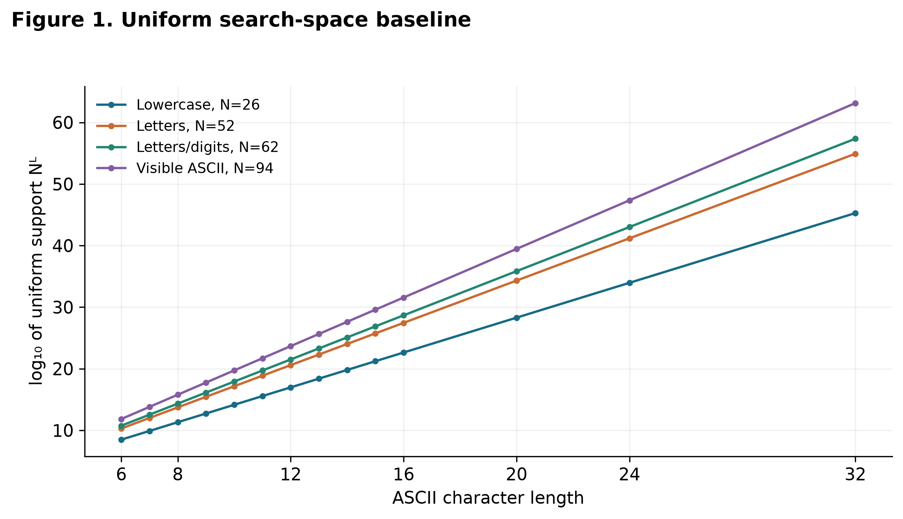
Figure 1. Theoretical support under independent uniform draws from four specified ASCII alphabets. N=94 excludes space. No empirical sample denominator or source-password entropy is implied.

5.6 Statistical analysis and revised model diagnostic
Spearman correlations are computed from exact weighted midranks on compressed rows. Distinct weighting assigns weight m to a row; account weighting assigns fm. These estimands answer different questions and are both retained. No population p-values or sampling confidence intervals are calculated: the historical, recovered, differentially private releases do not support treating every released count as an independent random participant. Tie bounds, distribution quantiles, and sensitivity analyses describe identifiable uncertainty and fragility without claiming to cover unquantified privacy or selection error.
A descriptive logistic model relates distinct-bin pooled top-10,000 membership to length across 6–16. Partly included ties become fractional positive/negative weights. The implementation uses a regularized logistic fit with C=10^6 and standardized length. Leaving one length group out provides an aggregate calibration diagnostic against a constant training-group fraction. The target cutoff is constructed using the complete pooled spectrum, including the held group. Accordingly, this is not prospective or independent-user validation. There are no structural covariates; the length-plus-structure model is DATA UNAVAILABLE.
An exploratory revision compares six fixed specifications on that same target, weighting, and eleven folds: intercept-only, linear/quadratic/cubic logistic, and cubic B-splines with four/five uniform knots. Means, scales, and knots are fitted using training lengths only; splines extrapolate linearly beyond the training span. Polynomial bases use powers of standardized length. The common C=10^6 penalty is basis-scale dependent. No degree, knot count, or penalty was tuned on held folds. The comparison was added after the original linear results and is not preregistered. Full-data and held-group scores are reported separately in the nonlinear-model supplement.
Planned checks vary weighting, early thresholds, frequency cutoffs, common-bin removal, and length bins. Excluding length 15 and restricting to 6–14 were added after observing its unusual tail; these are explicitly exploratory source diagnostics. They do not replace the complete primary analysis. No hypothesis-significance testing or p-value selection is used.
The new diagnostic removes held-group participation in cutoff construction. For each held length h, only the other ten primary length histograms define the frequency boundary for 10,000 training bins. The frozen rule qh(f) equals one above that cutoff, the training tie fraction at it, and zero below it. It is then applied to training and held released frequencies. Distinct-bin-weighted positive/negative mass gives exact sufficient statistics for the length-only binary objective. Scaling, polynomial bases and uniform spline knots use training lengths only; the six original fixed specifications and C=10⁶ are retained without held-fold tuning.
qₕ(f) = 1 if f > tₕ; qₕ(f) = αₕ if f = tₕ; qₕ(f) = 0 if f < tₕ.
The outcome is membership above a training-defined released-frequency threshold, not membership among a known string order or the original full-pool top 10,000. Cutoffs differ across folds. Distinct-bin-weighted binary log loss, binary Brier loss, group calibration error and observed/predicted ratios are reported against each fold's training-constant baseline. Binary Brier expectation is q(1−p)²+(1−q)p², retaining q(1−q); it differs from merely squaring group prevalence error. Equal-group loss is also exported. AUC and precision/recall are not pooled across changing fold targets with only one predicted score per held group. Eleven aggregate groups do not constitute independent-user or independent-source validation. Endpoint lengths 6 and 16 require extrapolation. The original diagnostic is preserved in Appendix C, with its full-pool target limitation explicit.

5.7 Robustness and privacy perturbation
Empirical. Conditional top-10,000 coverage changes by −6.55 percentage points from 6 to 7 and −11.62 from 7 to 8; changes become smaller across 8–13. It increases by 0.66 points from 13 to 14, 5.21 from 14 to 15, and 15.84 from 15 to 16. Conditional G50 ratios across all adjacent 6–16 pairs range from about 0.0407 to 6.50. G50 also depends mechanically on the size and frequency spectrum of each conditional group. These comparisons do not measure a causal resistance gain from appending a character to the same base secret.
Association robustness varies weighting, f≥2/f≥5 retention, top-100 removal, and exploratory length exclusions. Table 5 in Results reports every specified primary comparison.
Mechanism-specific mathematics. The cited release mechanism samples a sorted integer frequency spectrum g with weight proportional to exp(−ε′‖f−g‖₁/2), restricted to coordinate-bounded partitions around the original spectrum f. Zero padding allows positive-bin support and total mass to change. Sorting and the shared support couple outputs; this is not an independent Laplace/geometric perturbation of each password count. Harsha et al. report ε′=0.25 per list and total privacy ε=0.5, δ≤2⁻¹⁰⁰. These privacy parameters are distinct from a utility failure target. [5], [6]
For any stipulated spectral radius ‖f−g‖₁≤E, the count C of positive bins with frequency 1, frequency 2, or even frequency changes by at most E; the positive-bin total U also changes by at most E. Consequently, a conservative envelope for the original indicator fraction is
[max(0, (C − E)/(U + E)), min(1, (C + E)/(U − E))], U > E.
Here C and U are released counts; the envelope is [0,1] when U≤E. A one-count change can move a bin between singleton/doubleton categories and split or merge a rank tie, so proportional errors are largest at low frequencies. This indicator bound does not itself bound Spearman rho. The supplement derives a finite exponential-mechanism tail bound from partition counts and reports all fixed-radius scenarios.
Conditional numerical radius illustrations are reported in Appendix E, Table A8.

5.8 Verifier-cost measurement and threat model
The saved benchmark measures complete local matching-verification and hashing calls. Incorrect-input checks establish correctness and were not timed. Variance is reconstructed from the special n=5 linear-quantile identity: the saved minimum, q25, median, q75 and maximum are exactly the five sorted observations at saved precision. Their mean and sample variance (divisor n−1) are recoverable, but temporal order, paired covariance, scheduling and tail stability are not. No timing rerun or observation was invented. Function specifications are documented by RFC 8018 (PBKDF2) and RFC 9106 (Argon2). [26], [25]
For an online service, define B(T) as its admitted-request budget over horizon T and r(t) as a stipulated admitted-rate ceiling in the same account/service scope. A symbolic constraint is Kon(T) ≤ min(B(T), floor(∫₀ᵀ r(t) dt)). Throttling, lockout and delays alter this admitted budget. Authentication requires both a correct password event P and other required conditions F, giving Pr(authentication) = Pr(P) Pr(F given P); factor independence is not assumed.
For a purely hypothetical constant-cost offline model with w equal always-busy workers and complete-call cost c, finite-budget time is ceil(K/w)c. The measured experiment supplies only serial matching-call latency for w=1. A full-memory model also requires w Mcall ≤ Mavailable, excluding additional overhead; this necessary memory condition does not predict throughput. Argon2 lanes p are not independent workers w. GPU/ASIC capacity, parallel cost and nonmatching latency are NOT RUN. Multiplying a selected median by K is a constant-cost illustration, not the expected stochastic sum or password-recovery time. The full symbolic assumptions are retained in the hashing supplement and Figure S3.

6. Results

6.1 Length and released frequency
Empirical. Summing the LinkedIn length lists exceeds the full-list mass by 4,425, approximately 0.00254%, and the number of anonymous bins by 275. Separate privacy releases mean the two releases should retain their separate totals. The Yahoo archive contains 52 text histograms, although its documentation describes 51; only yahoo-all is analyzed.
Table 2. Primary length groups. Shares use all 174,296,614 units of mass in the length-partitioned release; the remaining supplied groups above 16 account for approximately 0.225%.
Length | Account mass | Anonymous bins | Mass share | Conditional G50 | Conditional top 10,000 | Pooled top 10,000
6 | 33,172,884 | 5,418,646 | 19.03% | 55,653 | 35.65% | 28.69%
7 | 23,626,429 | 6,672,366 | 13.56% | 226,077 | 29.10% | 19.68%
8 | 45,655,199 | 14,886,616 | 26.19% | 1,084,311 | 17.47% | 12.02%
9 | 22,664,131 | 8,750,881 | 13.00% | 1,261,281 | 16.09% | 7.89%
10 | 16,761,091 | 7,505,262 | 9.62% | 1,769,279 | 12.27% | 4.37%
11 | 7,838,163 | 3,814,033 | 4.50% | 1,064,976 | 10.75% | 2.45%
12 | 4,711,604 | 2,399,153 | 2.70% | 727,692 | 10.29% | 1.76%
13 | 2,311,635 | 1,242,692 | 1.33% | 410,675 | 9.39% | 0.69%
14 | 1,339,616 | 734,280 | 0.77% | 250,934 | 10.05% | 1.10%
15 | 15,212,723 | 5,524,373 | 8.73% | 1,630,230 | 15.26% | 14.46%
16 | 610,779 | 290,203 | 0.35% | 66,337 | 31.09% | 21.11%

All primary groups have distinct-bin median released frequency 2. Account-weighted median frequency declines from 60 at length 6 to 8 at 7, 4 at 8, and 2 at 9–16. Figure 2 displays both weightings and conditional G50.
The length-15 tail is unusual: 81.97% of Distinct Anonymous Bins have frequency 2, and 96.38% have even frequencies. After removing frequencies 1–2, the even share is still 97.76% among 814,313 bins; at f≥5 it is 97.36% among 198,059. At f≥100 it is 49.59%, but only 123 bins remain. The anomaly therefore extends beyond singleton/doubleton counts, without establishing a high-frequency parity effect. The sorted-spectrum L1 distance between the separately sanitized full release and the pooled length lists is 30,785; their frequency-2 multiplicities differ by only 114. These release-consistency observations are not a bound on distance to the missing original data (see the supplementary DP diagnostic report).
Interpretive hypotheses. Privacy processing can move counts and change positive-bin support, but the documented mechanism is not independent per-bin Laplace/geometric noise; Section 5.7 states its actual construction and conditional sensitivity. Upstream duplication, aggregation or length coding could also produce a localized parity pattern. Truncation is an unverified processing hypothesis: a universal 15-unit cutoff in the same length unit would conflict with groups above 15 only if their labels reflect original, untruncated lengths. That provenance and unit equivalence are unverified; localized recovery/processing effects remain possible. KoreLogic's interim 2016 report has a different length-15 count at an earlier recovery stage, so it is not a matched pre/post-privacy control. Neither it nor the released spectra identifies the cause. Source provenance and original preprocessing would be needed to discriminate these explanations. [6], [27]
Empirical. For lengths 6–16, Spearman rho(length, frequency) is −0.3346 under account weighting and +0.0405 under distinct weighting. Replacing frequency with its anonymous frequency midrank reverses each sign; it is not an independent validation because rank is a monotone inverse of the same released frequency. The full 64-length analysis gives −0.3357 and +0.0412, respectively.
Figure 2 retains every primary group. Appendix Table A1 includes complete conditional and pooled coverage/G50 values; no length-15 observation is silently removed.
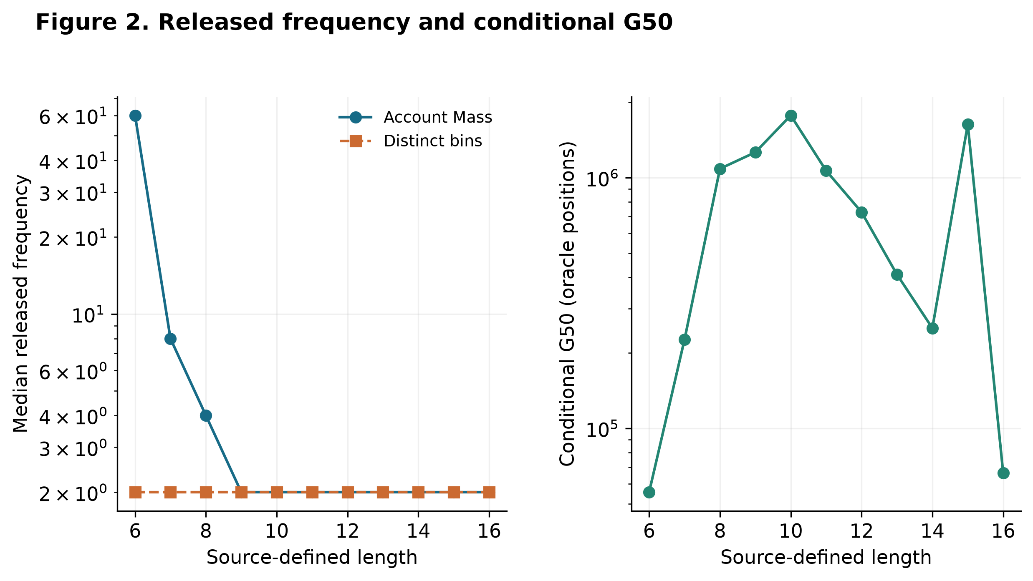
Figure 2. All primary groups 6–16: 173,904,254 units of released Account Mass and 57,238,505 Distinct Anonymous Bins. G50 orders each known-length group separately. Medians use the stated distinct-bin or mass weights; these are perturbed historical spectra, not population estimates.
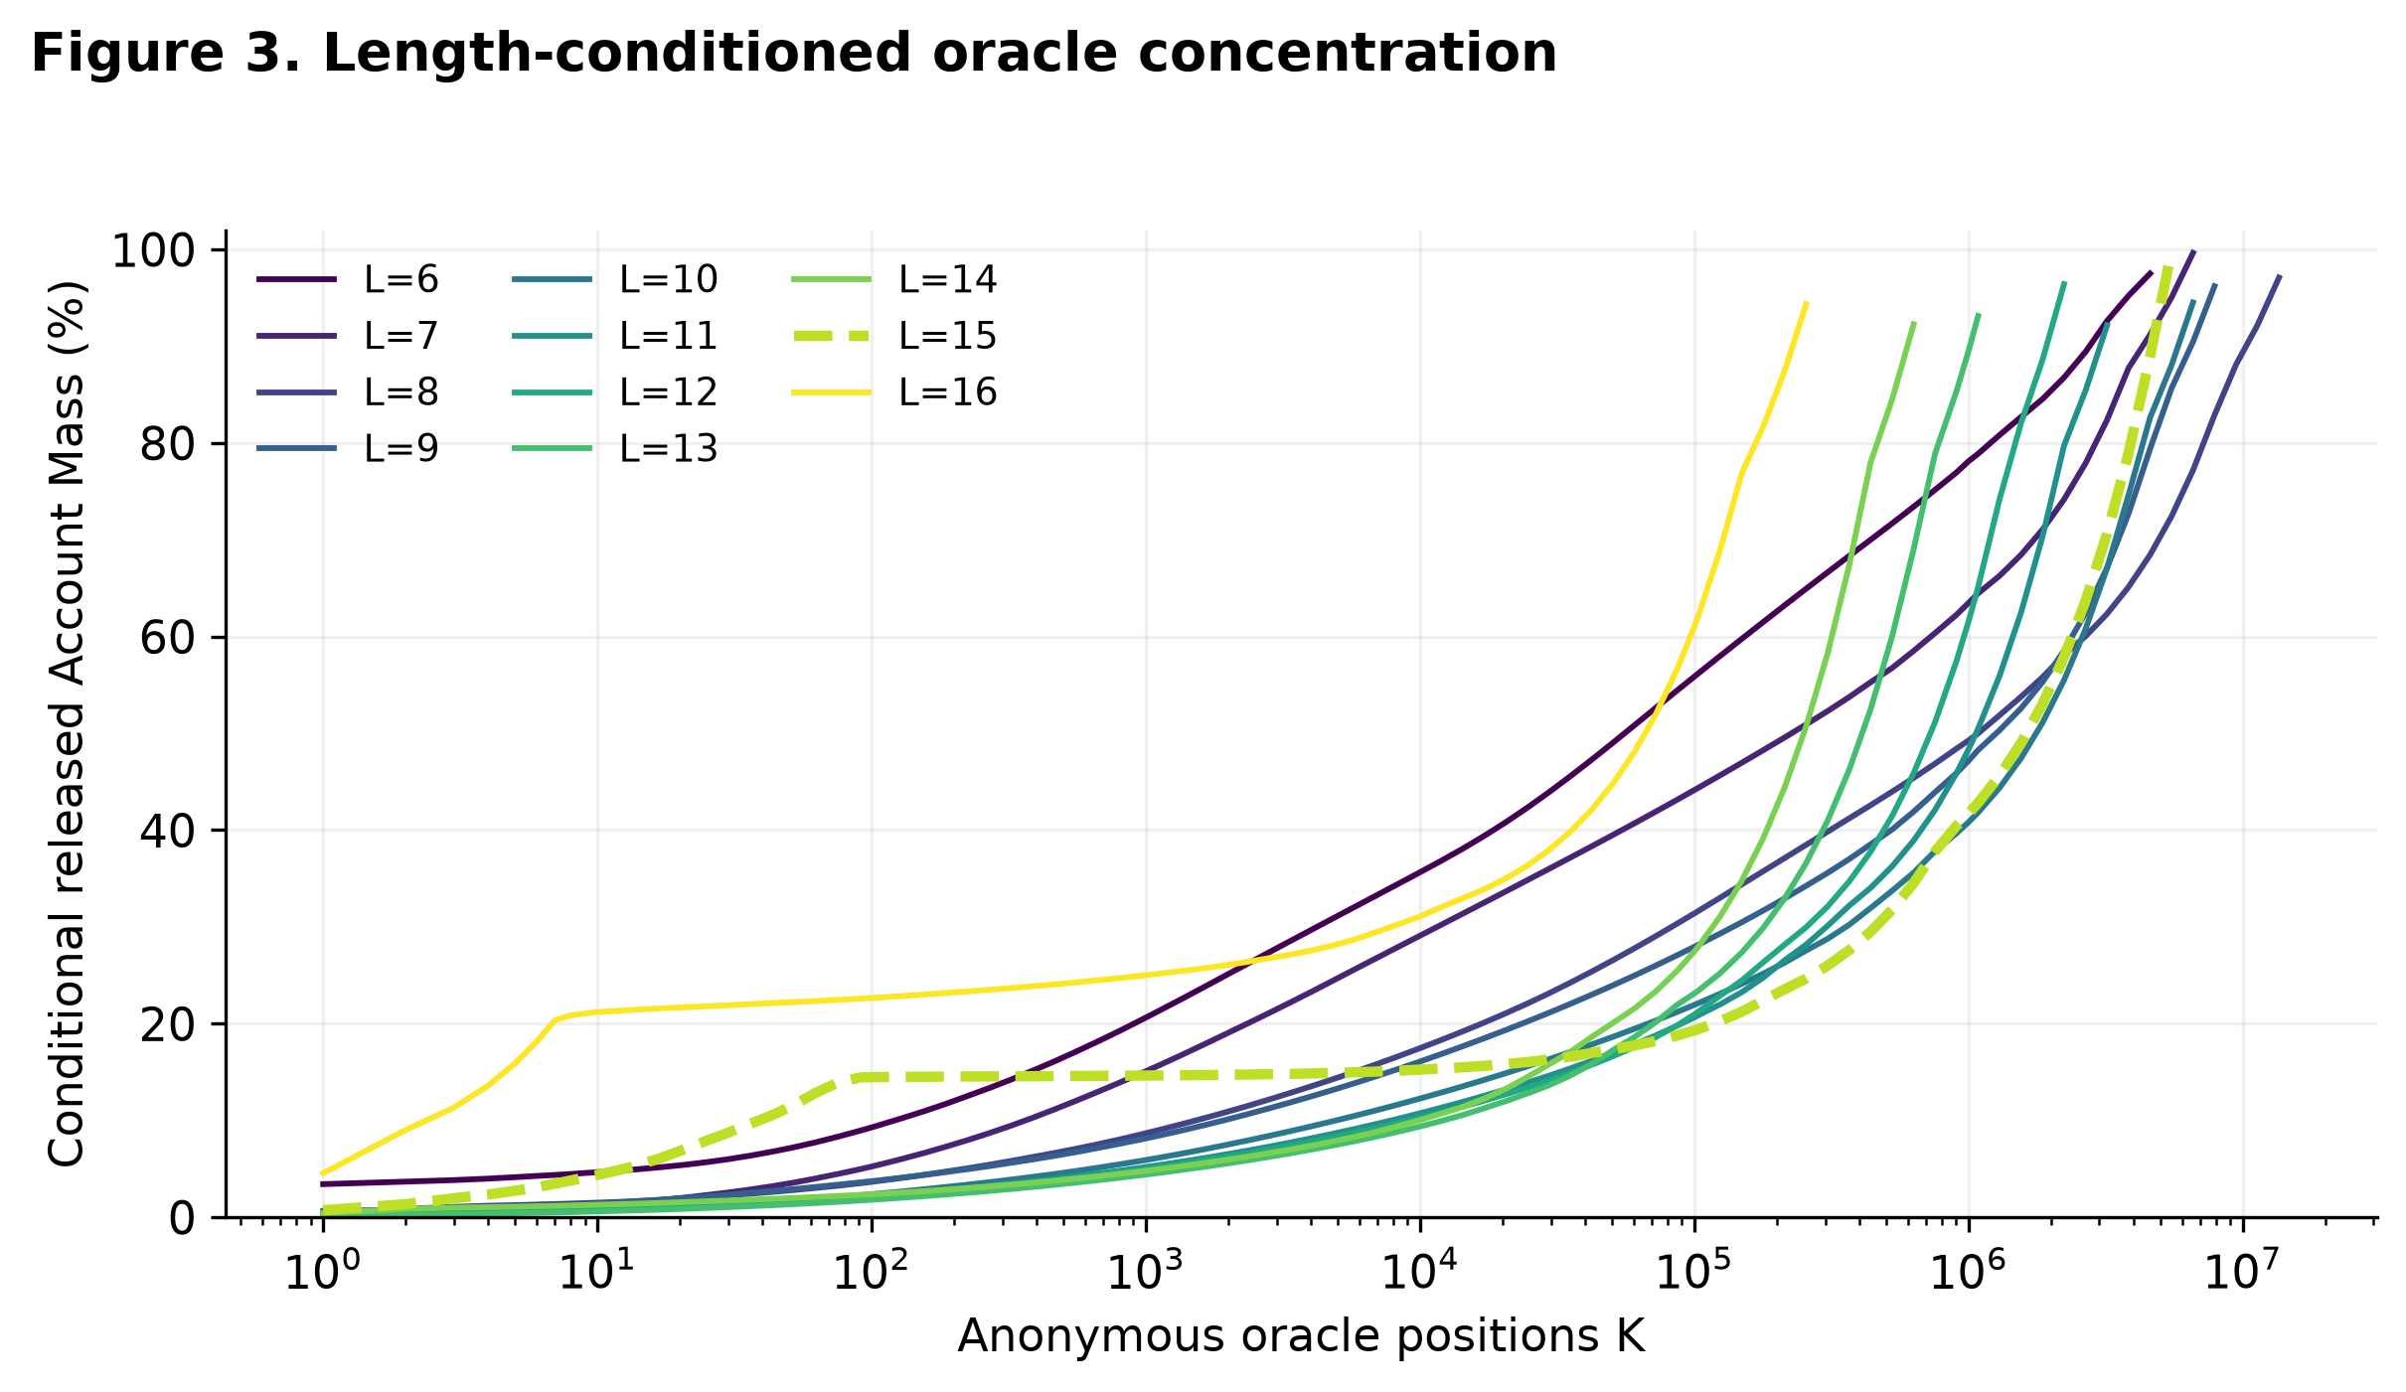
Figure 3. All eleven primary source-length groups, each divided by its own released Account Mass. Length 15 is dashed. Curves stop at the available positive-bin support; lines connect evaluated budgets. The oracle presumes length and the popularity order are known. No operational guessing or account recovery was measured.

6.2 Nominal length-matched corpus/generator comparison
Table 3. Conditional account-corpus coverage versus uniform mathematics at K=10,000. Uniform columns are theoretical probabilities, not observed recovery rates. The comparison matches nominal lengths; source encoding and normalization are unavailable.
Length | Uniform alphabet | Uniform theory | Released-spectrum oracle
6 | 26 | 0.00% | 35.65%
6 | 52 | 0.00% | 35.65%
6 | 62 | 0.00% | 35.65%
6 | 94 | 0.00% | 35.65%
7 | 26 | 0.00% | 29.10%
7 | 52 | 0.00% | 29.10%
7 | 62 | 0.00% | 29.10%
7 | 94 | 0.00% | 29.10%
8 | 26 | 0.00% | 17.47%
8 | 52 | 0.00% | 17.47%
8 | 62 | 0.00% | 17.47%
8 | 94 | 0.00% | 17.47%
9 | 26 | 0.00% | 16.09%
9 | 52 | 0.00% | 16.09%
9 | 62 | 0.00% | 16.09%
9 | 94 | 0.00% | 16.09%
10 | 26 | 0.00% | 12.27%
10 | 52 | 0.00% | 12.27%
10 | 62 | 0.00% | 12.27%
10 | 94 | 0.00% | 12.27%
11 | 26 | 0.00% | 10.75%
11 | 52 | 0.00% | 10.75%
11 | 62 | 0.00% | 10.75%
11 | 94 | 0.00% | 10.75%
12 | 26 | 0.00% | 10.29%
12 | 52 | 0.00% | 10.29%
12 | 62 | 0.00% | 10.29%
12 | 94 | 0.00% | 10.29%
13 | 26 | 0.00% | 9.39%
13 | 52 | 0.00% | 9.39%
13 | 62 | 0.00% | 9.39%
13 | 94 | 0.00% | 9.39%
14 | 26 | 0.00% | 10.05%
14 | 52 | 0.00% | 10.05%
14 | 62 | 0.00% | 10.05%
14 | 94 | 0.00% | 10.05%
15 | 26 | 0.00% | 15.26%
15 | 52 | 0.00% | 15.26%
15 | 62 | 0.00% | 15.26%
15 | 94 | 0.00% | 15.26%
16 | 26 | 0.00% | 31.09%
16 | 52 | 0.00% | 31.09%
16 | 62 | 0.00% | 31.09%
16 | 94 | 0.00% | 31.09%

Figure 4 distinguishes the empirical oracle spectrum from mathematical random distributions. These large differences depend on the idealized knowledge of the source-popularity order and cannot be presented as measured speedups of a real guesser. They show why using N^L as a human-password estimate changes the distribution being analyzed.
Theoretical. Figure 1 shows the N^L search-space baseline across all configured lengths. An extra uniform character adds 4.7004, 5.7004, 5.9542, or 6.5546 bits for N=26,52,62,94, respectively. Repeating an independently selected two-letter unit retains 9.4009 bits at all tested lengths; the four-letter-plus-fixed-suffix generator retains 18.8018 bits. The latter generators were sampled and their features checked, but these entropy values follow from their definitions. They do not estimate how often humans use such mechanisms.
For the repeated two-letter generator, adding displayed repetition beyond its two random positions adds zero entropy; the four-letter-prefix construction behaves likewise beyond its fixed random choices. A new independent EFF word adds log₂(7776) = 12.9248 unconditional bits, but an arbitrary additional displayed character in a phrase has no comparable universal multiplier. These are generator-specific statements, not measured human append-character effects.
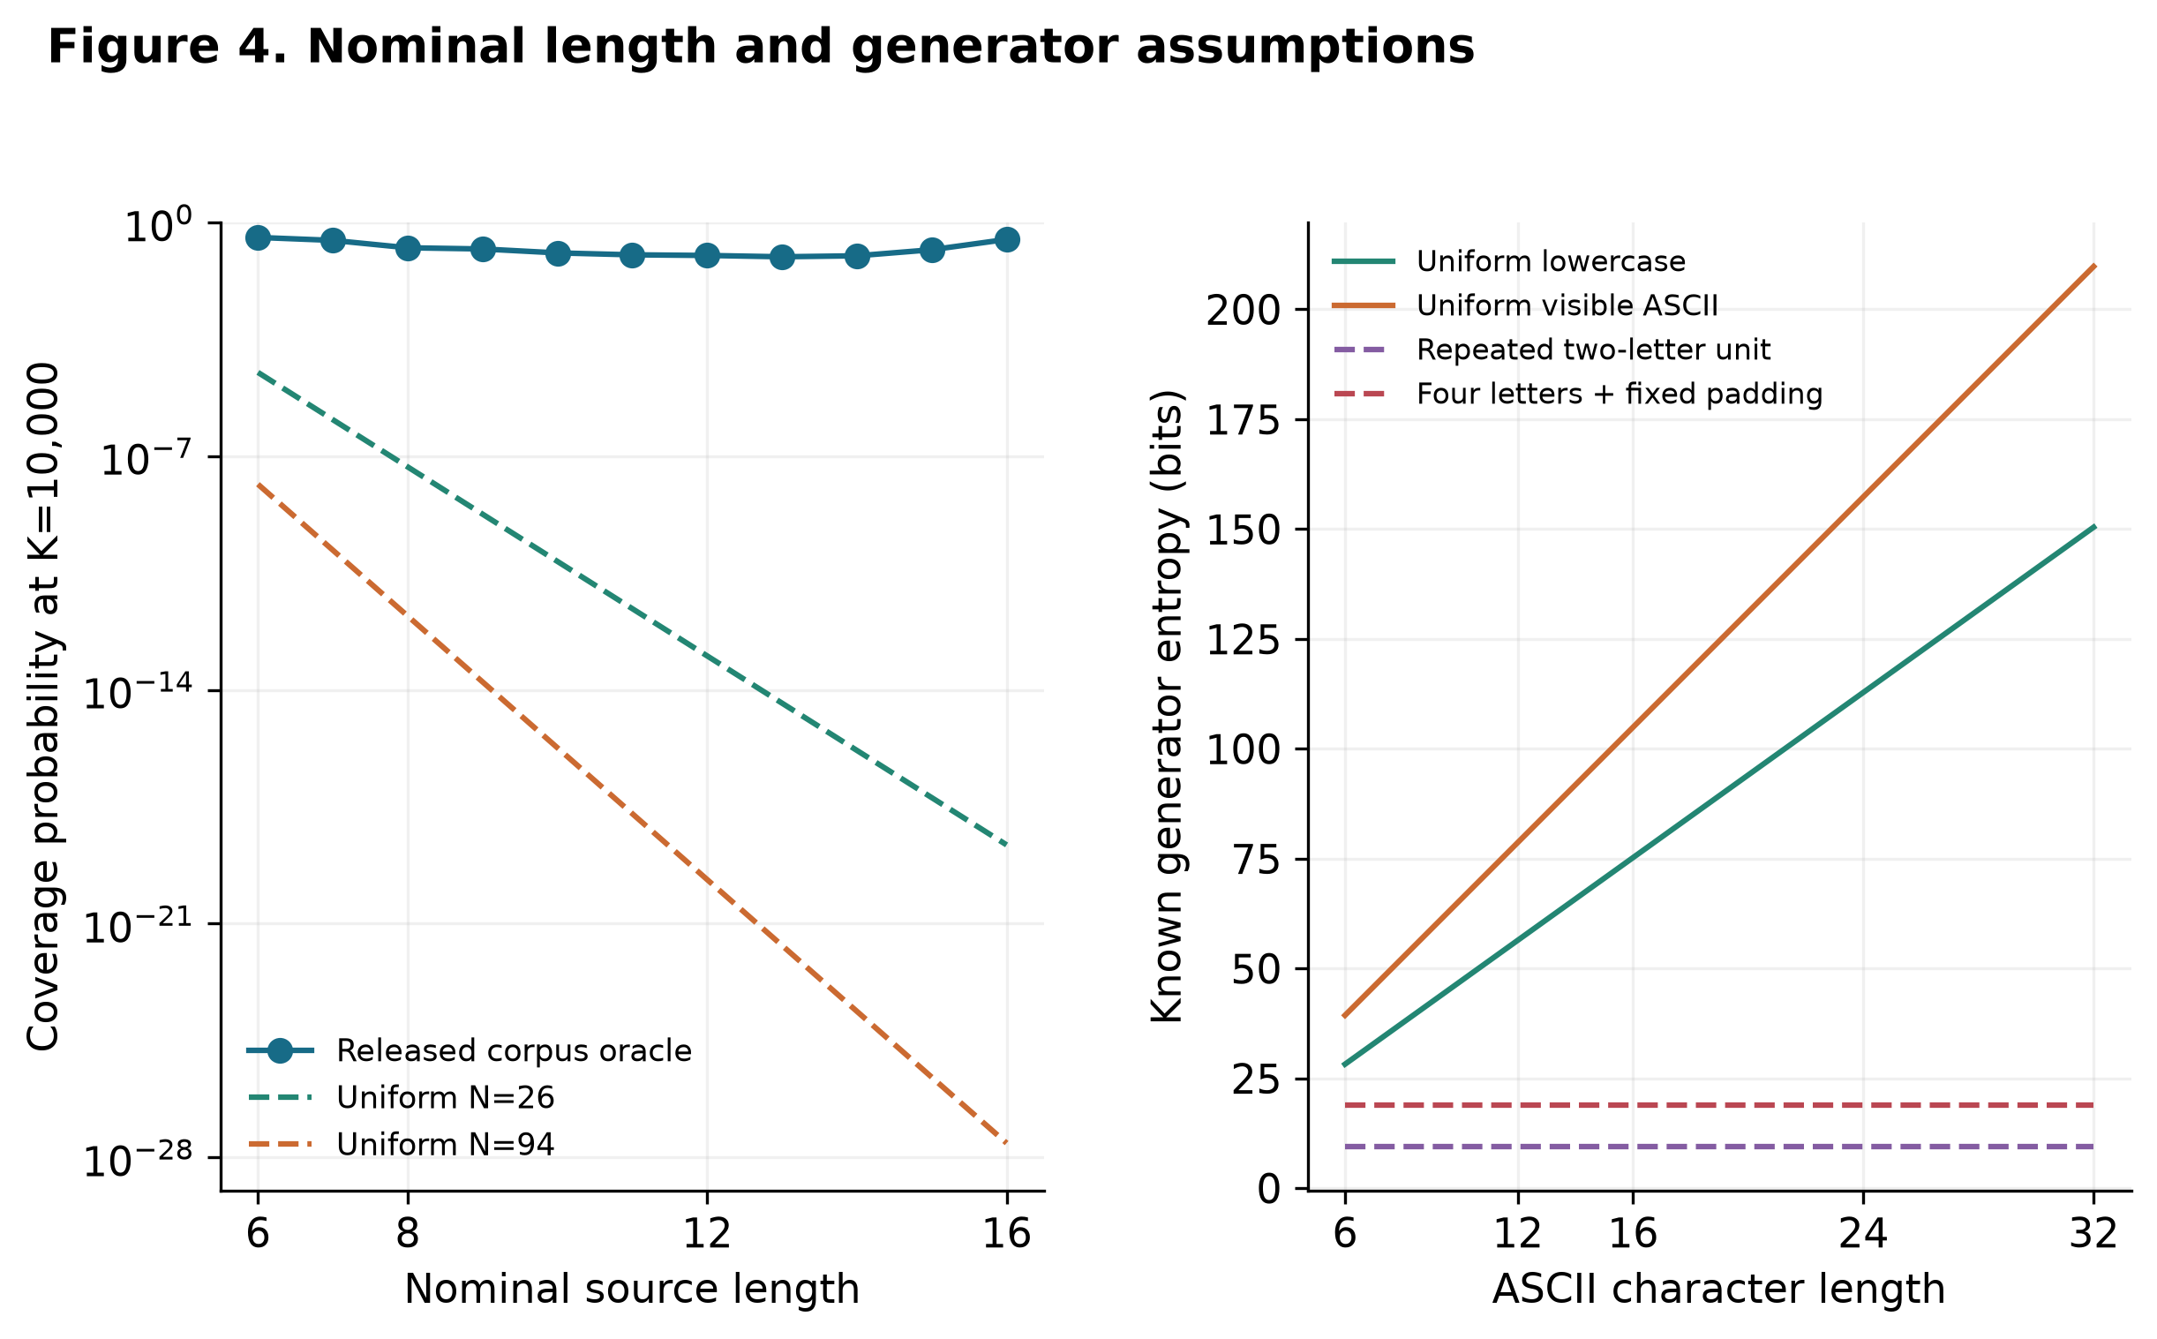
Figure 4. Left: empirical released conditional concentration versus mathematical min(K/Nᴸ,1), matched only by nominal length; source encoding and generation method are unknown. Right: entropy from four explicit injective uniform generators, checked using 16,800 frozen feature records. Equal local ASCII length permits different known generator entropy. This is not a matched human/random attack trial.

6.3 Length models and missing structural adjustment
Human length × structure: DATA UNAVAILABLE. There is no estimated Model B (length plus human structure) or Model C (human interactions). Synthetic literal features do not substitute for this experiment. Table 4 reports the feasible revised length-only calibration diagnostic.
Table 4. Training-only-threshold length-model comparison. Eleven folds; 57,238,505 held Distinct Anonymous Bins in total. Fold-specific binary targets differ; all six fixed specifications are reported. Values are descriptive without population intervals.
Model | Held log loss | Constant loss | Held Brier loss | Length 15 ratio | Length 16 ratio
intercept only | 0.0021687 | 0.0021687 | 0.00023123 | 0.09 | 0.18
linear logistic | 0.0020547 | 0.0021687 | 0.00023117 | 5.53 | 13.40
quadratic logistic | 0.0020520 | 0.0021687 | 0.00023116 | 2.04 | 2.53
cubic logistic | 0.0020517 | 0.0021687 | 0.00023116 | 1.45 | 2.00
bspline cubic 4knots | 0.0020634 | 0.0021687 | 0.00023118 | 0.31 | 0.77
bspline cubic 5knots | 0.0020645 | 0.0021687 | 0.00023118 | 0.30 | 0.71

Linear held-length log loss is 0.002054725, versus 0.002168710 for fold constants. Cubic reduces it to 0.002051667: an absolute reduction of 0.000003058, or 0.149% relative to linear. Its mean binary Brier loss is 0.000231163, versus 0.000231227 for constants. The small loss differences reflect severe class imbalance; they do not imply near-perfect classification. Linear underpredicts length 15/16 by 5.53/13.40, while cubic ratios remain 1.45/2.00. Both splines worsen aggregate loss relative to linear. No convergence warnings were recorded across 66 new fits. Figure 5 displays all specifications. The results cannot be directly compared with the original full-pool-target loss as if the target had remained fixed.
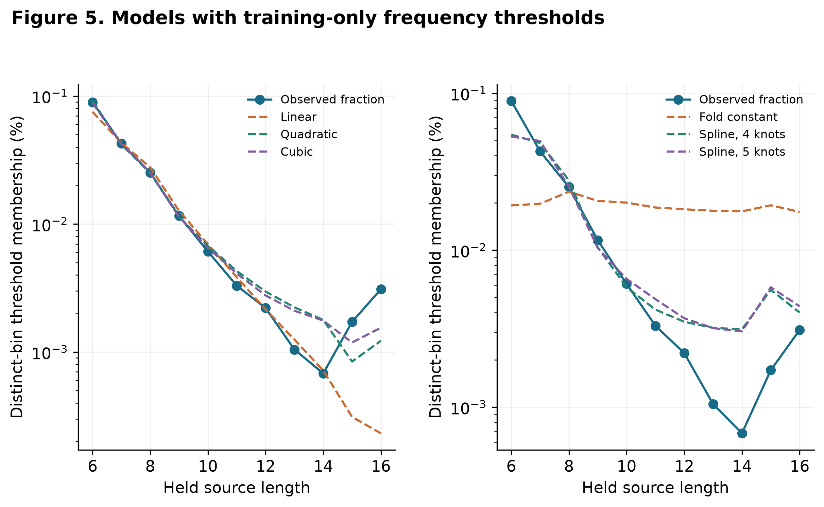
Figure 5. Six fixed exploratory models, eleven held-length folds. Each threshold and boundary-tie fraction uses only the other ten primary groups and is frozen before application to the held spectrum. Outcome thresholds differ across folds; weighted log loss is an aggregate diagnostic, not prospective user/source prediction. The held denominators total 57,238,505 Distinct Anonymous Bins. Human structural adjustment remains DATA UNAVAILABLE.
Table 5. Descriptive sensitivity of the primary association.
Condition | Spearman: bins | Spearman: mass | Anonymous bins | Account mass
all | 0.041 | -0.335 | 57,238,505 | 173,904,254
frequency at least 2 | -0.171 | -0.384 | 35,854,322 | 152,520,071
frequency at least 5 | -0.134 | -0.150 | 3,099,086 | 79,664,656
exclude length15 diagnostic | -0.063 | -0.365 | 51,714,132 | 158,691,531
restrict lengths6 to14 diagnostic | -0.061 | -0.366 | 51,423,929 | 158,080,752
remove pooled top100 | 0.041 | -0.350 | 57,238,405 | 169,027,177

Distinct-bin correlation is sensitive to the low-frequency tail and the length-15 group. Account-weighted association remains negative in these diagnostics, although its magnitude varies. Filtering changes the population being summarized; it does not establish the “correct” unperturbed statistic. Every specified threshold and alternate wider-bin result is exported, rather than selecting one favorable cutoff.
Retaining f≥2 removes 37.36% of primary Distinct Anonymous Bins but 12.30% of Account Mass. Retaining f≥5 removes 94.59% of bins and 54.19% of mass. Thus, the observed Spearman sign change is a major change in the estimand's included support; it is not direct evidence that privacy noise caused the original positive sign or that either filtered correlation recovers user behavior.

6.4 Oracle curves and long-group sensitivity
Figure 3 reports conditional curves for all eleven primary lengths with each group's own denominator. At 10,000 positions, conditional mass concentration ranges nonmonotonically across source groups; values at lengths 6, 13 and 16 are 35.65%, 9.39% and 31.09%. Pooled and conditional ranks answer different questions. Dictionary/rule/statistical train/test recovery curves are NOT RUN.
The revision's complete 42-cell long-threshold grid is shown in Figure 6. At pooled K=10,000, exposure among source lengths at least 12, 14, 15, 16, 20, 24 and 32 is respectively 9.95%, 13.37%, 14.38%, 13.12%, 1.30%, 1.44%, 0.00%. The original ≥16 cell is 131,591 / 1,003,139 = 13.12% of eligible released Account Mass. These changing denominators explain why a threshold change is not a within-person length effect. Length 15's unusual spectrum contributes to changes around that boundary. Zero exposure at a fixed budget does not establish universal strength. Expected tie allocation, sharp tie bounds and distinct-bin fractions for every cell accompany the table export.
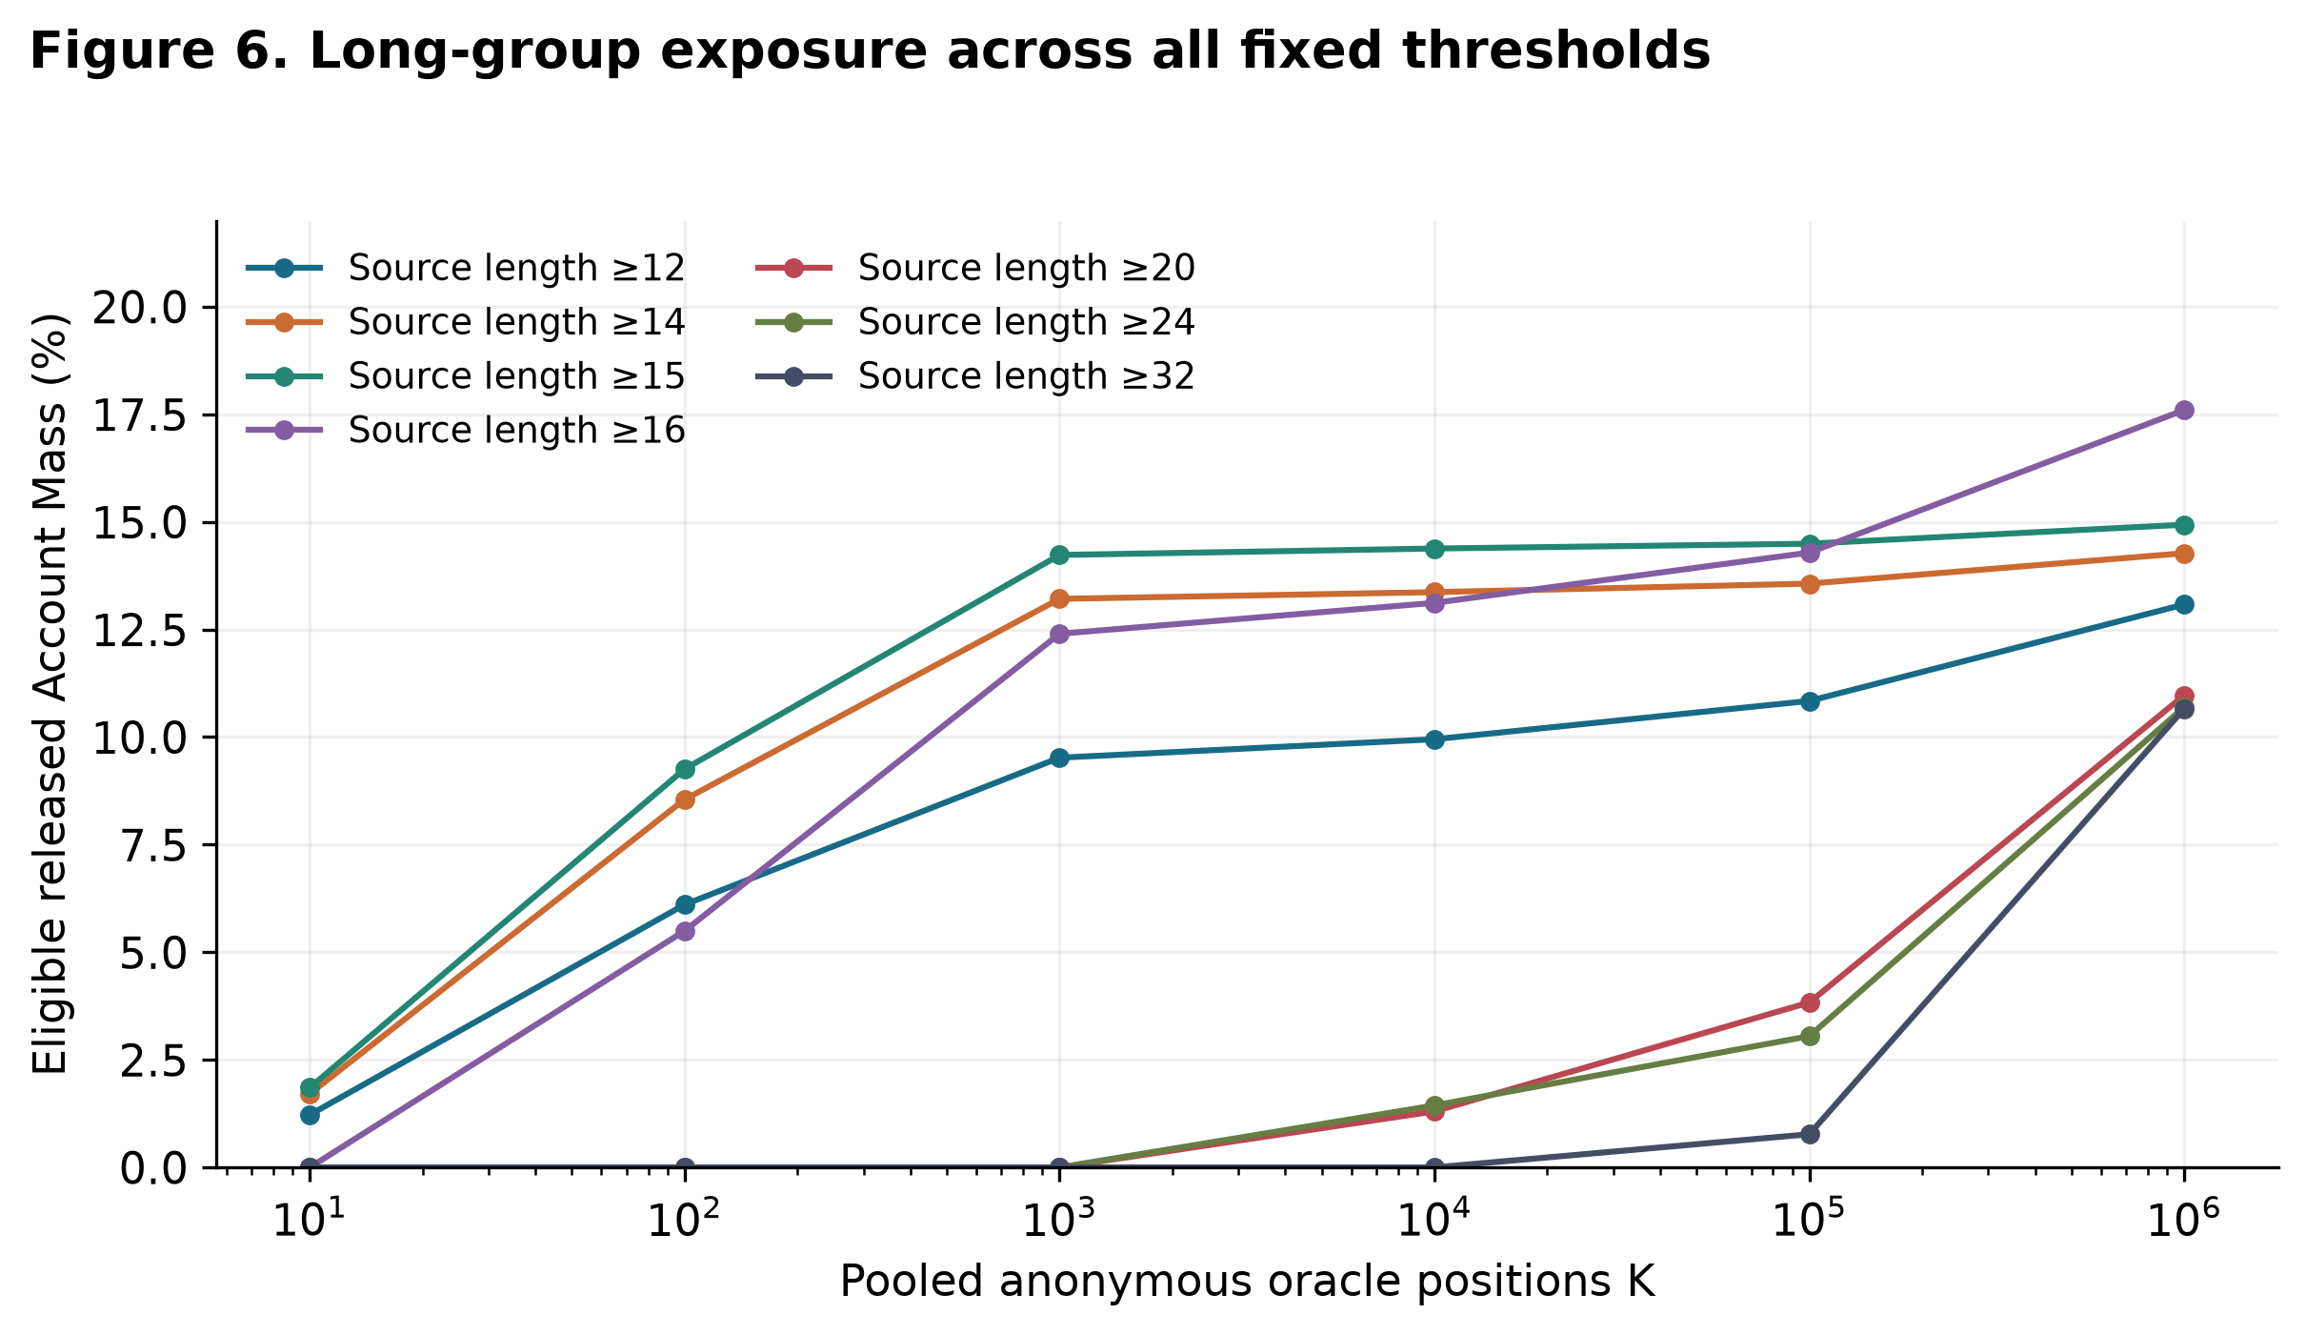
Figure 6. Complete exploratory grid: seven minimum lengths × six budgets = 42 cells. Each curve divides selected pooled-oracle mass by the released mass of all supplied lengths meeting its threshold. The original ≥16/top10,000 cell is retained. Sharp tie bounds and distinct-bin denominators are exported separately. Threshold sensitivity does not identify individual strings, cause, original population fractions or real attack success.

6.5 Complexity transformations
The complete fixed eight-example HIBP panel appears in Appendix B, Table A3 and Figure S1. All examples were observed, with materially different historical occurrence counts. Password1! has more occurrences than Password! in the frozen snapshot despite its greater length. This auxiliary illustration does not establish transformation prevalence, global rank or causal resistance gain. Naturally occurring transformation-family analysis and family-separated prediction remain DATA UNAVAILABLE.

6.6 Passphrases
Uniform selection of 2–6 EFF words gives 25.8496, 38.7744, 51.6993, 64.6241, and 77.5489 unconditional bits. Across three 100-specimen replicates, six-word median character length was 47 in each replicate, including spaces; four-word median was 31. Figure 7 combines sampled length quantiles with exact conditional-on-length entropy. These word-count calculations do not apply to ordinary sentences or to hand-selected word sequences.
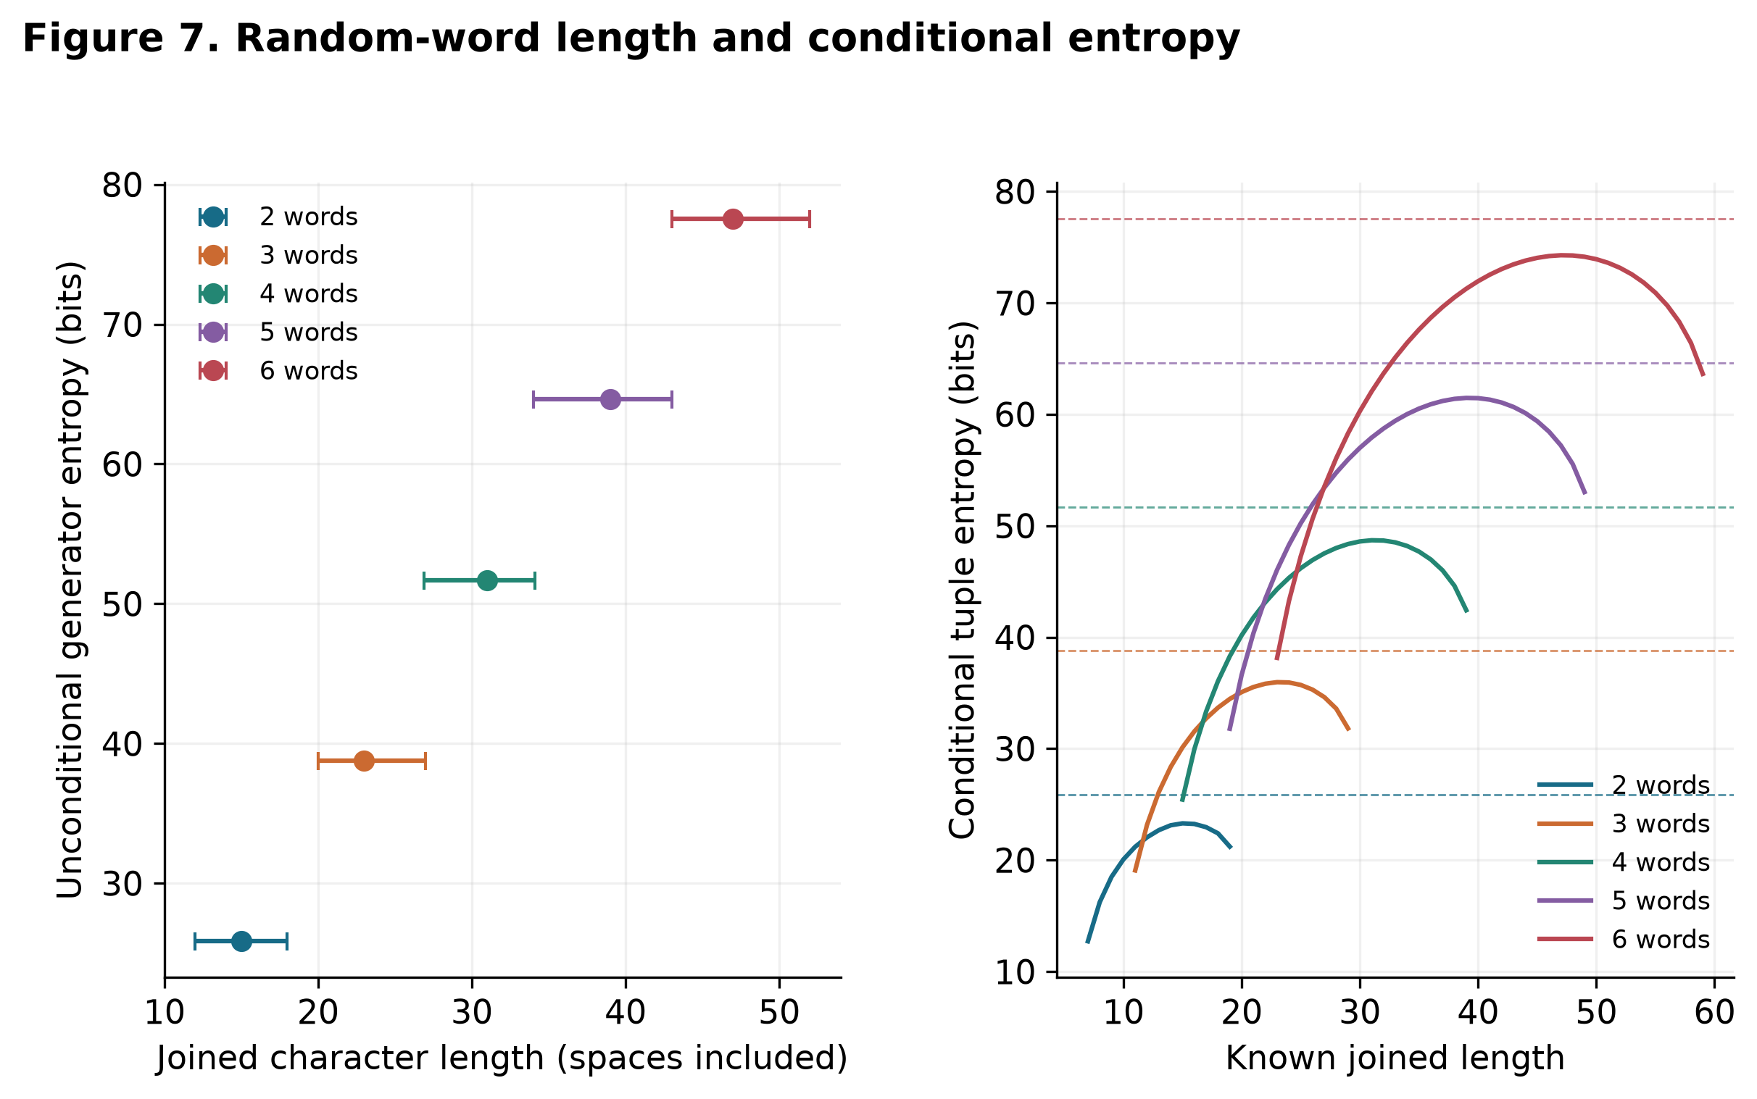
Figure 7. Independent uniform draws with replacement from 7,776 EFF words, joined by one space. Left: 1,500 frozen phrases; markers are medians of three replicate medians and bars are medians of replicate 10th–90th length quantiles, not confidence intervals. Right: exact convolution counts conditional on known word count and joined length; dashed lines are unconditional entropy. No ordinary human-sentence entropy is estimated.

6.7 Hashing and verifier cost
All 36 cells completed in the recorded Darwin 24.1.0 arm64/Python 3.12.14 environment, using OpenSSL 3.5.8, argon2-cffi 25.1.0 and bcrypt 5.0.0. There were 216 hash calls, 216 matching checks and 36 incorrect-input correctness checks including warmups. The serial protocol lasted about 31.58 seconds. Exact CPU/RAM were not saved at that run. A separate later observation identifies Apple M1, MacBookAir10,1, 8 GiB RAM, eight physical/logical cores, macOS 15.1.1 build 24B91; it is context, not independently verified historical machine continuity or thermal/load state.
Table 6. Local matching-verification summaries. Each configuration comprises four ASCII length cells (8/16/32/64 bytes), each with five timed observations after one warmup. IQR and sample-variance ranges are across those cell-specific values, not a pooled variance or uncertainty interval for the median of medians.
Algorithm | Cost level | 8 bytes (ms) | 16 bytes (ms) | 32 bytes (ms) | 64 bytes (ms)
argon2id | 1 | 22.17 | 22.17 | 23.26 | 22.17
argon2id | 2 | 40.07 | 39.40 | 38.27 | 38.48
argon2id | 3 | 120.72 | 120.55 | 121.44 | 118.97
bcrypt | 1 | 14.73 | 14.65 | 14.74 | 14.63
bcrypt | 2 | 58.44 | 60.01 | 58.39 | 59.00
bcrypt | 3 | 234.30 | 233.80 | 235.95 | 233.99
pbkdf2_sha256 | 1 | 10.97 | 10.37 | 10.89 | 10.37
pbkdf2_sha256 | 2 | 31.13 | 31.63 | 31.49 | 31.73
pbkdf2_sha256 | 3 | 61.79 | 62.84 | 62.38 | 62.56

The 72-row operation-by-cell uncertainty table preserves hash and verification statistics, means and extrema. A retained Argon2id 32 MiB/t=2/p=1 hash cell at eight bytes has median 39.585 ms, IQR 0.710 ms, maximum 299.644 ms and sample variance 13,546.425 ms². Its cause is unknown. This outlier shows why medians and quartile spans cannot summarize tail behavior fully. Figure 8 makes it visible. Five observations do not establish negligible length effects, temporal stability, p95/p99 latency or expected service capacity.
Parameter levels are unequal workloads and do not rank algorithms globally. The largest Argon2id cell has p=1, unlike RFC 9106's p=4 lower-memory option. Low-cost PBKDF2/bcrypt cells are experimental contrasts, not deployment recommendations. bcrypt above 72 bytes was rejected, not benchmarked. No optimized parallel or GPU/ASIC results were measured. [28], [25], [24]
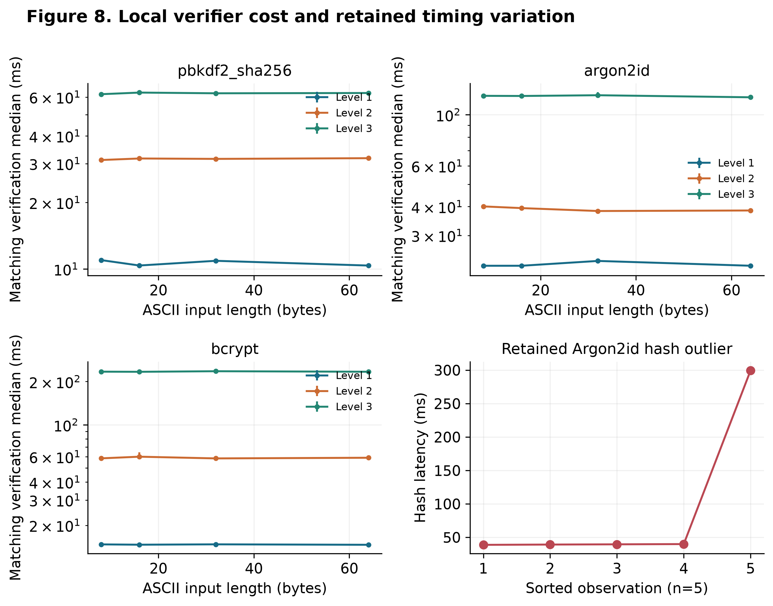
Figure 8. 36 cells, one warmup and five timed calls per operation/cell. Upper/left panels show matching-verification medians and descriptive quartile spans. Levels: PBKDF2 100k/300k/600k; Argon2id 19/32/64 MiB, t=2/2/3, p=1; bcrypt cost 8/10/12. Lower-right retains all five sorted hash times for Argon2id 32 MiB, 8 bytes, including 299.644 ms. Sorted times are recovered exactly from n=5 quantiles; temporal order was lost. Unequal parameter settings and one host do not rank security or attacker throughput.

6.8 Cross-dataset comparison and temporal limits
Table 7. Separate-source overall concentration. Each spectrum retains its own released mass denominator and frequency order. Difference is Yahoo minus LinkedIn in percentage points; it is not a population estimate or temporal effect.
Budget (K) | LinkedIn coverage | Yahoo coverage | Difference (pp)
10 | 1.28% | 1.89% | 0.60
100 | 2.80% | 3.62% | 0.83
1,000 | 7.13% | 8.32% | 1.18
10,000 | 14.24% | 16.55% | 2.31
100,000 | 24.01% | 28.81% | 4.80
1,000,000 | 37.68% | 45.02% | 7.34

Both historical releases show nonuniform concentration: at K=10,000, Yahoo exceeds LinkedIn by 2.312 percentage points, and at K=1,000,000 by 7.341 points. Figure 9 reports all six budgets. Yahoo's missing length covariate makes independent replication of the length relationship DATA UNAVAILABLE. The distinct collection/recovery processes, services and periods preclude a temporal policy-era inference. No incompatible sources are pooled, and the linked LinkedIn full/length outputs are not counted as separate validation populations.
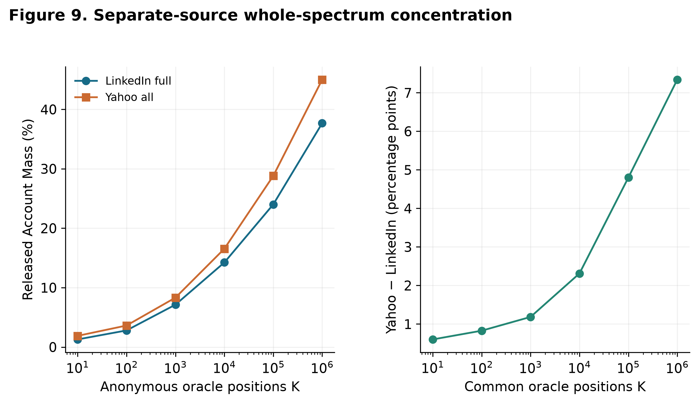
Figure 9. Separately analyzed historical spectra at six fixed common budgets. Denominators: LinkedIn full 174,292,189; Yahoo all 69,301,337 units of released Account Mass. They are not pooled. Differences describe overall concentration under their own frequency orders. Yahoo has no length covariate, so this cannot replicate the length association or establish a temporal trend.

7. Discussion
Interpretive. Account-weighted observations show a generally negative association between length and frequency, consistent with greater dispersion in many longer groups. The complete binned results and failed long-group calibration prevent a universal monotonic claim. Distinct-bin weighting produces a weak association whose sign changes under tail diagnostics. It would be misleading to collapse these two estimands into one statement that length is either “good” or “bad.”
The length-15 parity diagnostics warrant a source-processing audit before behavioral interpretation. Persistence above frequency two and agreement of the two overall spectra make a singleton-only explanation incomplete. They do not separate upstream processing, recovery selection, length coding and the particular privacy realization. Truncation remains a hypothesis rather than a documented LinkedIn property; the complete primary analysis retains this group.
The same nominal length also permits different generation distributions. Uniform-character mathematics gives exponentially increasing support, while the explicit pattern controls gain no entropy from fixed repetition or padding. A known deterministic injective transformation preserves a base generator's entropy; extra unpredictable choices would require a different generator model. This theoretical result explains why extra displayed characters alone cannot identify extra independent randomness. It does not establish the prevalence or guess ranks of those mechanisms in human choices.
The empirical frequency oracle presumes much more information than length alone. Without strings and independent training/test observations, its concentration curve cannot validate a realistic dictionary, rule, Markov, PCFG, or neural guesser. Such strategies remain literature background and NOT RUN comparisons here. The HIBP panel provides a limited transformation observation but cannot fill this gap.
Published comparisons show why one cannot assign a transferable oracle discount. Ur et al. found more than tenfold disagreement in estimated ranks for 51% of the passwords guessed by JTR, PCFG, or both, with censoring giving lower bounds for some differences. Melicher et al. reported 70% versus 57% coverage for the neural and next-best individual methods on their 4class8 test set at 10^15 modeled guesses under their PGS training protocol; this was an estimated-rank comparison, not that many verifier calls. These literature-only results quantify method dependence, not Δ for our LinkedIn release. Retrospective per-password minima across models also differ from one order using the same total budget. [19], [18]
The appropriate practical interpretation remains consistent with contemporary verifier guidance: length, compromised-password checks, throttling, MFA, and suitable storage address different parts of the problem. This historical reanalysis does not justify weakening minimum length or requiring arbitrary composition transformations. [1], [29]
The training-only-cutoff extension removes a specific held-group construction dependency, while leaving the original observational limits intact. Its endpoint calibration improves under polynomial flexibility, but cubic's 0.149% relative log-loss improvement is small, splines do not improve loss, and the targets vary by fold. Consequently, the extension supports a diagnostic description rather than a claim that length predicts future users or that structure is unnecessary. The absence of structural data is an explicit boundary on the conclusion, not evidence for or against structural dominance.
Practically, engineers should combine the applicable minimum length with whole-password compromised/common-value screening, admitted-request controls, password-manager-compatible input and MFA appropriate to the context. Selection unpredictability and verifier work factor are separate layers; successful local verification latency does not describe optimized cracking capacity or authentication compromise. These conclusions retain NIST's minimum of 15 characters for centrally verified single-factor passwords and the permitted eight-character minimum when used only as part of MFA. [1], [29]

8. Threats to Validity
The central missing experiment is structural adjustment on ethically usable human-choice data. The study therefore cannot answer whether structure dominates length after controlling for human patterns, and cannot compare actual performance across the five operational guessing strategies.
LinkedIn observations come from a historical recovered subset; old policies, service context, language, demographics, reuse, and recovery bias limit generalization. The length-15 tail is unresolved. Neither large count totals nor differential privacy validate original length coding or explain that group. Source-defined lengths cannot be equated precisely with Unicode code points or bytes. Generation mechanisms of the source bins are unobserved; the corpora are not verified cohorts of exclusively human-generated passwords. Missing lengths below six do not prove that no shorter passwords existed.
Privacy perturbation affects masses, frequency bins, ranks, and small groups. The mechanism-specific envelopes condition on a stipulated L1 radius; numerical mass proxies and β are explicitly hypothetical utility scenarios. They do not reconstruct the actual noise distribution, quantify Spearman uncertainty, or provide release-specific confidence intervals. Tie bounds cover only ordering uncertainty at equal released frequency; they do not cover privacy, sampling, recovery, or source errors. No population p-values or confidence intervals are supplied that would imply otherwise.
The pooled length histogram is a reconstructed noisy joint table, not the separate full histogram. Frequency order is an oracle description of the same release, not independently validated attack prediction. Conditional coverage and G50 depend on the size and distribution of each subgroup. The preserved original Appendix C diagnostic uses held-group information in cutoff construction. The revised diagnostic excludes that dependency but remains an aggregate within-source evaluation with severe class imbalance and endpoint errors.
Synthetic controls describe specified generators. The HIBP panel is deliberately selected, has no sampling denominator, and may change with service updates. Word-list entropy requires independent uniform sampling; ordinary sentences are not represented. Local hashing uses one host, short runs, ASCII inputs, and selected parameters. Exact timing and regenerated CSPRNG inputs will differ on rerun.
Distinct uncertainty sources. Privacy perturbation changes the released spectrum under the documented mechanism. Sampling uncertainty would require a supported population sampling model, which is absent. Historical selection reflects service/policy/demographic context; recovery selection reflects how the LinkedIn subset became available. Source-processing artifacts include unverified length units, normalization, duplication and truncation hypotheses. These sources are not combined into one confidence interval. Conditional L1 scenarios constrain certain indicator counts under their assumptions but do not quantify all five sources or identify the actual unperturbed Spearman association.
The new held diagnostic excludes a length from threshold construction, not a source or family of independently identified passwords. Training and test groups remain components of the same historical release and privacy process. Near-duplicate/family leakage cannot be audited from anonymous bins; no source-generalization claim is made. Its AUC/precision/recall are not replaced by inappropriate pooled metrics. Minima/budgets and nonlinear specifications are post-result exploratory sensitivity choices, fully reported to limit selective presentation.

9. Reproducibility and Data Availability
Public sources. Versioned LinkedIn/Yahoo anonymous aggregate releases and provider metadata are publicly available under the documented CC0 terms. The attributed EFF ordinary vocabulary is publicly available under its published terms. Source URLs, versions, license records, sizes and SHA-256 values accompany the acquisition manifest. The fixed HIBP snapshot is retained for downstream arithmetic; live service counts can change.
Supplied artifacts. The accompanying archive contains code, analysis configuration, frozen synthetic feature inputs, derived CSV tables, plot exports, mathematical derivations, reference audit and source manifests. It is computationally reproducible from the supplied frozen artifacts under the recorded environment; no restricted human corpus is required. Synthetic strings were transient and discarded, so secure regeneration is a new sample, not recovery of the original strings. Original timing reruns produce new measurements. No raw breached credentials, identifiers, salts or verifier records are released. No restricted human structural dataset is included; that analysis remains DATA UNAVAILABLE.
Code availability. Code is supplied with this manuscript under MIT; original prose and figures use CC BY 4.0, with third-party inputs retaining their terms. No public repository URL, archived repository DOI or Git commit has been assigned at this stage. Source/input/output digests identify the delivered snapshot; the artifact manifest and archive SHA-256 provide a verifiable substitute for this local delivery, without implying a deposited public repository. Publication should accompany a stable repository or archive deposit.
The analysis uses Python 3.12.14 and the pinned environment in requirements.lock (NumPy 2.5.3, pandas 3.0.6, SciPy 1.18.1, scikit-learn 1.9.1, Matplotlib 3.11.2). Analysis/cell-order seed is 20261005; CSPRNG sampling is intentionally unseeded. From a copied project directory, a fresh reader can run:
python3 -m venv .venv
.venv/bin/python -m pip install -r requirements.lock
.venv/bin/python experiments/reproduce.py
The command checks tests/source archives, recomputes the original aggregates and controls, DP/nonlinear diagnostics, training-only-threshold extension, hashing uncertainty and both plot sets, then checks every numerical CSV against its saved byte hash. Expected outputs are the results/tables and results/statistics directories, nine main/three appendix journal plates and the reproduction_check record. Timing calls and live acquisition are excluded from this command. The portable Word build uses requirements-document.txt and experiments/build_docx.py; its embedded-figure audit is recorded separately. On another numerical platform, any byte mismatch requires explicit inspection, not silent baseline replacement.

10. Conclusion
Source-defined length has a moderately negative Account-Mass-weighted association with released frequency in the analyzed LinkedIn spectrum, while the weak distinct-bin association is fragile to low-frequency and length-15 diagnostics. Conditional oracle concentration is nonmonotonic, and long-group membership changes with the specified minimum and budget. These results answer the descriptive release question; they do not identify a causal per-character resistance multiplier or current-user behavior.
For specified independent uniform generators, each new random choice increases support and entropy according to its alphabet or vocabulary. Fixed repetition/padding adds displayed length without new entropy. The nominal corpus/generator comparison therefore separates distributions and assumptions; it is not an observed human/random attack trial. A separate Yahoo spectrum corroborates overall concentration but cannot replicate the length association. Human structural adjustment, operational guessing and temporal change remain open.
The engineering implication is to retain the applicable NIST minimum length alongside compromised-password screening, throttling, suitable salted storage, manager-compatible inputs and MFA. The results do not weaken NIST SP 800-63B-4's 15-character single-factor requirement or justify treating length as a sufficient guarantee of unpredictable choice. [1], [29]
References
[1] David Temoshok; James Fenton; Yee-Yin Choong; Naomi Lefkovitz; Andrew Regenscheid; Ryan Galluzzo; Justin Richer. (2025). Digital Identity Guidelines: Authentication and Authenticator Management. National Institute of Standards and Technology. SP 800-63B-4. doi:10.6028/NIST.SP.800-63b-4. Accessed 6 October 2026.
[2] Richard Shay; Saranga Komanduri; Adam L. Durity; Phillip (Seyoung) Huh; Michelle L. Mazurek; Sean M. Segreti; Blase Ur; Lujo Bauer; Nicolas Christin; Lorrie Faith Cranor. (2014). Can Long Passwords Be Secure and Usable?. Proceedings of the SIGCHI Conference on Human Factors in Computing Systems. pp. 2927–2936. doi:10.1145/2556288.2557377.
[3] Patrick Gage Kelley; Saranga Komanduri; Michelle L. Mazurek; Richard Shay; Timothy Vidas; Lujo Bauer; Nicolas Christin; Lorrie Faith Cranor; Julio López. (2012). Guess Again (and Again and Again): Measuring Password Strength by Simulating Password-Cracking Algorithms. 2012 IEEE Symposium on Security and Privacy. pp. 523–537. doi:10.1109/SP.2012.38.
[4] Joseph Bonneau. (2012). The Science of Guessing: Analyzing an Anonymized Corpus of 70 Million Passwords. 2012 IEEE Symposium on Security and Privacy. pp. 538–552. doi:10.1109/SP.2012.49.
[5] Jeremiah Blocki; Anupam Datta; Joseph Bonneau. (2016). Differentially Private Password Frequency Lists. Network and Distributed System Security Symposium. doi:10.14722/ndss.2016.23328.
[6] Benjamin Harsha; Robert Morton; Jeremiah Blocki; John Springer; Melissa Dark. (2021). Bicycle Attacks Considered Harmful: Quantifying the Damage of Widespread Password Length Leakage. Computers & Security. Vol. 100. Article 102068. doi:10.1016/j.cose.2020.102068.
[7] Richard Shay; Patrick Gage Kelley; Saranga Komanduri; Michelle L. Mazurek; Blase Ur; Timothy Vidas; Lujo Bauer; Nicolas Christin; Lorrie Faith Cranor. (2012). Correct Horse Battery Staple: Exploring the Usability of System-Assigned Passphrases. Proceedings of the 8th Symposium on Usable Privacy and Security. pp. 7:1–7:20. doi:10.1145/2335356.2335366.
[8] Joseph Bonneau. (2016). Deep Dive: EFF's New Wordlists for Random Passphrases. Electronic Frontier Foundation. Source. Accessed 6 October 2026.
[9] Saranga Komanduri; Richard Shay; Patrick Gage Kelley; Michelle L. Mazurek; Lujo Bauer; Nicolas Christin; Lorrie Faith Cranor; Serge Egelman. (2011). Of Passwords and People: Measuring the Effect of Password-Composition Policies. Proceedings of the SIGCHI Conference on Human Factors in Computing Systems. pp. 2595–2604. doi:10.1145/1978942.1979321.
[10] Matteo Dell'Amico; Pietro Michiardi; Yves Roudier. (2010). Password Strength: An Empirical Analysis. IEEE INFOCOM 2010. doi:10.1109/INFCOM.2010.5461951.
[11] Matt Weir; Sudhir Aggarwal; Michael Collins; Henry Stern. (2010). Testing Metrics for Password Creation Policies by Attacking Large Sets of Revealed Passwords. Proceedings of the 17th ACM Conference on Computer and Communications Security. pp. 162–175. doi:10.1145/1866307.1866327.
[12] Michelle L. Mazurek; Saranga Komanduri; Timothy Vidas; Lujo Bauer; Nicolas Christin; Lorrie Faith Cranor; Patrick Gage Kelley; Richard Shay; Blase Ur. (2013). Measuring Password Guessability for an Entire University. Proceedings of the 2013 ACM SIGSAC Conference on Computer and Communications Security. pp. 173–186. doi:10.1145/2508859.2516726.
[13] Yunkai Zou; Maoxiang An; Ding Wang. (2025). Password Guessing Using Large Language Models. 34th USENIX Security Symposium. pp. 7799–7818. Source.
[14] Jeremiah Blocki; Peiyuan Liu. (2023). Towards a Rigorous Statistical Analysis of Empirical Password Datasets. 2023 IEEE Symposium on Security and Privacy. Source.
[15] Anonymous Anon. (2019). linkedin_files.zip. doi:10.6084/m9.figshare.7350287.v2. Accessed 6 October 2026.
[16] Joseph Bonneau. (2015). Yahoo Password Frequency Corpus. doi:10.6084/m9.figshare.2057937.v1. Accessed 6 October 2026.
[17] Matt Weir; Sudhir Aggarwal; Breno de Medeiros; Bill Glodek. (2009). Password Cracking Using Probabilistic Context-Free Grammars. 2009 IEEE Symposium on Security and Privacy. pp. 391–405. doi:10.1109/SP.2009.8.
[18] William Melicher; Blase Ur; Sean M. Segreti; Saranga Komanduri; Lujo Bauer; Nicolas Christin; Lorrie Faith Cranor. (2016). Fast, Lean, and Accurate: Modeling Password Guessability Using Neural Networks. 25th USENIX Security Symposium. pp. 175–191. Source.
[19] Blase Ur; Sean M. Segreti; Lujo Bauer; Nicolas Christin; Lorrie Faith Cranor; Saranga Komanduri; Darya Kurilova; Michelle L. Mazurek; William Melicher; Richard Shay. (2015). Measuring Real-World Accuracies and Biases in Modeling Password Guessability. 24th USENIX Security Symposium. pp. 463–481. Source.
[20] Hashcat Project. (n.d.). Rule-Based Attack. Source. Accessed 6 October 2026.
[21] Jerry Ma; Weining Yang; Min Luo; Ninghui Li. (2014). A Study of Probabilistic Password Models. 2014 IEEE Symposium on Security and Privacy. pp. 689–704. doi:10.1109/SP.2014.50.
[22] Briland Hitaj; Paolo Gasti; Giuseppe Ateniese; Fernando Perez-Cruz. (2019). PassGAN: A Deep Learning Approach for Password Guessing. Applied Cryptography and Network Security: 17th International Conference, ACNS 2019. Vol. 11464. pp. 217–237. doi:10.1007/978-3-030-21568-2_11.
[23] Have I Been Pwned. (n.d.). API Documentation: Pwned Passwords. Source. Accessed 6 October 2026.
[24] OWASP Foundation. (n.d.). Password Storage Cheat Sheet. Source. Accessed 6 October 2026.
[25] Alex Biryukov; Daniel Dinu; Dmitry Khovratovich; Simon Josefsson. (2021). Argon2 Memory-Hard Function for Password Hashing and Proof-of-Work Applications. RFC Editor. 9106. doi:10.17487/RFC9106. Accessed 6 October 2026.
[26] Kathleen Moriarty; Burt Kaliski; Andreas Rusch. (2017). PKCS #5: Password-Based Cryptography Specification Version 2.1. RFC Editor. 8018. doi:10.17487/RFC8018. Accessed 6 October 2026.
[27] Rick Redman. (2016). LinkedIn Revisited -- Full 2012 Hash Dump Analysis. KoreLogic. Source. Accessed 6 October 2026.
[28] Niels Provos; David Mazières. (1999). A Future-Adaptable Password Scheme. 1999 USENIX Annual Technical Conference, FREENIX Track. Source.
[29] OWASP Foundation. (n.d.). Authentication Cheat Sheet. Source. Accessed 6 October 2026.
[30] NVIDIA Corporation. (2023). NVIDIA Ada GPU Architecture. Source. Accessed 6 October 2026.
[31] Ronny Krashinsky; Olivier Giroux; Stephen Jones; Nick Stam; Sridhar Ramaswamy. (2020). NVIDIA Ampere Architecture In-Depth. NVIDIA Corporation. Source. Accessed 6 October 2026.
[32] NVIDIA Corporation. (2022). NVIDIA A100 Tensor Core GPU: Data Sheet. Source. Accessed 6 October 2026.
[33] NVIDIA Corporation. (2023). GPU Performance Background User's Guide. Source. Accessed 6 October 2026.
[34] Hashcat Project. (n.d.). Implementation Limits. Source. Accessed 6 October 2026.

Appendix A. Detailed coverage and status
Table A1. Oracle concentration by length. Every percentage uses Account Mass in Table 2 as denominator. Conditional K uses a separate length-aware order; pooled K uses one order across all released lengths. G50 is conditional. Figure 3 displays conditional curves; Figure 9 gives separate-source comparators.
Length | Account mass | Anonymous bins | Conditional G50 | Conditional G90 | Conditional top 10,000 | Pooled top 10,000
6 | 33,172,884 | 5,418,646 | 55,653 | 2,767,009 | 3565.11% | 2868.83%
7 | 23,626,429 | 6,672,366 | 226,077 | 4,309,724 | 2909.73% | 1967.75%
8 | 45,655,199 | 14,886,616 | 1,084,311 | 10,321,097 | 1747.43% | 1201.61%
9 | 22,664,131 | 8,750,881 | 1,261,281 | 6,484,468 | 1609.17% | 789.47%
10 | 16,761,091 | 7,505,262 | 1,769,279 | 5,829,153 | 1226.87% | 436.52%
11 | 7,838,163 | 3,814,033 | 1,064,976 | 3,030,217 | 1074.88% | 244.51%
12 | 4,711,604 | 2,399,153 | 727,692 | 1,927,993 | 1028.51% | 175.77%
13 | 2,311,635 | 1,242,692 | 410,675 | 1,011,529 | 938.57% | 69.05%
14 | 1,339,616 | 734,280 | 250,934 | 600,319 | 1004.98% | 109.67%
15 | 15,212,723 | 5,524,373 | 1,630,230 | 4,672,775 | 1525.50% | 1446.34%
16 | 610,779 | 290,203 | 66,337 | 229,126 | 3109.05% | 2111.21%
17 | 100,371 | 51,187 | 21,906 | 41,980 | 2627.65% | 0.00%
18 | 58,250 | 29,184 | 12,471 | 24,121 | 4151.76% | 0.00%
19 | 30,887 | 15,460 | 6,705 | 12,883 | 7133.75% | 0.00%
20 | 37,003 | 16,455 | 5,436 | 12,837 | 7466.96% | 237.01%
21 | 11,266 | 5,583 | 2,489 | 4,742 | — | 0.00%
22 | 26,852 | 12,782 | 4,321 | 10,097 | 8963.95% | 0.00%
23 | 5,166 | 2,547 | 1,181 | 2,214 | — | 0.00%
24 | 24,159 | 12,130 | 4,200 | 9,715 | 9118.34% | 0.00%
25 | 2,692 | 1,263 | 543 | 1,082 | — | 0.00%
26 | 21,198 | 10,583 | 3,582 | 8,464 | 9724.97% | 0.00%
27 | 1,441 | 677 | 289 | 577 | — | 0.00%
28 | 15,522 | 7,139 | 2,047 | 5,587 | — | 1137.74%
29 | 789 | 315 | 114 | 272 | — | 0.00%
30 | 19,239 | 9,763 | 3,453 | 7,840 | — | 0.00%
31 | 457 | 141 | 16 | 101 | — | 0.00%
32 | 6,522 | 3,533 | 1,331 | 2,881 | — | 0.00%
33 | 212 | 71 | 16 | 58 | — | 0.00%
34 | 10,002 | 5,133 | 1,866 | 4,133 | — | 0.00%
35 | 149 | 46 | 8 | 32 | — | 0.00%
36 | 3,128 | 1,573 | 565 | 1,261 | — | 0.00%
37 | 140 | 31 | 4 | 20 | — | 0.00%
38 | 6,165 | 3,151 | 1,186 | 2,535 | — | 0.00%
39 | 103 | 22 | 3 | 12 | — | 0.00%
40 | 1,369 | 754 | 291 | 618 | — | 0.00%
41 | 48 | 8 | 3 | 7 | — | 0.00%
42 | 2,794 | 1,371 | 500 | 1,092 | — | 0.00%
43 | 108 | 13 | 4 | 10 | — | 0.00%
44 | 582 | 242 | 96 | 212 | — | 0.00%
45 | 90 | 19 | 3 | 12 | — | 0.00%
46 | 1,447 | 702 | 264 | 558 | — | 0.00%
48 | 394 | 146 | 38 | 117 | — | 0.00%
49 | 136 | 23 | 3 | 17 | — | 0.00%
50 | 622 | 306 | 120 | 245 | — | 0.00%
51 | 104 | 22 | 5 | 16 | — | 0.00%
52 | 255 | 57 | 8 | 38 | — | 0.00%
53 | 171 | 42 | 6 | 25 | — | 0.00%
54 | 649 | 195 | 23 | 142 | — | 0.00%
56 | 84 | 21 | 6 | 16 | — | 0.00%
58 | 238 | 34 | 4 | 20 | — | 0.00%
60 | 255 | 36 | 3 | 13 | — | 0.00%
62 | 103 | 23 | 4 | 17 | — | 0.00%
64 | 88 | 29 | 3 | 21 | — | 0.00%
66 | 106 | 7 | 1 | 3 | — | 0.00%
68 | 68 | 10 | 3 | 7 | — | 0.00%
70 | 105 | 35 | 5 | 25 | — | 0.00%
72 | 178 | 52 | 4 | 35 | — | 0.00%
78 | 118 | 30 | 4 | 24 | — | 0.00%
84 | 46 | 15 | 2 | 11 | — | 0.00%
90 | 148 | 20 | 5 | 14 | — | 0.00%
96 | 76 | 15 | 2 | 12 | — | 0.00%
102 | 89 | 26 | 4 | 18 | — | 0.00%
108 | 94 | 13 | 4 | 10 | — | 0.00%
114 | 82 | 18 | 4 | 12 | — | 0.00%

Table A2. Evidence and execution status. Frequency-oracle concentration is not operational recovery performance.
Analysis | Status | Scope
A exhaustive search | RUN THEORETICAL | N^L, expected guesses and uniform coverage, no actual enumeration
D frequency informed | RUN AGGREGATE | anonymous conditional/pooled frequency oracle; no candidate strings
B dictionary order | NOT RUN | strings and independently validated training/test corpus unavailable
C transformation order | NOT RUN | no candidate generator; HIBP panel measures occurrence counts only
E statistical guessing | NOT RUN | no appropriate plaintext training/test corpus; literature only
Length-only descriptive model | RUN EMPIRICAL AGGREGATE | distinct-bin top10k membership; leave-length-out calibration
Length+structure human model | DATA UNAVAILABLE | anonymous histograms have no structural covariates
Synthetic characters/passphrases | RUN CONTROLLED | CSPRNG generation and feature validation, theoretical entropy
Local password hashing | RUN EMPIRICAL | 36 cells;5 reps;3 algorithms;no credential cracking

Appendix B. Auxiliary transformation observations
Table A3. Complete fixed-example HIBP panel, queried 5 October 2026. Counts are historical corpus occurrences. Panel n=8; no corpus population denominator or global rank is available.
Example | Length | Corpus occurrences | Ratio to base | Evidence type | Global rank
password | 8 | 52,372,427 | 1.000 | empirical corpus count; selected public panel | UNAVAILABLE
Password | 8 | 15,358,389 | 0.293 | empirical corpus count; selected public panel | UNAVAILABLE
password1 | 9 | 9,643,893 | 0.184 | empirical corpus count; selected public panel | UNAVAILABLE
Password1 | 9 | 3,461,492 | 0.066 | empirical corpus count; selected public panel | UNAVAILABLE
password! | 9 | 296,199 | 0.006 | empirical corpus count; selected public panel | UNAVAILABLE
Password! | 9 | 147,314 | 0.003 | empirical corpus count; selected public panel | UNAVAILABLE
Password1! | 10 | 584,516 | 0.011 | empirical corpus count; selected public panel | UNAVAILABLE
P@ssword1! | 10 | 17,329 | 0.000 | empirical corpus count; selected public panel | UNAVAILABLE

Empirical. Every selected example appeared in the service corpus, with widely differing counts. The ten-character Password1! has more occurrences than the nine-character Password!, showing that count need not decline in this selected family when length increases. This is an observational count comparison, not a transformation intervention, security multiplier, or attack-rank comparison. Figure S1 displays the complete panel. No name, date, year-suffix, or population-wide transformation prevalence result was fabricated.
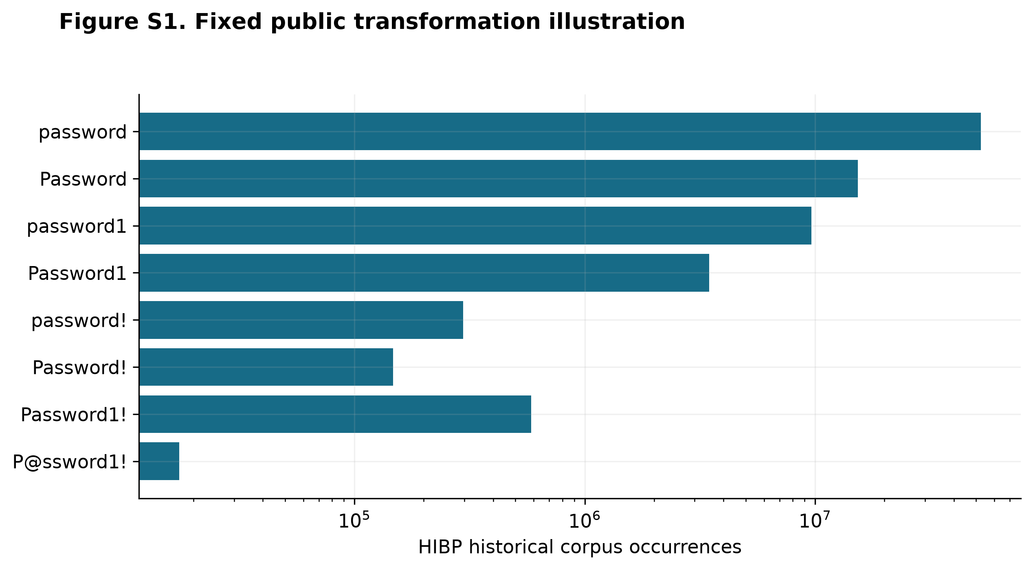
Figure S1. Eight deliberately selected public teaching examples, frozen HIBP snapshot of 5 October 2026. Counts are corpus occurrences, not current use, population prevalence, global guess ranks or causal transformation effects. Every selected example is reported.

Appendix C. Original full-pool model diagnostic
Table A4. Original linear length model. Outcome is pooled top-10,000 membership; 57,238,505 Distinct Anonymous Bins across 11 primary groups. Values are descriptive fitted summaries without population confidence intervals.
Held length | Observed fraction | Predicted fraction | Training constant | Log loss | Constant loss
6 | 0.06% | 0.05% | 0.01% | 0.005325 | 0.005822
7 | 0.03% | 0.03% | 0.02% | 0.002994 | 0.003072
8 | 0.02% | 0.02% | 0.02% | 0.001747 | 0.001746
9 | 0.01% | 0.01% | 0.02% | 0.001054 | 0.001076
10 | 0.01% | 0.01% | 0.02% | 0.000624 | 0.000688
11 | 0.00% | 0.00% | 0.02% | 0.000369 | 0.000464
12 | 0.00% | 0.00% | 0.02% | 0.000257 | 0.000370
13 | 0.00% | 0.00% | 0.02% | 0.000131 | 0.000269
14 | 0.00% | 0.00% | 0.02% | 0.000088 | 0.000236
15 | 0.00% | 0.00% | 0.02% | 0.000221 | 0.000339
16 | 0.00% | 0.00% | 0.02% | 0.000405 | 0.000444

The original linear diagnostic underpredicts the observed early-bin fraction by about 5.62 times at length 15 and 13.44 times at 16. Low average loss is not evidence of near-perfect classification: early membership is rare under distinct-bin weighting.
Table A5. Fixed exploratory nonlinear comparison. Full-data scores are fitted descriptions; held-length scores use the same folds and distinct-bin weights as Table A4. Observed/predicted ratios above one indicate underprediction and below one indicate overprediction.
Model | Held log loss | Held Brier loss | Length 15 ratio | Length 16 ratio | Loss ratio vs. linear
intercept only | 0.0017081 | 0.00017465 | 0.09 | 0.18 | 1.059
linear logistic | 0.0016130 | 0.00017461 | 5.62 | 13.44 | 1.000
quadratic logistic | 0.0016100 | 0.00017461 | 2.07 | 2.53 | 0.998
cubic logistic | 0.0016094 | 0.00017461 | 1.43 | 2.01 | 0.998
bspline cubic 4knots | 0.0016197 | 0.00017462 | 0.31 | 0.77 | 1.004
bspline cubic 5knots | 0.0016211 | 0.00017462 | 0.30 | 0.71 | 1.005

Figure S2 shows every fixed model's held-group calibration. Quadratic and cubic terms describe the upturn better than the linear fit; the cubic ratios fall to 1.43 and 2.01 at lengths 15 and 16. The improvement in aggregate log loss is small. Both spline specifications have higher held-group log loss than the linear model and overpredict length 15; extra flexibility does not guarantee better calibration. Length 16 is an extrapolation fold because its training maximum is 15. These are exploratory descriptions of the released spectrum, not validation of realistic guessing or a causal effect. Human length plus structure remains DATA UNAVAILABLE.
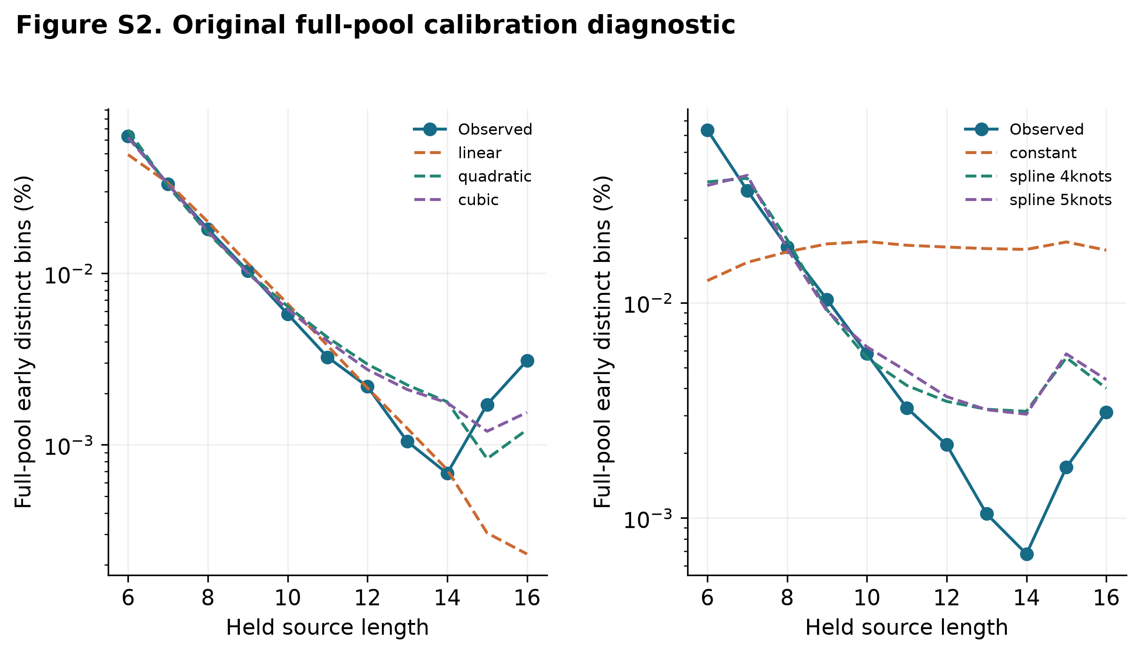
Figure S2. Preserved original diagnostic with labels and cutoff from the full 64-length pool, including held groups. This differs from Figure 5's training-only threshold target and is nonprospective. All six fixed specifications and all eleven primary groups are retained; human structure is DATA UNAVAILABLE.

Appendix D. Mathematical budget illustrations and hardware context
Table A6. Time for a hypothetical 10,000-check budget. Arithmetic transports an assumed rate or measured local serial latency to a fixed budget; it does not estimate password recovery time.
Scenario | Configuration | Rate/checks per second | Seconds for 10,000
online hypothetical | 1/second | 1.000 | 10000.000
online hypothetical | 10/second | 10.000 | 1000.000
online hypothetical | 100/second | 100.000 | 100.000
local serial verification illustration | argon2id level3 | 8.289 | 1206.358
local serial verification illustration | bcrypt level3 | 4.271 | 2341.456
local serial verification illustration | pbkdf2_sha256 level3 | 16.007 | 624.720

Figure S3 illustrates these fixed-budget scenarios. Real online throttling, lockout, detection, latency, and MFA change what an attacker can attempt or accomplish. Real offline capabilities vary with hardware, parameters, parallelism, and implementation. None were measured against external systems.
These numerical illustrations use a selected constant-cost proxy; they are not expectations of random elapsed times, measurements of admitted online traffic or optimized offline rates.
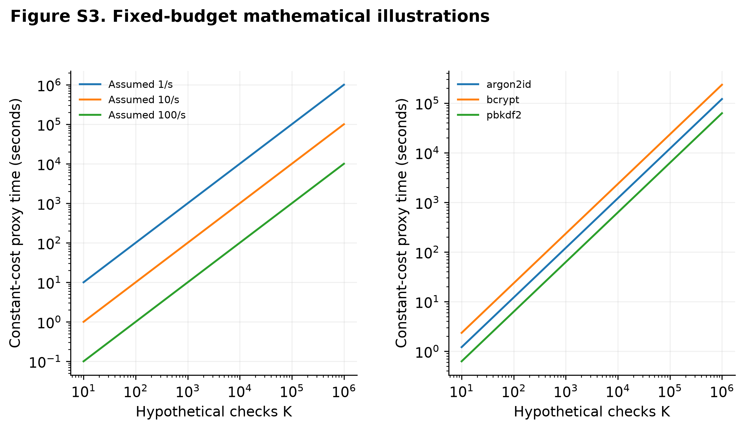
Figure S3. Online rates are assumed admitted checks; offline illustrations multiply a chosen local matching-verification median proxy by K. This is constant-cost arithmetic, not expected stochastic runtime, optimized attacker speed or recovery time. Lockout, throttling and MFA are separate conditions. No real system was tested.
Table A7. Accelerated-hardware comparability context. Memory specifications describe devices, not password-verification throughput. GPU/ASIC measurements and attack-rate conversions are NOT RUN.
Device | Memory | Bandwidth | Status
NVIDIA GeForce RTX 4090 | 24 GB GDDR6X | 1,008 GB/s | Specification context only
NVIDIA A100 40 GB | 40 GB HBM2 | 1,555 GB/s | Specification context only
NVIDIA A100 80 GB PCIe | 80 GB HBM2e | 1,935 GB/s | Specification context only
NVIDIA A100 80 GB SXM | 80 GB HBM2e | 2,039 GB/s | Specification context only

Manufacturer capacities use GB, not GiB. Hardware entries come from [30], [31], and [32].
The CPU reciprocal latency cannot supply a defensible GPU/ASIC multiplier. Comparisons require the same function, PRF/version, iteration or work factor, Argon2 memory/passes/lanes, input semantics, software, resource allocation, and measurement boundary. Argon2's p denotes lanes within a call; m denotes total memory across those lanes. Peak bandwidth or arithmetic figures do not determine sustained verification capacity. Hashcat implementations also have kernel/input limits; a public benchmark with another workload is not a measurement of these exact cells. The hardware-comparability supplement records these requirements. [25], [33], [34]

Appendix E. Conditional privacy-sensitivity illustrations
Conditional sensitivity example, length 15. The table evaluates that mathematical bound with utility target β=0.05 at assumed true masses equal to the released mass A₁₅ or 2A₁₅. These data-dependent mass proxies are assumptions; the resulting envelopes are not actual 95% intervals for this release or estimated noise magnitudes.
Table A8. Conditional radius illustrations for length 15. These are assumption-dependent envelopes, not release-specific confidence intervals.
Assumption | L1 radius | Frequency-1 bounds | Positive-even bounds | Conditional top-10,000 bounds
fixed_radius | 1,000 | 3.27%–3.31% | 96.34%–96.41% | 15.25%–15.26%
fixed_radius | 10,000 | 3.11%–3.48% | 96.02%–96.73% | 15.18%–15.33%
fixed_radius | 100,000 | 1.46%–5.20% | 92.89%–100.00% | 14.50%–16.02%
fixed_radius | 1,000,000 | 0.00%–26.12% | 66.28%–100.00% | 8.15%–23.36%
theoretical_mass_proxy (mass 15,212,723) | 80,297 | 1.81%–4.82% | 93.56%–99.27% | 14.65%–15.87%
theoretical_mass_proxy (mass 30,425,446) | 113,449 | 1.21%–5.46% | 92.43%–100.00% | 14.40%–16.12%

Under these stipulated radii, the large parity/doubleton pattern persists. This constrains the hypothesis that DP created the whole pattern from substantially lower original proportions, conditional on the documented mechanism and radius assumptions. It does not specify what those original proportions were, identify upstream processing, demonstrate truncation, or recover user behavior. Six diagnostic tables and the derivation are supplied in the DP supplement.

