**RC Car Requirements**

# **Introduction**

**This project’s purpose is to learn and experiment with new things, so it will have multiple different functionalities. Because of this there will be multiple ‘requirements’ chapters belonging to each. The main distinct groups are:**

* **The car itself: It should be able to go forwards, backwards, turn, break, stay idle, rotate the ESP Cam module (this will be mounted on a servo motor and it should be able to rotate 180°). It should be able to connect to the controller module (Android app, or ESP controller) and execute their commands. It should be able to use the Camera module and send the pictures to the Android App if necessary. It should be able to communicate with the Android App using Wi-Fi.**
* **The ESP control module: It should be able to process sensor data form an MPU6050 (this is used for the gesture control), it should be able to process data from a microphone (this is used for the voice control).**

**It should be able to give commands to the Car module according to the measured inputs from the sensors, to switch between control modes if that is required.**

* **The Android App: It should be able to read the inputs from the touch screen (Xbox-PlayStation like controller) and process them in order to send the relevant commands to the Car module, it should be able to communicate using Wi-Fi with the Car module.**

**The above-mentioned requirements are just to give an idea of who is responsible for what and go gain a general understanding about the project’s main components. These will be individually discussed in more detail in the following chapters.**

# **Requirements for the RC car module**

**The Car itself will have the following hardware components:**

* **4 DC motors (**Figure 1**) with a 1:48 gear ratio and a rated voltage of 3 – 6 V.**

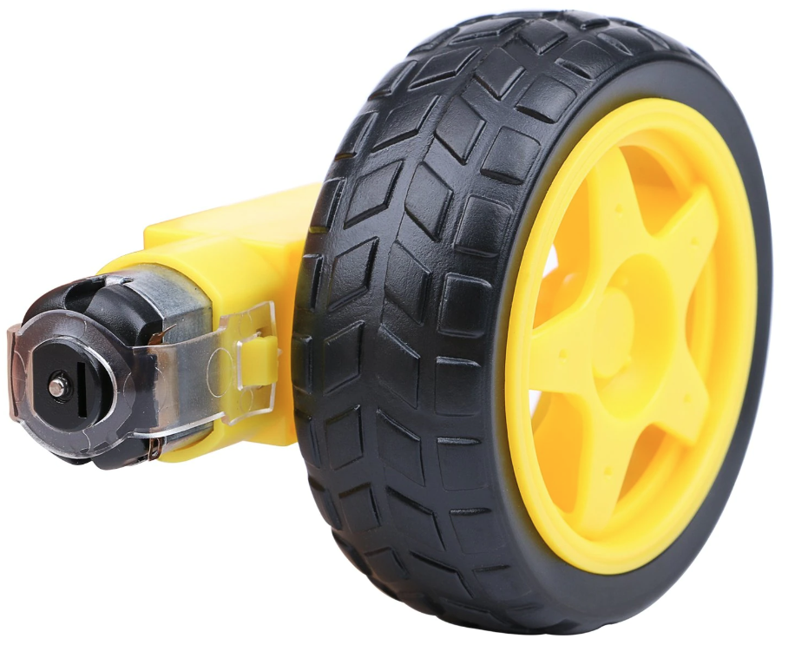

Figure

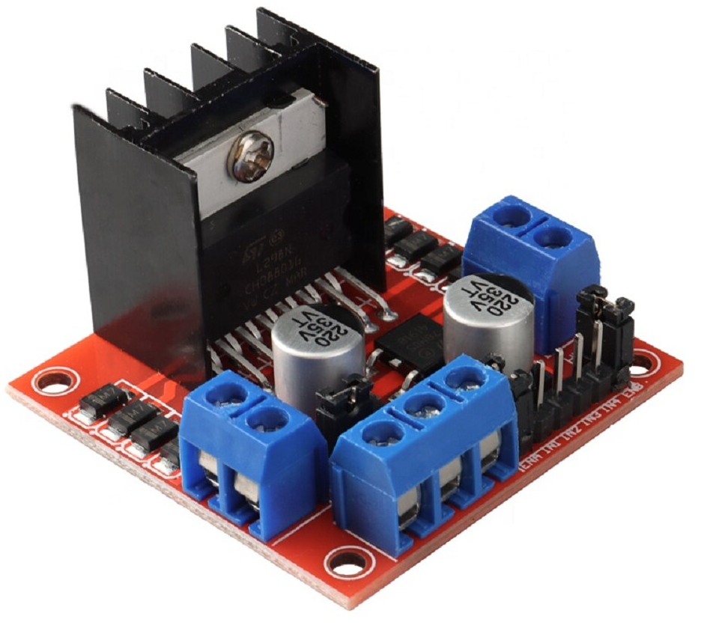

# **Requirements for the ESP Controller module**

# **Requirements for the Android App**