CardCreator – documentation

Card is generated from left to right. When the elements overlap, the one on the top will be the one on the right column.

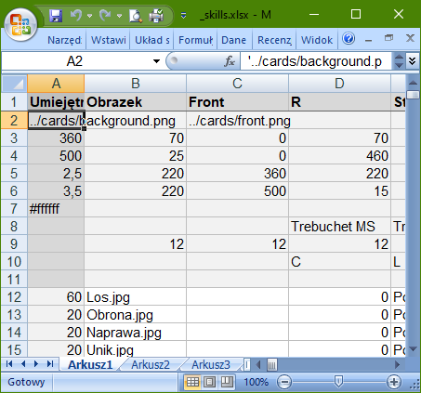

Cards’ elements

Cards

Number of card repetitions in PDF

Width and height in inches when creating PDF.

HTML text color

The way of joining columns with the same name

v – vertically

h - horizontal

Text alignment (L/C/R)

Max font size

Font

HTML text color – if empty, card’s text color is used.

Width in pixels

Position y in pixels

Position x in pixels

Height in pixels

Element’s background

Element’s name (if column “name” exists, generated card has its content as a name)

Width and height in pixels, when generating cards

Card background