1. Enter project Details
2. Enter Epic
3. (Go on project settings and click on features and enable all features like deployments and all we will get versions feils from their)
4. Enter versions.
5. Enter User stories to Backlog
6. Drag User stories to that’s epics-(When u will click on epics like browser what are there is browser will show)
7. Drag user stories to respective versions(when u will click on version what are the user features are in versions)
8. 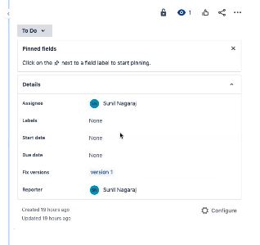Click on epic Browser and click on all details it will show u on right side click on right click open in a new tab
9. Assign to some one
10. Click on configure and add the configures add like priorities etc..
11. 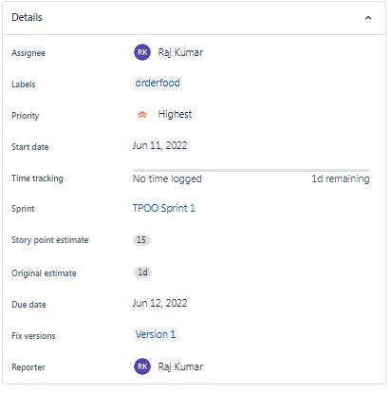
12. Enter Work log time for anything user stories and epics etc
13. Priorities setting
14. Click on version 1 and drag all the version 1 things to sprint 1.
15. Once after adding user stories to sprints we cannot modify. User stories
16. Start Sprint 1. Add description and click on start – after clicking on start we will go to kanban

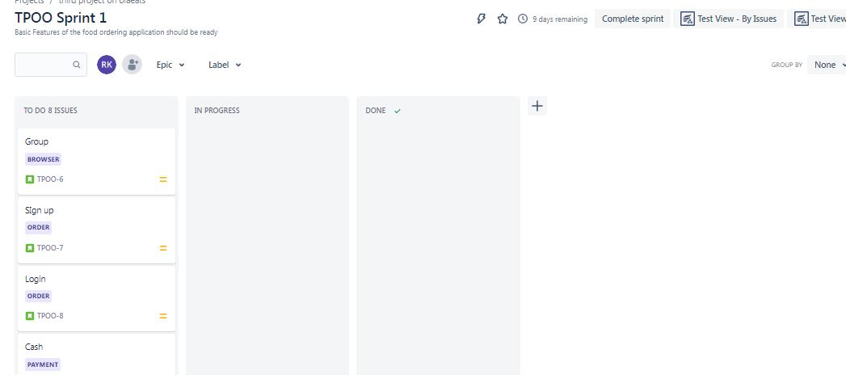

1. Add fields like Inprogress,Developer, Testing,Deplyoment
2. All user stories drag to sprint1.Than start sprint.
3. Once done click on complete sprint 1.(go to zephyr squad steps)
4. 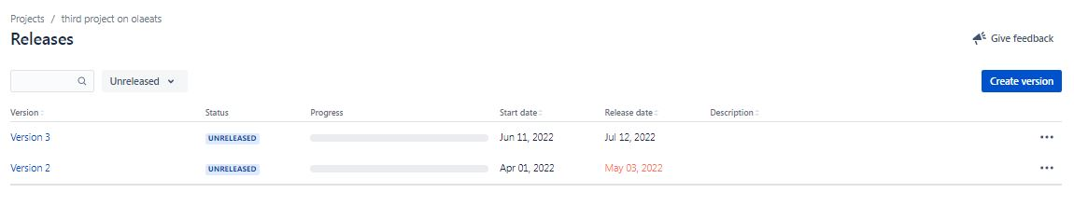Click on Release and Release version one
5. By clicking on Release un Release we can see everything what released how many are there etc
6. Same by clicking on version 2 drag and put it in Sprint 2 start sprint
7. And same like above kanban, develop, test, deploy, done and release
8. Story estimate- Time taken complete all stories
9. Story Point estimate –Time taken complete 1stories
10. Then he said about Reports
11. Now we are discussing about how to assign task, sub task, child task
12. Developer develop the Search by filters and debit card and testers test the thing
13. Click on add a child issue
14. Addsub task like I have developed the software now test the sw. and we will assign anyone
15. Now go for start sprint 2
16. GO to board and the things in todo and develop and testing
17. Select issue type like subtask what u have added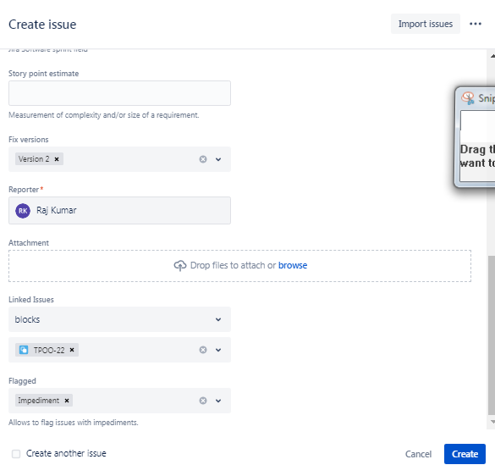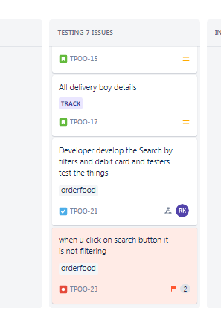
18. Now we are pluggin the Zephard squad
19. Add Zephardsquard to jeera
20. Add a task to Sprint 3 and start sprint 3 and drag everything in Testing.
21. Now go and create a issue type go to Project settings and click on issue types( there are 5 types of issue types Epic,bug,subtask,userstory,bug).
22. 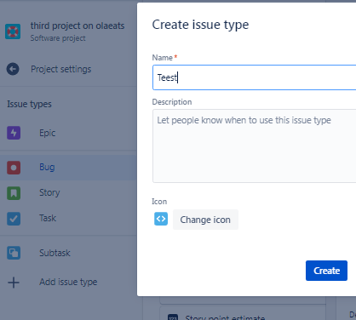
23. GO back to project settings click on zephyr squad and select issue type
24. 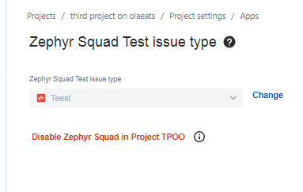And enable it next..next..next
25. Go back to project and on Report
26. We will go on Board and create a issue type Teest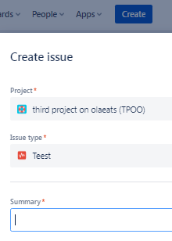
27. Go to backlog add it to sprint 3 – Go to Board- add to testing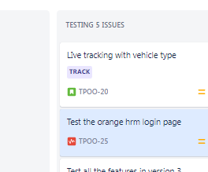
28. Click on orangehm login—Add description—add test cycles.—click on zephyr squad
29. Go on add cycle summary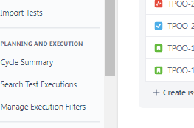
30. Create new test cycle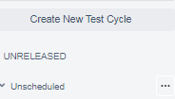
31. Type Regression testing and create once added go back to board
32. Click on test the login page of hm orange Teest add test cyclces
33. Add Test Cycles(Manual )
34. Click on right side … 3dots and select execute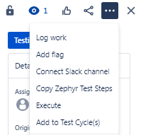
35. 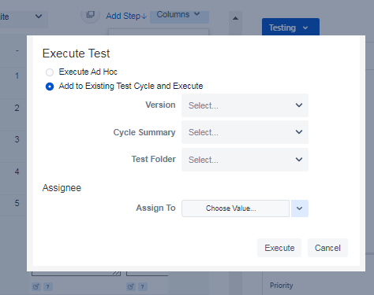
36. Add verion, cycle summery, assign. And click on execute
37. Click on pass and comments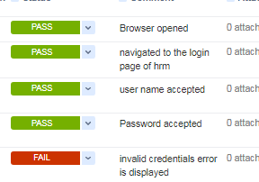
38. Create a new defect 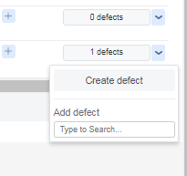
39. Click on done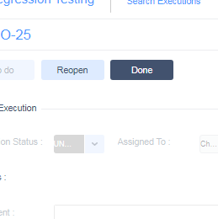
40. Click on reopen and give as pass and click on defect. Click on it and go to that page
41. Click on done and over all execution status is pass now
42. Once after done everything go project and zyphersquade.
43. 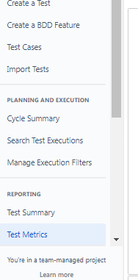 Click on test execution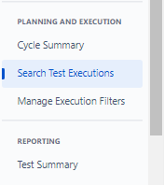
44. And click on test summary..and all those things like test matrics, test summaries all those reports.

Import

1.Executed test case through excel file. Import file…

1…Click on zephyr squad and click on test cases

2.click on export test cases and file will save in your system.

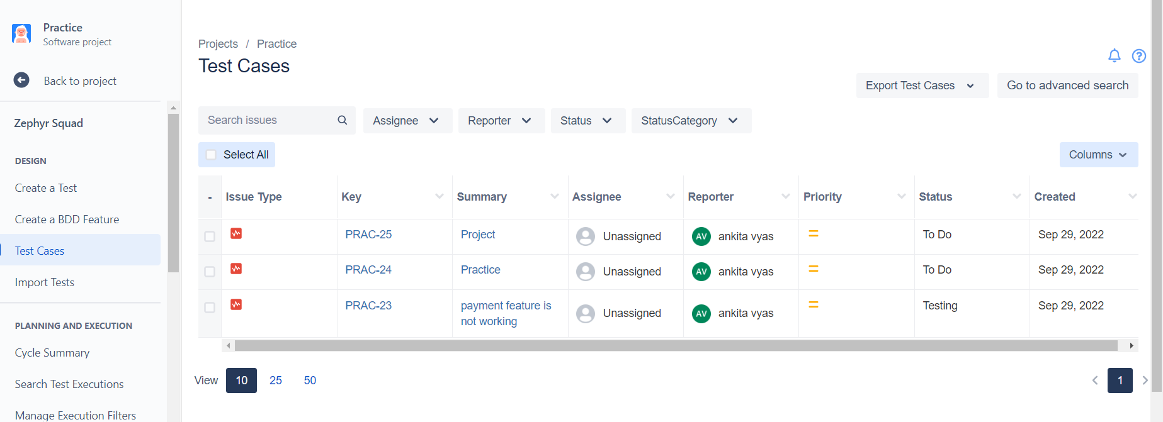

3. We add some data in export file….add some columns in last Like test step ,test data and result and than save.

4.Than click on Import Tests

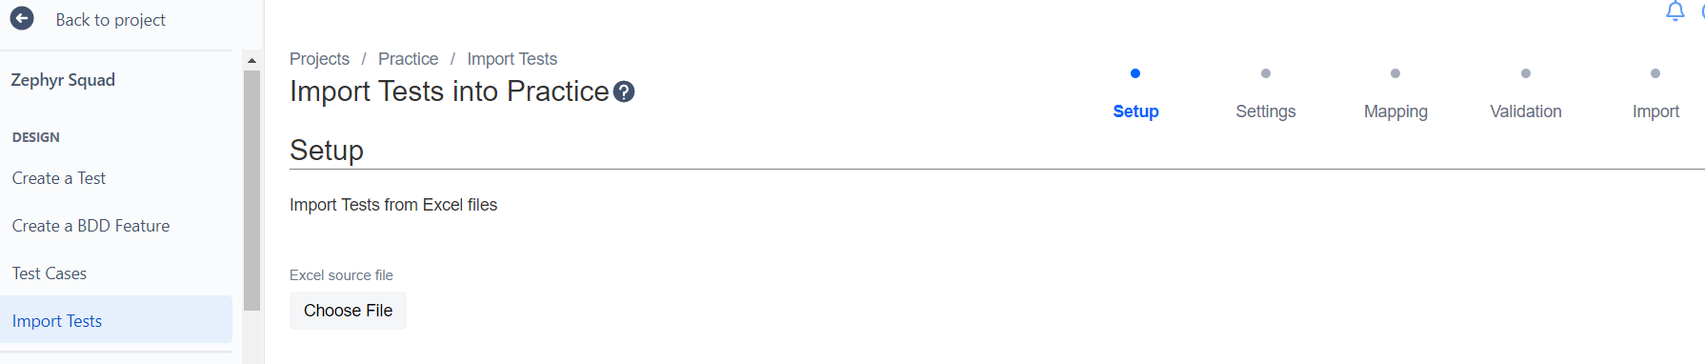

5.Choose file from the system where your file is downloaded. Click on next.

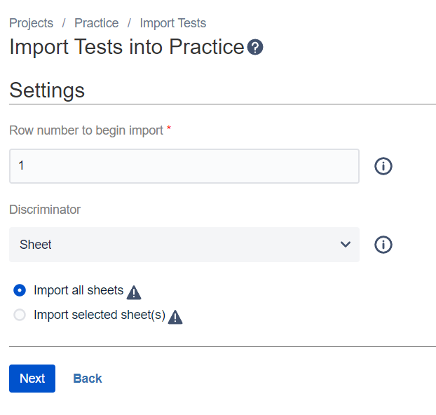

Click on next

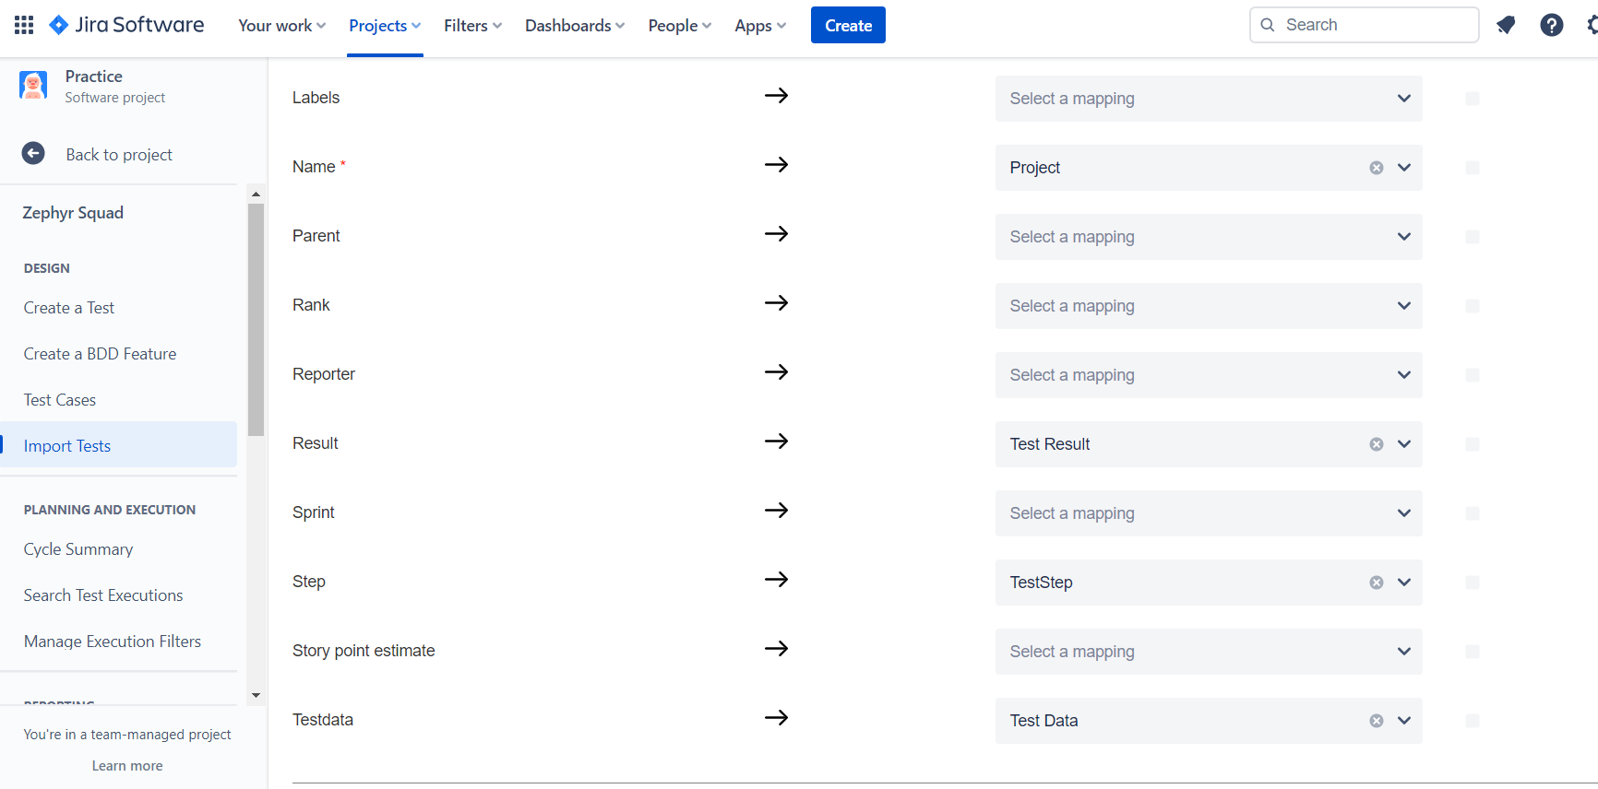

Select result==Test result

Name==Project

Step===Test Step

Testdata ==TestData

Click on next and validate it.

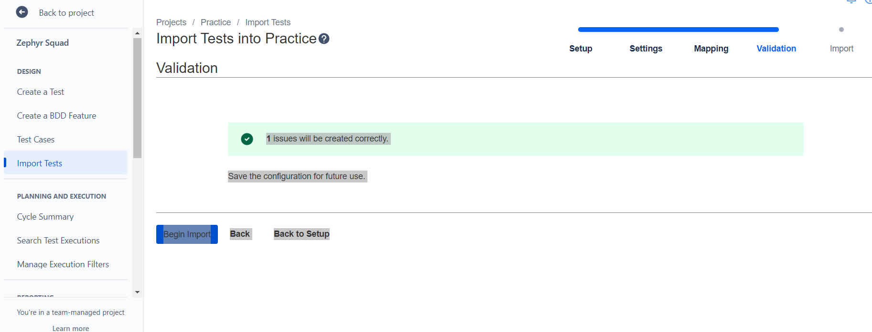

Click on Begin import

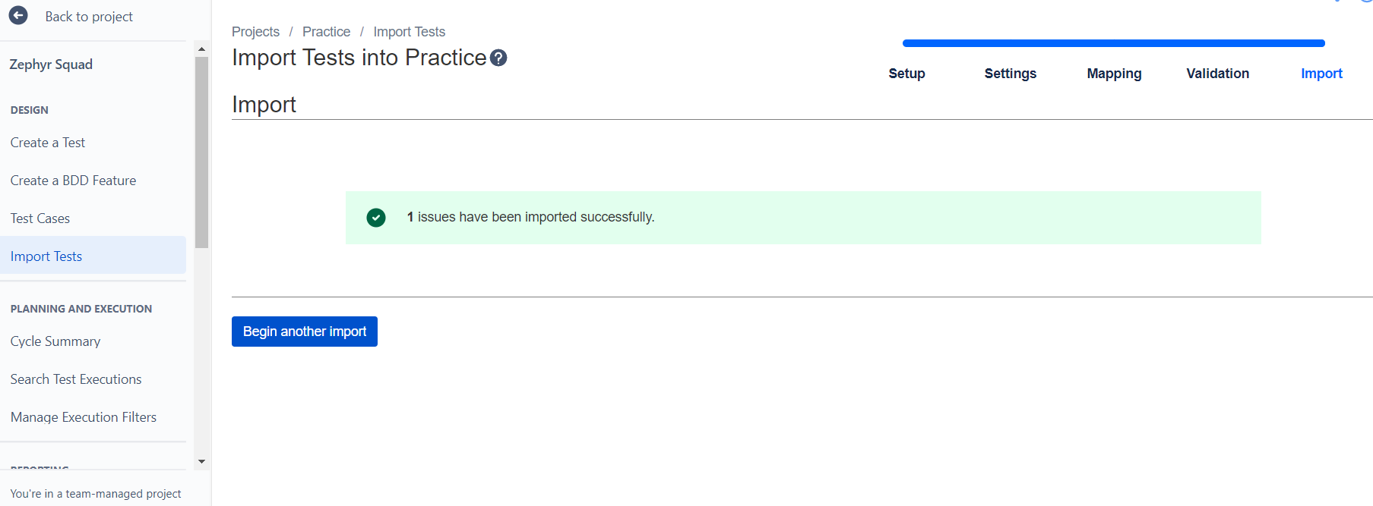

Click on test cases

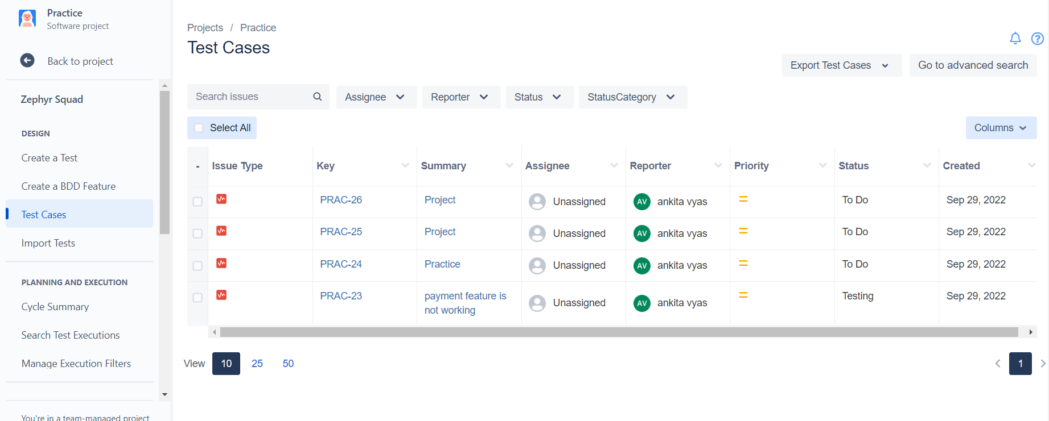

Click on prac-26

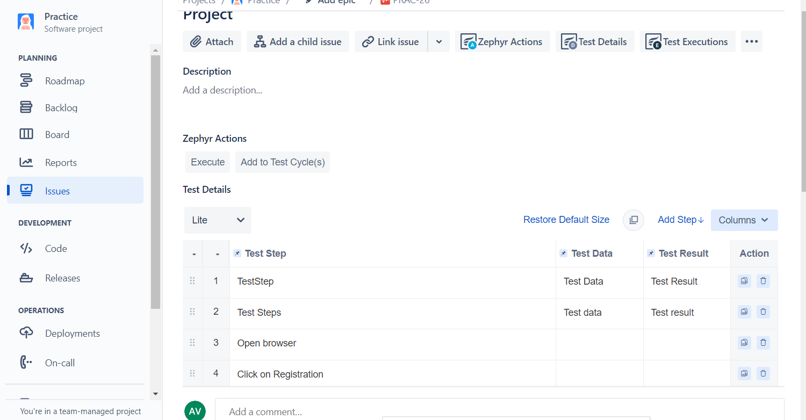

Click Add to testCycles

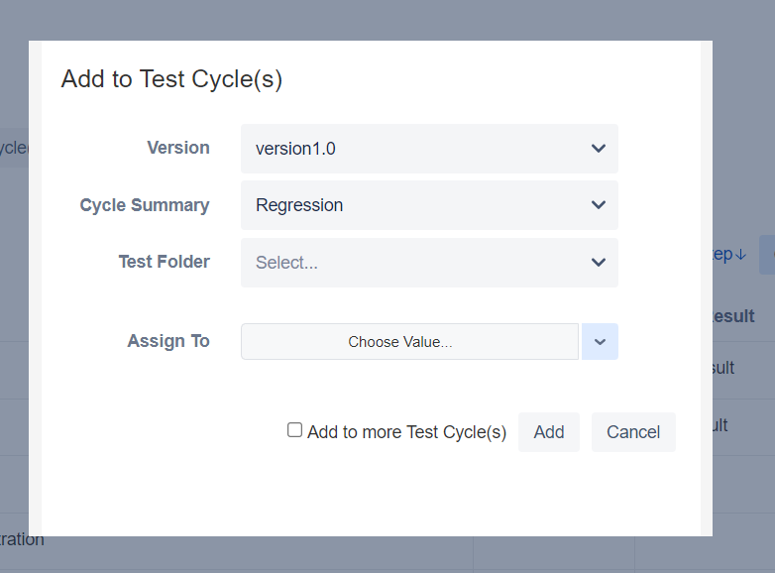

Click on add

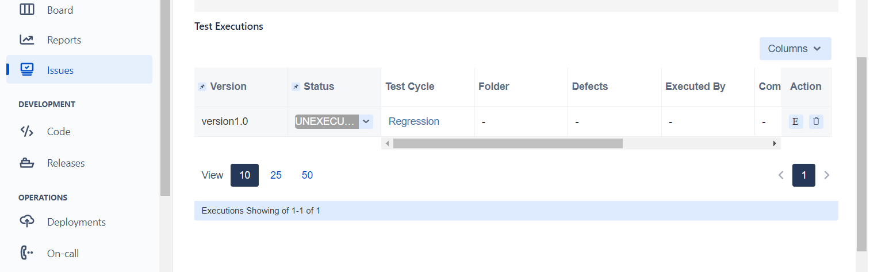

Three ways to execute Testlifecycle

1Execute===2.E====3=Three dots

After click on execute

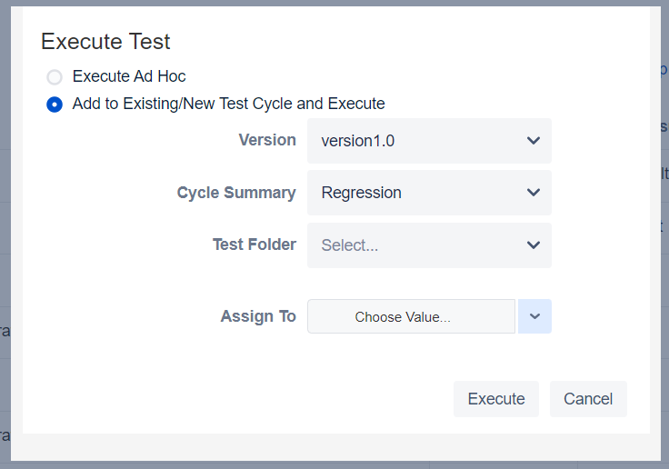

Go to point no 36.