Scope Change Number *(Must match with the change log entry)* Date: 21/06/2023

*(For Avenues Tech use only)* Partner: KCB

Product: DigiRemit

Project Name: Policy hyperlinks on website homepage and post login

CRF Created By: Saurabh Gawade

Developer Name:

Production Movement By:

***Type of Change Priority Change*** *(Related to Function)* ***Request Type***

☐Business Change or Need ☒Critical ☐ Operational ☒ Paid

☐ Scope Change or Need ☐High ☐ Compliance ☐ At no Cost

☐ Scheduled Change ☐Normal ☐ Service

☐ Error Correction ☐Low ☒ Miscellaneous

☒ Regulatory Requirement ☐ Internal Changes

☐ Network, Server & System

☐ Cosmetic

☐ Functionality

☐ Admin tool Development

☐ Others (Please Specify):

***Checklist (For request Initiator)***

☒ Required Screenshots Provided ☐ Required URLs’ provided☐Login credentials provided *(Cases to case basis)*

☐ Flow Chart ☐ Details of Admin tool involved

***Description of the Requested Change(s)***

Change type: regulatory

Change required: Add GMT’s (Golden Money Transfer) policies on landing page of KCB remit portal. GMT is collection partner for KCB in the United States therefore their polices needs to be displayed on KCB remit portal

The following **policies** needs to be hyperlinked with its corresponding link

1. **License list:** <https://gmtsend.com/state-license-list>
2. **Compliance Statement:** <https://gmtsend.com/compliance-statement>
3. **Privacy Policy:** <https://gmtsend.com/privacy-policy>
4. **Terms of Use:** <https://gmtsend.com/terms-of-use>

The following Homepage & Post login image will depict how it will look on the UI. On click of any policy the user will be opened with the link in a separate tab on the browser.

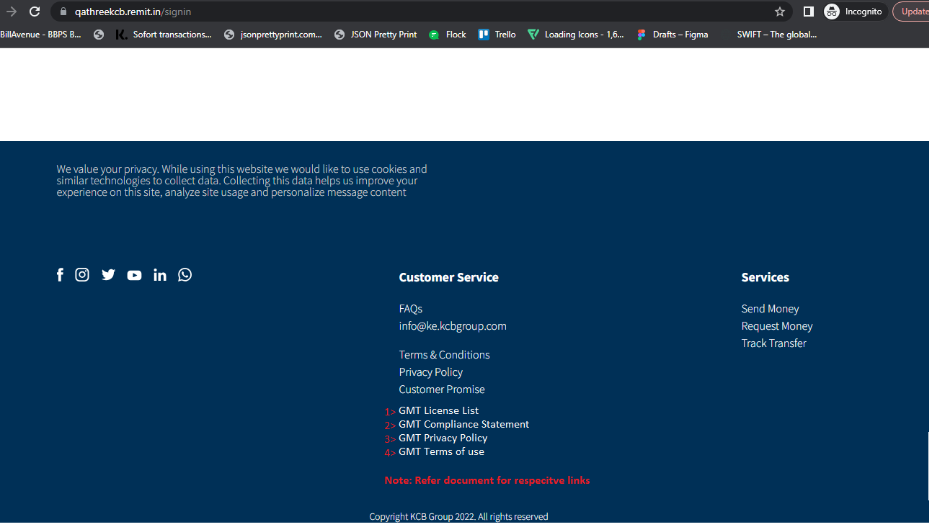

**Post login Footer will also have the hyperlinks similar to the above sample screen.**

***Impact Due to Suggested Change(s)***

***Impact Summary***

***Development Estimation***

Resource Required *(Man days)*: Effort Estimation Approved by:

*(Project to be commenced post approved by Partner)*

***Authorization***

Project Manager’s Name & Signature: Date: 21/06/2022

Developer’s Name & Signature: Date: Click or tap to enter a date.

CRF Reviewed & Approved by: Date: Click or tap to enter a date.

***Note:***

1. Complete scope of work to be defined appropriately by the request initiator
2. Request initiator can use subsequent pages for screenshots & additional information
3. Avenues Technology shall provide timelines & effort estimation only for the scope defined in the CRF. In-case of addition in the scope of work, the timeline may differ
4. Above timelines shared by Avenues Technology is estimation purpose. Actual timeline may differ