How to run the web api

**Run from visual studio:**

From the project root open the solution file using visual studio.

Set the project “BuySellService” as the startup project

**Make sure the port is 64237**

This is important. Because the Front end application is a separate solution and will connect to this specific location for consuming the api

The application will run

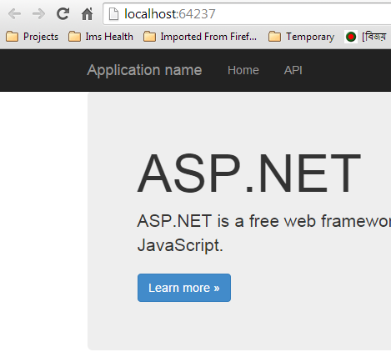

Now run the Front end application and consume the service.